
Welfare
Rules
Databook
Welfare Rules
Databook: State TANF
Policies as of July2013

OPRE Report 2014-52

Welfare Rules Databook: State TANF Policies as of July 2013
final report
OPRE Report 2014-52
September 2014
Erika Huber, David Kassabian, and Elissa Cohen, The Urban Institute
Submitted to:
Girley Wright, Project Officer
Office of Planning, Research and Evaluation
Administration for Children and Families
U.S. Department of Health and Human Services

Contract Number: HHS P23320095654WC
Task Order Number: HHS P23337001T
Project Director: Linda Giannarelli
The Urban Institute
2100 M Street NW
Washington, DC 20037



This report is in the public domain. Permission to reproduce is not necessary. Suggested citation: Huber, Erika, David Kassabian, and Elissa Cohen (2014). Welfare Rules Databook: State TANF Policies as of July 2013, OPRE Report 2014-52, Washington, DC: Office of Planning, Research and Evaluation, Administration for Children and Families, US Department of Health and Human Services.

Disclaimer
The views expressed in this publication do not necessarily reflect the views or policies of the Office of Planning, Research and Evaluation, the Administration for Children and Families, or the US Department of Health and Human Services.

This report and other reports sponsored by the Office of Planning, Research and Evaluation are available at http://www.acf.hhs.gov/programs/opre/index.html.

This project was funded by the Department of Health and Human Services, Administration for Children and Families and the Department of Health and Human Services, Assistant Secretary for Planning and Evaluation.

The authors thank the many state TANF administrators who verified the WRD data, as well as our HHS/ACF project officer, Girley Wright, and the other HHS staff who provided comments. In addition, this paper builds on work by numerous past and present Urban Institute staff members. Specifically, Caitlin Brandt, Jason Cherry, and Katherine Kerstetter, performed the bulk of the updating of the WRD for 2013. Also, the project continues to benefit from the organizational and conceptual work of Gretchen Rowe, who managed and then directed the Welfare Rules Database project from 1998 through 2010, and Mary Murphy, who was the primary analyst on the project from 2004 through 2010.

The nonpartisan Urban Institute publishes studies, reports, and books on timely topics worthy of public consideration. The views expressed are those of the authors and should not be attributed to the Urban Institute, its trustees, its funders, or other authors in the series.

Contents

Introduction and Background 1
The Welfare Rules Database 2
The Databook 10
Policies as of July 2013 13
I. Initial Eligibility 15
A. Does the state try to divert some families from becoming recipients? 16
B. How does family composition or individual status affect eligibility? 18
C. What level of assets can a family have and still be eligible? 28
D. How is income counted in determining eligibility? 30
E. How much income can a family have and still be eligible? 33
II. Benefits 97
A. If a family passes all eligibility tests, what is received? 98
III. Requirements 121
A. Once determined eligible, what must a recipient family do to maintain benefits? 122
B. What work activities are required? 123
IV. Ongoing Eligibility 149
A. What eligibility tests must recipient families pass for continuing eligibility? 150
B. Are children eligible if born while the family receives benefits? 155
C. How long can a family receive benefits? 156
V. Policies across Time, 1996–2013 205
Appendix 1: Component Descriptions 248
About the Authors 257

Tables

I.A.1 Formal Diversion Payments, July 2013 40
I.A.2 Mandatory Job Search at Application, July 2013 44
I.B.1 Eligibility of Units with Pregnant Women with No Other
Children, July 2013 48
I.B.2 Eligibility Rules for Two-Parent, Nondisabled
Applicant Units, July 2013 50
I.B.3 Special Rules Imposed on Minor Parent
Eligibility, July 2013 52
I.B.4 Inclusion of Stepparents in the Assistance Unit, July 2013 54
I.B.5 State Practices Regarding Eligibility of Nonexempt,
Pre-PRWORA, Qualified Aliens, July 2013 56
I.B.6 States Using State Funds to Help Noncitizens
Who Entered after Enactment and Are Ineligible
for Federal TANF Assistance, July 2013 58
I.B.7 State Practices Regarding Eligibility of
Nonexempt, Post-PRWORA, Qualified Aliens
after Five Years, July 2013 60
I.B.8 Treatment of Noncaretaker Adults in Household,
July 2013 62
I.B.9 Eligibility Requirements for Children, July 2013 66
I.B.10 Inclusion of SSI Recipients in the Assistance Unit,
July 2013 68
I.B.11 Inclusion of Nonparent Caretakers in the
Assistance Unit, July 2013 70
I.C.1 Asset Limits for Applicants, July 2013 74
I.D.1 Treatment of Grandparent Income, July 2013 78
I.D.2 Treatment of Stepparent Income, July 2013 80
I.D.3 Treatment of Income and Assets of
Nonparent Caretakers, July 2013 84
I.E.1 Income Eligibility Test for Applicants, July 2013 86
I.E.2 Earned Income Disregards for Income Eligibility
Purposes, July 2013 88
I.E.3 Standards for Determining Eligibility, July 2013 90
I.E.4 Maximum Income for Initial Eligibility for a
Family of Three, July 2013 94
II.A.1 Earned Income Disregards for Benefit
Computation, July 2013 104
II.A.2 Benefit Determination Policies, July 2013 108
II.A.3 Standards for Determining Benefits, July 2013 112
II.A.4 Maximum Monthly Benefit for a Family
with No Income, July 2013 116
II.A.5 Maximum Monthly TANF Benefit for a
Child-Only Unit with One Child, No Income, July 2013 118
III.A.1 Behavioral Requirements, July 2013 130
III.B.1 Work-Related Activity Exemptions for
Single-Parent Head of Unit, July 2013 132
III.B.2 Work-Related Activity Requirements for
Single-Parent Head of Unit, July 2013 138
III.B.3 Sanction Policies for Noncompliance with Work
Requirements for Single-Parent Head of Unit,
July 2013 142
III.B.4 Work-Related Activity Requirements for
Nonparent Caretakers and Parents Outside the Unit,
July 2013 146
IV.A.1 Eligibility Rules for Two-Parent, Nondisabled
Recipient Units, July 2013 160
IV.A.2 Treatment of Child Support Income for
Recipients, July 2013 162
IV.A.3 Asset Limits for Recipients, July 2013 166
IV.A.4 Income Eligibility Tests for Recipients, July 2013 172
IV.A.5 Earned Income Disregards for Continuing Income
Eligibility Purposes, July 2013 174
IV.A.6 Maximum Income for Ongoing Eligibility for a
Family of Three, July 2013 176
IV.B.1 Family Cap Policies, July 2013 178
IV.C.1 State Lifetime Time Limit Policies, July 2013 180
IV.C.2 Other State Time Limit Policies, July 2013 184
IV.C.3 State Time Limit Exemption Policies, July 2013 186
IV.C.4 State Time Limit Extension Policies, July 2013 194
L1 Formal Diversion Payments, 1996–2013 (July) 210
L2 Types of Special Restrictions on Two-Parent,
Nondisabled Units’ Eligibility, 1996–2013 (July) 214
L3 Maximum Income for Initial Eligibility for a Family
of Three, 1996–2013 (July) 216
L4 Earned Income Disregards for Benefit
Computation, 1996–2013 (July) 218
L5 Maximum Monthly Benefit for a Family
of Three with No Income, 1996–2013 (July) 224
L6 Work-Related Exemption When Caring for a
Child under X Months, 1996–2013 (July) 226
L7 Most Severe Sanction Policy for Noncompliance
with Work Requirements for Single-Parent
Adults, 1996–2013(July) 230
L8 Asset Limits for Recipients, 1996–2013 (July) 238
L9 Vehicle Exemptions for Recipients, 1996–2013 (July) 240
L10 Family Cap Policies, 1996–2013 (July) 244

Introduction and Background
This publication, the Welfare Rules Databook, presents the key policies that each state used to determine cash aid under the Temporary Assistance for Needy Families (TANF) program as of July 2013. The Databook also provides longitudinal tables describing various state policies for selected years between 1996 and 2013. The tables are based on the information in the Welfare Rules Database (WRD), a publicly available, online database funded by the Department of Health and Human Services and developed and maintained at the Urban Institute.
While TANF is a federally funded program, the specific policies governing eligibility status and benefit levels are determined at the state level, within the overall structure established by the federal legislation. Thus, a family that is eligible for several hundred dollars of cash aid each month in one state may be eligible for much less in another state and completely ineligible in a third state. The impact of increased earnings, the amount of time a family can receive TANF before becoming ineligible, and the amount of money a family can have in savings are three other aspects of program policy that vary substantially across the states.
The Databook provides researchers and policymakers with substantial information on how the TANF program operates across the states. It is divided into five groups of tables: initial eligibility in 2013; benefits in 2013; requirements in 2013; ongoing eligibility in 2013; and policies across time, 1996–2013. Each chapter begins with an overview of the policies, followed by details relating to specific tables.
While most of the tables are updates of tables included in prior Databooks, there is one new table in this year’s book: table IV.A.5. Earned Income Disregards for Continuing Income Eligibility Purposes. This table displays how much of a recipient’s earned income is disregarded when determining eligibility and benefits amounts. Previously, this information was captured in footnotes in table I.E.2 Earned Income Disregards for Income Eligibility Purposes, but displaying this information in a separate table is meant to make it clearer and more accessible since states sometimes implement different income disregards between applicants and recipients.
The Databook summarizes the detailed information in the WRD. Users interested in a greater level of detail are encouraged to use the full database, available at http://anfdata.urban.org/wrd/. This site includes a point-and-click interface, as well as extensive documentation.
The following sections first discuss the background and structure of the WRD, and then describe the contents and structure of the tables in this book.

The Welfare Rules Database
The Welfare Rules Database is a comprehensive resource for comparing cash assistance programs across all 50 states and the District of Columbia, researching changes across time in cash assistance rules within a single state, or determining the rules governing cash assistance in one state at a point in time. The WRD is longitudinal and currently provides information on state Aid to Families with Dependent Children (AFDC) and TANF policies from 1996 through 2013. The WRD was initially developed to meet the needs of researchers under the Urban Institute’s Assessing the New Federalism project and was made publicly available in August 1999. The Department of Health and Human Services, Administration for Children and Families (HHS/ACF) and the Department of Health and Human Services, Office of the Assistant Secretary for Planning and Evaluation (HHS/ASPE) currently fund the maintenance and development of the WRD.
The Development of the WRD
The WRD was developed in response to the increasing difficulty since the early 1990s of tracking how states operate their cash assistance programs for needy families. Under AFDC, the structure of eligibility and benefit computation was mostly determined federally. States were allowed to set certain policies—such as the standards used to establish eligibility and benefits, and the rules for two-parent families—but those choices were detailed in the State Plans they submitted to HHS/ACF and in annual reports issued by HHS/ACF summarizing the State Plans. In the early to mid-1990s, as more states received waivers to experiment with welfare rules, it became increasingly difficult to research states’ policies. The Waiver Terms and Conditions agreed to by the state and the federal government often did not provide full implementation details, and the implementation schedules often changed after the agreement was reached. The August 1996 passage of the Personal Responsibility and Work Opportunity Reconciliation Act (PRWORA), replacing AFDC with the TANF block grant, further increased both the degree of variation across state programs and the difficulty of tracking program rules. In addition, the Deficit Reduction Act of 2005, which reauthorized the TANF program in 2006, strengthened work participation requirements and further altered state TANF policies.
Currently, each state is required to submit a TANF State Plan to the federal government every two years. TANF State Plans provide an overview of states’ choices under the block grant. However, the plans’ level of detail varies considerably across states, and they generally offer insufficient information to completely understand the details of eligibility, benefit computation, and client requirements. Further, although states are expected to notify the federal government if any of their choices change after the plan is submitted, they are not required to do so.
The WRD was developed to provide detailed information about states’ TANF policies, going beyond the level of detail in most states’ official State Plans and capturing changes in policies that occur between the submissions of those plans. The WRD focuses on cash assistance policies and some closely tied transitional benefits; it does not attempt to capture other uses of federal TANF funds (such as state earned income tax credits, and child care programs).
Although the WRD’s main focus is federally funded policies, information on policies provided under “separate state” programs (SSPs) or “solely state-funded” programs (SSFs) is included when those benefits are considered part of the same basic program by the state and are therefore included in the caseworker manual. Thus, if a state funds benefits to two-parent units under an SSF program, or funds benefits to certain immigrant units under SSP funding, those benefits are included to the extent they are described in the caseworker materials. Note that the WRD does not separately identify which policies use SSP or SSF funds. This is particularly relevant for readers who are examining both the eligibility and benefit policies in the Databook and information on TANF spending or caseloads. The federal government’s administrative data sources capture information on SSP programs separately from information on TANF programs; information on SSF programs is not collected or disseminated by the federal government.
Contents of the WRD
The WRD provides in-depth information on a wide range of policy topics. These topics are currently organized into 31 categories that together describe most significant dimensions of state policies regarding cash assistance to needy families. While the categories may be ordered in various ways, it is useful to consider the rules in the sequence in which individuals seeking and receiving assistance will likely encounter them. The 31 categories are listed on the following two pages, organized into five sections, beginning with initial eligibility.
- Initial Eligibility

    - Does the state try to divert some families from becoming recipients?
Diversion

    - How does family composition or individual status affect eligibility?
Eligibility by Number/Type of Parents
Eligibility of Units Headed by a Minor Parent
Eligibility of Pregnant Women
Employment-Related Eligibility of Two-Parent Families
Eligibility of Individual Family Members
Inclusion of Noncitizens in the Unit
Treatment of Additional Adults in the Household
Other Nonparent Caretaker Policies

    - What level of assets can a family have and still be eligible?
Asset Test

    - How is income counted in determining eligibility?
Countable Income
Income and Assets of Children
In-Kind Income
Deemed Income
Child Support
Earned Income Disregards

    - How much income can a family have and still be eligible?
Income Eligibility Tests
Dollar Amounts

- Benefits

      - If a family passes all eligibility tests, what is received?
Benefit Computation

- Requirements

      - Once determined eligible, what must a recipient family do to maintain benefits?
Contracts and Agreements
School Policies for Dependent Children
Immunization and Health Screening Requirements
Child Support Sanctions

      - What work activities are required?
Activities Exemptions
Activities Requirements
Activities Sanctions
Minor Parent Activities Requirements and Bonuses
Components

- Ongoing Eligibility

      - How long can a family receive benefits?
Time Limits

      - Are children eligible if born while the family receives benefits?
Family Cap

Note: The categories under sections I.B–I.E and II may also be relevant to ongoing eligibility. In most states, recipients are also required to pass nonfinancial and financial tests to continue receiving benefits. These tests may differ for initial and ongoing eligibility.

- Transition to Self-Support

      - What happens after cash assistance ends?
Transitional Benefits
Sources of Information for the WRD, and Verification of the Data
The primary sources of information for the WRD (and thus for the tables in the Databook) are the caseworker manuals and/or regulations used in each state and the District of Columbia. The Urban Institute has a subscription or other arrangement with each state to obtain the manuals or regulations as well as the ongoing updates to those manuals or regulations. These documents provide a consistent source of detailed information on policy changes and implementation dates across states and time.
States were given the opportunity to verify the key policies in the 2013 Databook tables. The 49 states that reviewed the Databook tables are:
Alabama | Indiana | Nebraska | South Dakota
Alaska | Iowa | Nevada | Tennessee
Arizona | Kansas | New Hampshire | Texas
Arkansas | Kentucky | New Jersey | Utah
California | Louisiana | New Mexico | Vermont
Colorado | Maine | New York | Virginia
Connecticut | Maryland | North Carolina | Washington
Delaware | Massachusetts | North Dakota | West Virginia
Florida | Michigan | Ohio | Wisconsin
Georgia | Minnesota | Oklahoma | Wyoming
Hawaii | Mississippi | Oregon
Idaho | Missouri | Pennsylvania
Illinois | Montana | South Carolina

A similar verification process has been performed in each year since the first year of the Databook, which described policy variations in 1999. In those verification rounds, 44 states reviewed the complete 1999 data or the 1999 tables, 46 states reviewed the complete 2000 data or the 2000 tables, 45 states reviewed the 2001 tables, 46 states reviewed the 2002 tables, 45 states reviewed the 2003 tables, 46 states reviewed the 2004 and 2005 tables, 44 states reviewed the 2006 and 2007 tables, 47 states reviewed the 2008 tables, 42 states reviewed the 2009 tables, 46 states reviewed the 2010 tables, 42 states reviewed the 2011 tables, and 45 state reviewed the 2012 tables. Portions of the 1996–98 data in the WRD have been verified against selected secondary sources but have not been fully reviewed by state TANF staff.
General Points about the WRD
The WRD
- contains information on the cash assistance rules in effect in each state across time. It does not include information on proposals or legislation that has not been implemented.
- focuses on welfare rules. The database does not contain information regarding caseloads, budgets, outcomes, or administrative practices.
- contains at least one “record” (a set of coded variables) for each state, year, and category of rules.
- contains additional records when the state changes a policy during the year or when the state’s policy varies by geographic regions of the state, demographic characteristics of the assistance units, or “component” groups across the state. (The term “component” is used when the state’s caseload is divided into mutually exclusive groups based on multiple characteristics.)
- indicates when states vary policies by county or other sub-area of a state. However, in states that are considered to have devolved administration of the TANF program to the county level, data are recorded only for the largest county in the state.
- contains for every year, state, and category of rules one record that is designated the “majority rule” record. This record represents the policy that affected the majority of the caseload for the majority of the year.
It is important to note that neither the WRD nor the Databook addresses the issue of how rules may be implemented in practice. As noted above, the WRD is based on caseworker manuals and regulations, which typically do not include information on the likelihood of various outcomes. For instance, if a particular type of recipient may be assigned to one of several work activities, the manuals do not typically address the issue of which activity is the most likely assignment. Thus, for certain policies, two states may look similar in the database and yet in practice be different, and other states’ policies may look different and yet be similar in practice.

The Databook
Content of the Databook
The descriptions of the policies in this Databook are focused on what is relevant to the individuals and families to whom the policies apply. The book describes the rules that affect individuals and families in each state, but it generally does not specify whether those policies are imposed as a result of federal or state requirements. Thus, this book does not exhaustively describe federal requirements or prohibitions. Federal TANF policies are fully described in resources available from the Administration on Children and Families.
The tables included in this book are designed to provide readers with easy access to key TANF policies across states as of July 2013. The first four chapters of the Databook provide information as of July 2013 across four broad policy areas: initial eligibility, benefits, requirements, and ongoing eligibility. The last chapter provides longitudinal tables for selected policies with data from 1996 through 2013.
The data for the tables are extracted from the WRD and represent only a portion of the overall information in the database. Even for the policy areas addressed in this book, further details are available online in the WRD. In general, the Databook tables focus on the “majority rule” for an aspect of policy, while the full online database allows exploration of policy variations across months of the year and different subsets of the caseload.
Structure of the Tables
Each table follows the same general structure. Typically, the body of each table includes one row per state, which represents the policies in place as of July 2013. If different policies were used for different types of families, the tables show the policies for the predominant type of family in the state—generally, nonexempt, single-parent units with children. As mentioned earlier, if a state’s policies in an area vary by geographic subarea, the policies for the largest area in the state are shown.
Some tables include more information than just the rules for the majority of the caseload. In some cases, additional information is included in an additional row for the state; in other cases, additional information is included in footnotes.
- Additional data as a second row: A second row is added to the body of the table if a state divides its entire caseload into mutually exclusive groups that are treated differently across more than one policy. These groups—”components” in the WRD—are usually defined by more than one characteristic, such as “units containing a child under 13 years old whose unit head is job ready.” Descriptions of states’ components are located in appendix 1.
- Additional data as a footnote: Several types of variations may appear as footnotes in the tables. These include variation by type of assistance unit (two-parent units versus one-parent units or applicants versus recipients) or geographic areas (pilot projects in a few counties versus the rest of the state). These types of policies are footnoted in some, but not all, tables. The tables do not capture all the variation in policies across regions and types of units, but the full WRD database contains this information. In addition, states with county variations in policy are footnoted. The footnote indicates the name of the county (the largest in population in the state) to which the policy applies.
Each 2013 table is numbered by chapter and section. For example, table III.A.1 refers to the first table in chapter III, section A. The longitudinal tables are numbered L1 through L10. The numbering of the tables in this book generally corresponds to the numbering in the 1999 through 2012 books. The 2012 edition included six new tables, added throughout the Databook and maintained in this version. This Databook has one change in table numbering: Table IV.A.6, “Maximum Income for Ongoing Eligibility for a Family of Three, July 2013” had been numbered IV.A.5 in previous versions. Table IV.A.5 is now the new table, “Earned Income Disregards for Continuing Income Eligibility Purposes, July 2013.”

Policies as of July 2013

Initial Eligibility

The tables in this chapter of the Databook describe key aspects of the rules imposed on families and individuals to determine initial eligibility for TANF cash assistance as of July 2013. Rules for initial eligibility apply to individuals who are newly applying or reapplying for assistance. To be eligible, an applicant family must pass both nonfinancial tests, based on the demographic characteristics of the family and its members, and financial tests, based on the income and asset holdings available to the family. This chapter is divided into five sections covering initial eligibility rules related to diversion, family composition, assets, income definitions, and income tests.

A. Does the state try to divert some families from becoming recipients?
Many states have policies that attempt to divert from assistance applicants who may be able to become self-sufficient with some type of state help other than regular monthly cash aid. These types of policies were developed during the 1990s, first under state waivers and then after the passage of PRWORA.
Two policies intended to encourage self-sufficiency are diversion and job search at application. As of July 2013, approximately two-thirds of states have formal diversion programs. Under these programs, families may choose to receive a lump-sum cash payment to deal with immediate needs instead of receiving a monthly TANF benefit. Generally, states provide benefits to families to alleviate short-term problems that interfere with either keeping or finding employment. Families that accept diversion payments typically are barred from applying for monthly TANF benefits for some period. Most diversion programs are voluntary; however, a few states require certain families to enroll in a diversion program before applying for monthly TANF benefits. These programs, generally lasting about four months, provide benefits to families but also require that they participate in job-related activities.
Eighteen states have instituted job search-at-application policies, which encourage applicants to find work. These policies require applicants to look for jobs either before or while their applications are processed. To be eligible for aid, applicants must prove that they have searched for jobs at a set number of businesses or participated in the state’s job-related programs. States hope that applicants will find jobs and no longer need assistance or at least be employed by the time they begin receiving assistance. However, most states that require job search exempt participants who are ill or incapacitated, caring for someone who is ill or incapacitated, over a certain age, or pregnant.
Below is a further discussion of these topics and the tables included in this section.
Formal diversion: Table I.A.1 describes states’ formal diversion programs. For purposes of the WRD and this table, a formal diversion program diverts eligible applicants or recipients from ongoing TANF receipt by providing a lump-sum cash payment paid directly to the family or to a vendor for expenses incurred by the family. Other strategies that states may use to divert applicants from ongoing receipt of cash benefits (such as requiring an applicant to participate in job search or resource and referral services) are not identified as diversion programs in this table.
Families applying for a diversion payment must still be eligible for assistance using the state’s eligibility rules (see sections I.B–I.E). The rules generally are the same for families that apply for diversion and those that apply for monthly assistance.
The amount of a diversion payment varies greatly across the states. Currently, 10 states provide families a flat, nonvariable lump-sum amount of diversion, regardless of the family’s size. These payments range from $1,000 in Kansas and Texas to $2,500 in New Mexico. Most of the 16 states with diversion programs determine the lump-sum diversion payment amount based on a multiple of the maximum benefit the family could receive if it were eligible and received monthly TANF payments. The diversion payments range from two to four months’ worth of monthly benefits, depending on the state. The majority offer up to three months of the maximum benefit the family would receive if receiving assistance. Note that the maximum diversion amount in these states is also affected by family size, since in most states the maximum TANF benefit increases with family size.
Table I.A.1 describes whether a state provides a diversion payment, the maximum payment, the form of the payment, how often a recipient may receive the maximum payment, the period of TANF ineligibility after receiving a diversion payment, and whether the diversion payment counts toward the state’s time limit. In most states with diversion payments, months in which a family receives a diversion payment do not count toward the time limit.
Related tables: Table L1 indicates whether each state had a formal diversion program in selected years from 1996 through 2013.
Mandatory job search at application: Table I.A.2 indicates which states require applicants to search for a job before application as a condition of eligibility, what kinds of activities are required, who is exempt from the activities, and what happens to individuals who do not comply with the requirement. Presently, 18 states require an applicant to seek employment either before or while the application is processed. The job search requirements vary considerably by state, as do the sanctions for noncompliance. Thirteen states will deny an application for failure to comply with job search requirements.

B. How does family composition or individual status affect eligibility?
To be eligible for either a diversion payment or monthly benefits, a family must pass several nonfinancial tests based on the demographic characteristics of the overall family or individuals within the family. States impose several rules on families to determine whether they are potentially eligible for TANF and, if so, which family members will be considered when determining eligibility.
At the most basic level, the family must include a child or, in some states, a pregnant woman. States define the maximum age of a child for purposes of TANF, and they may require that a child be living with either a parent or another relative. If the family includes two parents, some states impose special eligibility tests based on the parents’ current or prior labor force status. If the parent is a teenager, she may or may not be eligible to receive a benefit on her own, and in most states she is eligible only if she is living with her parents or in another state-approved setting.
When a family passes these initial tests, the next step in the eligibility process is to determine what many states refer to as the “assistance unit”—the group of people whose needs are considered in establishing the benefit. The definition of the assistance unit can have substantial implications for a unit’s eligibility. All else equal, in states that increase eligibility limits with unit size, a larger assistance unit means a greater chance of eligibility. In some cases, however, including an individual in the unit also means including his or her income in the unit’s countable income, which can lower the chance of eligibility. Finally, in most states, the size of the assistance unit determines the maximum benefit that will be paid.
In general terms, the assistance unit consists of the dependent children and their parents—including any parents who are in the household, even if those parents are not married; however, states vary in the treatment of stepparents, immigrant parents, a parent’s nonparent partner, and parents and children who receive benefits from the Supplemental Security Income (SSI) program. For instance, many states prohibit the inclusion of stepparents in the assistance unit, while other states require their inclusion, and still others give the family the option. The degree to which individual noncitizens are eligible to be in the assistance unit also varies from one state to the next. States base the eligibility of noncitizens on several factors, including when they arrived in the country, how long they have resided in the country, and their immigrant status.
Many children live with caretakers who are not their parents—often a grandparent or another relative. Nonparent caretakers may or may not be considered part of the assistance unit, depending on their characteristics and, in some cases, their own choice. When the only adults in the family are prohibited from being in the assistance unit (due to immigrant status, receipt of SSI, or nonparent caretaker status in some states and circumstances), or when they choose not to be in the unit (nonparent caretakers in other states and circumstances), a “child-only” assistance unit is formed.
Below is a further discussion of these topics and the tables included in this section.
Eligibility of pregnant women: Table I.B.1 indicates whether units with pregnant women who have no other children are eligible to receive TANF cash assistance. New to the table this year are two columns that indicate whether the father and unborn child are also eligible for benefits—usually meaning they are included in the family size. For the 32 states that provide TANF benefits to pregnant women with no other children, the table also indicates the month of pregnancy in which benefits begin. Seven of the states provide benefits to the father, and one state—Nebraska—will consider the unborn child in the family size used to determine benefits.
Two-parent eligibility for applicants: In most states, two-parent families face the same types of eligibility tests as single-parent families, although they may face additional eligibility requirements, as indicated in Table I.B.2. In three states—Louisiana, New Hampshire, and North Dakota—these families are completely ineligible for cash aid under TANF or any closely related program.
In nine other states, these types of families are potentially eligible, but they face additional tests not imposed on single-parent families: an “hours test,” a work history test, and/or a waiting period. Under an hours test, the unit is ineligible if the principal wage earner is working more than a specified number of hours a month. States may apply this rule when determining the initial or continuing eligibility of two-parent families. Under a work history test, the eligibility of two-parent units is restricted to those where the principal wage earner worked during a certain number of calendar quarters over a specified number of years, or where the principal wage earner satisfies other criteria related to labor force attachment. Waiting periods restrict the eligibility of two-parent families until a certain number of days or weeks after the family would otherwise have been eligible. In other words, under a 30-day waiting period, if the principal wage earner becomes unemployed and the family would not have been eligible when the parent was working, the family would not become eligible to apply for assistance until one month after the parent losses his or her job.
Related tables: See table IV.A.1 for details on the hours test for recipients and table L2 for information on the rules for two-parent units in selected years from 1996 through 2013.
Minor parent eligibility: Table I.B.3 describes special eligibility rules for families where the parent is a minor (usually defined as under age 18 and never married). The first column indicates whether a minor parent can ever head a TANF unit and receive the benefit in his or her own name. The second column indicates whether the state requires the minor parent to live with a parent or in another state-approved setting (referred to in the table as a living arrangement restriction). The majority of states (41) allow minor parents to apply for TANF as the head of a unit. In nearly all states, a minor parent must live with her own parent(s) or in some other state-approved setting unless exempt due to good cause.
Related tables: See table I.D.1 for the rules related to the treatment of income from the parents of a minor parent who is heading her own assistance unit.
Eligibility of stepparents: Table I.B.4 describes whether a stepparent is included in the TANF assistance unit. Depending on the state policy, stepparents may be required to be part of the unit, may be prohibited from being part of the unit, or may be included in the unit at the option of the family. This table focuses on rules for stepparents who have no child in common with their spouses, have no biological children of their own in the assistance unit, are living in the home, and are not incapacitated. As shown in the table, 22 states always include the stepparent in the family in this circumstance, 13 allow the family to choose whether to include the stepparent, and the remaining 16 never allow a stepparent to be included. State rules for stepparents not meeting these criteria may vary and are discussed in the WRD.
Related tables: See table I.D.2 for the rules related to the treatment of income from a stepparent who is not included in the assistance unit.
Eligibility of noncitizens: Under the AFDC program, undocumented immigrants and temporary residents were ineligible to be members of assistance units, and the income of a legal immigrant’s sponsor could be treated as available to the immigrant (a process known as “deeming”) for a limited time. However, most legal immigrants were potentially eligible for benefits. After the passage of PRWORA, though, noncitizens’ access to federal TANF benefits was significantly restricted. PRWORA created the “qualified alien” distinction, which more narrowly defined the group of noncitizens potentially eligible for most federally funded TANF assistance. The federal law also extended sponsor deeming and further limited qualified aliens’ access to assistance based on their date of entry into the country. Qualified aliens who entered the United States before August 22, 1996 (the date PRWORA was passed), are potentially eligible for assistance without any waiting period, whereas most qualified aliens who arrive in the country on or after August 22, 1996, are subject to a five-year bar on federal TANF assistance. Some immigrants are exempt from the waiting period, in particular refugees and veterans. After the five-year bar, qualified aliens are again potentially eligible for federally funded TANF assistance. Also, after the five-year bar, a qualified alien who has accumulated 40 quarters of work cannot be denied eligibility based on immigrant status.
Although federal law determines which noncitizens are potentially eligible for federally-funded benefits and during which periods, states have some flexibility. States can provide or deny assistance to certain qualified aliens the federal government has indicated are potentially eligible for benefits. States can also provide state-funded assistance to certain aliens ineligible for federally funded assistance, such as qualified aliens during the five-year bar or certain unqualified aliens.
States have made three types of decisions about the eligibility of noncitizens: (1) Will some or all qualified aliens who arrived before PRWORA (pre-PRWORA) be eligible for benefits?; (2) Will some or all noncitizens who arrived on or after PRWORA (post-PRWORA) be eligible for benefits during the five-year bar?; and (3) Will some or all post-PRWORA noncitizens be eligible for benefits after the five-year bar? As of 2013, all states provide TANF benefits to at least some, if not all, pre-PRWORA qualified aliens. However, states vary considerably in their decisions concerning post-PRWORA noncitizens. Tables I.B.5, I.B.6, and I.B.7 describe the variation in state policies concerning pre-PRWORA and post-PRWORA noncitizens.
Table I.B.5 describes whether states consider pre-PRWORA qualified aliens eligible for federally funded assistance. The table provides eligibility rules for several different categories of qualified aliens, including legal permanent residents, asylees/refugees, noncitizens with deportation withheld, noncitizens paroled in the country for at least one year, and battered noncitizens. Even if a state does not provide assistance to all pre-PRWORA qualified aliens, those qualifying for special exceptions based on work history (having accumulated 40 quarters) or veteran or military status are still eligible for federally funded benefits.
Table I.B.6 shows whether states use their own funding to provide assistance to post-PRWORA qualified aliens during the five-year bar. Some states fund all qualified aliens, while others fund only legal permanent residents or particular groups of post-PRWORA noncitizens, and a few states fund certain groups of nonqualified aliens. Note that during the five-year bar, veterans and recent refugees are always potentially eligible for federally funded benefits.
Table I.B.7 shows whether states consider post-PRWORA qualified aliens eligible for federally funded assistance after they have resided in the United States with a qualified alien status for at least five years. The table provides eligibility rules for several different categories of qualified aliens: legal permanent residents, asylees/refugees, noncitizens with deportation withheld, noncitizens paroled in the country for at least one year, and battered noncitizens. Even if a state does not provide assistance to all qualified aliens following the five-year bar, those qualifying for special exceptions based on work history or veteran or military status are still eligible for federally funded benefits.
Two points are important to note for all three tables concerning the treatment of noncitizens. First, even if a state will potentially fund cash aid to an immigrant in a particular circumstance, that immigrant might still be ineligible if the immigrant has a sponsor whose income is deemed available for the immigrant’s support. Policies related to sponsor deeming are not shown in the tables but are included in the WRD. Second, all noncitizen rules discussed here apply to individuals, not to entire families. Within a family, some individuals may be ineligible based on immigrant status, while others may remain eligible. The WRD provides details on the extent to which income from these ineligible family members is deemed available to the eligible individuals in the unit.
Treatment of additional adults in the household: Table I.B.8 captures policies related to “noncaretaker adults.” A noncaretaker adult is defined here as an additional adult living in the household with a parent or caretaker of children. The noncaretaker adult is neither the primary caretaker of the children nor a parent of any children in the household. In this table, a noncaretaker adult could be an adult who is related to the parent or children (for instance, the children’s aunt), the unmarried partner of the parent, or a friend of the parent who is not a relative or in a relationship with the parent. The table describes whether these groups are eligible to be included in the TANF unit. The table also provides information about how states count income and calculate benefits when these individuals are not included in the assistance unit. Most states (30) exclude noncaretaker adults living in the household who are not caring for a child from the assistance unit, while four states (Hawaii, New York, Vermont, and Virginia) allow any adult living in the household to be part of the unit. In most cases, the income and assets of noncaretaker adults is not counted toward eligibility and benefit computation.
Basic eligibility requirements for children: Table I.B.9 addresses basic criteria for determining the potential eligibility of a family (as opposed to individuals within the family). The first two columns of the table show the maximum age at which a child can be TANF-eligible. In most states, someone is considered a child through age 17 (in other words, until the 18th birthday) regardless of school status, and is considered a child through age 18 (until the 19th birthday) if he or she is in school. However, two states (Michigan and Virginia) and the District of Columbia consider a nonstudent a child only through age 15, three states (Arkansas, Indiana, and Mississippi) do not use a higher age for students, and two states (Maine and New Hampshire ) use a higher age than 18 for students. As explained earlier, if a family does not include someone who qualifies as a child (or, in some states, a pregnant woman), the family will not be eligible for TANF.
The last column of table I.B.9 addresses a second issue related to overall family eligibility—whether a child whose caretaker is a nonrelative is potentially eligible for help from TANF. Different states’ social safety net systems take different approaches to children living with nonrelatives. Twenty-one states allow a child whose caretaker is a nonrelative to potentially be helped by TANF, while the rest support these families through other programs. (AFDC did not cover children with nonrelative caretakers.)
Inclusion of SSI recipients in the assistance unit: The Supplemental Security Income program provides cash aid to low-income individuals who are age 65 or over and low-income individuals under age 65—including children—who are judged by the program to have a disability. As shown in table I.B.10, most states (45) do not include an SSI recipient in the TANF assistance unit; this approach (which was the policy under the AFDC program) views the disabled individual’s needs as covered by SSI. However, six states do include an SSI recipient in the TANF assistance unit, and five of those states count at least some of the SSI recipient’s income or assets in determining the unit’s income or assets.
Related tables: Table II.A.5 gives the maximum benefit paid to a child-only TANF case with one child, when the parents have been excluded due to SSI receipt.
Inclusion of nonparent caretakers in the assistance unit: As mentioned earlier, when a child lives with a caretaker other than a parent, and when the child is potentially eligible for benefits, the caretaker may or may not be considered part of the assistance unit. Table I.B.11 shows the widely varying state policies in this area. Most states give at least some caretakers an option of whether to be included. Being included in the unit could increase the TANF benefit (depending on the caretaker’s income), but it could also lead to additional requirements that would not be placed on a child-only unit (related to time limits and work requirements). Twenty-one states give all nonparent caretakers the option to be included (except, of course, caretakers who are completely ineligible because they are nonrelatives in states that do not serve that group through TANF). An additional 26 states give some caretakers the option to be included, while always excluding others; in these cases, caretakers may be treated differently depending on their income level and/or on their relationship to the child. Four states never include nonparent caretakers in the assistance unit, and the remaining state (North Dakota) always includes some caretakers but either prohibits or gives an option to others.
The final column of the table is relevant in the situation when a child’s caretakers are a married couple—for example, his/her grandmother and grandfather. Some states never include the primary caretaker’s spouse, others require it, and others leave the choice to the primary caretaker.
Related tables: See table I.B.9 for whether the state ever provides TANF to a child living with a caretaker who is not a relative. Also, table I.D.3 describes the treatment of the income and assets of nonparent caretakers, table II.A.5 gives the maximum benefits paid to child-only units with a single child, and table III.B.4 describes work activity requirements for nonparent caretakers.

C. What level of assets can a family have and still be eligible?
If the family passes the nonfinancial eligibility tests, the state then calculates the amount of assets the family owns. Most states restrict the amount of assets a family may hold and still be eligible for assistance; however, these amounts vary greatly by state and by type of asset.
If the family’s total assets exceed the amounts determined by the state, the family is ineligible for assistance.
Asset limits for applicants: Table I.C.1 describes each state’s asset tests for applicants. States determine the maximum value of assets—including vehicles—an applicant family may hold and still remain eligible for benefits.
The first column of the table provides the limit on the value of unrestricted assets a family may hold and still be eligible for assistance. Unrestricted assets include the cash value of any asset the state counts toward the limit, regardless of the asset’s purpose. Most states have some level of asset limit for applicants, ranging from $1,000 to $10,000. Seven states (Alabama, Colorado, Hawaii, Louisiana, Maryland, Ohio, and Virginia) have no asset limit for applicants.
The second column describes whether some or all of the value of a vehicle is excluded in determining the amount of a family’s assets for eligibility purposes. When a portion of the vehicle’s value is exempted, the value may be given in terms of equity or fair-market value. The fair-market value is the amount for which the vehicle could be sold, while the equity value is the fair-market value minus any amount still owed on the vehicle. When a family still owes money on a vehicle, the equity value will be less than the fair-market value, so this distinction is important when comparing vehicle exemption amounts across states. Eighteen states exclude all vehicles owned by the household as assets, and the same number of states exclude one vehicle per household or driver. The remaining states exempt a certain amount of value, ranging from $1,500 to $10,000.
Related tables: The limits may vary for determining the initial eligibility of applicants versus the continuing eligibility of recipients. For information on the asset test for recipients, see table IV.A.3. Tables L8 and L9 provide information on asset limits for recipients and the vehicle exemption for recipients, respectively, from 1996 through 2013.

D. How is income counted in determining eligibility?
Once a family has passed the state’s asset tests, its available income is computed for eligibility purposes. States have discretion in determining the portion and types of earned and unearned income they will count, in addition to whose income will count, for eligibility purposes. Generally, states count most of the earned income from each assistance unit member toward the unit’s gross income (total income of the unit); however, states vary greatly in their treatment of unearned income. There are several types of unearned income; this book only addresses unearned income in the form of child support payments (in chapter IV, Ongoing Eligibility). For more details on the treatment of other unearned income, including interest income, EITC income, and lump-sum income, see the WRD.
States determine not only how much and what type of income is counted, but also whose income is counted. Many states count a portion of or all income from certain individuals who are not part of the assistance unit but have an obligation to support a member of the assistance unit. In particular, when a stepparent or a parent of a minor parent lives in the same home as the applicant but is not considered part of the assistance unit, a portion of that person’s income is sometimes counted against the applicant for eligibility and benefit computation purposes. Typically, states view a portion of the income of these individuals as being required for their own needs; they “allocate” that portion to the information, and any remaining income is “deemed available” to the assistance unit as unearned income. This income may or may not actually be available to the unit, but the state assumes the individual bears some financial responsibility and therefore requires that a portion of his or her income count against the unit. Another group of individuals whose income may receive special treatment is nonparent caretakers.
Below is a further discussion of these topics and the tables included in this section.
Treatment of grandparent income: Table I.D.1 describes the treatment of grandparent income for application units. When a minor parent is potentially eligible to head her own assistance unit, a portion of her parents’ income may be deemed available to the minor’s unit when determining eligibility and benefits. Typically, income is deemed from the minor’s parents (referred to here as grandparents) only if the minor is living in the home with her parents; in New Jersey, however, the income is deemed even if the minor is not living with her parents. Most states (38) require that some of the grandparent income be deemed to the minor parent; on the other hand, four states (Arizona, Arkansas, Delaware, and Vermont) do not deem grandparent income. In the remaining states, minor parents must be included in a unit with their parents.
Generally, states allow the grandparents to disregard a portion of their earned income, similar to the earned income disregards available to applicants. In addition, the grandparents may subtract from their income a second disregard approximating the amount of their basic needs and the needs of their dependents outside the unit. The income that remains after these disregards is deemed available to the minor unit and is counted as unearned income for eligibility and benefit computation purposes.
The first column indicates if the state deems income, the second column indicates the initial earned income disregard available to the grandparents, and the third column describes any other disregards available to the grandparents (most often referred to as the need-based disregard). The table indicates the income standards used by states to determine the disregard. To determine the value of these standards for a family size of three, see table I.E.3 (Standards for Estimating Eligibility).
Related tables: Table I.B.3 describes whether minor parents are potentially eligible to head their own TANF units.
Treatment of stepparent income: In states where a stepparent is either always excluded from the assistance unit or may choose to be excluded from the assistance unit, a portion of the stepparent’s income may be deemed available to the unit. As with grandparent deeming, states generally allow the stepparent to disregard a portion of his or her earned income, similar to the earned income disregards available to applicants. In addition, the stepparent may subtract from his or her income a second disregard approximating the amount of his or her basic needs and the needs of his or her dependents outside the unit. The remaining income after these disregards is deemed available to the stepparent’s spouse and the spouse’s dependents and is counted as unearned income for eligibility and benefit computation purposes.
Table I.D.2 describes the deeming process for stepparents’ income. The first column indicates if the state deems income, the second column indicates the initial earned income disregard available to the stepparent, and the third column describes any other disregards available to the stepparent (most often referred to as the need-based disregard). The table indicates the income standards used by states to determine the disregard. To determine the value of these standards for a family of three, see table I.E.3 (Standards for Estimating Eligibility). Just over half of states (27) require that stepparent income be deemed to the assistance unit. The remaining states do not require stepparent income to be deemed; in 21 states, this is because stepparents are required to be included in the unit.
Related tables: Table I.B.4 describes whether stepparents are potentially eligible to be included in the assistance unit.
Treatment of income and assets of nonparent caretakers: In general, as shown in table I.D.3, the treatment of a nonparent caretaker’s income and assets depends on whether that person has been included in the assistance unit. In most states, if the caretaker is included in the unit then her/his income and assets are counted; if the caretaker is not included in the unit, then her/his income and assets are not counted. This means that a unit that is “child only” because the child lives with a nonparent caretaker often has a countable income of $0. However, some states have different approaches, including different policies for eligibility determination versus benefit computation, and different policies depending on the caretaker’s total income. For example, Arizona and New Jersey count the nonparent caretaker’s income for eligibility purposes, but not for determining benefit amounts.
Related tables: Table I.B.11 describes whether nonparent caretakers are included in the assistance unit.

E. How much income can a family have and still be eligible?
To determine initial eligibility for benefits, most states impose income eligibility tests on applicants. States use the total gross income calculated from the unit’s earned and unearned income as a starting point for these tests. Many states currently impose one income test on applicants; others use a combination of tests, which may include a gross income test, a gross earnings test, an unearned income test, or a net income test. There are other tests, but these are the most common. A gross income test compares the unit’s total income (earned and unearned) with a state-determined standard. If the unit’s income is less than the standard, the next test is applied, if there is one, or the unit is considered eligible and a benefit is computed. A gross earnings test and an unearned income test both work similarly, but only the unit’s earned income is used for a gross earnings test and only the unit’s unearned income is used for an unearned income test.
States may also impose net income tests, either after a gross income test or in lieu of it. Net income is calculated by subtracting the state’s earned income disregards from the unit’s gross earned income and then adding to this amount the unit’s unearned income. The net income is then compared to an income standard determined by the state. If the net income is less than the standard, the next test is applied, if there is one, or the unit is considered eligible and a benefit is computed.
The following sections describe the types of eligibility tests in the states, the earned income disregards used for the net income tests, the income eligibility standards used for the various tests, and a calculation of the maximum income for initial eligibility at application. The first three tables must be used together to fully understand the income eligibility tests in each state.
Income eligibility tests for applicants: Table I.E.1 describes states’ income eligibility tests for determining whether an applicant can begin receiving benefits. The table indicates which state income standard is used for each test. To determine the value of the particular standard for a three-person family, see table I.E.3, discussed below. States that impose a net income test generally disregard a portion of the unit’s earned income before comparing the income to the state’s income standard. These earnings disregards are captured in table I.E.2.
Even if a family passes all eligibility tests, in some states the family may not qualify for a positive benefit under that state’s benefit computation formula. In those cases, the family will not receive a benefit. Nine states have streamlined their eligibility policies and do not perform any income tests other than the implicit test imposed by benefit computation. In those states, table I.E.1 indicates “No explicit tests.”
Related tables: As mentioned above, table I.E.3 provides the eligibility standard(s) used to determine eligibility for a three-person family. Tables I.D.1 and I.D.2 describe policies concerning the deeming of income from grandparents and stepparents that may be used when determining gross income for income eligibility tests. Table I.E.2 describes the earned income disregards that may be used for net income tests. Table I.E.4 combines information on the income eligibility tests applied to applicants with information on the earned income disregards and eligibility standards to show the maximum earnings a family can have and still be eligible for TANF. Table L3, in the last section of this book, provides the same information as in table I.E.4 for 1996 through 2013.
Earned income disregards for income eligibility: Table I.E.2 describes the earned income disregards applied to applicants’ and recipients’ income in determining net income for the income eligibility tests. The amount of earned income that is disregarded varies greatly across states. The most common disregard is $90 of monthly income, which is in place in 14 states, and four states disregard 20 percent of monthly income. In some cases, states also use net income tests to determine a recipient’s continuing eligibility In cases where different earned income disregards are used in applying net income tests for recipients versus applicants, the rules for recipients are captured in table IV.A.5, a new addition to this Databook. Additional disregards for child care expenses paid by a family or special disregards for units affected by a family cap or time limit are not included in table I.E.2; however, this information is included in the WRD. When a state has no explicit net income tests, the table indicates “No explicit net income test.” Some states have net income tests but do not apply any of the earned income disregards described in the table to the applicant’s earnings. In those cases, “No disregards allowed” appears in the table. Where states vary disregards between applicants and recipients, the amount of income not counted generally is more restricted for applicants and more generous for recipients.
Eligibility standards: As described earlier, most income tests involve state-established income amounts that vary by the size of the assistance unit. The WRD includes the standards for each family size from 1 through 12. Table I.E.3 provides the standards for a three-person assistance unit.
Table I.E.3 identifies the standard by the name used in the caseworker manual. Under the former AFDC program, the standard for income eligibility tests was called the “need standard.” Currently, because of the complexity of state programs, identifying the need standard is no longer clear. States may compare an assistance unit’s income against multiple standards, depending on the type or amount of income. Therefore, the term “need standard” is not used in the table unless the state explicitly uses it to refer to its eligibility standard. The value of these standards varies significantly across states. The values for a family of three range from the $188 “Recognizable needs standard” used in Texas, to the $3,845 “Standard of Need,” in New Hampshire. Twelve states use the current year’s federal poverty guidelines as part of the eligibility determination process ($1,628 for a family of three); Delaware and Virginia use the previous year’s guidelines ($1,591 for a family of three). These values are not the same as the maximum income used to determine eligibility (which is indicated in table I.E.4) and should be interpreted in conjunction with other tables.
Some details concerning eligibility standards are not included in table I.E.3. In some states, different dollar amounts are used in different regions of the state; in those cases, table I.E.3 includes the amounts applied to the majority of the state’s caseload. In other states, the amounts may be higher for families with certain types of “special needs,” such as a pregnancy; the amounts in table I.E.3 assume no special needs. Also, a few states vary standards for one-parent families, two-parent families, and child-only units; table I.E.3 includes values for a one-parent family with two children. Some states prorate the eligibility and/or benefit standards depending on whether a unit pays for shelter; the amounts in the table assume the unit pays all shelter costs and does not live in public housing.
Related tables: These standards by themselves are not necessarily comparable across states, since the income tests might differ. To determine how the standards are used in practice, see tables I.D.1, I.D.2, I.E.1, and IV.A.4.
Maximum income for initial eligibility for a family of three: Table I.E.4 synthesizes the various financial rules related to initial eligibility to provide information on the maximum amount of income a family of three can earn and still be eligible for assistance. The calculation incorporates information on the income eligibility rules for applicants, earned income disregards for eligibility and benefit computation, benefit computation policies, and the eligibility and payment standards. The calculation determines the maximum amount of earnings an applicant can have and still be technically eligible for assistance in each state. Technical eligibility does not mean the unit will necessarily receive a cash benefit, but it will have passed all eligibility tests and will be eligible for some positive amount. Most states distribute a cash benefit only if it is greater than $10.
The calculation assumes the assistance unit includes one parent and two children, has only earned income, has no child care expenses, contains no children subject to a family cap, has no special needs, pays for all shelter costs with no subsidies, and is subject to the benefit standard that applies to the majority of the state’s caseload. For a family of three, amounts range from $269 of monthly income, in Alabama, to $1,740, in Hawaii. Among the 48 contiguous states, the highest income a family of three can have is $1,526 in Nevada.
Related tables: Table L3 provides the maximum income for initial eligibility from 1996 through 2013. Table IV.A.6 provides information on the amount of earnings a recipient may receive and remain eligible for assistance.
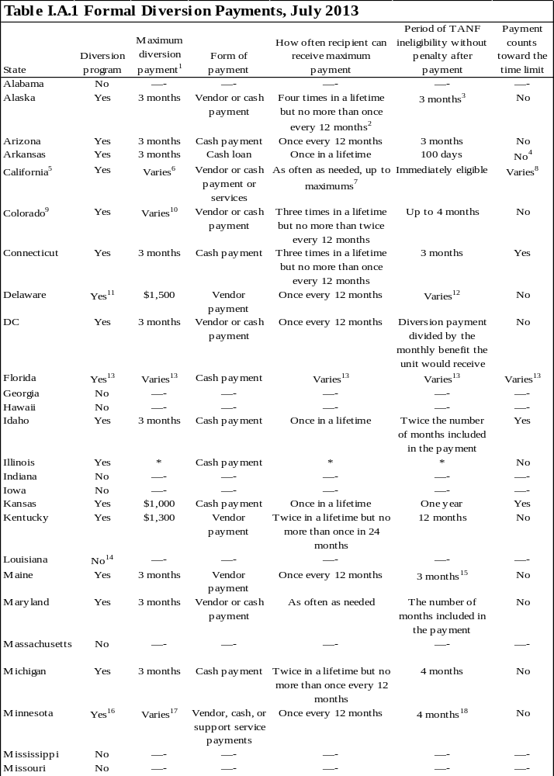
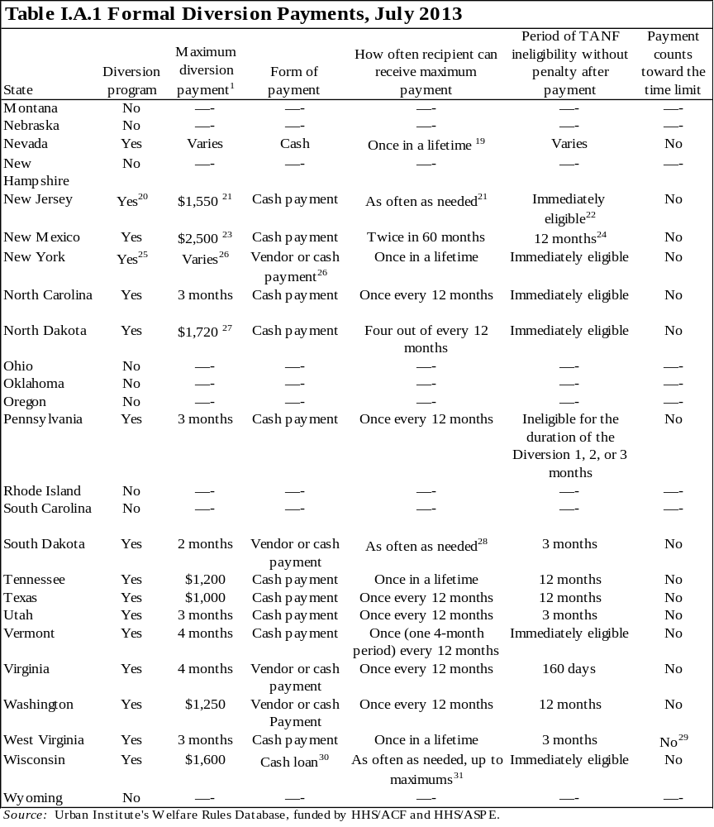
Notes: Many states require recipients of diversion assistance to be currently employed or seeking employment. Eligibility and diversion payment decisions often are made case by case. Receipt of diversion often precludes TANF applicants from being eligible for a certain period , but the degree of ineligibility may be decreased subject to a penalty such as prorating and deducting the diversion payment from initial TANF benefits. For more information on eligibility and payment calculations related to diversion assistance, see the "Diversion" category in the full Welfare Rules Database available online at http://anfdata.urban.org/wrd/WRDWelcome.cfm.

¹ The maximum diversion payment is either a flat payment, regardless of the family's size and the state's maximum benefit (represented in the table by a dollar amount), or a multiple of the maximum benefit the family would have received if it were receiving monthly TANF benefits (represented in the table by a number of months of benefits the family could receive). If the state provides diversion payments based on a multiple of the maximum benefit, the amount will vary by the family size and the generosity of the state's maximum benefits.
² If unexpected circumstances arise after the initial diversion payment has been issued, and the family has not received the full amount of diversion for which it was initially eligible, supplemental payments may be made to meet the additional short-term needs , up to the total remaining balance.
³ If a family applies for assistance during the three-month ineligibility period, the entire amount of the diversion payment is treated as unearned income to the family. The diversion payment is prorated equally over the three months, and the prorated amount is counted as monthly income.
⁴ If the diversion loan is repaid, then it does not count toward the time limit. If it is not repaid, then it does count toward the time limit.
⁵ Counties have the option to vary their diversion programs. These policies refer to Los Angeles County.
⁶ The maximum diversion cash payment is the greater of $2,000 or three times the maximum aid payment for the family size. In cases where an applicant has a one-time expense that exceeds the standard maximum diversion payment, payments up to $4,000 may be issued if necessary to retain self-sufficiency. Recipients may receive only $4,000 or three times the maximum aid payment for the family, whichever is greater, annually, and no more than $10,000 in a lifetime.
⁷ Diversion payments may be made as often as needed, up to a maximum annual amount of the greater of $4,000 or (3 months x maximum aid payment) and a maximum lifetime amount of $10,000.
⁸ If the unit applies for monthly TANF benefits after the diversion period (diversion amount divided by the maximum aid payment) ends, the state counts one month toward the time limit. If the unit applies during the diversion period, it can choose to count the diversion payment toward the time limit or to repay the diversion amount at a rate of 10 percent of the monthly benefit each month until the diversion is repaid. The number of months counted toward the 48-month time limit is calculated by dividing the total diversion payment by the maximum aid payment for the apparently eligible assistance unit at the time the diversion payment was made. The month(s) resulting from the calculation less any partial month, is (are) counted toward the 48-month time limit.
⁹ Counties have the option to vary their diversion programs. These policies refer to Denver County.
¹⁰ The amount of the payment is determined case by case. If assistance greater than $1,500 is requested, it must be approved by a designated staffing team.
¹¹ The program is related to retaining or obtaining employment and is only for parents living with natural or adopted children.
¹² The period of ineligibility depends on the amount of the diversion payment. Units receiving $1–$500.99 are ineligible for one month, units receiving $501–$1,000.99 are ineligible for two months, and units receiving $1,001–$1,500 are ineligible for three months.
¹³ Florida has three separate diversion programs. An assistance unit may receive a one-time payment of up to $1,000 in up-front diversion or cash severance diversion, or up to the amount needed to relocate in relocation assistance. Cash severance diversion also is available to employed TANF recipients. Up-front diversion and relocation assistance do not count toward time limits. Cash severance diversion does not count toward time limits if the payment is made in a month in which the unit also receives a TANF payment. If the payment is made in a month in which the unit does not receive a TANF payment, the cash severance diversion payment counts as a month toward the time limit.
¹⁴Although it still exists in the law, Louisiana's diversion program has not received funding since September 2002. According to the legislation authorizing the program, a recipient can receive a cash payment worth up to four months of TANF benefits and is subsequently ineligible for TANF for four months without a penalty after receiving diversion. An individual can receive diversion payments twice in a lifetime but no more than once every 12 months.
¹⁵ Units that apply for benefits during the three-month ineligibility period must repay any diversion payment received for any period that was covered by both diversion and TANF.
¹⁶ Minnesota's four-month Diversionary Work Program (DWP) is mandatory for all TANF applicants, unless exempt. Recipients receive financial assistance and must participate in four months of intensive employment services focused on helping the participant obtain an unsubsidized job before entering regular TANF. Failure to comply with the employment services, which may include a structured job search, results in ineligibility for both DWP and TANF until compliance. After completing the four-month program, participants who still require assistance may apply for TANF as applicants. See table I.A.2 for more information.
¹⁷ DWP benefits are provided monthly and are equal to the difference between the unit's countable income and the sum of its actual housing costs, utility costs, $35 a month for telephone services, and up to $70 per unit member for personal needs. The total monthly grant amount cannot exceed the cash portion of the TANF transitional standard (see table II.A.3). DWP recipients are eligible to receive SNAP benefits in addition to their diversion benefits (unlike the TANF calculation, which combines the cash and SNAP benefits; see table II.A.2 for more details on the combined SNAP and TANF benefit). The unit is not required to assign child support payments over to the state while participating in DWP.
¹⁸ The unit may apply for TANF at the completion of the four-month diversion program. If a unit applies for TANF any time within 12 months of receiving either TANF or DWP assistance, it moves directly into TANF and is not eligible to participate in diversion.
¹⁹ More than one diversion payment may be provided if a new or unforeseen circumstance appropriate for another payment occurs.
²⁰ New Jersey's diversion program, the Early Employment Initiative, is mandatory for applicants who have a work history that equals or exceeds four months of full-time employment in the past 12 months, appear to meet TANF eligibility requirements, are not in immediate need, and do not meet criteria for a deferral from work requirements. Participants receive a one-time lump-sum payment and are required to pursue an intensive job search for 15 to 30 days while their application is processed. If participants obtain employment and withdraw their applications, they are eligible to receive a second lump-sum payment to assist in the transition to employment. If no employment is secured, the applicant is referred back to the WFNJ/TANF agency for cash assistance. See table I.A.2 for more information.
²¹ The maximum amount a family would receive is relative to the number of people in the unit. The amount included in the table is for a unit of eight or more people. The maximum diversion payment for a family of three is $750. If the agency feels an individual may benefit, he or she may be considered suitable for repeated participation in EEI when determining subsequent eligibility for the program.
²² If a participant is unable to find a job through the diversion program or loses employment and reapplies for TANF benefits within 60 days of the original application, TANF benefits will be retroactive to the date of application.
²³ The grant amount is $1,500 for a family of one to three people and $2,500 for a family of four or more.
²⁴ Units may apply for assistance after only four months of ineligibility if they can demonstrate good cause. Good cause may include loss of employment not due to voluntarily quitting, catastrophic illness or accident of a family member that requires an employed participant to leave employment, being a victim of domestic violence, or another condition that renders an employed family member unable to care for the basic needs of the family.
²⁵ New York has three types of diversion payments: diversion payments (for crisis needs such as moving expenses, storage fees, or household structural or equipment repairs), diversion transportation payments (for employment-related transportation expenses), and diversion rental payments (for rental housing).
²⁶ Eligible individuals include cash assistance applicants or reapplicants who meet eligibility criteria for cash assistance, but are deemed unable to meet the work requirements. The value of the payment is determined case by case depending on the specific needs of the family.
²⁷ Maximum diversion payments vary by the activity and supportive services for which the individual uses the payment. Cash payment for emergency needs is limited to $430 a month for up to four months. Additional supportive services can include $1,000 for the cost of books, tuition, and fees associated with a work activity; $1,000 for moving expenses related to a job offer or for vehicle repairs; $250 for employment-related clothing; $150 for tools or equipment required for employment; and $150 a month for transportation.
²⁸ South Dakota has no formal limit on the number of payments a unit may receive, but a state source reports that it is unlikely that an assistance unit would receive a diversion payment more than once every 12 months.
²⁹ For units that received diversion assistance before July 2000, three months are counted toward the lifetime limit.
³⁰ Repayments are expected within 12 months but may be extended to 24 months. The loan may be paid back in cash or through a combination of cash and volunteer community service (valued at the higher of the state or federal minimum wage).
³¹The caseworker may issue loans for between $25 and $1,600. In a 12-month period, a unit may receive several loans, but it may not receive more than $1,600 in total loans or have an outstanding loan balance of more than $1,600.
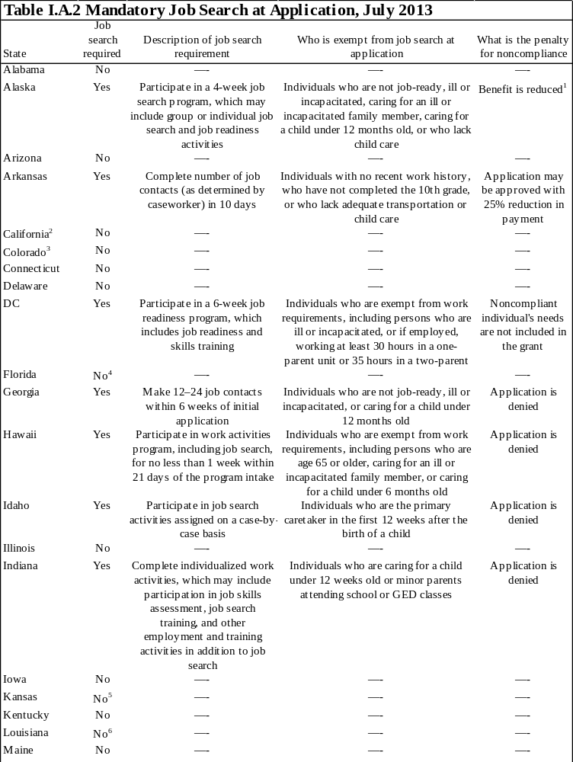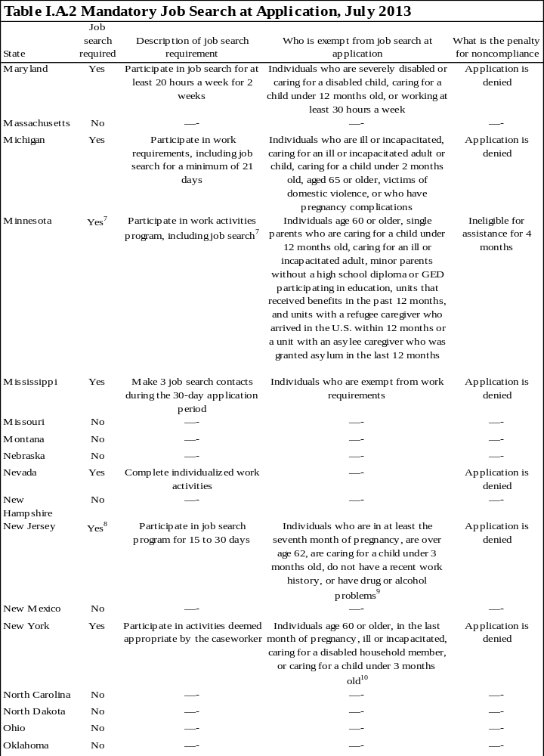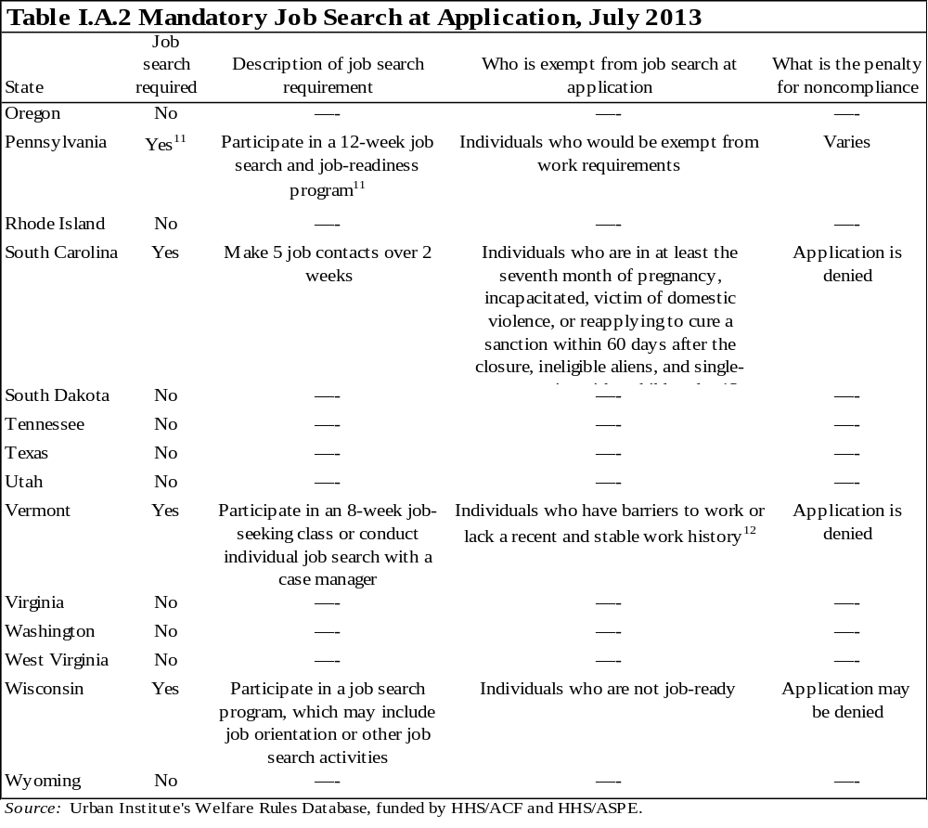
Note: This table refers to single-parent unit heads over 21 years old.
¹ The unit's benefit is reduced by the difference between the adult-based need standard for a two-person unit and the child-only need standard for a one-person unit.
² Counties have the option to vary their diversion programs. These policies refer to Los Angeles County. See table I.A.1 for more information.
³ Counties have the option to vary their diversion programs. These policies refer to Denver County. See table I.A.1 for more information.
⁴ Applicants are required to engage in work activities, which may include job search, as determined by the local workforce board.
⁵ As a condition of eligibility, applicants are required to register for the jobs program online and to complete at least one module of the KeyTrain assessment.
⁶ Work-eligible applicants must register for work at a Louisiana Workforce Commission Business and Career Solutions Center. Applicants who do not register will have their application denied.
⁷ As a condition of eligibility, applicants must participate in the four-month Diversionary Work Program (DWP), during which they receive benefits and intensive employment services focused on helping them obtain unsubsidized jobs before receiving TANF. The participant and the caseworker determine the number of hours the participant must spend on job search. The participant must accept any offer of suitable employment and is required to meet the reporting requirement of job search. The participant must set an overall employment goal and a means of achieving it. If the participant is a victim of domestic violence, the employment plan is developed in association with a family violence advocate. After the Diversionary Work Program is complete, participants still needing assistance may apply for TANF as applicants. See table I.A.1 for more information on DWP.
⁸ Job search is a mandatory part of the state's diversion program. Once in the program, participants receive an activity payment and are required to search for a job during the TANF application process. If no employment is secured, the applicant is referred back for traditional cash assistance. See table I.A.1 for more information.
⁹ Recent work history is defined as four or more months of full-time employment in the past 12 months.
¹⁰ The caretaker of a child exemption may last for no more than 12 months in a recipient's lifetime and it may not last for more than three months for any one child unless the social services official makes a determination to extend the exemption for up to the total of 12 months.
¹¹ As a condition of eligibility, applicants are required to document that they have applied for at least three jobs a week while the application is pending authorization for benefits.
¹² Stable work history is defined as six or more months of employment in the past 12 months.
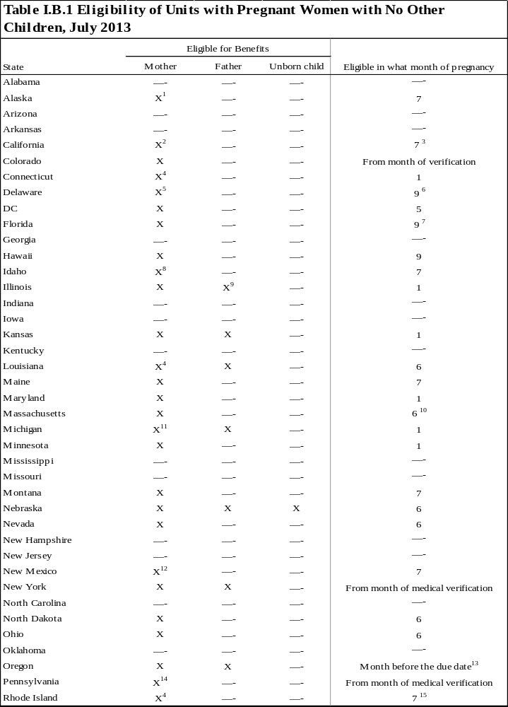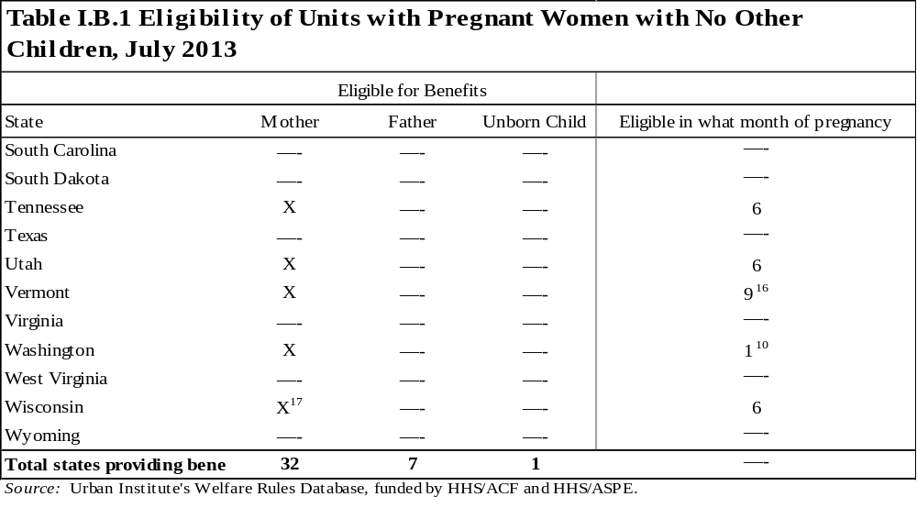
¹ The needs, resources, and income of all household members who would be required to be in the mandatory filing unit must be considered in determining eligibility. If the woman is eligible, the payment is based solely on the pregnant woman's income and needs.
² A pregnant woman must meet the eligibility requirements as if her child were already born and living with her. If the father of the unborn child is living in the home, his income, resources, and needs are counted to determine her eligibility and benefits. After the child is born, the father and child will be added to the assistance unit if eligible.
³ A pregnant woman age 18 or younger is eligible from the date the pregnancy is verified.
⁴ A pregnant woman must meet the eligibility requirements as if her child were already born and living with her.
⁵ A pregnant woman's financial eligibility in the month that her child is due is determined by comparing her gross income to 185 percent of the standard of need for one person. If she lives with the father of her unborn child, financial eligibility is determined by comparing the sum of the pregnant woman's income and the father's income to the standard of need for three people (the number of people who would be included in the family unit when the child is born). If income exceeds the standard, the application is denied. If income is less than the standard, only the mother's income and needs are considered in determining the amount of the grant.
⁶ A pregnant woman is eligible on the first day of the month in which the child is expected.
⁷ A pregnant woman is eligible in the ninth month, unless her doctor verifies that she is unable to work; then, she is eligible in the seventh month.
⁸ A pregnant woman is eligible only if she is in her last trimester and unable to work for medical reasons.
⁹A pregnant woman and her spouse, if living with her, are eligible for assistance.
¹⁰ A pregnant woman may receive benefits only after a licensed medical practitioner has verified the pregnancy and determined the expected date of delivery.
¹¹ The father must be married to the mother to be eligible.
¹² The needs, resources, and income of the otherwise eligible father of the unborn child are considered in determining eligibility and benefits if the father lives in the home.
¹³ A pregnant woman who is at risk or has a safety concern due to domestic violence may be eligible for benefits earlier.
¹⁴ A pregnant woman must meet the eligibility requirements as if her child were already born and living with her. If the pregnant woman's spouse is living in the home, his income, resources, and needs are included in this calculation. If she is not married, the income, resources, and needs of the father will not be included in the eligibility calculation until the child is born and paternity has been established.
¹⁵ A pregnant woman can begin to receive assistance within three months of her medically verified due date.
¹⁶ A pregnant woman may be eligible in the seventh month if she is a minor or is documented as having a high-risk pregnancy.
¹⁷ A pregnant woman is eligible in the third trimester if unmarried and medically verified to be at risk. After the child is born, the mother and child may receive the Custodial Parent of an Infant level of benefits for the first eight weeks.
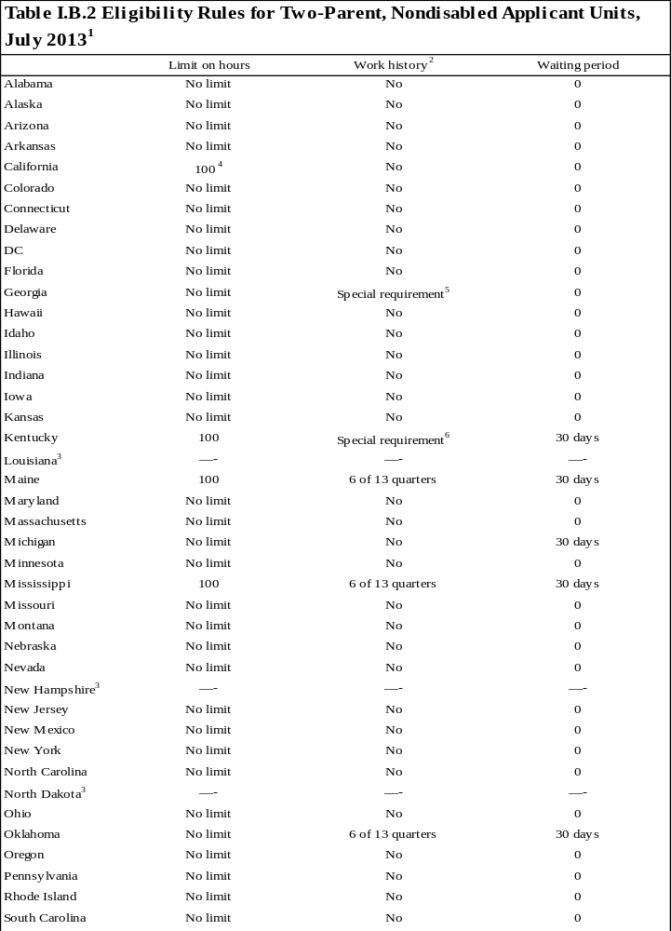
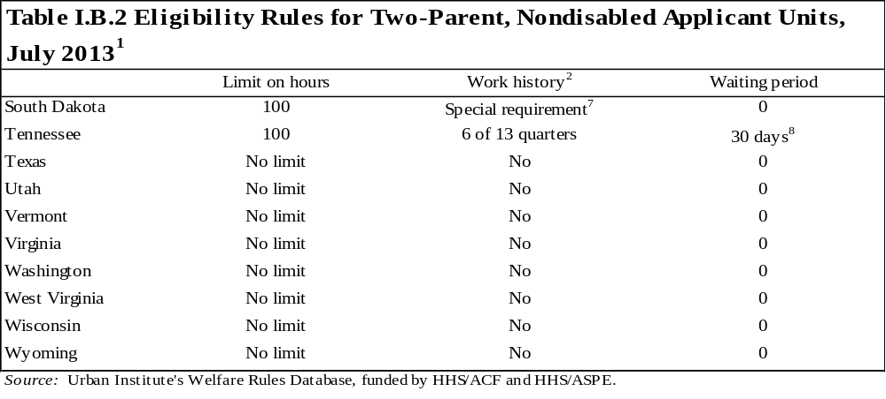

Note: In some states, benefits are provided to two-parent units under a state-funded program instead of through federal TANF. This table describes the treatment of two-parent units regardless of the funding source.

¹ Eligibility rules for two-parent, nondisabled families are special categorical rules in addition to the other state rules that all units must pass. Under the AFDC program, states imposed rules on two-parent families’ work effort, including limits on hours of work, work history tests, and waiting periods. Some states have continued to impose these policies under TANF.
² Applicants have to demonstrate previous attachment to the workforce; under AFDC, applicants were required to work at least six of the last 13 quarters. The 13-quarter period must have ended within one year of applying for assistance. Generally, work history could also be established if one of the following applied: (1) the applicant received unemployment compensation (UC) benefits within 12 months of the date of application or (2) the applicant would have been eligible for UC benefits within the previous 12 months but did not apply or his or her employment was not covered by UC laws.
³ The state does not provide benefits to two-parent, nondisabled units.
⁴ To be eligible for cash assistance, the individual has to have been employed less than 100 hours during the four-week period before the date of eligibility for cash aid.
⁵Applicants must be connected to the workforce, which includes one of the following: (1) currently working at least 20 hours a week, (2) receiving UC or received UC benefits within 12 months before the application date, (3) unemployed or working less than 20 hours a week and earned $500 within the six months before application, (4) receiving retirement benefits or received retirement benefits in any of the six months before the application month, or (5) has received disability benefits based on 100 percent disability in any of the last six months.
⁶Applicants must have earned at least $1,000 during the 24-month period before the month of application. Two semesters of full-time attendance in a postsecondary institution may be substituted for $500 of the $1,000.
⁷ The parents in the unit must have a combined gross income in the past six months of at least $1,500 and must not have voluntarily terminated employment, reduced hours worked, or refused a job offer within the previous six months (without good cause).
⁸ The 30-day waiting period applies only to the primary wage earner.
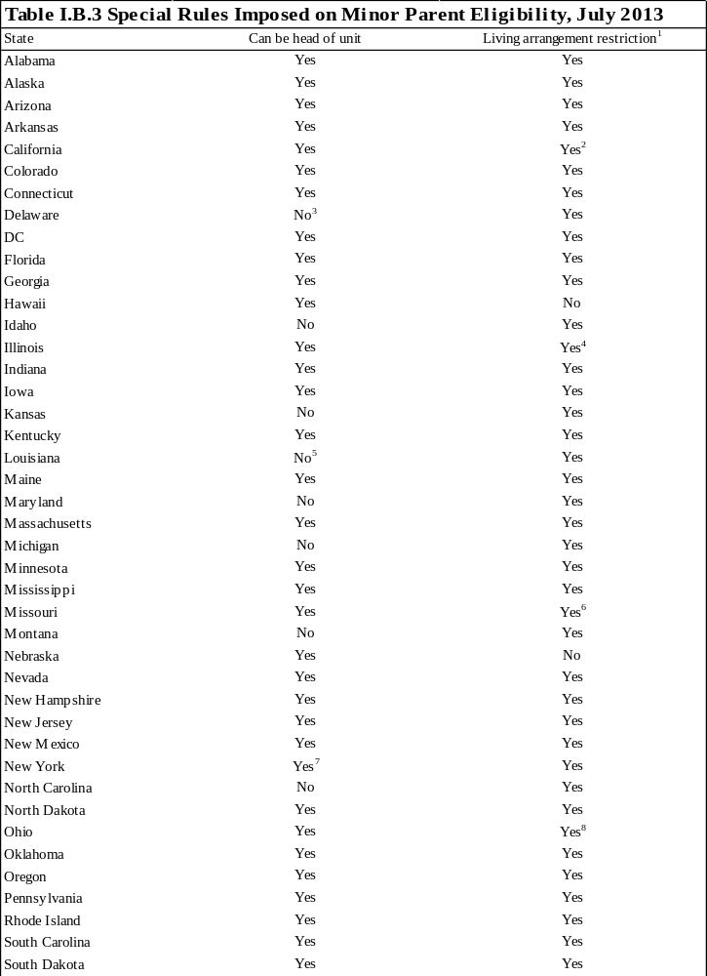
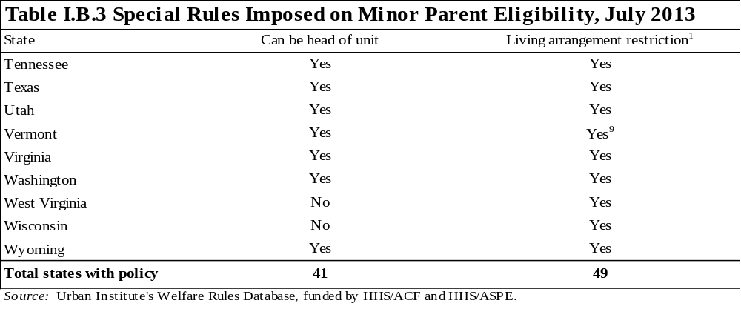

¹ This variable indicates whether the state requires unmarried minor parents, who have not been legally emancipated, to live with their parent(s) or in another state-approved setting. If "Yes" is coded, a minor is not eligible to receive assistance unless living with a parent or in an approved setting.
² A minor parent is exempt from living with his or her parent(s) if he or she does not have a living parent or legal guardian, there is no a state-licensed living arrangement available, a child-protection services worker determines that such a living arrangement would be physically or emotionally unsafe, or the minor parent has lived apart from his or her parent(s) for more than 12 months.
³ Children born to teenage parents are ineligible for cash assistance unless the parent is married. The minor parent may receive noncash assistance services in the form of vouchers for their child(ren) upon request; however, vouchers are not automatically distributed each month. Voucher payments are distributed through a protective payee to the minor parent's parent or the adult in the supervised living arrangement.
⁴ Minor parents may receive benefits for up to six nonconsecutive months without complying with the residency requirement.
⁵ A minor parent may head his or her own household if certain exemptions are met.
⁶ A minor parent is exempt from living with his or her parent(s) if he or she does not have a living parent or guardian (or if the whereabouts of the parent or guardian is unknown), the minor parent's legal living parent or guardian will not allow the minor parent to live in his/her home, the state determines that such a living arrangement would be physically or emotionally unsafe, the minor parent lived apart from any parent or legal guardian for at least a year before either the birth of the dependent child or applying for benefits, or the state determines good cause to live apart from a parent or adult relative or other approved setting.
⁷ To receive assistance, the minor parent must be at least 16 years old to be designated the head of the assistance unit.
⁸ When the residency requirements are imposed, the benefit is paid to a protective payee whenever possible.
⁹ Minor parents may be exempt if they are 17 years old and have lived independently for at least six months, live with their child’s other parent and both parents are age 16 or older, or if no appropriate living arrangement is available.
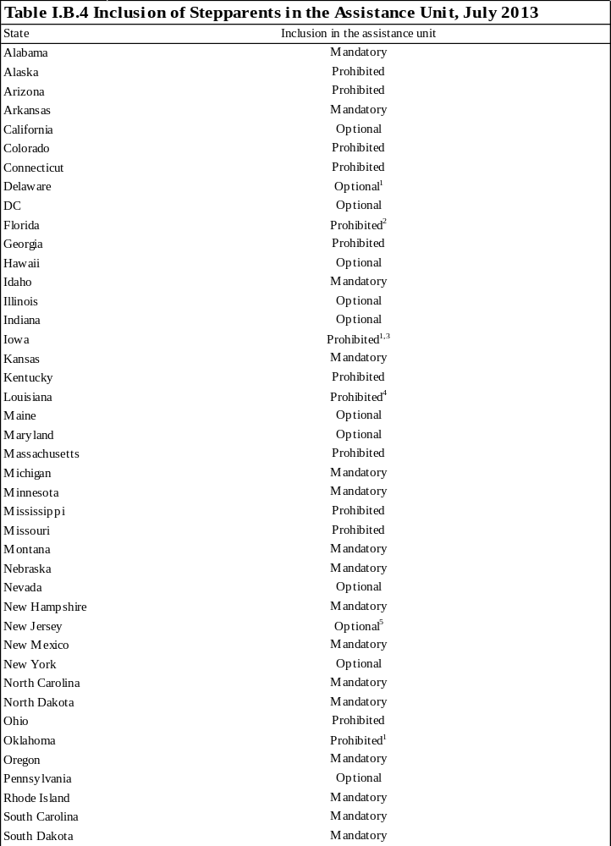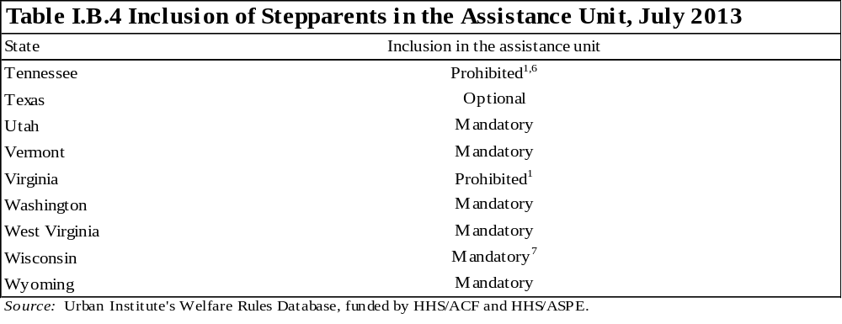

Note: The table describes units in which the stepparent has no child in common with the spouse (head of unit), the stepparent has no dependents of his or her own living in the unit, the spouse is living in the home, and the spouse is not incapacitated.

¹The stepparent may be included if the natural or adoptive parent of the child is incapacitated.
² If the natural parent is not in the home, the stepparent has the option to be included.
³ The stepparent may be included if he or she is incapacitated.
⁴ Louisiana does not provide benefits to two-parent, nondisabled families. If the stepparent is disabled, incapacitated, or caring for a disabled family member living in the home, s/he may be included.
⁵ The stepparent is a mandatory participant in the unit unless the stepparent's income causes the assistance unit to become ineligible, in which case the stepparent is not required to be included in the unit. If the stepparent chooses not to receive assistance, the unit becomes a child-only unit (the spouse is also excluded from the unit) and his or her income is used to determine eligibility but not the benefit amount. For more information regarding deeming, see table I.D.2.
⁶ When a caretaker marries while receiving assistance, s/he can choose to exclude the new spouse from the assistance unit for up to three months, regardless of income. After three months, the new spouse becomes a mandatory assistance unit member, and his/her income and resources must be considered in determining eligibility and benefit computation.
⁷ The stepparent is included in the W-2 group for income purposes but cannot be the mandatory work program participant.
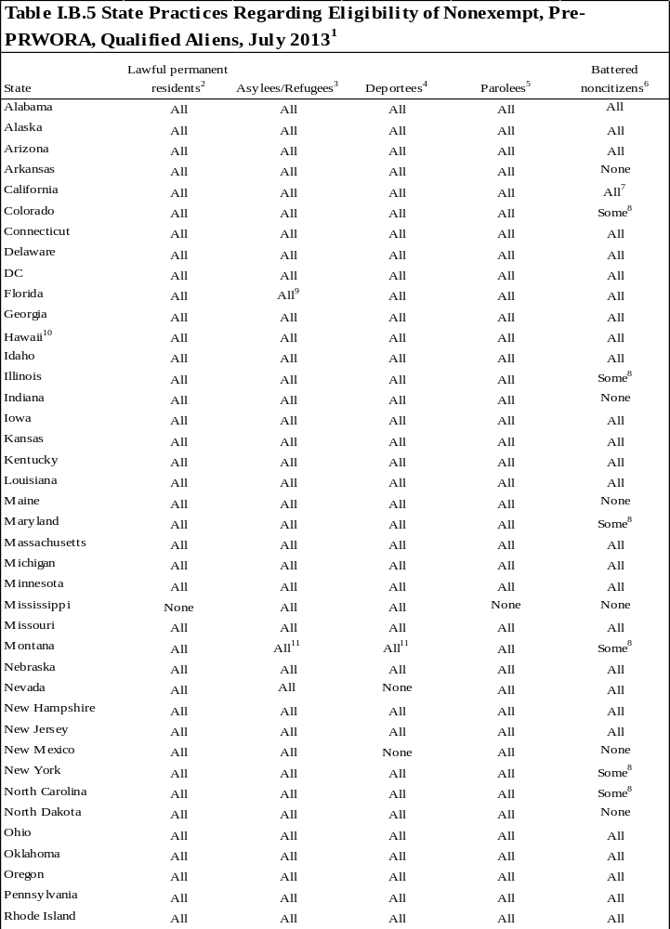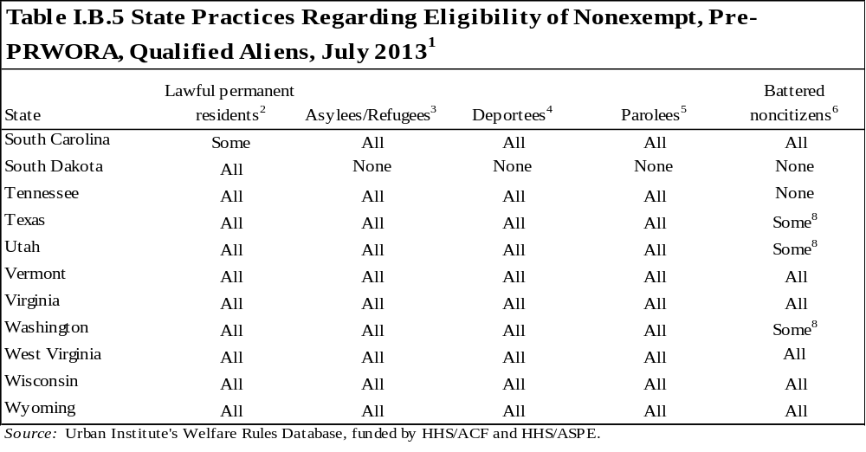
Note: This table refers only to the largest groups of qualified aliens that entered the United States before August 22, 1996. It does not address a few smaller groups of qualified aliens, including Cuban/Haitian entrants and aliens granted conditional entry before April 1, 1980.

¹ This table provides information on the eligibility of certain groups of qualified aliens for federally funded TANF assistance. It does not cover the eligibility of other nonqualified aliens who may be eligible for state-funded assistance. Aliens are categorized by their current immigrant status (rather than their initial status upon entry into the United States, if different).
² Lawful permanent residents are individuals who have been admitted into the United States permanently.
³ Asylees and refugees are immigrants who flee their countries owing to persecution because of race, religion, nationality, political opinion, or membership in a social group. Refugees request permission to enter the country, while asylees are already in the United States and request permission to stay.
⁴ Deportees are individuals who have been granted a stay of deportation or have had their deportation withheld.
⁵ Parolees are individuals permitted entry into the United States in cases of emergency or because of an overriding public interest. The table only discusses the eligibility of aliens paroled into the United States for at least one year. Aliens paroled into the United States for less than a year are not "qualified" aliens according to the immigrant definition in PRWORA.
⁶ Battered noncitizens refer to those individuals who meet the statutory definition of a battered alien pursuant to 8 USC 1641 (c).
⁷ While battered noncitizens who meet the qualified alien definition are eligible for federally funded TANF benefits, all battered noncitizens are eligible for CalWORKs state-funded benefits who meet the definition of permanently residing in the United States under color of law.
⁸ Some battered noncitizens who meet the qualified alien definition are eligible.
⁹An asylee is eligible if it is within eight months of the date asylee status was obtained.
¹⁰All immigrant units are funded through a state program with the same eligibility rules as TANF. No immigrant units, however, are eligible for federal TANF funding.
¹¹ Qualified aliens with this status are only eligible for benefits for seven years beginning on the date they entered the United States.
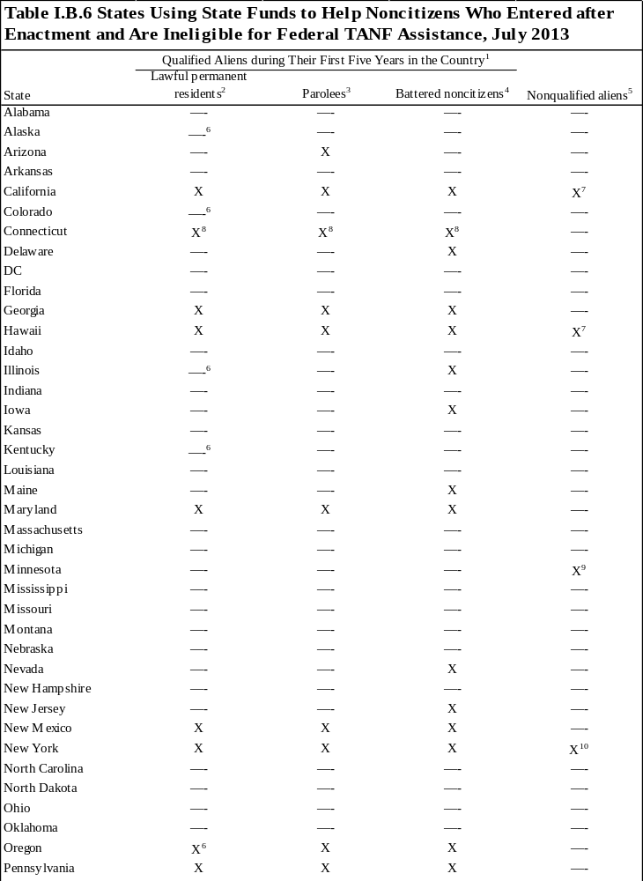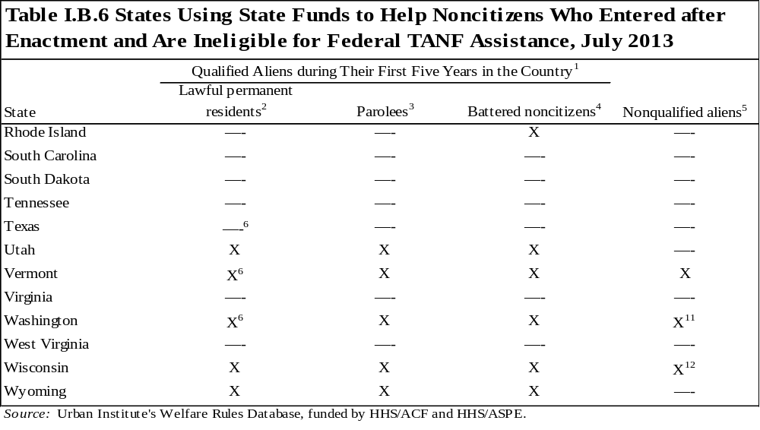
Note: This table refers only to noncitizens that have entered the United States on or after August 22, 1996, and are ineligible for federally funded TANF assistance because of the five-year bar or nonqualified status. Refugees, asylees, and deportees are eligible for federal funding during this period and therefore are not included in this table.

¹ Qualified aliens are defined under PRWORA as lawful permanent residents (includes Amerasians), refugees, asylees, individuals who have had their deportation withheld, parolees admitted for one or more years, certain battered aliens, Cuban/Haitian entrants, and aliens granted conditional entry before April 1, 1980.
² Lawful permanent residents are individuals who have been admitted into the United States permanently.
³ Parolees are individuals permitted entry into the United States in cases of emergency or because of an overriding public interest. The table only discusses the eligibility of aliens paroled into the United States for at least one year. Aliens paroled into the United States for less than a year are not "qualified" aliens according to the immigrant definition in PRWORA.
⁴ Battered noncitizens refer to those individuals who meet the statutory definition of a battered alien pursuant to 8 USC 1641 (c).
⁵ The groups of noncitizens listed here are not qualified aliens as defined by federal law; therefore, these groups would never be eligible for most federally funded TANF benefits.
⁶ Additionally, certain American Indians born in Canada may be regarded as lawful permanent residents for purposes of eligibility and are therefore qualified aliens. These individuals are eligible for benefits during the five-year bar.
⁷ All nonqualified aliens who are legally in the country and are not nonimmigrant aliens lawfully admitted for a temporary purpose or temporary residence are eligible for assistance.
⁸ To be eligible, all noncitizens must pursue citizenship to the maximum extent allowed by law, unless incapable owing to mental retardation, a medical condition, a language barrier, or a domestic violence situation.
⁹ Individuals with temporary protective status and some legal immigrants aged 18–70 who have been in the state for four years and are participating in literacy or citizenship classes are eligible.
¹⁰ Individuals permanently residing in the United States under color of law as defined by the state and parolees in the country for less than one year are eligible for assistance.
¹¹ Individuals permanently residing in the United States under color of law may receive assistance if qualified.
¹² Individuals with employment authorization by the US Citizenship and Immigration Services are eligible for assistance.
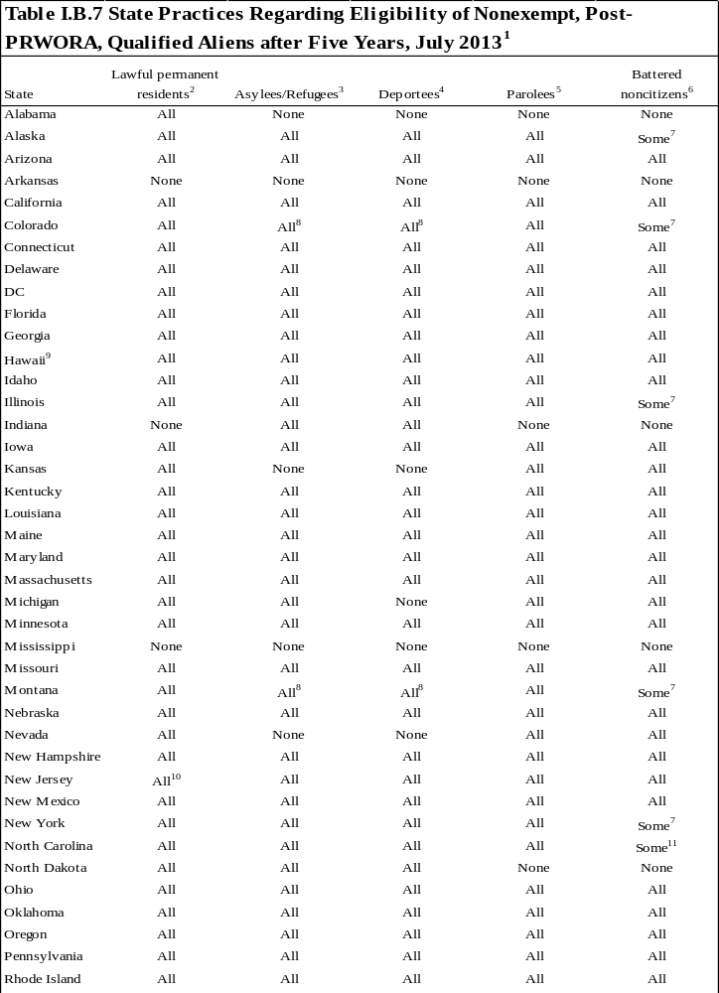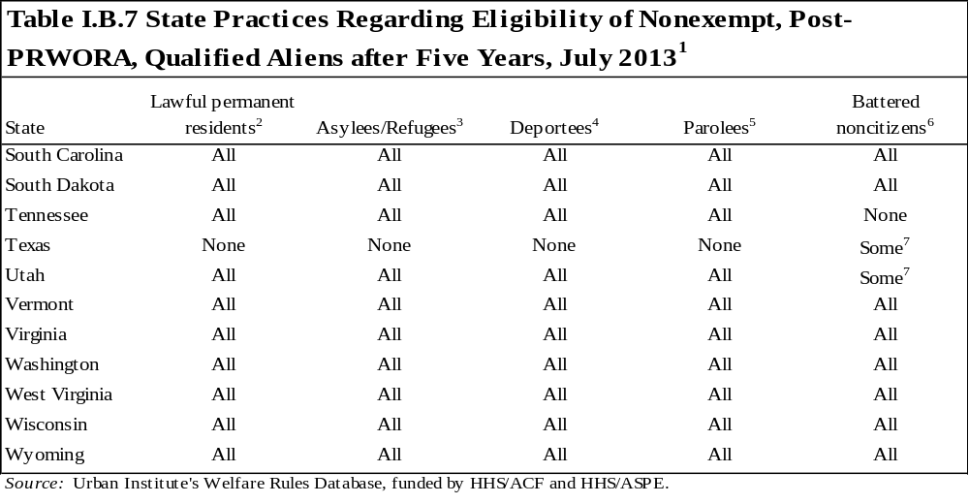
Note: This table refers only to the largest groups of qualified aliens who entered the United States on or after August 22, 1996. It does not address a few smaller groups of qualified aliens, including Cuban/Haitian entrants and aliens granted conditional entry before April 1, 1980.

¹ This table identifies the eligibility for federally funded TANF assistance of certain groups of qualified aliens after the expiration of the five-year bar. It does not provide information on the eligibility of other nonqualified aliens who may be eligible for state-funded assistance. Aliens are categorized by their current immigrant status (rather than their initial status upon entry into the United States, if different).
² Lawful permanent residents are individuals who have been admitted into the United States permanently.
³ Asylees and refugees are immigrants who flee their countries owing to persecution because of race, religion, nationality, political opinion, or membership in a social group. Refugees request permission to enter the country, while asylees are already in the United States and request permission to stay.
⁴ Deportees are individuals granted a stay of deportation or who have had their deportation withheld.
⁵ Parolees are individuals permitted entry into the United States in cases of emergency or because of an overriding public interest. The table only discusses the eligibility of aliens paroled into the United States for at least one year. Aliens paroled into the United States for less than a year are not "qualified" aliens according to the immigrant definition in PRWORA.
⁶ Battered noncitizens refer to those individuals who meet the statutory definition of a battered alien pursuant to 8 USC 1641 (c).
⁷ Some battered immigrants who meet the qualified alien definition.
⁸ Qualified aliens with this status are only eligible for benefits for seven years beginning on the date they entered the United States.
⁹ All immigrant units are funded through a state program with the same eligibility rules as TANF. No immigrant units, however, are eligible for federal TANF funding.
¹⁰Aliens who were not continuous residents of the United States (meaning they left the United States for 30 days or more) before becoming lawful permanent residents are ineligible for benefits.
¹¹ Battered immigrants must be the spouse, former spouse, widow, child, or parent of a child of a US citizen or lawful permanent resident.
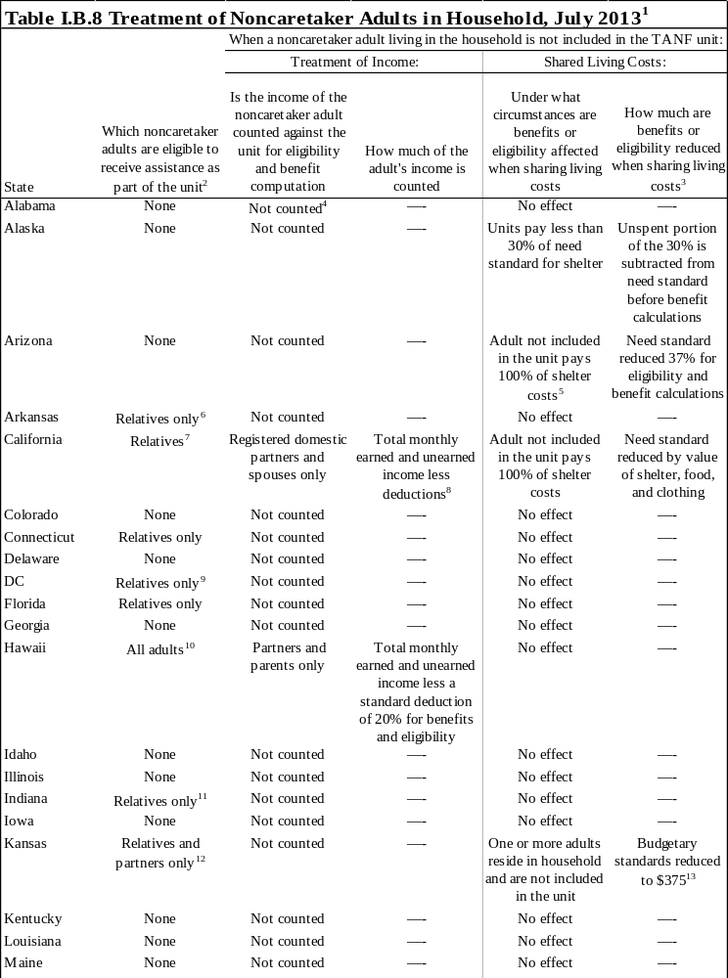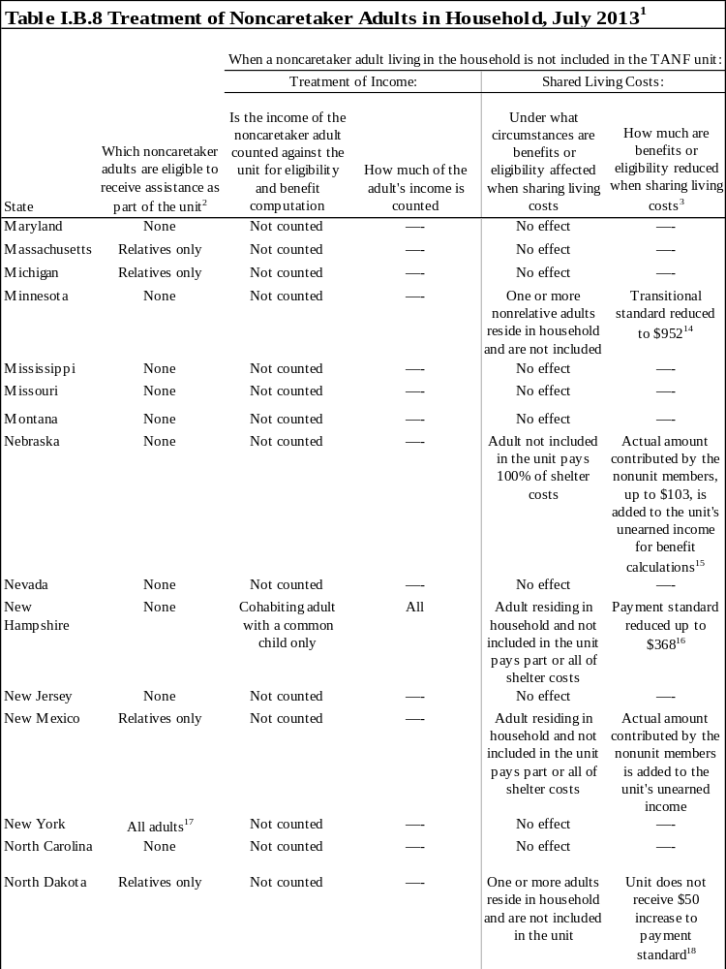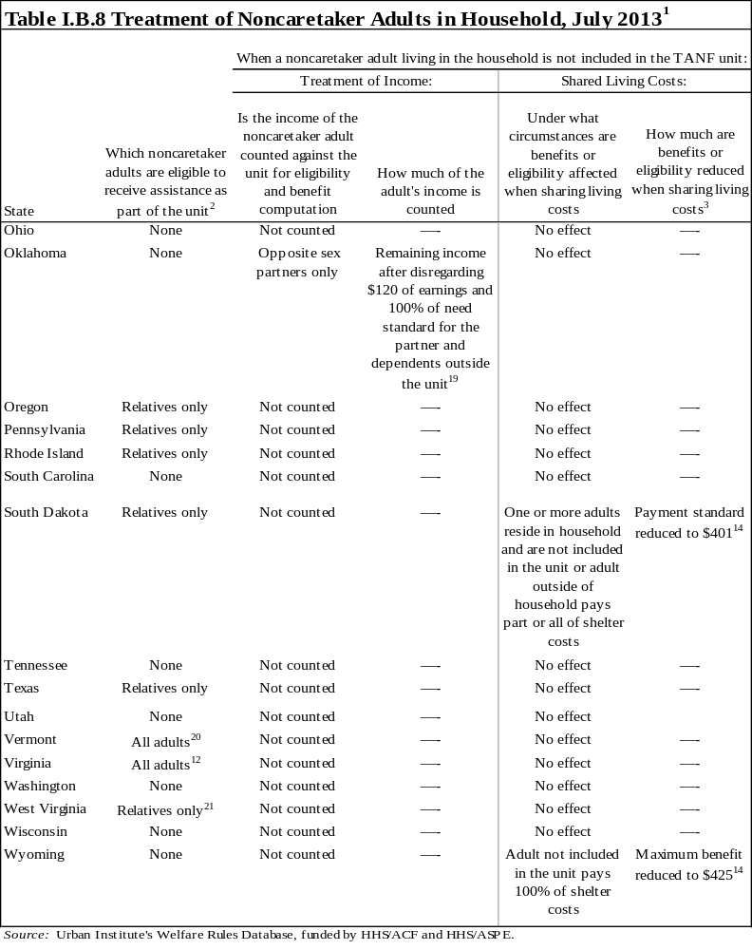
Note: When there is variation, the values in the table represent the amounts for individuals living in the largest county and for a family size of three.

¹ A "noncaretaker adult" is an additional adult living in the household with a parent or caretaker of children. The noncaretaker adult is not the primary caretaker of the children, nor a parent of any children in the household. In this table, a noncaretaker adult could be an adult who is related to the parent or children, the partner of the parent, or a friend of the parent who is not a relative or in a relationship with the parent. A separate set of policies may apply to noncaretaker adults who are renters or boarders sharing a household with the unit.
² When "all adults" appears in the table, it means relatives who are not primary caretakers, partners of the parent or caretaker, and nonrelative nonpartners are potentially eligible to receive assistance as part of the unit.
³ Unless otherwise specified, the reduction applies to both eligibility calculations and benefit computation, when applicable.
⁴ The income of adult non-unit members living in the household is included only if the income received is formally earmarked for a member of the assistance unit.
⁵ The shelter payments must be made directly to the landlord, mortgage company, owner, or other lien holder and be paid on an ongoing basis for three or more consecutive months.
⁶ Only one additional adult may be included in the unit.
⁷ Relatives, spouses of the primary caretaker, and registered domestic partners of the primary caretaker may be included at the option of the unit head.
⁸ California has two categories of noncaretaker-adults. The first category includes spouses, registered domestic partners and aided relative noncaretakers. All the columns in the table I.B.8 denote policies for this category of adults. The second category includes unrelated nonpartner adults (e.g. boyfriend, girlfriend, etc).
⁹ A caretaker relative is an optional group member who may be included or excluded from the group depending on which is advantageous to the group.
¹⁰ The additional adult must provide care that is deemed essential and would need to be provided if the additional adult were not in the household.
¹¹ To be eligible, the adult must be providing care to the children in the unit.
¹² Cohabiting partners are mandatory unit members.
¹³ The amount of the reduction varies by family size and county. The value in the table applies to a family of three in the largest county.
¹⁴ The amount of the reduction varies by family size. The value in the table applies to a family of three.
¹⁵ The amount added to the unit's unearned income varies by family size. The value in the table applies to a family of three.
¹⁶ The standard used to calculate the unit's benefit equals the actual amount the unit pays in shelter costs plus the maintenance payment allowance ($307) up to the payment standard ($675). If the unit does not pay any shelter costs, the standard is equal to $307. The amount of the standards varies by family size. The value in the table applies to a family of three.
¹⁷ To be eligible, the adult must be deemed essential to the well-being of the family applying for or receiving TANF benefits. Inclusion of noncaretaker adults is prohibited for voluntary Child Assistance Program participants.
¹⁸ North Dakota increases the payment standard by $50 for units paying their entire shelter costs. While technically not a reduction in benefit, units who share housing expenses do not receive this increase.
¹⁹ Partners may also subtract the actual amount paid to individuals not living in the household but claimed as dependents, and alimony and child support payments made to individuals outside the household. The remaining income after all disregards are applied is counted in the unit's unearned income for eligibility and benefit computation purposes.
²⁰ Additional adults are eligible only if they are needy but not eligible for SSI or TANF on their own and they provide specific care and/or services that the unit head cannot perform and that are deemed essential and would need to be provided if the additional adult were not in the household.
²¹ A caretaker relative who is not a natural or adoptive parent cannot be included in the unit when a parent resides in the home.
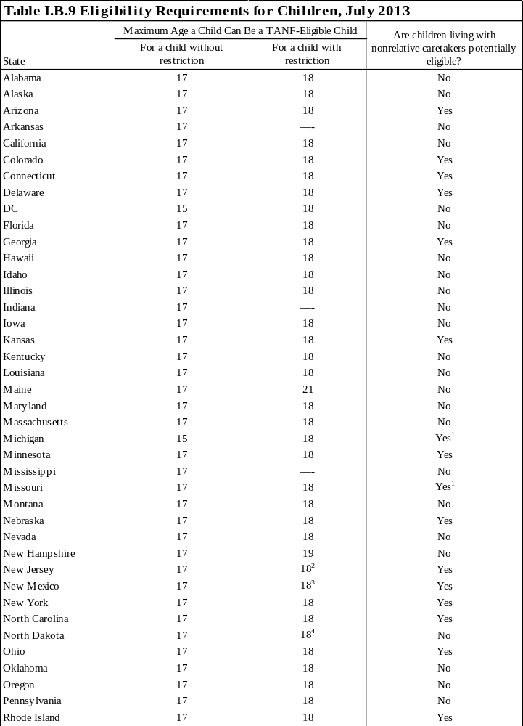
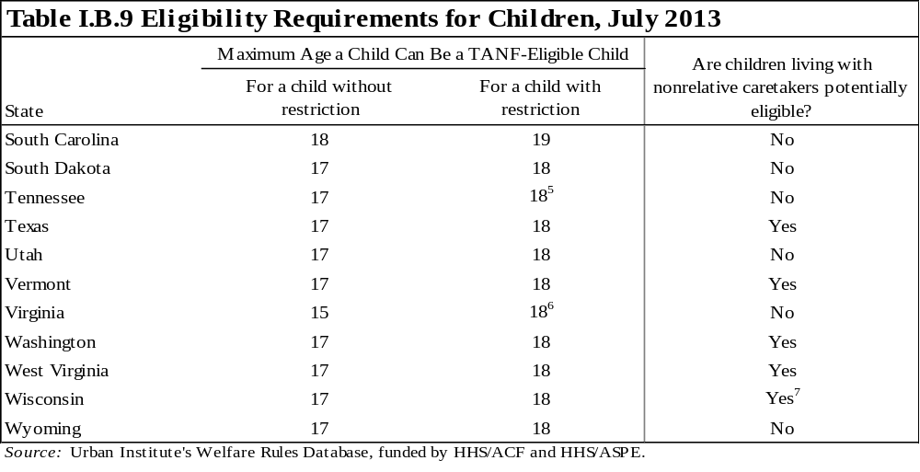

Note: In most cases, restriction means a full-time student in secondary or vocational/technical school. Other restrictions are footnoted.

¹ Unrelated legal guardians receive benefits paid from a state-only funding source.
² Children up to age 21 are considered children if they are enrolled in a special education program.
³A student receiving special education services regulated by the State Board of Education will be considered a dependent child until age 22.
⁴ Children are eligible through the month in which they turn 19 if they will graduate high school that month.
⁵ A child with a disability who will not complete high school or an equivalent vocational or technical training before turning 19 is eligible for benefits through the month of his/her 19th birthday
⁶A child who is 18 years old is not eligible if s/he is in postsecondary school.
⁷ Families with nonrelative caretakers are potentially eligible for kinship care.
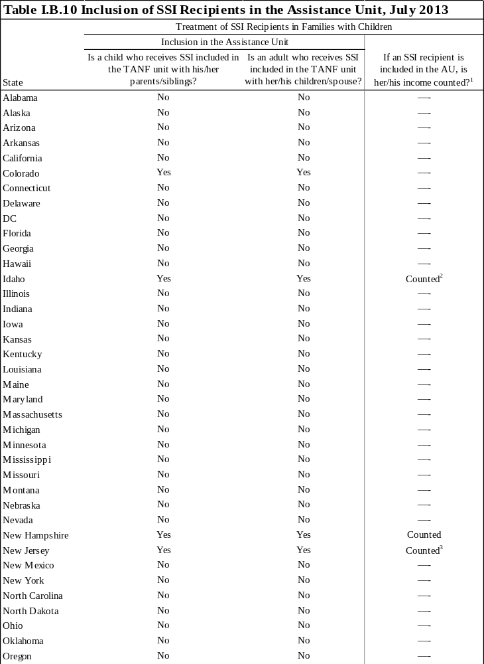
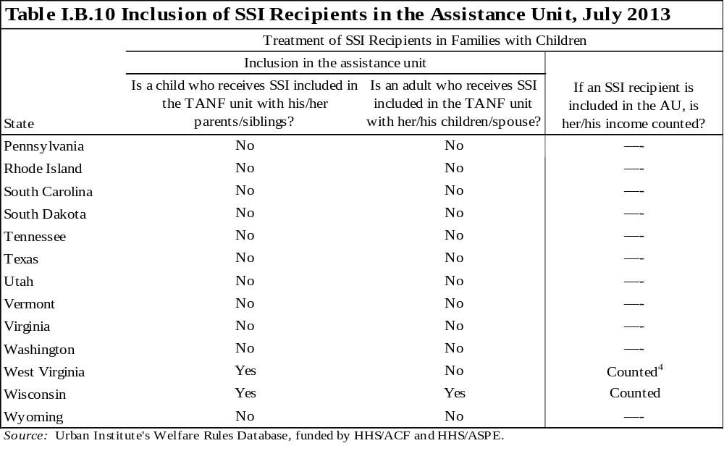

¹ A —- means that the SSI recipient cannot be included in the assistance unit.
² The SSI income and other assets are counted if the person receiving SSI is part of a one-parent household, a two-parent household, or a caretaker household with only one child in the unit. In a caretaker household with multiple children, if any child receives SSI, that income is not counted.
³ While the income of a person on SSI is not included, the assets are included.
⁴ While the SSI recipient's SSI allocation is not counted, the non-SSI income and assets of the individual are counted.
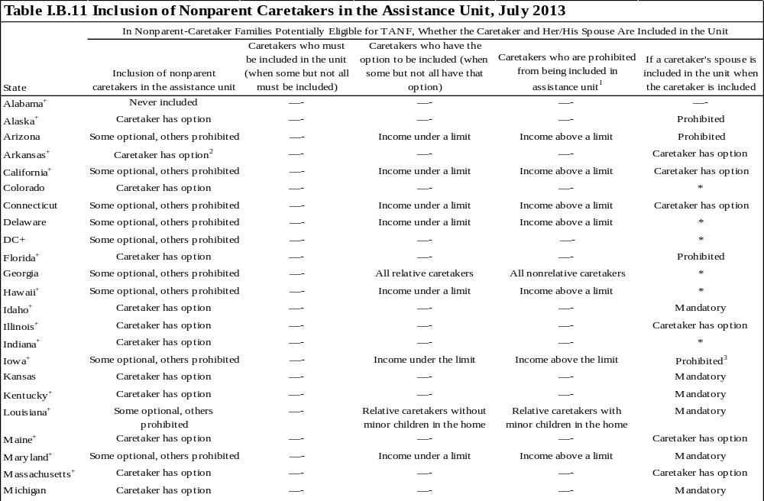

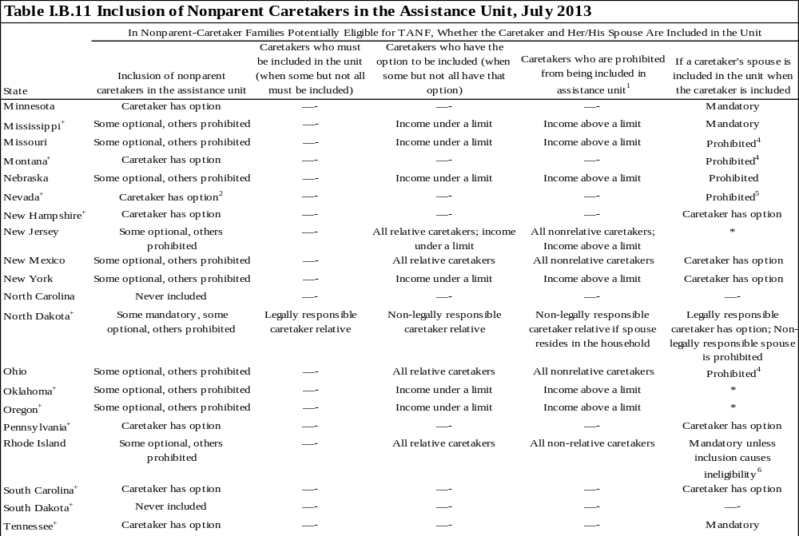
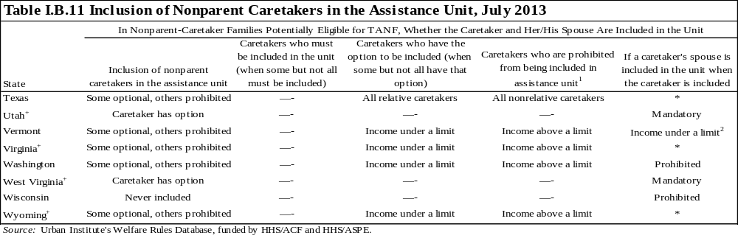

* Data not obtained.
+ Information applies only to families with a relative caretaker. Children in families with nonrelative caretakers can never receive TANF in this state.

Note: "Included in the assistance unit" indicates the person is considered in the family size for purposes of determining the benefit. This table applies only to families with potential eligibility for TANF based on their composition; Table I.B.9indicates if families in which the caretaker is a nonrelative are ever eligible.

¹ A state will only have "All nonrelative caretakers" indicated when the state forbids such caretakers from being included the unit, but still allows the children living with such caretakers to be eligible for benefits.
² Only one caretaker relative may be included in the unit at a time.
³ Although the spouse is not counted as a member of the assistance unit, some of his/her income may be deemed available to the unit. The resources of the spouse would be counted.
⁴ Although the spouse is not counted as a member of the assistance unit, some of his/her income may be deemed available to the unit.
⁵ The caregiver's spouse or domestic partner's income is used to determine eligibility for the caregiver and children.
⁶ If the caretaker spouse's income renders the assistance unit ineligible for cash assistance, then caretaker has the option to apply for cash assistance for the child(ren) in his/her care only.
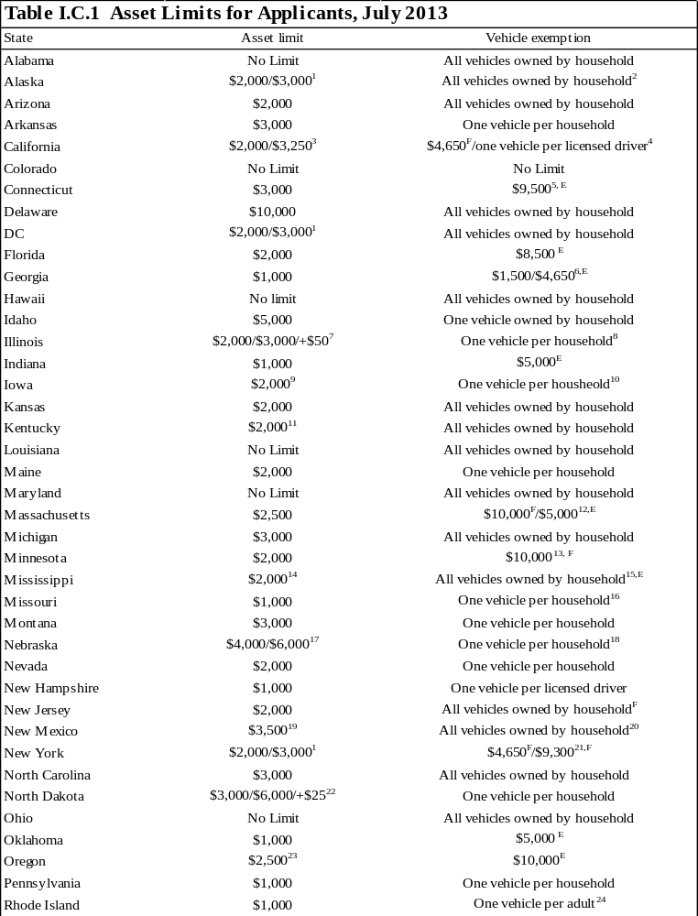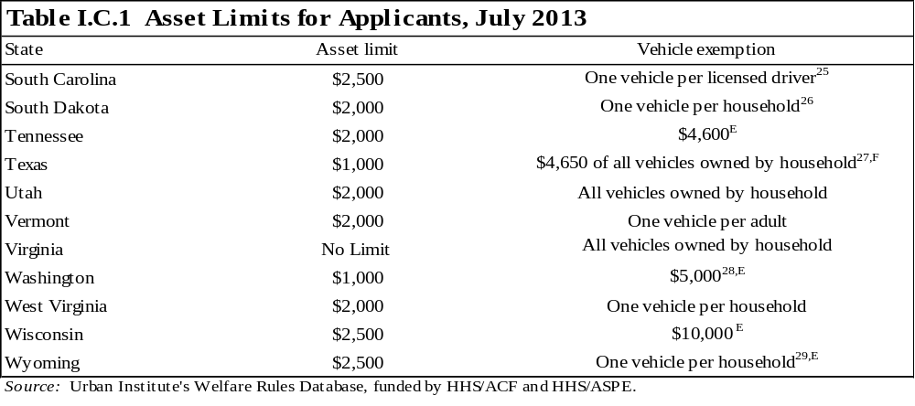^{E} Equity value of the vehicle.
^{F} Fair-market value of the vehicle.

Note: Many states have separate policies regarding different types of vehicles, such as income-producing vehicles, recreational vehicles, and vehicles that are used as homes. See the Welfare Rules Database for more information on these policies.

¹ Units including an elderly person may exempt $3,000; all other units exempt $2,000.
² Vehicles are exempt if used to meet the family's basic needs such as getting food, medical care, or other essentials; to go to and from work, school, training, or work activity (such as job search or community service); or to transport a disabled family member, whether or not he or she is a part of the assistance unit. If the vehicle does not meet one of these requirements, the equity value of the vehicle is counted in the determination of resources.
³ Units including an elderly or disabled person may exempt $3,000; all other units exempt $2,000
⁴ Each vehicle must be evaluated for both its equity and fair-market values; the higher of the two values counts against the family's asset limit. Before this calculation, all the following vehicles are completely excluded: (1) is necessary for long-distance travel that is essential for employment; (2) is necessary to transport a physically disabled household member; (3) would be exempt under previously stated exemptions but the vehicle is not in use because of temporary unemployment; (4) used to carry fuel or water to the home and is the primary method of obtaining fuel or water; and (5) the equity value of the vehicle is $1,501 or less. To determine the countable fair-market value of each remaining vehicle, exclude $4,650 from the vehicle's fair-market value. To determine the countable equity value of each remaining vehicle, exclude one additional vehicle per adult and one additional vehicle per licensed child who uses the vehicle to travel to school, employment, or job search. The full equity value of each remaining vehicle is counted. For each vehicle not completely excluded, the higher of the fair-market value or the equity value counts against the family's asset limit.
⁵ The unit may exempt up to $9,500 of the vehicle's equity, or the entire value of one vehicle used to transport a handicapped person. The motor vehicle exclusion is applied to the registered vehicle with the highest fair market value.
⁶ If the vehicle is used to look for work, or to travel to work or education and training, the unit may exclude $4,650 of the value. If the vehicle is not used for these purposes, $1,500 of the equity value is excluded.
⁷ The asset limit is based on unit size: one person receives $2,000, two people receive $3,000, and three or more people receive $3,000 plus $50 for every additional person.
⁸ If a vehicle has special equipment for the disabled, the added value of the special equipment is exempt and does not increase the vehicle's value. When there is more than one vehicle, the equity value of the vehicle of greater value is exempt.
⁹ If at least one member of the household applying was a program recipient in the month before the month of application, then the asset limit is increased to $5,000.
¹⁰Additionally, $4,658 of the equity value of an additional vehicle is exempt for each adult and working teenager whose resources must be considered in determining eligibility.
¹¹ Only liquid resources are considered for eligibility determinations. Liquid resources include cash, checking and savings accounts, CDs, stocks and bonds, and money market accounts.
¹² The state compares the value of the vehicle with two standards: $10,000 of the fair-market value and $5,000 of the equity value. If the value of the vehicle exceeds either limit, the excess counts toward the asset limit; if the value of the vehicle exceeds both limits, only the excess of the greater amount counts toward the asset limit.
¹³ The amount is the loan value of the vehicle with the highest loan value, which has not already been totally excluded under the following provisions: (1) exclude all motor vehicles essential to operating a self-employment business; (2) exclude any vehicle used as the unit's home; (3) exclude one vehicle per physically disabled person needed to transport the disabled unit member; (4) exclude the value of special equipment added to a vehicle for a handicapped member of the assistance unit; (5) exclude any vehicle used for certain long-distance traveling for the employment of a unit member; and (6) exclude any vehicle if at least 50 percent of its use is to produce income. $7,500 of the loan value of additional vehicles is also exempt. Minnesota uses the loan value of the vehicle as listed in the current NADA Used Car Guide, Midwest edition instead of the fair-market value. The loan value is generally slightly less than the estimated fair-market value.
¹⁴If the unit is considered broad-based categorically eligible, it is not subject to asset limits.
¹⁵ Determination of whether to count a vehicle is made case by case.
¹⁶ $1,500 of the equity value of the unit's second vehicle is exempt.
¹⁷ The asset limit is based on unit size: one person receives $4,000, and two or more people receive $6,000.
¹⁸ The entire vehicle is exempt only if used for employment, training, or medical transportation. If a unit has more than one vehicle that meets the exemption criteria, only the vehicle with the greatest equity value will be exempt.
¹⁹ The total limit is $3,500, but only $1,500 of that amount can be in liquid resources and only $2,000 can be in nonliquid resources.
²⁰ The entire vehicle is exempt only if used for transportation to work, work activities, or daily living requirements. If the vehicle is not used for these purposes, the entire equity value of the vehicle is subject to the asset test.
²¹ If the vehicle is needed to seek or retain employment, $9,300 of the vehicle is exempt. Otherwise, $4,650 of the fair-market value is exempt.
²² The asset limit is based on unit size: one person receives $3,000, two people receive $6,000, and another $25 is allowed for each additional person thereafter.
²³ There is more than one phase of the application process in Oregon. The asset limit for applicants first applying for TANF is $2,500. If the applicant makes it through the first stage of application, s/he must participate in the assessment program in which s/he is assessed and given a case plan to follow. If the applicant does not follow the case plan, s/he maintains the $2,500 asset limit as long as he or she is in the assessment program. If the applicant complies with the case plan, s/he is allowed a $10,000 asset limit.
²⁴ Exemptions for adult drivers cannot exceed two vehicles per household. Additionally, the entire value of a vehicle used primarily to provide transportation for a disabled family member is exempt.
²⁵ Vehicles owned by or used to transport disabled individuals or that are essential to self-employment are also exempt.
²⁶ In addition to one primary vehicle, an assistance unit may totally exclude a vehicle used to transport water or fuel to the home when it is not piped in or to transport a disabled member or SSI recipient in the household. The assistance unit may also exclude $4,650 of the fair-market value of a vehicle used to transport members of the unit for education or employment.
²⁷All licensed vehicles used for transporting disabled household members are exempt.
²⁸ The entire equity value of a vehicle used to transport a disabled household member is also exempt.
²⁹ This exemption applies to a single-parent unit. Two vehicles are exempt for a married couple.
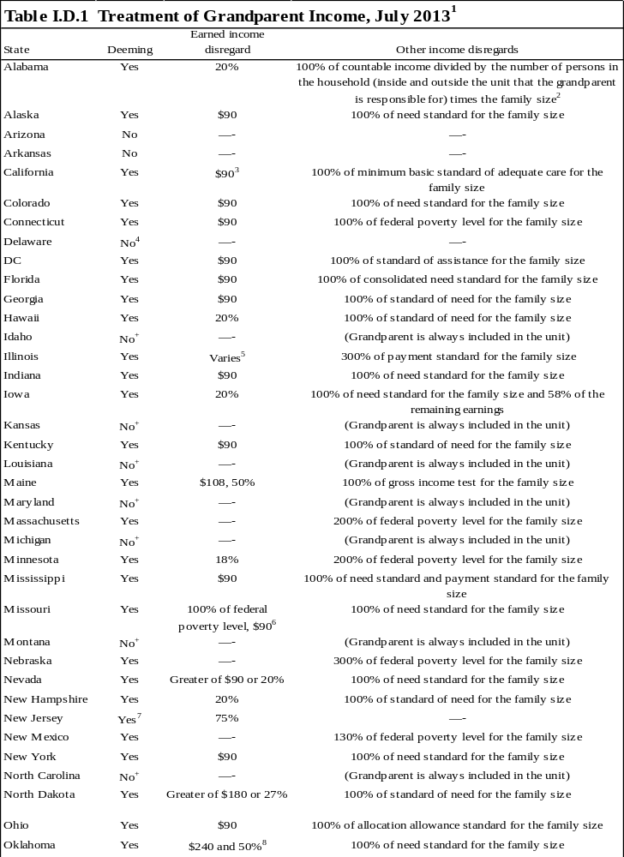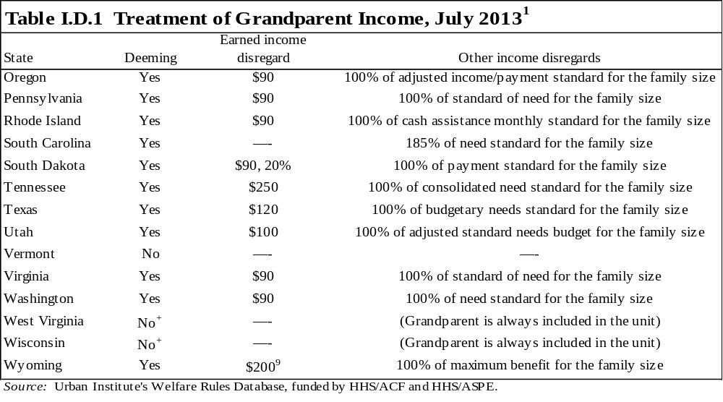
Notes: "Family size" represents the grandparent and all dependents outside the assistance unit. In general, states also deduct child support payments, alimony, and payments made to dependents outside the household from the grandparent's income before deeming to the unit. See table I.E.3 for information on the value of the standards for a family of three.
The table describes the treatment of grandparent’s income for applicant units. If different policies are used for recipient units, it is footnoted.

+ There is no deeming because the grandparent must be included in the unit for the minor to receive benefits. Therefore, the grandparent's income is treated like that of other unit members for eligibility and benefit computation purposes.

¹ In this table, "grandparent" refers to the parent of a minor parent. This table describes whether a portion of the grandparent's income is deemed available to the minor and her child when the grandparent is not part of the assistance unit but living in the household with the minor. The table describes the disregards that the grandparent and his or her dependents are allowed to claim for their own needs. The remaining income after these disregards are deducted from the grandparent's income is the amount available, or deemed, to the minor parent and her children.
² The grandparent's remaining income after deductions is divided by the total number of dependents who do not receive assistance plus the grandparent and her child applying for assistance (the minor parent's child is not included in this calculation). This amount is deemed and the remainder is allocated to the grandparent.
³ Recipient units may disregard the lesser of the remainder of the unused $225 Disability Based Income disregard or $112, and 50 percent of the remainder.
⁴ There is deeming if a minor parent's children were born on or before December 31, 1998. In such cases, the grandparent in applicant units may disregard 100 percent of the federal poverty level for the family size and recipient units may disregard 200 percent of the federal poverty level.
⁵ The difference between 50 percent of the current federal poverty level for the applicant's family size and their TANF payment level is disregarded.
⁶ The grandparent may initially disregard earned income up to 100 percent of the federal poverty level for the number of dependents in his or her household. He or she may then disregard an additional $90 of earned income.
⁷ Income is deemed to a minor parent unit even if he or she is not living in the home with the grandparent. The rules for deeming are the same.
⁸ This disregard is applicable to those working at least 30 hours per week. If those working are employed less than 30 hours a week, then the disregard is $120 and then an additional 50 percent of the remaining income.
⁹ Married couples with a child in common may disregard $400.
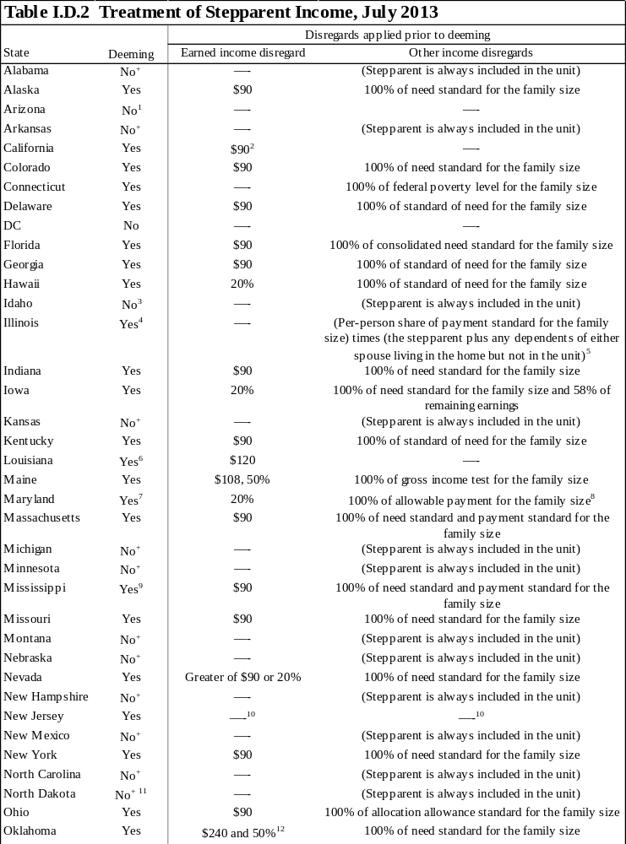
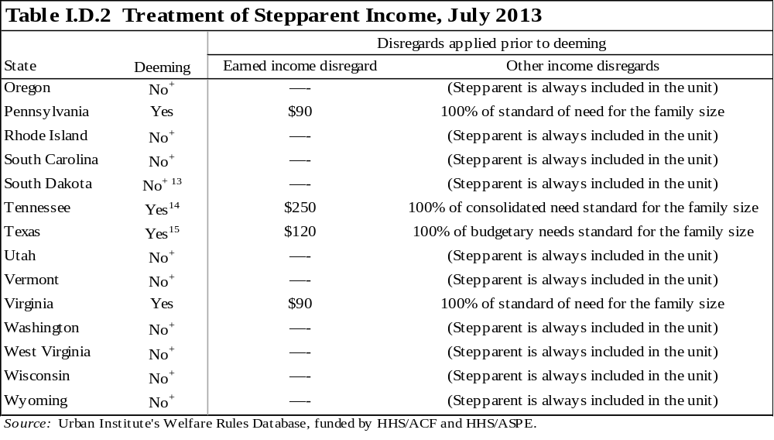
Notes: "Family size" represents the stepparent and all dependents outside the assistance unit. In general, states also deduct child support payments, alimony, and payments made to dependents outside the household from the stepparent's income before deeming to the unit. See table I.E.3 for information on the value of the standards for a family of three.

These policies apply to units in which the stepparent is not a part of the assistance unit but is living in the household, has no child in common with the spouse (head of unit), and has no dependents of his or her own living in the unit. Unless otherwise noted, the stepparent's income is deemed to the spouse and the spouse's dependents.

⁺ There is no deeming because the stepparent must be included in the unit. Therefore, the stepparent's income is treated like that of other unit members for eligibility and benefit computation purposes.

¹ While not deeming in the traditional sense, the income of the stepparent is counted for the needy family test.
² If the stepparent is not included in the unit, there is a $90 earned income disregard for applicant eligibility purposes. For recipient benefit computation, add the stepparent's income to all other family income and then disregard the less of the remainder of the unused $225 Disability Based Income disregard or $112, and 50 percent of the remainder.
³ Stepparents are always included in the unit; however their income is treated differently from the income of parents. Stepparents have 50 percent of their earned and unearned income disregarded.
⁴ The stepparent's income is deemed only to the spouse.
⁵ When computing the payment standard, the family size includes the TANF unit, the stepparent, and all dependents of either spouse.
⁶ The stepparent is included in the unit if s/he is disabled, incapacitated, or caring for a disabled family member living in the home.
⁷ The stepparent's countable income is tested against 50 percent of the federal poverty level for a household size that includes the stepparent, the members of the assistance unit, and any other dependents not in the unit. When the income is below 50 percent of the federal poverty level, no income is deemed to the unit. When the income is over 50 percent of the federal poverty level, all of the stepparent's income minus deductions is deemed to the unit.
⁸ Deduct all child support, alimony, and child care paid to someone outside the household up to a maximum of $200 per child if employed full time and up to $100 per child if employed part time (full time is defined as 100 hours or more a month) before applying this disregard.
⁹ If a recipient marries for the first time, his or her new spouse may receive a one-time, 100 percent disregard for six consecutive months.
¹⁰ The stepparent is not required to be a member of the unit if his or her income makes the unit ineligible for benefits. If the stepparent chooses not to receive assistance, the unit becomes a child-only unit and the stepparent’s income is treated as follows: (1) For determining the eligibility of the unit, the income of all household members, including the natural parent, his or her children, the stepparent, and any children the stepparent can claim as dependents, is used to determine the children’s eligibility for assistance. If total household income is below 150 percent of the federal poverty level, the assistance unit is eligible for benefits. (2) For determining the benefits, all the income of the stepparent is excluded. However, the natural parent's earned income is reduced by the appropriate earnings disregard and by the payment benefit level for a unit of one. All remaining income of the natural parent is used in determining the benefits for the children.
¹¹If a parent marries while receiving TANF and the stepparent is not eligible for TANF, his or her income is disregarded for the first six months. Beginning in month seven, there is a stepparent income disregard of 27 percent or $180, whichever is greater. If the stepparent is eligible for TANF, s/he is included in the assistance unit and income is treated the same as other members of the TANF household.
¹² This disregard is applicable to those working at least 30 hours per week. If those working are employed less than 30 hours a week, then the disregard is $120 and then an additional 50 percent of the remaining income.
¹³ A Native American stepparent who is under exclusive jurisdiction of a tribe for the purposes of determining the domestic relations rights of the family has the option of being included in the assistance unit.
¹⁴ When a caretaker marries while receiving assistance, different deeming rules can apply. The caretaker can choose to exclude the new spouse and his or her income and resources for a period of three months, beginning on the first day of the month following the month of the marriage. During this time, eligibility and benefits for the unit are determined as if the spouse were not present in the home. No income is deemed, and the spouse’s needs are not included. This policy applies regardless of the spouse's income and even if the spouse is the father of one of the assistance group children. After the three month period, the new spouse must be included in the assistance unit and his or her income and resources are fully counted.
¹⁵ For the first six months of a new marriage, all stepparent income is disregarded, provided the family's total gross income is less than 200 percent of the federal poverty level.
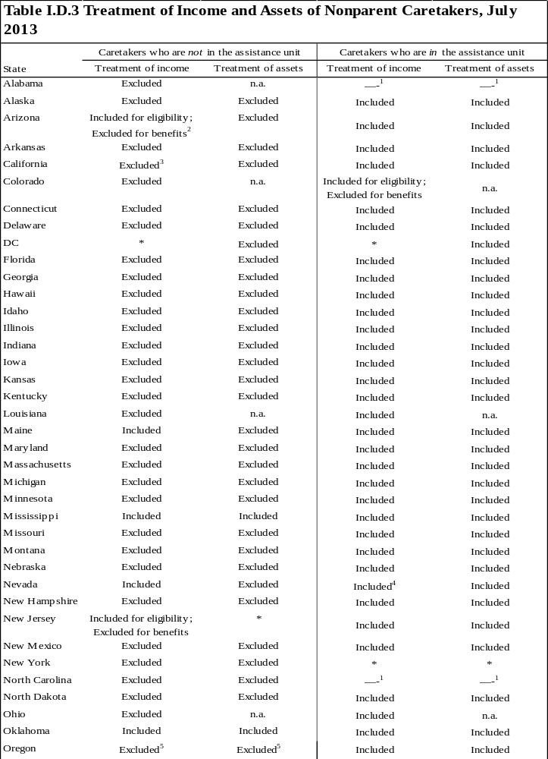
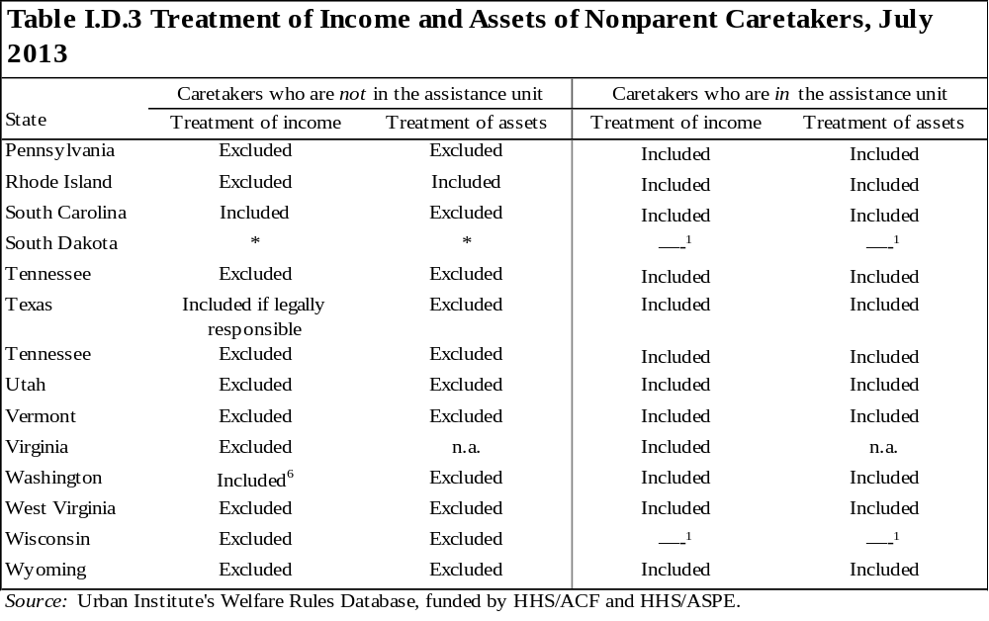

* Data not obtained.

Note: n.a. indicates the state does not have an income or an asset test.

¹ The state never allows nonparent caretakers to be in the assistance unit.
² For initial eligibility, the total family income, including the caretaker's income, cannot exceed 130 percent of the federal poverty guideline.
³ Income is included if participating in the KinGap program.
⁴ If countable income (gross earned and unearned) of all household members exceeds 275 percent of the federal poverty guideline, the assistance unit is ineligible. If the countable income is less than 275 percent of the federal poverty guideline, only the child’s income and resources are considered in determining the child(ren)'s eligibility and payment.
⁵ If countable income of all nonrelative caretakers, his/her spouse, and children, and the child requesting TANF exceeds 185 percent of the federal poverty guideline, the assistance unit is ineligible. If the countable income is less than 185 percent of the federal poverty guideline, only the child’s income and resources are considered in determining the child(ren)'s eligibility and payment.
⁶ If countable income (gross earned and unearned) of all household members exceeds 300 percent of the federal poverty guideline, the assistance unit is ineligible if subject to means testing.
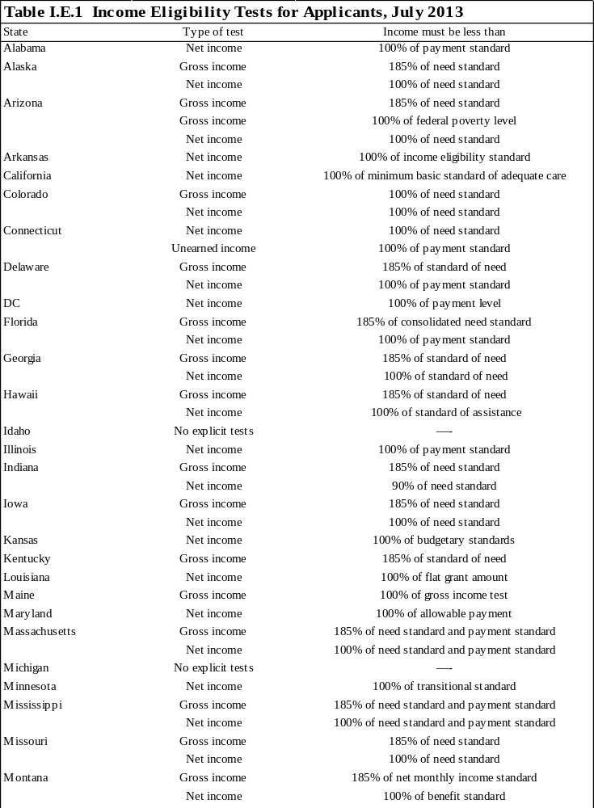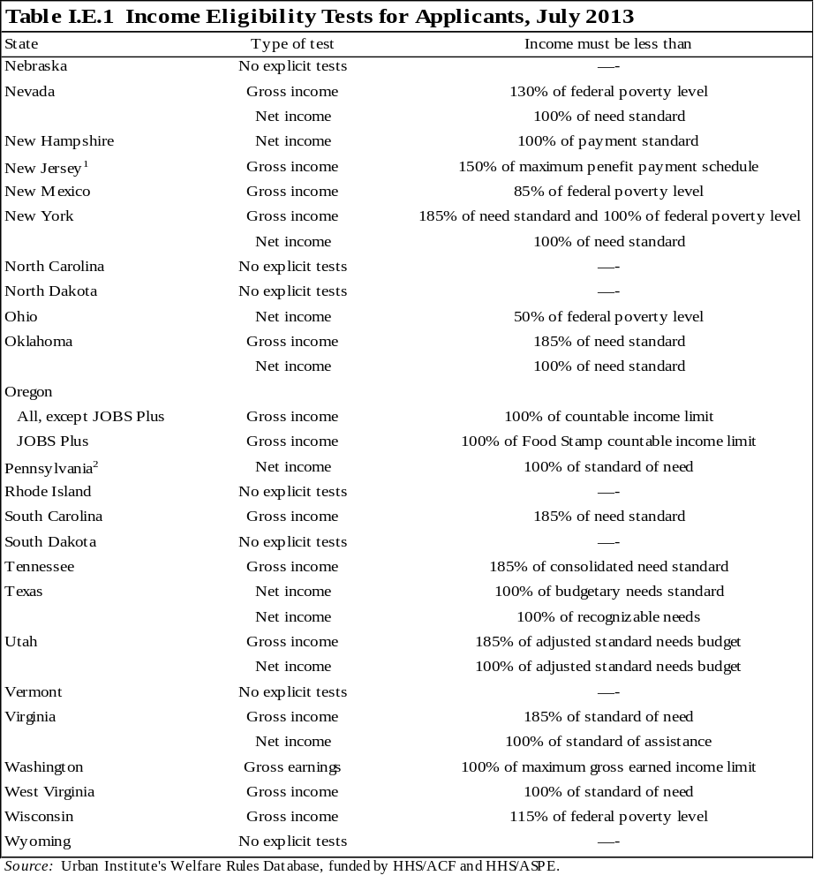Notes: "No explicit tests" indicates that either the state imposes no income tests on applicants or the state imposes an income test, but the calculation of the test and disregards allowed for the test are the same as those used to calculate the benefit. In some states, applicants could pass the explicit tests shown, but might not be eligible for a positive benefit because of the way the state computes benefits. See table II.A.2 for information on benefit computation policies.

See table I.E.3 for information on the value of the standards for a family of three.

¹ In households where the natural or adoptive parent is married to a non-needy stepparent, the gross household income may not exceed 150 percent of the federal poverty level.
²Applicants who have received benefits in one of the last four months are subject to the same net income test as recipients.
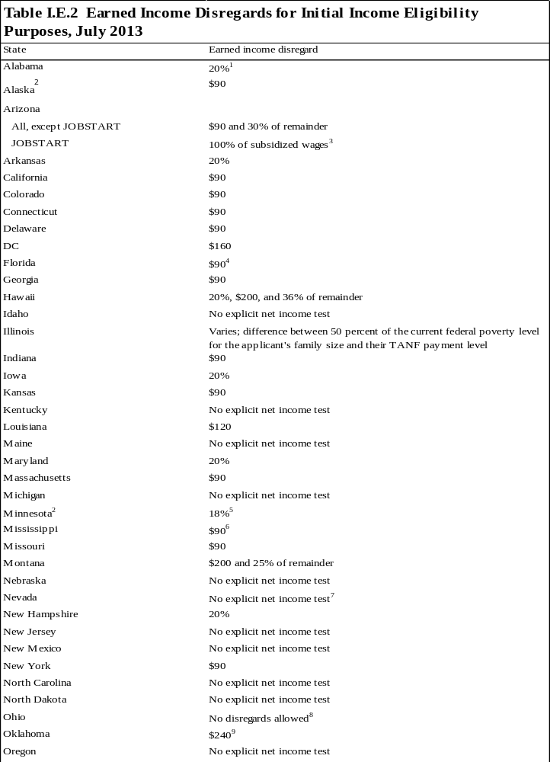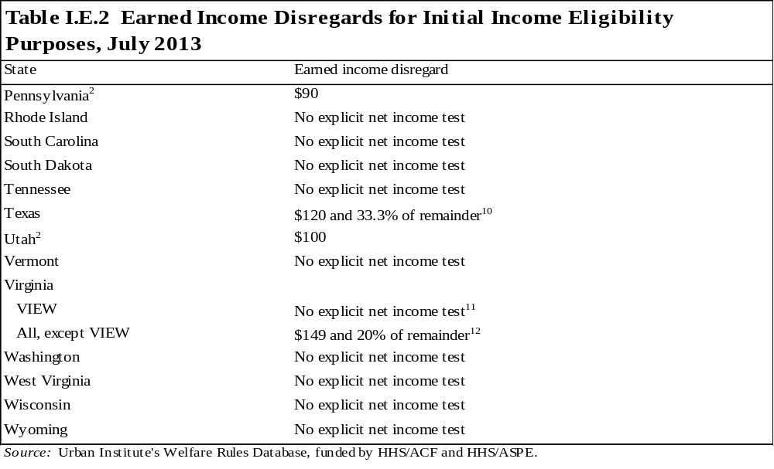
Notes: Only earned income disregards are described in the table. Child care disregards and other special disregards, such as deductions for units subject to a time limit or a family cap, are not included.

This table only shows earned income disregards for explicit net income tests. "No explicit net income test" indicates that either the state does not impose a net income test at application or the state imposes a net income test, but the calculation of the test and disregards allowed for the test are the same as those used to calculate the benefit. See table II.A.1 for earned income disregards specifically for benefit computation and table II.A.2 for information on benefit computation policies.

The table describes the disregards used for initial applicant eligibility purposes. See table IV.A.5 for the disregards used for ongoing, recipient eligibility purposes. Several states treat applicants who have recently received benefits as recipients.

¹The earned income disregard cannot be applied to the earnings of an individual receiving assistance beyond the 60th month under a hardship extension.
² This state considers units who have received assistance in one of the previous four months as recipients for the purpose of earned income disregards. See table IV.A.5 for more information.
³ In addition to the 100 percent disregard of all subsidized JOBSTART wages, recipients can disregard the standard $90 and 30 percent of the remainder for any non-JOBSTART earned income.
⁴ Applicant units receiving assistance in one of the last four months may disregard $200 and 50 percent.
⁵ Different disregard rules apply to participants in the four-month diversionary work program.
⁶ If a recipient marries for the first time, his or her new spouse may receive a one-time 100 percent disregard for six consecutive months.
⁷ The disregards allowed for the test are no different from those used to calculate the benefit. See table II.A.2 for information on benefit computation policies.
⁸ This state does test net income for initial eligibility but does not allow units to apply the type of earned income disregard discussed in this table. The net income test includes more specific disregards, such as deductions for dependent care.
⁹ This disregard applies to individuals working full time (defined as 20 hours a week for individuals with a child under age 6 and 30 hours a week for all others). Individuals who are not employed full time may disregard $120.
¹⁰ This disregard applies to the net income test comparing income with recognizable needs. Only the $120 disregard is applied to the net income test comparing income to the Budgetary Needs Standard. See table I.E.1 for income eligibility tests.
¹¹ All applicants must pass the same initial income eligibility tests. VIEW income eligibility tests and earned income disregards apply only to recipients who have met the initial eligibility requirements.
¹² The dollar amount of the initial disregard varies by family size. For one to three unit members, the disregard is $149. For four members, it is $160; for five members, it is $187; and for six or more members, it is $214.
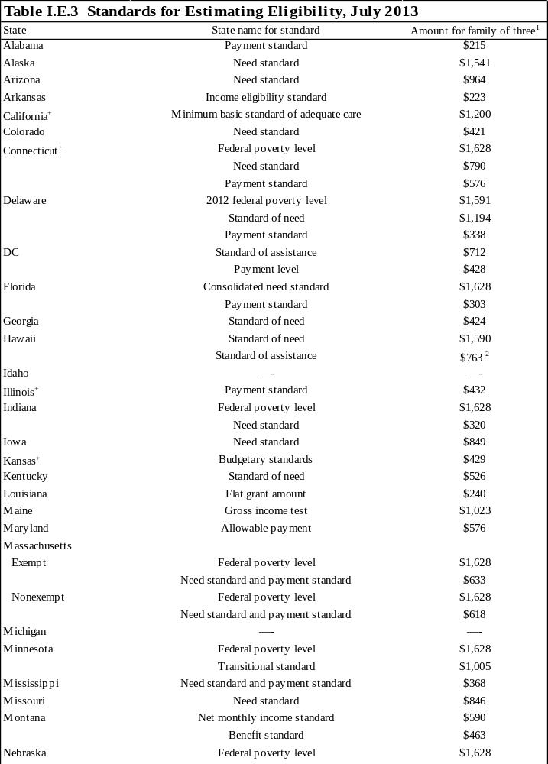
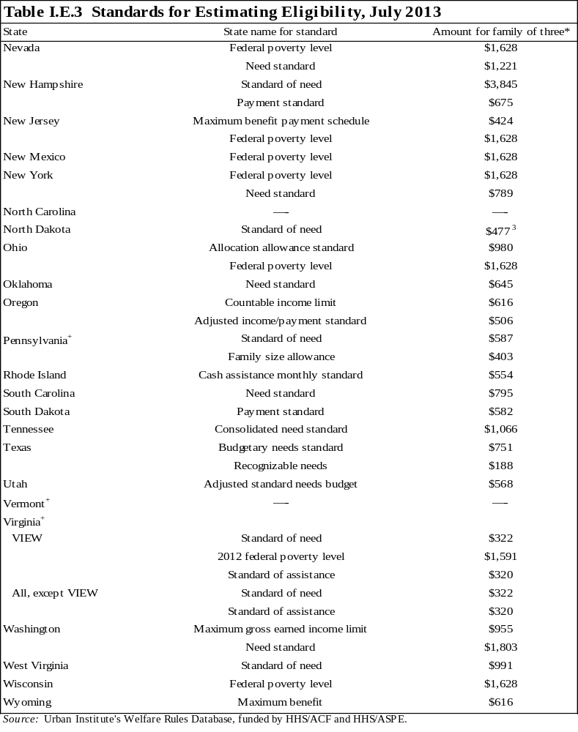

Notes: The values in this table represent all standards used during the eligibility process, including those used for grandparent deeming, stepparent deeming, applicant income eligibility tests, and recipient income eligibility tests. See tables I.D.1, I.D.2, I.E.1, and IV.A.4 for more information on how these standards are used. This table provides information on the standards only; to determine how the standards are applied, see the companion tables listed above. A "--- "implies there are no explicit income tests for that state.
+ Dollar amount used to calculate benefit varies within the state, either by county or by region of the state. Calculations are based on the dollar amount that applies to the majority of the state. See WRD for more information.

¹ The amounts in the table are based on the following assumptions about the assistance unit: there is one adult and two children; the children are not subject to a family cap; and the unit has no special needs, pays for shelter, and lives in the most populated area of the state.
² The standard of assistance is $610 for a family of three in the third or subsequent months of receiving benefits.
³ This amount includes a $50 increase in the payment standard given to units who pay for shelter.
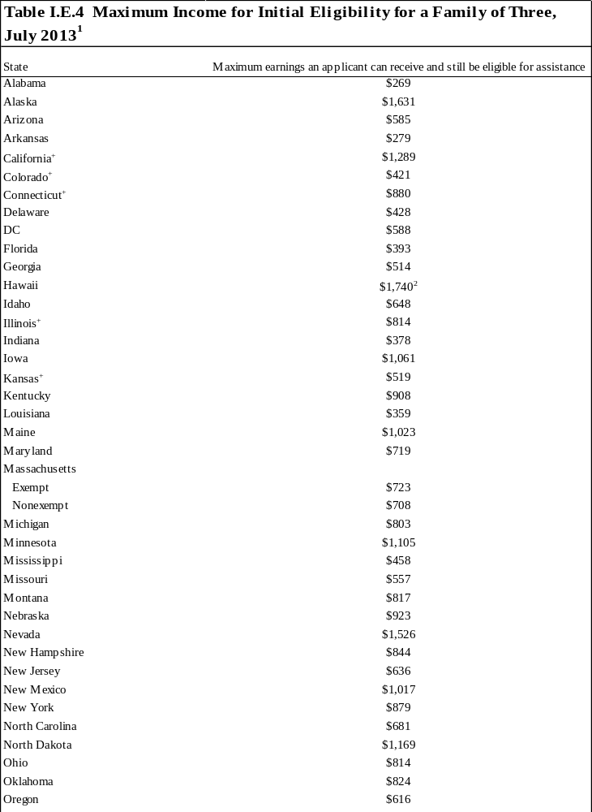
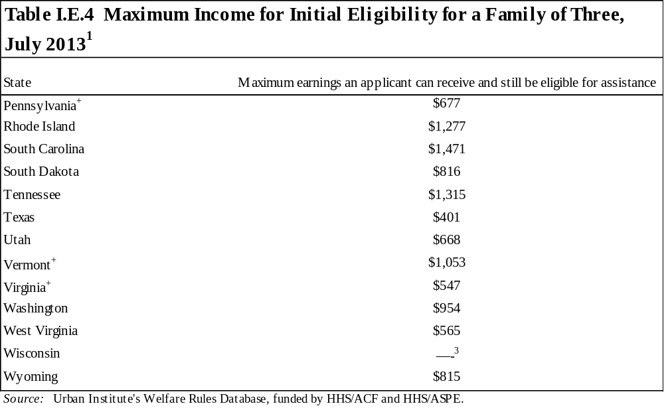
Note: Initial eligibility is calculated assuming that the unit is employed at application, has only earned income, has no child care expenses, contains one adult and no children subject to a family cap, has no special needs, pays for shelter, and lives in the most populated area of the state.

+ Dollar amount used to calculate benefit varies within the state, either by county or by region of the state. Calculations are based on the dollar amount that applies to the majority of the state. See WRD for more information.

¹ The values in this table represent the maximum amount of earnings an applicant can have and still be technically eligible for assistance in each state. Technical eligibility does not mean that the unit will necessarily receive a cash benefit, but it will have passed all the eligibility tests and is eligible for some positive benefit. Most states only distribute a cash benefit equaling $10 or more.
² This threshold applies to units that have received assistance for no more than two months in a lifetime. For units applying for their third and subsequent months of benefits, the eligibility threshold for a family of three is $1,441.
³ Units with earnings at application will not receive a cash benefit, except for some Community Service Job participants who may qualify for a prorated cash benefit. Applicants may earn up to $1,872 and still be eligible for nonfinancial assistance.

Benefits

The tables in this chapter of the Databook describe key aspects of the rules for calculating the assistance unit’s benefit as of July 2013.

A. If a family passes all eligibility tests, what is received?
If a family passes all eligibility tests, both nonfinancial and financial, a benefit is computed. Although states use many different formulas to determine benefits, most states apply some general rules. All but two states allow recipients to disregard a portion of their earned income before benefit computation and then use the unit’s total net income to calculate the benefit. In the more straightforward calculations, net income is subtracted from a state-determined standard (often called the payment standard), which varies by family size, and the benefit paid is the difference—sometimes referred to as the income deficit. Some states, however, have developed more complex calculations. For instance, some states impose a statutory maximum benefit, which generally varies by family size. In these states, the benefit is either the income deficit or the statutory maximum, whichever is less. Still other states multiply the income deficit by a percentage, which is sometimes referred to as the benefit reduction rate. This percentage of the income deficit is the benefit provided to the unit. Some states combine both a statutory maximum and benefit reduction rate into their calculation. States have broad discretion in how to structure changes to benefit amounts, if any; some states may regularly augment the dollar amounts used in benefit computation, while other states may have infrequent or less structured patterns of changing these standards. The following section describes these policies in greater detail.
Earned income disregards for benefit computation: Table II.A.1 describes the earned income disregards allowed in determining net income for benefit computation. If a state does not apply any earned income disregards to compute net income for benefit computation (so all of a family’s earnings are included as income for benefit computation), “no disregards allowed” appears in the table. Some states disregard a portion of the child care expenses paid by a family and/or allow special disregards for units subject to a family cap or time limit. Those disregards are not included in the table, but are captured in the WRD.
In rare cases, states use different earned income disregards to determine the benefit of a unit in its first month of eligibility versus subsequent months. If that is the case, the body of the table describes the rules for the subsequent months of eligibility, and the rules for the first month are footnoted.
Related tables: Disregards for benefit computation and income eligibility may differ. For information on the earned income disregards used for income eligibility, see table I.E.2. Table L4, in the last section of this book, describes the earned income disregards used for benefit computation from 1996 through 2013.
Benefit determination policies: Table II.A.2 describes how states compute benefits for units that pass all applicable eligibility tests. In most cases, net income is subtracted from a payment standard, which typically varies by the size of the assistance unit. The table indicates which income standards are used by states to determine the benefit. To determine the value of these standards for a family size of three, see table II.A.3.
Related tables: Table II.A.3 provides the benefit standard(s) used to compute benefits for a three-person family. To calculate the net income used for benefit computation, table II.A.1 describes the earned income disregards allowed, and tables I.D.1, I.D.2, and IV.A.2 include policies on treatment of unearned income (amounts deemed from grandparent units and stepparent units, and child support income). Table II.A.4 combines information from table II.A.2 with information on benefit standards for various family sizes (shown in II.A.3 for three-person families) and presents the benefit paid to an assistance unit with no net income and with two, three, four, five, or six members. Table L5, in the last section of this book, provides the maximum benefits paid to a three-person unit for selected years from 1996 through 2013.
Benefit standards: As described earlier, most benefit computation procedures involve state-established income amounts that vary by the size of the assistance unit. The WRD includes the benefit standards used for each family size from 1 through 12. Table II.A.3 provides the standards for a three-person assistance unit with one adult and two children. The table identifies the standard by the name used in the caseworker manual. Under the former AFDC program, the standards for benefit computation were the payment standard and, if the state included one, the maximum benefit. However, owing to the complexity of state programs, identifying the payment standard and maximum benefit is no longer clear. States may include multiple standards in the benefit calculation, depending on the type or amount of income. Therefore, the terms payment standard and maximum benefit are not used in the table unless the state explicitly uses them to refer to their benefit computation standards.
Some details concerning benefit standards are not included in the table. In some states, different dollar amounts are used in different regions of the state; in those cases, the table includes the amounts applied to the majority of the state’s caseload, but a footnote alerts the reader to the fact that the benefits are not constant across the state. In other states, the amounts may be higher for families with certain special needs, such as a pregnancy; the amounts in the table assume no special needs. Also, a few states vary standards for one-parent families, two-parent families, and child-only units; the table includes values for a one-parent family with two children. Some states prorate the eligibility and/or benefit standards depending on whether a unit pays for shelter; the amounts in the table assume the unit pays all shelter costs and does not live in public or subsidized housing.
The final two columns show value of the statutory maximum benefit in states that have implemented this policy. In 2013, ten states had a statutory maximum benefit, ranging from $170, in Mississippi, to $1,005 in Minnesota, for families of three.
Related tables: These standards by themselves are not necessarily comparable across states, since benefit computation procedures might differ. To determine how the standards are used in practice, see table II.A.2. Table II.A.4 provides the benefit paid to a two-person through six-person units with no other income, and table L5 provides the three-person maximum benefits for selected years from 1996 through 2013. Table II.A.5 provides the benefit paid to a unit consisting of a single child, with no adults.
Maximum monthly benefit for a family with no income: Table II.A.4 provides information on the maximum benefit in each state for family sizes two through six. The maximum benefit calculation combines the information on a state’s benefit computation policies with the dollar amounts used for benefit computation to present the benefit paid to a unit with no income. If a state computes benefits as a payment standard minus net income, then this figure will simply equal the payment standard. In other cases, this figure will equal a statutory maximum benefit that is less than the payment standard. In still other cases, it will be a percentage of the payment standard. The calculation assumes the assistance unit includes one parent with the other unit members as children, contains no children subject to a family cap, has no special needs, pays for all shelter costs with no subsidies, and is subject to the benefit standard that applies to the majority of the state’s caseload. Data for family sizes larger than six people may be found in the WRD.
The table shows large variation in the benefit amounts. For a three-person family, the maximum monthly benefit ranges from $170 to $923, with a median of $428. Benefits are higher for larger families, but the average per-person benefit generally falls with family size. For a six-person family, the maximum monthly benefit ranges from $242 to $1,238, with a median of $619.
Related tables: Table L5 provides the benefit paid to a three-person assistance unit with no net income for 1996 through 2013. Table II.A.5 gives the maximum benefits paid to child-only units with one child.
Maximum monthly TANF benefit for a child-only unit with one child, no income: Table II.A.5 provides the maximum monthly TANF benefit that could be paid to a child-only unit consisting of a single child. Information is shown for three different circumstances that may lead to child-only units: when the child lives with a nonparent caretaker, a parent/caretaker who receives SSI, or a parent who is excluded due to immigrant status. In almost all states, the maximum benefit is the same in all three of those circumstances. However, in Nevada, South Dakota, and Wisconsin, different benefits are paid to children living with caretaker relatives versus children living with parents receiving SSI. In Tennessee, a child living with an ineligible parent receives a different benefit amount than one living with a nonparent caretaker or parent who receives SSI. (If a state always requires that nonparent caretakers be in the assistance unit, no value is shown for child-only units due to nonparent caretakers.) Focusing on one-child units in which the child lives with a nonparent caretaker, the maximum monthly benefit ranges from $81 to $539, with an average of $238 and a median amount equal to $205.
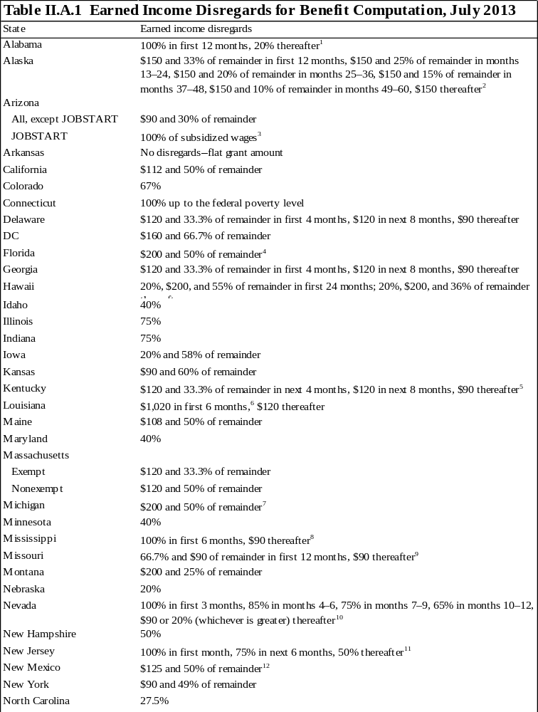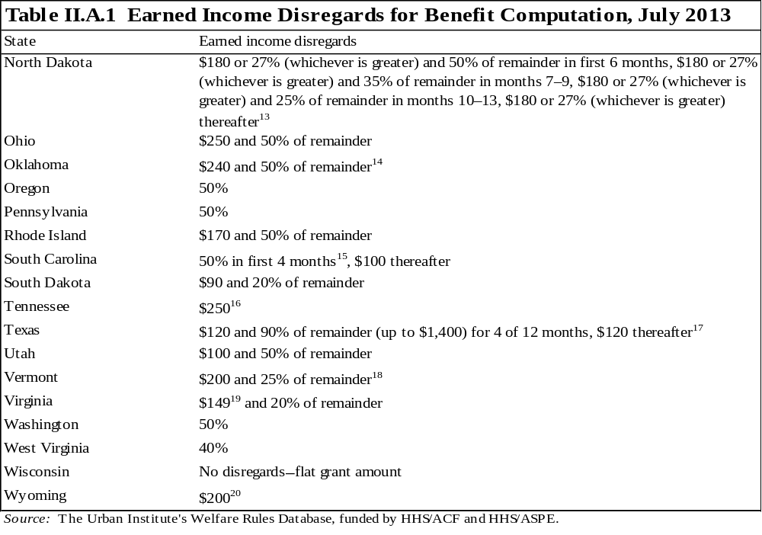
Notes: Only earned income disregards are described in the table. Child care disregards and other special disregards, such as deductions for units subject to time limits and family caps, are not included.

The table describes the earned income disregards used to compute a recipient's benefit. If different disregards are used to compute an applicant's benefit in the first month, they are footnoted.

When no duration is specified for the disregards, they remain for the entire period of receipt.

¹ The earned income disregard cannot be applied to the earnings of an individual receiving assistance beyond the 60th month under an extension. The disregard can only be applied to earnings reported within 10 days of receipt.
² These disregards also apply to applicants who have received assistance in one of the previous four months.
³ In addition to the 100 percent disregard of all subsidized JOBSTART wages, recipients can disregard the standard $90 and 30 percent of the remainder for any non-JOBSTART earned income.
⁴ The $200 and 50 percent disregard also applies to applicants who have received benefits in one of the past four months.
⁵ Recipients are eligible for the one-time 100 percent disregard if they become newly employed or report increased wages acquired after approval.
⁶ The six months in which the extra $900 is disregarded need not be consecutive, but the recipient may use this extra disregard in no more than six months over the course of his or her lifetime.
⁷ Applicants may disregard $200 and 20 percent of remainder.
⁸ Recipients are eligible for the one-time 100 percent disregard if they find employment of 35 hours a week within 30 days of either their initial approval for TANF or the beginning of job-readiness training. If work is not found, the recipient will never be eligible to receive the disregard again. An additional 100 percent disregard is available to units for three months when the unit's case is subject to closure because of increased earnings and the individual is employed for at least 25 hours a week at the federal minimum wage or higher. The recipient may not have already received the six-month disregard, unless there has been at least a 12-month break in receipt of TANF benefits. The three-month disregard may be received more than once during the 60-month TANF benefit period, provided there is a period of at least 12 consecutive months in which a family does not receive TANF benefits before the family reapplies for assistance. If a recipient marries for the first time, his/her new spouse may receive a one-time 100 percent disregard for six consecutive months.
⁹ These disregards apply only to recipients who become employed while receiving TANF. Applicants and those recipients who gained employment before receiving TANF are allowed to disregard $120 and 33.3 percent of the remainder for the first four months, $120 the next eight months, and $90 thereafter.
¹⁰ The first 12 months of disregards are available to the recipient again if they have been off TANF for at least 12 months.
¹¹ These disregards apply to individuals working 20 or more hours a week. Individuals employed fewer than 20 hours a week may disregard 100 percent in the first month of employment and 50 percent thereafter. However, if an individual's hours increase to 20 hours during the first six months, he or she may disregard 75 percent for the remainder of the six-month period. The 100 percent disregard is applicable only once every 12 months, even if employment is lost and then regained.
¹² Two-parent units may disregard $225 and 50 percent of the remainder. An additional $125 may be disregarded for each nonbenefit group member whose income is deemed available..
¹³ If a parent marries while receiving assistance, the income of his or her new spouse is disregarded for the first six months. The disregard for the new spouse only applies if his or her needs were not previously included in the unit.
¹⁴ These disregards apply to individuals working full time, defined as 20 hours a week for recipients caring for a child under age 6 and 30 hours a week for all other recipients. Individuals working less than full time may disregard $120 and 50 percent of the remainder.
¹⁵ The 50 percent disregard is available only once in a lifetime and may only be applied to consecutive months.
¹⁶ If a parent marries while receiving assistance, the unit may choose to exclude the new spouse from the unit for three months. At the end of the three-month period, the new spouse becomes a mandatory member of the assistance unit, and his or her income is counted in benefit computation calculations.
¹⁷ Once the recipient has received four months (they need not be consecutive) of the 90 percent disregard, s/he is not eligible to receive the disregard again until the TANF case has been denied and remains denied for 1 full month and 12 calendar months have passed since the denial. The 12-month ineligibility period begins with the first full month of denial after the client used the fourth month of the 90 percent disregard. The earnings of a TANF recipient's new spouse are disregarded for six months if the total gross income of the budget group does not exceed 200 percent of the federal poverty level.
¹⁸ These disregards apply to recipients with income from unsubsidized employment or a combination of subsidized and unsubsidized employment. For recipients with earnings from subsidized employment only, the disregard is $90.
¹⁹ The disregard varies by family size; for one to three family members, the disregard is $149. For four members, the disregard is $160; for five members, the disregard is $187; and for six or more family members, the disregard is $214
²⁰ Married couples with a child in common may disregard $400.
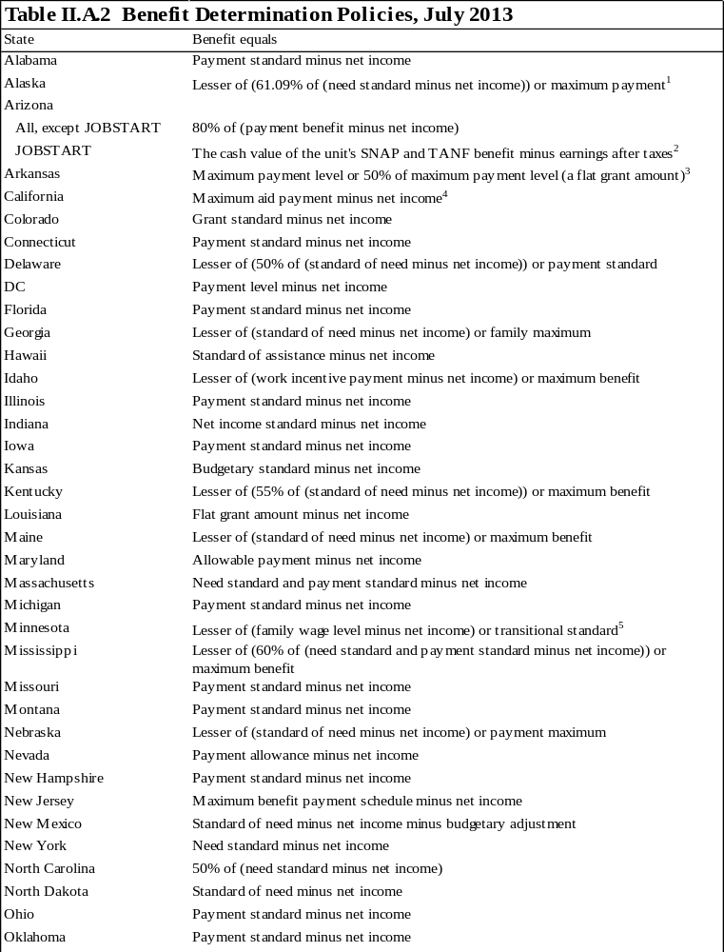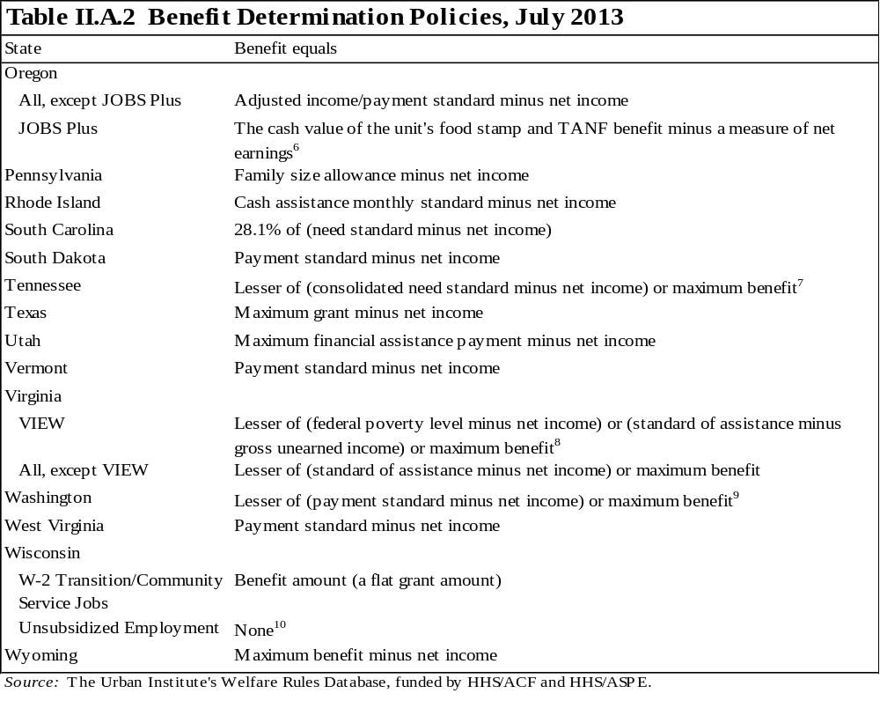
Note: For information on the benefit standards, see table II.A.3.

¹ Two-parent units in which both parents are able to perform gainful activities will have their benefits reduced by 50 percent for July, August, and September.
² JOBSTART recipients receive wages from their subsidized employer. However, the state provides a supplemental payment for units whose adjusted gross income (earnings net of FICA and federal and state taxes) is less than the cash value of the SNAP benefits and TANF benefits they would have otherwise received. The supplemental payment is determined by subtracting the unit's adjusted gross income from the cash value of its food stamp and TANF benefit.
³ The benefit is equal to the maximum payment level for the unit size if the unit's gross income is less than $446. If the gross income is greater than $446, the benefit will be reduced to 50 percent of the maximum payment level. Arkansas refers to this policy as the gross income trigger.
⁴ In households with a stepparent not receiving assistance, the unit receives the lesser of (1) maximum aid payment (for family size including the stepparent) minus net income or (2) the maximum aid payment for family size excluding the stepparent.
⁵ The calculation applies to recipients with earned income only. The calculation for recipients without earned income is transitional standard minus net income. The calculation for recipients with earned and unearned income is the following: if the family wage level minus earned income is less than the transitional standard, the benefit equals the family wage level minus total net income (earned and unearned income). If the family wage level minus earned income is greater than the transitional standard, the benefit equals the transitional standard minus unearned income. Also, the Minnesota Family Investment Program (MFIP) payment standards include the state's SNAP allotment. MFIP recipients' cash and SNAP grants are computed with the same calculation. A flat amount (based on family size) for the SNAP allotment is subtracted from the benefit amount, and any remaining amount is provided to the unit in cash. To calculate the TANF grant amount without SNAP, subtract the food portion of the MFIP standard from the benefit. Unless otherwise exempt, all applicants must first participate in a mandatory, four-month diversion program before receiving TANF. See table I.A.1 for benefit determination policies that apply during this period.
⁶ The benefit is equal to the maximum of (A-C or B-D), where A equals the full benefit equivalent, the sum of welfare and SNAP benefits, calculated using normal rules. B equals the minimum benefit equivalent, A minus the difference between adjusted income/payment standard for the unit including the JOBS Plus participant and adjusted income/payment standard for the unit not including the JOBS Plus participant. C equals the JOBS Plus participant's wage multiplied by his or her available hours (all scheduled hours, regardless of whether the participant worked those hours), minus $90, $50 pass-through, $102 earned income credit refund, and any garnishment withheld. D equals the JOBS Plus participant's wage times hours actually worked, minus $90, $50 pass-through, $102 earned income credit refund, and any garnishment withheld.
⁷ When a caretaker marries while receiving assistance, s/he can choose to exclude the new spouse from the assistance unit for up to three months. If the new spouse is not included in the unit, none of his/her income or resources is counted for eligibility or benefit computation purposes. If the caretaker chooses to include the new spouse in the unit, all his/her income is counted for eligibility and benefit computation calculations. After three months, the new spouse becomes a mandatory unit member and all his/her income will be considered in determining eligibility and benefit computation.
⁸ The benefit for two-parent units equals the lesser of (150 percent of the federal poverty level minus net income), or (standard of assistance minus gross unearned income), or maximum benefit. For all units, the maximum benefit only limits benefits for units with six or more members.
⁹ The maximum benefit is the same for families with eight or more members.
¹⁰ Units in the unsubsidized employment component receive wages from an unsubsidized job and are ineligible for a cash benefit; they may still receive support services if they are otherwise eligible.
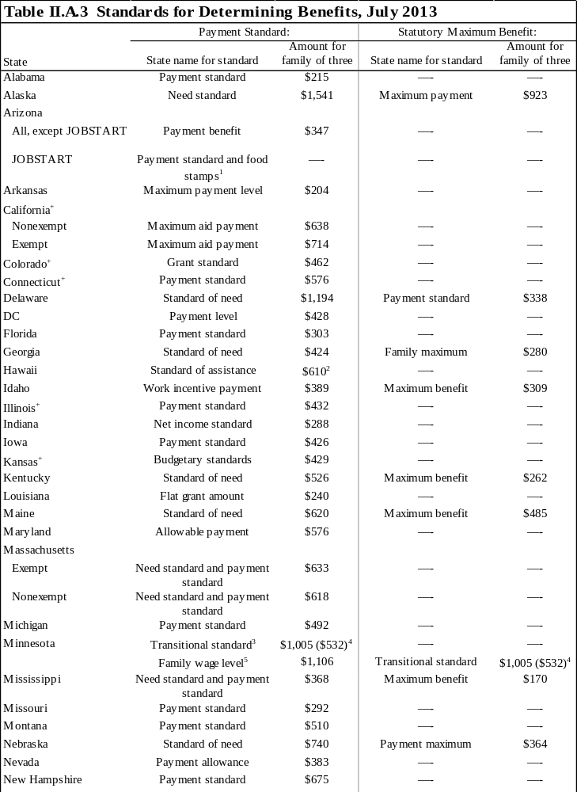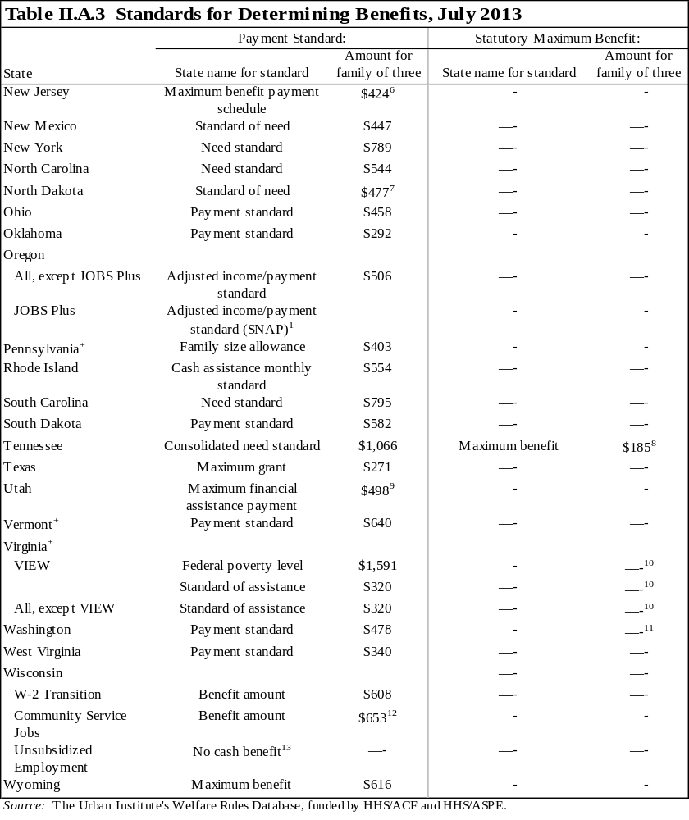

Notes: This table provides information on the standards only. For information on how the standards are used, see table II.A.2.
The amounts in the table are based on the following assumptions about the assistance unit: there is one adult and two children; the children are not subject to a family cap; and the unit has no special needs, pays for shelter, and lives in the most populated area of the state.

+ Dollar amount used to calculate benefit varies within the state, either by county or by region of the state. Calculations are based on the dollar amount that applies to the majority of the state. See WRD for more information.

¹ See footnote 2 in table II.A.2 for a description of the standard.
² Applies to units that have received assistance for at least two months in a lifetime. For units receiving their first and second months of benefits, the standard of assistance for a family of three is $763.
³ This applies to recipients without earnings
⁴ Minnesota's transitional standard includes the food stamp allotment for each unit size. The SNAP and cash benefit are computed together for welfare recipients. The SNAP allotment is a flat benefit, based on family size, which is subtracted from the benefit amount. Any remaining benefit is given to the unit as cash. The value of the TANF benefit only is in parentheses.
⁵ This standard applies to recipients with any earned income.
⁶ An additional $150 is added to the benefit amount for exempt units receiving assistance beyond the 60th month.
⁷ This amount includes a $50 increase to the payment standard given to units who pay for shelter.
⁸ For units where the caretaker is over age 60, disabled, caring full time for a disabled family member, or excluded from the assistance unit, the maximum benefit for a family of three is $232.
⁹ Pregnant women may receive an allowance of $15 per month beginning in the third month before the expected month of delivery until the pregnancy ends. Parents involved in certain work, training, or education related activities may receive an additional payment of $60 per month.
¹⁰ The maximum benefit only applies to payments for units with six or more members.
¹¹ The maximum benefit only applies to payments for units with nine or more members.
¹² Community Service Jobs participants can receive a prorated payment if they are working 40 hours a week in a combination of unsubsidized employment, work training, and educational activities. Education may never fulfill more than 10 hours of the requirement. Participants working 20 to 29 hours a week in an unsubsidized job may receive $218, those working 15 to 19 hours receive $327, and individuals working 10 to 14 hours a week receive $435. Individuals who are working fewer than nine hours are eligible for the full payment. Individuals employed full time are not considered to have barriers to work and are therefore ineligible for payments.
¹³ Recipients participating in unsubsidized employment receive wages and do not receive TANF cash assistance.
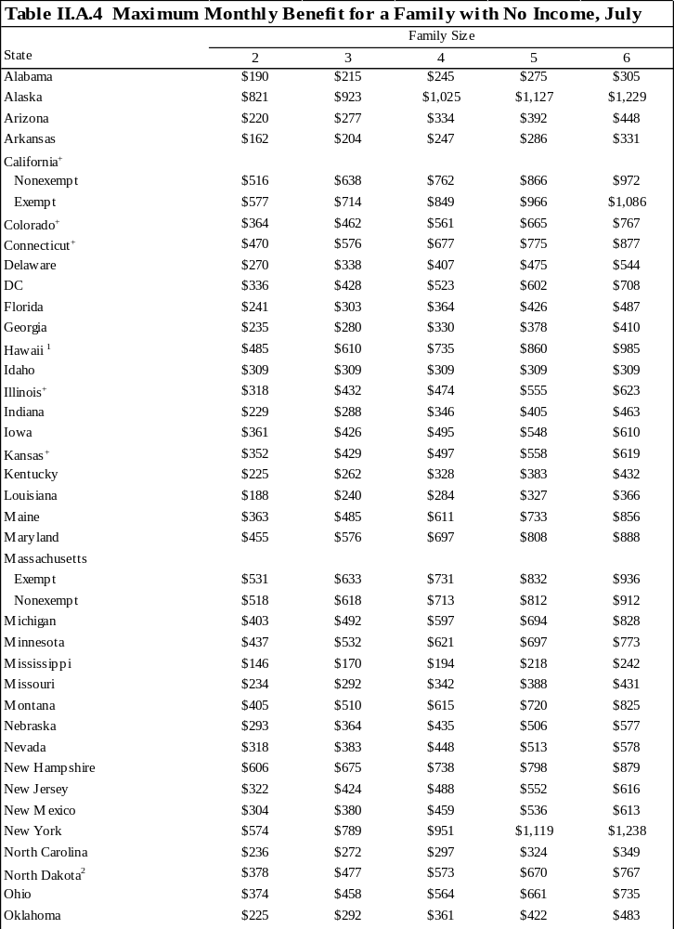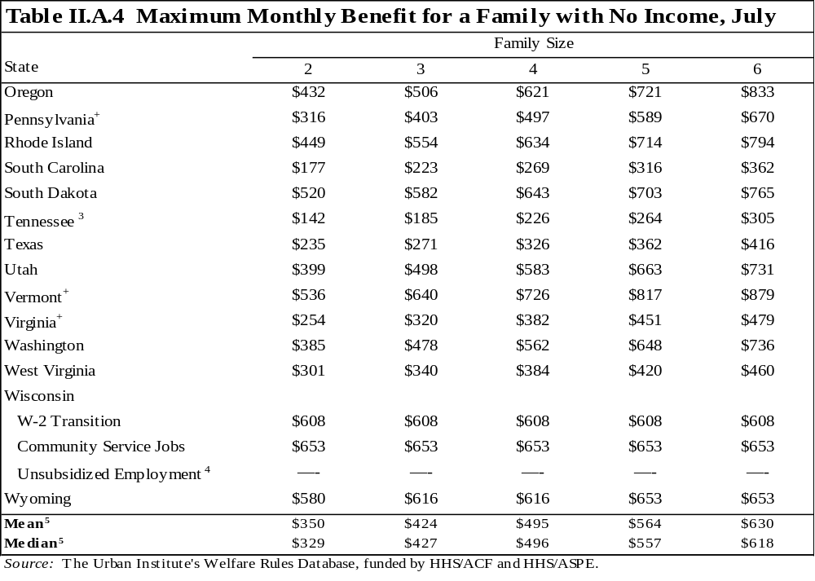

Note: Maximum benefits are calculated assuming that the unit contains one adult and no children subject to a family cap, has no special needs, pays for shelter, and lives in the most populated area of the state.

+ Dollar amount used to calculate benefit varies within the state, either by county or by region of the state. Calculations are based on the dollar amount that applies to the majority of the state. See WRD for more information.

¹ This benefit applies to units that have received assistance for two or more months in a lifetime.
² This amount includes a $50 increase to the payment standard given to units who pay for shelter.
³ Benefits vary for units where the caretaker is over 65, disabled, caring full-time for a disabled family member, or excluded from the assistance unit.
⁴ Recipients participating in unsubsidized employment receive wages and do not receive TANF cash assistance.
⁵ The calculations only include one value per state (the policy affecting the largest percent of the caseload).
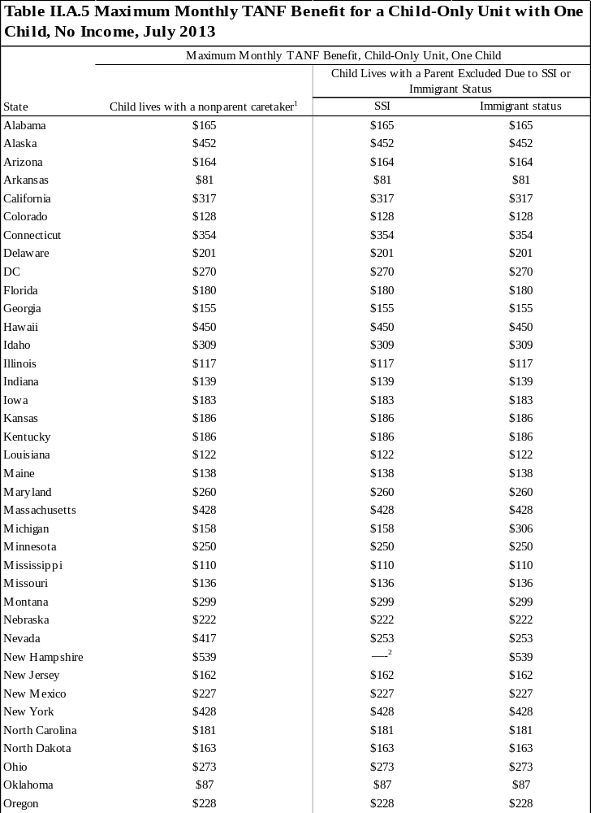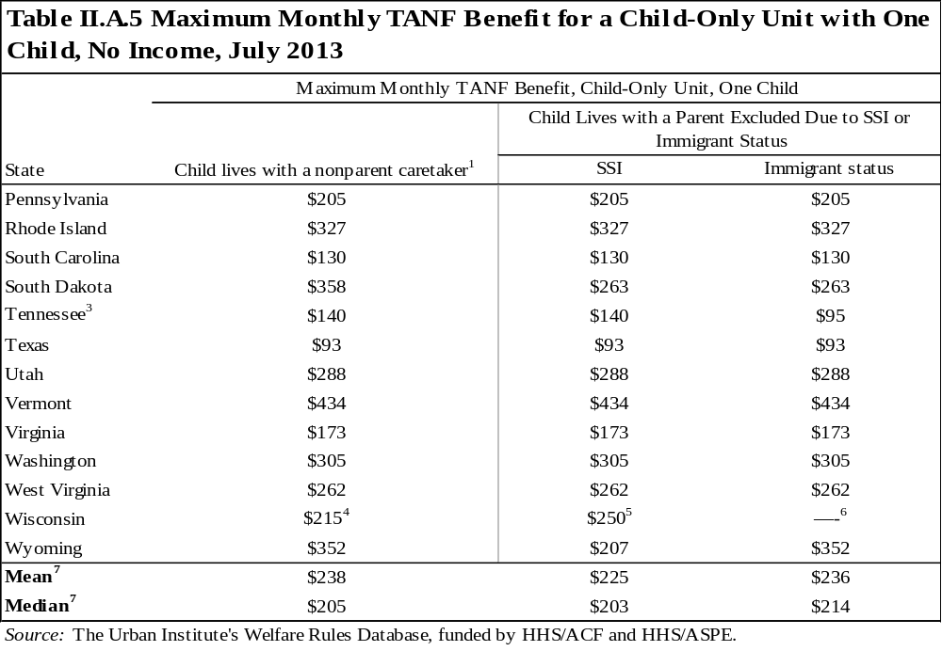
¹ This column specifically refers to cases where the nonparent caretaker was never included in the unit.
² Parents receiving SSI are also eligible for TANF benefits.
³A greater benefit is provided to child-only cases if the caretaker is a nonparent, is disabled, receives SSI, is caring for a disabled relative in the home, or is age 65 or older. All other child-only cases receive the standard payment amount.
⁴ Families with a nonparent caretaker excluded are potentially eligible for a kinship care payment of $215 per month per child.
⁵ Children whose parents/caretakers are SSI recipients are covered by a component of the TANF program called caretaker supplement. Caretaker supplement benefits are $250 per child per month for the first child and $150 per child per month for each additional child. To be eligible, a child's sole custodial parent receives SSI or the child lives with both custodial parents and both receive SSI. The parent(s) are not included in the grant amount, and the unit's benefit only is made up of the caretaker supplement payments. Children must still meet asset and income requirements.
⁶ Families with a parent excluded because of immigrant status are not eligible for TANF or components of TANF.
⁷ The calculations only include one value per state (the policy affecting the largest percent of the caseload).

Requirements
The tables in this chapter of the Databook describe the requirements for the individual members of an assistance unit as of July 2013. Numerous requirements may be imposed on a family for it to become and/or remain eligible for TANF. To receive benefits, most states require recipients to negotiate and sign contracts that detail what is required of individuals within the unit. These requirements vary considerably by state but can include conditions for dependent children, such as immunization and school attendance, as well as conditions for the adult head of the household, such as work-related requirements.
The following two sections describe some requirements that individuals within the unit must fulfill to become and remain eligible for assistance, including those related to behavior and work activities.

A. Once determined eligible, what must a recipient family do to maintain benefits?
States may impose several types of behavioral requirements (requirements that attempt to influence or alter one’s actions) on individuals in the assistance unit. These requirements may affect adults and/or children in the unit and may include anything from requiring adult recipients to submit to drug testing to requiring dependent children to maintain a minimum grade point average in school. Fulfilling behavioral requirements can be a condition of initial and/or continuing eligibility.
Behavioral requirements: Although behavioral requirements affect adults and minor parents in many states, this book focuses on requirements imposed on dependent children. The typical requirements imposed on dependent children include school, immunization, health screening, and other health requirements. The following describes these policies further:

- School:
School policies may require children to attend school or to achieve at least a minimal grade point average. This book addresses only the school requirements imposed on dependent children, not those that may be imposed on minor parents (which are included in the WRD).
States may also offer a school bonus, which provides financial incentives for assistance units whose children meet specific attendance or achievement standards. Unless otherwise noted, the school bonuses apply to both dependent children and minor parents.
- Immunization:
These policies require parents to have their children immunized.
- Health screening:
Health screening requirements may include regular checkups for both children and adults, although the requirements usually apply only to children.
- Other health requirements:
Other health requirements primarily involve compliance with the rules of the Early and Periodic Screening, Diagnosis, and Treatment (EPSDT) program.
Table III.A.1 describes whether any requirements listed above are imposed for either initial or continuing eligibility. Requirements are only included in this table if (1) they are either explicitly mentioned in the state’s TANF manual as a requirement for cash assistance or recipients must sign a contract including one of the requirements to receive benefits, and (2) a sanction results from noncompliance. The table also describes whether the state provides school bonuses. The dollar amounts of bonuses, and the dollar amounts of sanctions for not complying with requirements, are not included in the table but are available in the WRD.

B. What work activities are required?
Under the TANF block grant, the federal government requires states to (1) meet the annual work participation rate determined by the federal government; and (2) ensure that every recipient is working (as defined by the state) as soon as the state determines he or she is able or after 24 months of benefit receipt, whichever is earlier. Therefore, states require most adult heads of an assistance unit to perform some type of work-related activity after a given period. The activities available and the timing of the requirement vary greatly by state. Who is required to participate can also vary considerably. States may, and most do, exempt (or excuse) groups of recipients from participating in activities based on some demographic or individual characteristic. In cases where the recipient is not exempt but also not complying with activity requirements, the state may sanction the family by reducing or eliminating the unit’s benefit. Parents and caretakers who are not included in the assistance unit are generally not required to engage in work-related activities, and nonparent caretakers who are in the assistance unit are generally required to participate in the same way as parents, but those policies vary across the states. Below is a further discussion of these topics and the tables included in this section.
The policies included in the tables are effective as of July 2013; however, in early 2006 the Deficit Reduction Act of 2005, which reauthorized the TANF program, became law and substantially changed work-related policies. The law narrows the definitions of work activities, counts more groups of individuals in the states’ participation calculations, recalibrates the caseload reduction credit (using fiscal year 2005 as the base year instead of 1995), and tightens states’ accountability, including imposing new penalties for noncompliance with work verification plans. Although the basic work-related rules—who is exempt from work, how many hours of work are required, and what is the minimum sanction for noncompliance—did not change under the new legislation, states have responded and will continue to respond to the new legislation by changing these policies.
Work-related exemptions: States may, but are not required to, exempt certain individuals or groups from participating in work-related activities. Such an exemption does not, however, remove the individuals from the calculation of the state’s federal work participation rate. The categories of recipients who may be removed from the denominator of the participation rate calculation include single parents of a child under 12 months old, recipients sanctioned for refusing to meet work requirements under certain situations, and, following the Deficit Reduction Act of 2005, parents needed in the home to care for a disabled family member.
Table III.B.1 describes each state’s key rules for exempting the single-parent head of an assistance unit from work-related requirements. An individual may be exempt if he or she works a specified number of hours in an unsubsidized job, is ill or incapacitated, is caring for an ill or incapacitated person, is elderly, is in a specified month of pregnancy, or is caring for a child under a specified age. These exemptions are the most common, but this list is not exhaustive. For other exemption criteria, see the WRD. While not providing an explicit exemption, some states will consider some of these criteria as “good cause” for noncompliance.
Related tables: Table L6 provides the exemption for a parent caring for a young child from 1996 through 2013.
Work-related activities: Work programs vary widely from state to state based on several factors, including who must work, how much work is required, and what activities are considered work. Table III.B.2 provides a general overview of state activities requirements. The table describes when the recipient must begin participating, allowable activities the recipient could participate in, and how many hours the recipient must participate a week, including what share of those hours can be spent in education and training programs. Not all assistance units have the same work requirements. For simplicity, this table only includes the activities requirements for units headed by a single parent over age 20.
Users of this table should keep in mind that the caseworker manuals on which the WRD is based do not provide complete information about how these work requirements are implemented. In particular, caseworker manuals do not generally indicate the likelihood that a recipient will be assigned to one activity or another. Thus, two states could have the same potential activities but have very different policies for how often different activities are assigned in practice. Alternatively, one state might include a potential activity not listed in another state’s list but in practice rarely assign anyone to that activity. Another complexity is that one state may explicitly indicate that a particular type of recipient (such as one without a high school diploma) will always be assigned to a certain activity (such as education and training), whereas another state might not include such a provision in the manual but nevertheless be very likely to assign individuals without diplomas to educational activities. Despite these limitations, the table provides a starting point for understanding the range of work-related requirements across states.
Work-related sanctions: If adults required to participate in activities do not comply with requirements, the state can sanction the unit. States have discretion to define what constitutes noncompliance and what will result from the noncompliance. Typically, if a recipient does not participate in his or her assigned activities for the specified number of hours, he or she is not complying and could be sanctioned. A sanction generally results in the removal of the noncompliant individual from the unit for benefit computation, a percentage reduction in the entire unit’s benefit, or a full benefit sanction. Often states increase the severity of the sanction based on the number of times or the amount of time the individual is noncompliant.
Table III.B.3 describes sanction policies for failing to comply with work requirements. The table provides both the initial sanction (for the first instance of noncompliance) and the most severe sanction (after multiple instances of noncompliance). For both the initial and most severe sanctions, the table describes the amount of the reduction in benefits and the duration of the sanction. When the sanction is described as “adult portion of the benefit,” the state recomputes benefits using an assistance unit size that excludes the noncompliant adult. (If the adult has any income, some or all of it is deemed available to the children to prevent an increase in benefit.) The WRD includes more details on sanctions, including any sanctions that occur between the initial and most severe sanctions.
Related tables: Table L7 describes the most severe sanction for 1996 through 2013.
Work-related activity requirements for nonparent caretakers and parents outside the unit: In some cases, adults who are not included in the assistance unit are nevertheless still subject to work-related activity requirements, with variations in policy across states and by the reason that the adult is not in the unit. As shown in table III.B.4, in 34 states, a parent who is outside the unit due to immigrant status is not required to participate in work-related activities; however, 13 states require such a parent to participate, and 3 states give the parent the option to participate. Another case shown in the table is an adult who is not in the assistance unit due to a time limit, in those states that exclude the adult after a time limit is reached. In most of the states with that type of policy, the excluded adult is still subject to work requirements. In the case of nonparent caretakers who are outside the unit, four states require their participation (assuming that they are not exempt for some other reason, such as age or disability) and four states allow it as an option. The final column of table III.B.4 addresses nonparent caretakers who are included in the assistance unit. Most states require these caretakers to participate in work-related activities (again, if they are not exempt for another reason), but in Texas their participation is optional.
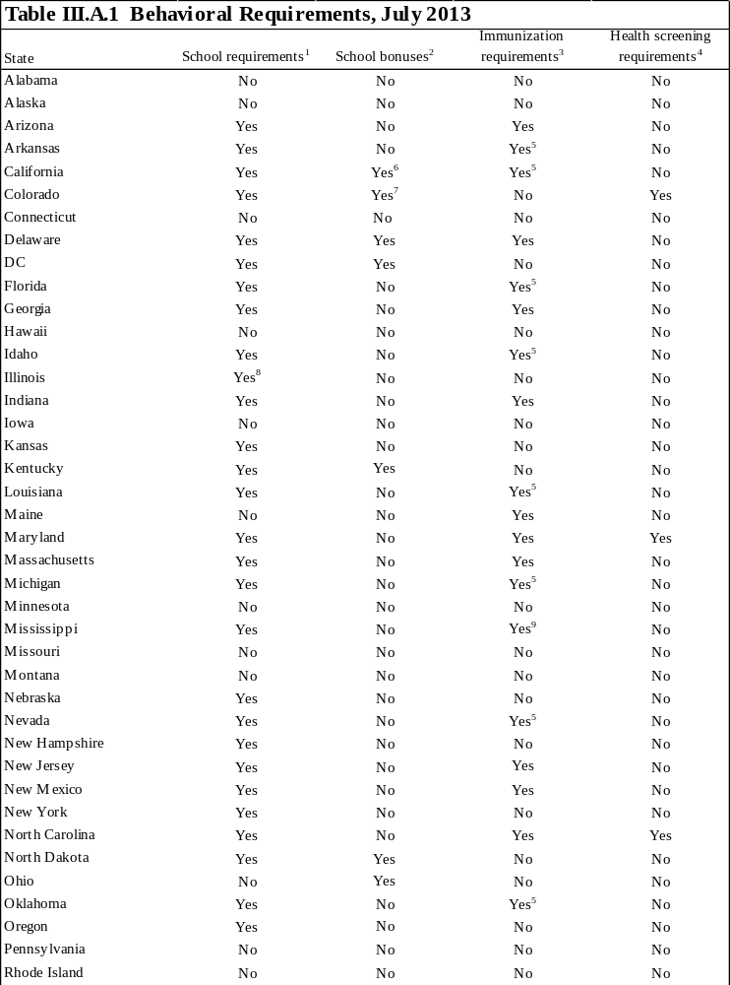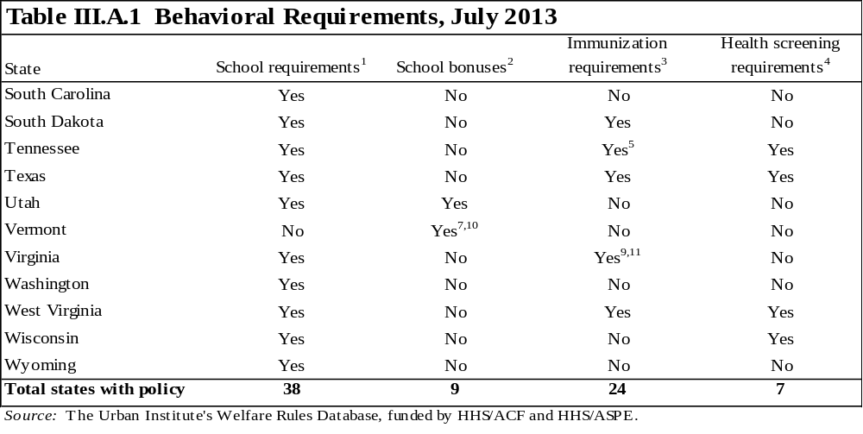
¹ School requirements apply only to requirements for dependent children, not minor parents. A requirement is coded "Yes" if the state explicitly mentions it as a requirement for cash assistance or if it is included as a requirement in the recipient's contract and noncompliance results in a sanction. These policies may require children to attend school or to achieve a minimum grade point average; they may also require parents to be involved in their children's education in some way.
² This variable captures financial incentives for assistance units whose children meet specific attendance or achievement standards. Unless otherwise noted, school bonuses apply to both dependent children and minor parents.
³ Immunization requirements include information on standard immunizations for children. A requirement is coded "Yes" only if the state explicitly mentions it as a requirement for cash assistance or if it is included as a requirement in the recipient's contract and noncompliance results in a sanction.
⁴ Health screening requirements include information on regular checkups for both children and adults, although the requirements usually apply only to children. A requirement is coded "Yes" only if the state explicitly mentions it as a requirement for cash assistance or if it is included as a requirement in the recipient's contract and noncompliance results in a sanction.
⁵ The immunization requirement may be waived if the procedures would risk the child's health or violate the family's religious beliefs.
⁶ School bonuses apply to pregnant or teen parents under age 19.
⁷ School bonuses only apply to teen parents aged 16 through 19.
⁸ Requirement is dependent on existing agreements with community agencies and varies in implementation.
⁹ The immunization requirement may be waived if the procedures would risk the child's health or violate the family's religious beliefs. Children under two months old are exempt.
¹⁰ School bonuses are allowed at case manager discretion.
¹¹ Children are exempt from showing proof of required immunizations if they are enrolled in school or a licensed day care center.
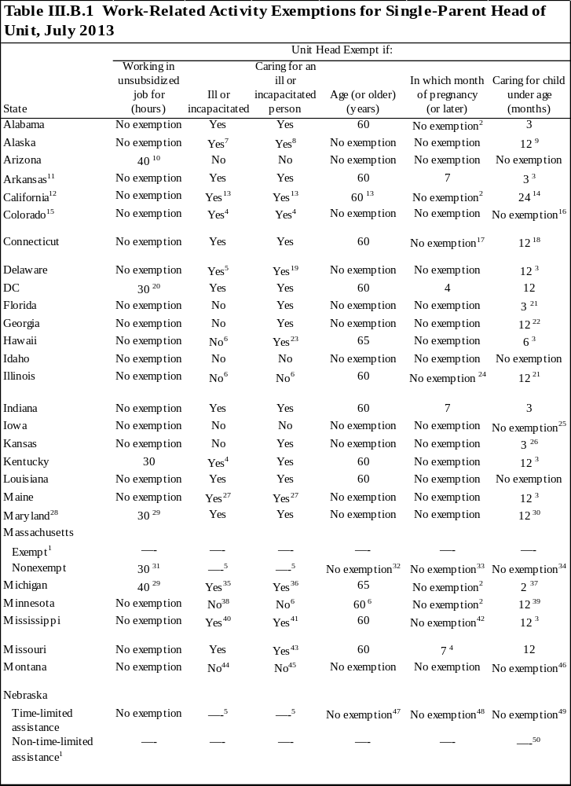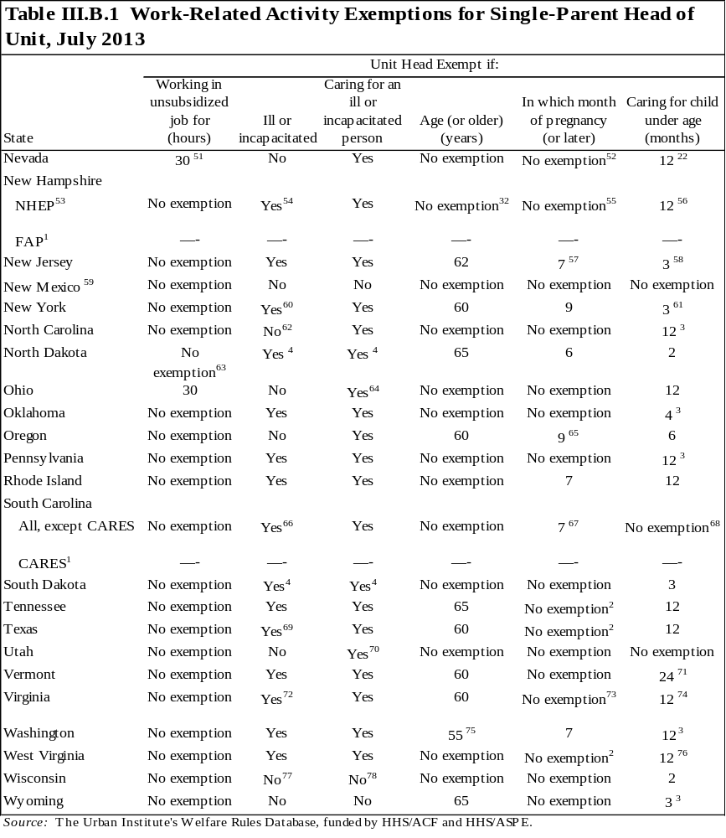
Note: This table refers to single-parent unit heads over 21 years old.

¹ Recipients in this component are automatically exempt from activities requirements. See appendix 1 for more information on the composition of the component.
² A pregnant woman may qualify for an exemption if the pregnancy is disabling and prohibits her from participating in work or training programs.
³ The exemption is limited to 12 cumulative months in the recipient's lifetime.
⁴ The state does not consider these groups technically exempt, but they may meet the state's criteria for good cause for noncompliance or deferral.
⁵ Individuals with this characteristic are placed in an alternative component. See appendix 1 for more information on components.
⁶ Recipients meeting these criteria are not exempt, but the state does recognize that they may not be able to participate fully. The amount of participation required from each recipient is determined case by case.
⁷An incapacitated person may be fully or partially exempt from work requirements, but s/he is still required to participate in self-sufficiency activities.
⁸ If the incapacitated person is an adult, the caretaker is exempt only if s/he is related to the person and providing 24-hour care.
⁹ The exemption is limited to 12 cumulative months in the recipient's lifetime. While the caretaker is exempt, s/he may be required to participate in self-sufficiency activities.
¹⁰ To be exempt, the job must pay at least the minimum wage and be expected to last at least 30 days.
¹¹ Counties are given discretion to grant temporary exempt status when the recipient does not have adequate support services, such as transportation or child care. A review of the exemptions occurs at least every six months. SSI/SSDI recipients and individuals ineligible because of immigration status are exempt.
¹² Counties have the option to vary some activities exemptions. Statewide exemptions are noted; all other exemptions apply to Los Angeles County only.
¹³ Recipients may receive a young child exemption for caring for a child less than 24 months of age. This is a once in a lifetime exemption, though subsequent young child exemptions are available for children under 6 months old. This is a statewide exemption.
¹⁴ Recipients may receive an exemption for caring for a child less than 24 months of age. This is a once in a lifetime exemption, though subsequent exemptions are available for children under 6 months old. This is a statewide exemption.
¹⁵ Counties have the option to vary some activities exemptions. All exemptions apply to Denver County only.
¹⁶ A recipient caring for a child under the age of 6 may not be sanctioned if the individual has a demonstrated inability to obtain child care.
¹⁷ A pregnant recipient may qualify for an exemption if her physician indicates that she is unable to work. She may also be exempt from work requirements for six weeks postpartum.
¹⁸ The exemption applies only if the child less than 1 year old is not subject to a family cap.
¹⁹ To qualify for this exemption, the ill or incapacitated individual must be the child or the spouse of the exempt individual and living in the home.
²⁰ The hours apply to recipients with children age 6 or older. Recipients with children under 6 years old are required to work 20 hours to be exempt.
²¹ The recipient may be required to attend classes or other activities.
²² Single custodial parents can have one 3-month exemption per child up to a cumulative total of 12 months.
²³ To qualify for this exemption, the ill or incapacitated individual must be a family member living in the home who does not attend school full time.
²⁴ Pregnant women are not exempt, but they are considered to have a barrier to full-time employment for the six weeks before the due date and the 12 weeks after birth. The amount of participation required is determined case by case.
²⁵ Although recipients are not exempt, they may be absent from work without sanction if they have a newborn child. Absence from activities is determined using the standards of the Family and Medical Leave Act of 1993. The maximum time available for one parent is 12 workweeks during any 12-month period.
²⁶ The exemption cannot be claimed by any adult in the unit when at least one adult has reached the 48th month of cash assistance.
²⁷ To be exempt, the ill or incapacitated person must receive SSI or the head of household must be caring for a spouse who is receiving SSI.
²⁸ In Maryland, exemptions do not apply to individuals who have received 24 cumulative months of federal cash assistance. The only exemption that may be available after 24 months is to single parents who are caring for a child under age 6 and who are unable to obtain appropriate child care.
²⁹ To be exempt, the job must pay minimum wage or higher.
³⁰ The exemption is limited to 12 cumulative months in the recipient's lifetime. A single parent caring for a child under the age of 6 who is unable to obtain child care may be exempt.
³¹ This exemption applies to parents whose youngest child is mandatory school age or older. If the youngest child is between 2 years old and mandatory full-time school age, 20 hours a week are required. (Parents with children less than 2 years old are placed in the exempt component and do not have work requirements.)
³² Recipients age 60 and older are placed in an alternative component. See appendix 1 for more information on components.
³³ Women who are pregnant and within 120 days of their expected due date are placed in an alternative component. See appendix 1 for more information on components.
³⁴ Individuals caring for a child under 2 years old are placed in an alternative component. See appendix 1 for more information on components.
³⁵Individuals with a mental or physical illness, limitation, or incapacity that is expected to last more than 90 days and prevents participation in employment activities are required to undergo a medical review. After the medical review, the individual may be determined disabled and required to apply for SSI or RSDI, work ready with limitations and referred to the work program, or s/he may be deemed work ready and referred to the work program.
³⁶ The incapacitated person must be a spouse or dependent child.
³⁷ Women are exempt from activities requirements for two months after giving birth when the newborn is in the home or for postpartum recovery when the newborn is not in the home.
³⁸ Persons meeting this criterion will not be required to meet full participation requirements if the participant's condition significantly restricts his/her employment opportunities or ability to maintain suitable employment for at least 20 hours per week. The number of hours and the types of activities required will be determined on a case-by-case basis.
³⁹ The exemption applies once in a lifetime.
⁴⁰ If determined eligible for vocational rehabilitation, ill and incapacitated clients can be assigned to a work program activity.
⁴¹ This exemption applies only to parents, not caretaker relatives.
⁴² A recipient may only be exempt in her third trimester in the case of a complication with the pregnancy. She may also be exempt from work requirements for six weeks postpartum.
⁴³The exemption applies only if no alternative care is available.
⁴⁴ A person declared totally incapacitated by a qualified medical professional and who is unable to engage in any participation activities may not be required to participate. The case must be reviewed monthly, and the individual must maintain biweekly contact with the case manager.
⁴⁵A person who is needed in the home to care for a disabled child or family member who lives in the home and does not attend school full time may count this activity as a participation requirement. A physician must support the claim of need, the case must be reviewed at least quarterly, and the individual must maintain biweekly contact with the case manager.
⁴⁶ Individuals caring for a newborn child may count this activity toward participation requirements for 2 full months following the child's birth, up to a total of 12 months in an individual's lifetime. Individuals can choose not to participate in other work activities during this time.
⁴⁷ Recipients age 65 and older are placed in an alternative component. See appendix 1 for more information on components.
⁴⁸ Pregnant women will be placed in an alternative component the month before the month of their due date. See appendix 1 for more information on components.
⁴⁹ Recipients caring for children under 3 months old are placed in an alternative component. See appendix 1 for more information on components.
⁵⁰ Recipients caring for a child under 3 months old are exempt and would be non-time-limited for the period of time they qualify for this exemption. This exemption can be extended if a written statement from the attending physician states that the parent requires additional postpartum recovery time, or special medical conditions of the child require the presence of at least one parent or needy caretaker relative, guardian, or conservator. See appendix 1 for more information on components.
⁵¹ Recipients working 30 hours a week or more are exempt only from job training requirements. A single custodial parent with a child under age 6 must be employed a minimum of 20 hours a week to be exempt from job training requirements.
⁵² A woman is exempt only when determined unable to work by a physician. The exemption applies only to job training requirements.
⁵³ Exemptions are not available to individuals in this component who have received TANF assistance for 39 or more months.
⁵⁴ Recipients who are temporarily ill or incapacitated are exempt from work requirements for a six month period with medical verification. Clients may apply for an additional six month exemption, but will be required to apply for SSI/SSDI.
⁵⁵ A pregnant woman with a verified medical condition that prevents participation would follow the same exemption protocol as other clients with a temporary incapacity.
⁵⁶ The exemption is limited to 12 cumulative months in the recipient's lifetime. If the recipient has received the 12-month exemption and has an additional child, the unit must participate in NHEP until the child is 12 weeks old. Recipients who have received TANF assistance for 39 or more months are not eligible for this exemption.
⁵⁷ Before the third trimester, recipients may be exempt if a physician certifies that a medical reason exists.
⁵⁸ The exemption may be extended if a physician certifies it is medically necessary for the parent or child.
⁵⁹ There are no activities exemptions. Participants may request a limited work participation status reducing their required hours to no less than one hour per week. Individuals who have extraordinary circumstances may be granted a complete reduction of required hours.
⁶⁰ The exemption must be supported by medical documentation.
⁶¹ The exemption may last for no more than 12 months in a recipient's lifetime and it may not last for more than three months for any one child unless the social services official makes a determination to extend the exemption for up to the total 12 months.
⁶² A healthcare provider may limit the activities and participation hours for a disabled individual to less than 30 per week.
⁶³ An individual may be granted "good cause" from participation in work-related activities due to medical reasons, beginning with the sixth month of pregnancy thru the month of birth. Once born, the caretaker is exempt from participation for two months. However, the individual is subject to 12 cumulative months in the recipient’s lifetime.
⁶⁴ To qualify for this exemption, the ill or incapacitated individual must be a family member living in the home full time and the disability must last a minimum of 30 days.
⁶⁵ Participants in their seventh or eighth month of pregnancy may be required to have only limited participation.
⁶⁶ Individuals with incapacities expected to last 90 days or longer are placed in the CARES program. See appendix 1 for more information on components.
⁶⁷ Although technically not an exemption, an individual in the seventh month of pregnancy has legal cause for not meeting participation requirements.
⁶⁸ A parent personally providing care for his/her child under age 1 will be expected to participate in the work program but cannot be sanctioned for failure to do so.
⁶⁹ To qualify for this exemption, the incapacity must be expected to last a minimum of 180 days.
⁷⁰ To qualify for this exemption, the caregiver must be a family member living in the home, the only family member available to assist the ill or incapacitated person and the disability must last a minimum of 30 days.
⁷¹ Work requirements may be modified or deferred for recipients caring for a child under 24 months old. The work requirement cannot be deferred for more than 24 months during a lifetime. However, recipients who have exhausted the 24-month exemption and are caring for a child under 13 weeks old may receive a work exemption.
⁷² To be fully exempt, a recipient must obtain a note from a doctor or other certified professional indicating that s/he is unable to participate in at least 20 hours of activities a week. If the individual can participate in at least 20 hours of activities a week, s/he must participate in work activities that take into consideration his/her limitations.
⁷³ A recipient in her third trimester of pregnancy may have the initial job search and/or job readiness assignment waived and be assigned to another activity.
⁷⁴ The exemption is limited to 12 cumulative months in the recipient's lifetime. The caretaker can be exempt for a maximum of six additional weeks if s/he has another child after the limit expires. Recipients caring for a child subject to a family cap are only exempt while the child is under 6 weeks old.
⁷⁵ This exemption applies only to nonparent relative caretakers.
⁷⁶ The state does not consider these groups technically exempt; however, they may meet the state's criteria for good cause for noncompliance or deferral. This is a one-time exemption and may be taken any time while the child is under 12 months. In addition, all mothers are eligible for a 12-week postpartum exemption following the birth of any additional child.
⁷⁷ The state does not consider these groups technically exempt; however, they may meet the state's criteria for good cause for noncompliance. In addition, the assignment of activity requirements may be adjusted on a case-by-case basis (e.g., the individual may be assigned to physical therapy or mental health treatment).
⁷⁸ The state does not consider these groups technically exempt; however, they may meet the state's criteria for good cause for noncompliance. In addition, the assignment of activity requirements may be adjusted on a case-by-case basis (e.g., the individual can be assigned caring for the ill or incapacitated individual as his/her participation requirement; the ill or incapacitated individual must be the child or the spouse of the exempt individual and living in the home).

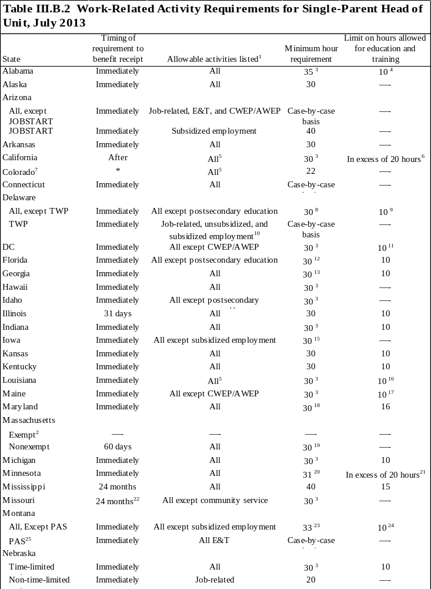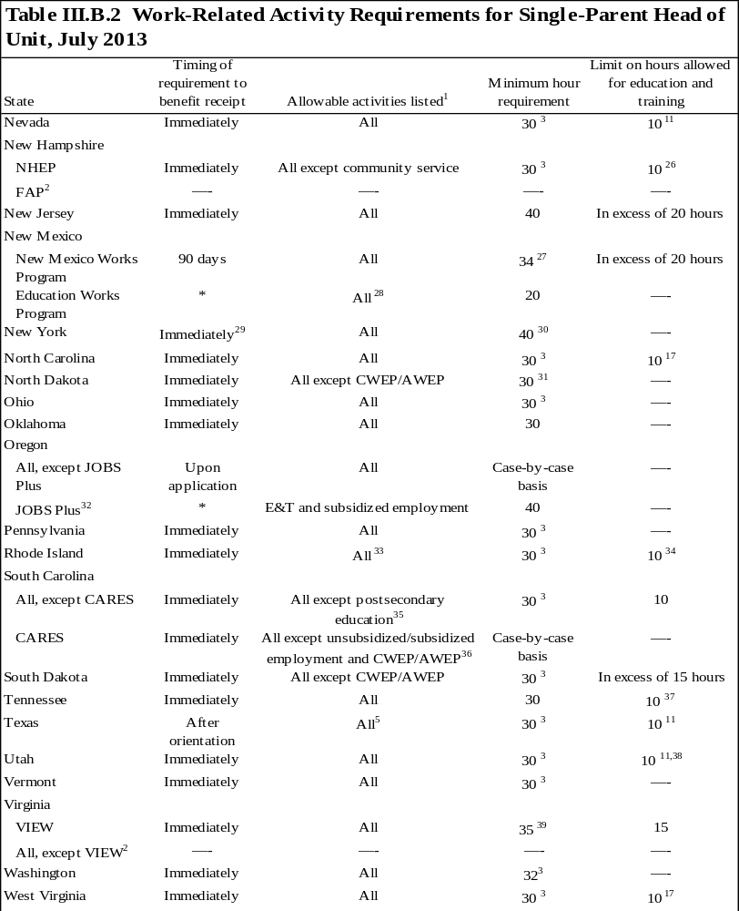

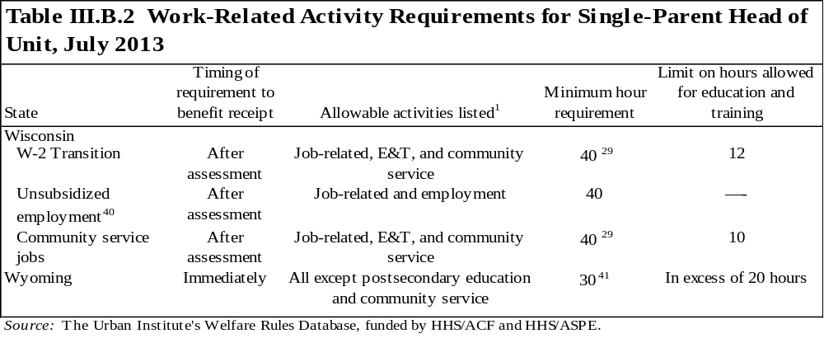
* Data not obtained.
Note: The table contains the activity requirements for single-parent recipients 21 years old or older.

¹ All possible activities include the following: (a) Job-related activities include one or more of the following: job skills training, job readiness activities, job development and placement, and job search; (b) Education and training (E&T) activities include one or more of the following: basic or remedial education, high school/GED, English as a second language, postsecondary education, and on-the-job training; (c) Employment activities include one or more of the following: unsubsidized job, work supplement/subsidized job, CWEP/AWEP, and community service.
² Recipients in this component are not required to participate in work activities. See appendix 1 for a description of components.
³ The hours apply to recipients with children age 6 or older. Recipients with children under 6 years old are required to work 20 hours.
⁴ Generally, recipients are required to participate in either job-related or employment activities for at least 25 hours a week. However, on a case-by-case basis, the caseworker may determine that educational activities are necessary for a recipient to overcome barriers to employment. In these cases, the limit on the number of hours that may be spent in education may be waived.
⁵ Recipients move from one set of activities to another after a set period. Generally, they begin with job-related activities and end with employment; see the WRD for details.
⁶ Nonexempt recipients who are already enrolled in an undergraduate program can participate in education for their entire requirement if it leads to self-supporting employment. Hourly limitations apply to other programs.
⁷ Counties have the option to vary their activity requirements. These policies refer to Denver County.
⁸ The hours apply to recipients who are not attending school or who have children aged 6 or older. Recipients attending school or have children under than 6 years old are required to work 20 hours
⁹ There is no limit on education hours for recipients who applied before January 1, 2000 and who have not yet received 22 months of benefits.
¹⁰ Recipients in the transitional work program must develop an individualized transitional work plan with their case manager and comply with the activities requirements and deadlines established in the plan.
¹¹ These hours apply to recipients with children age 6 or older. Recipients with children under 6 years old must spend all required hours in non-education-related activities.
¹² On-the-job training and work supplementation require a full-time (32- to 40-hour) commitment.
¹³ When the agency determines it possible, the recipient must participate for a minimum of 40 hours a week. Recipients with children under 6 years old are only required to work 20 hours.
¹⁴ Recipients with children under the age of 12 weeks are only required to participate in life skills training.
¹⁵ Participation must be either equivalent to the level of commitment required for full-time employment or deemed significant enough to move the recipient toward full-time employment.
¹⁶ Vocational education may be used to satisfy all 30 hours of the work requirement.
¹⁷ These hours apply to recipients with children age 6 or older. The number of hours that may be spent in education and training is not capped for parents of children under 6 years old.
¹⁸ The state requires recipients to work 40 hours, but recipients caring for a child age 6 or older are not sanctioned if working at least 30 hours. Recipients caring for a child under 6 years old must work at least 20 hours.
¹⁹ This requirement applies to parents whose youngest child is mandatory school age or older. If the youngest child is between age 2 and the mandatory full-time school age, 30 hours a week are required. (Parents with children under 2 years old are placed in the exempt component and do not have work requirements.)
²⁰ The hours apply to recipients with children age 6 or older. Recipients with children under 6 years old are required to work 21 hours.
²¹ Participants who participate in work activities for at least 20 hours a week are encouraged to participate in education and training activities.
²² The requirement is imposed at 24 months or until the state determines the recipient is work ready, whichever is sooner.
²³ The hours apply to recipients with children age 6 or older. Recipients with children under 6 years old are required to work 27 hours.
²⁴ These hours apply to recipients with children age 6 or older. The number of hours that may be spent in education and training is capped at two hours for parents of children under 6 years old.
²⁵ Recipients in this component must be enrolled in E&T activities for at least 12 credit hours per semester or 30 credit hours per year as well as complete 180 hours of work activities per year. See appendix 1 for description of components.
²⁶ Individuals may count vocational and postsecondary education as core activities for 12 months with no limit on the hours per week. After 12 months as a core activity, there is a 10-hour limit.
²⁷ Recipients with children under age 6 may not be required to work more than 24 hours a week.
²⁸ Education Works program activities are focused on education and training; however, with program approval, participants may also take part in any other activity relevant to their education and pursuant to the New Mexico Works Cash Assistance Program.
²⁹ The social services official shall ensure that each parent or caretaker of a dependent child is engaged-in-work as soon as practicable, but no later than 24 months (whether or not consecutive) from initial receipt of assistance.
³⁰ Recipients can be assigned to work activities for up to 40 hours per week, unless otherwise limited.
³¹ The hours apply to recipients with children age 6 or older. Recipients with children under 6 years old are required to work 20 hours. Victims of domestic violence may participate at a reduced level. Qualified aliens with limited English proficiency may also participate at a reduced level for 60 days from date of entry into the United States.
³² Recipients volunteer for the JOBS Plus program. This program provides on-the-job training, while paying benefits as wages from a work-site assignment.
³³ Recipients may be required to begin with intensive employment services if deemed appropriate by the caseworker.
³⁴ Individuals with reading test scores below third grade level or below sixth grade level, if the individual has very limited or no prior work experience, may participate in educational activities with no limit on the number of hours for six months as part of an intensive work readiness program.
³⁵ Postsecondary education is an allowable activity for those who are not considered job-ready.
³⁶ Recipients experiencing disabilities that prevent full-time participation, but who are able to participate in limited work and training activities, may participate in any cash assistance work program activities for which they qualify even though special accommodations may be needed. The participant’s disability must prevent full participation in these cash assistance work activities for 90 days or longer (see appendix 1 for a description of components).
³⁷ This limit does not apply to vocational education or degree programs directly related to employment in current or emerging occupations for the first 12 months.
³⁸ This limit is for basic or remedial education, high school/GED, and English as a second language activities. Postsecondary education and on-the-job training may count for up to 20 hours.
³⁹ These hours refer to recipients not employed full time. Recipients employed full time are required to work 30 hours.
⁴⁰ Recipients participating in unsubsidized jobs receive wages and are ineligible for a cash benefit.
⁴¹ The state stresses that recipients are required to work 40 hours a week, but in cases where the recipient is unable to work the full 40 hours, caseworkers can scale back the number of hours to a minimum of 30 hours a week. For recipients with children under age 6, the minimum is 20 hours a week.
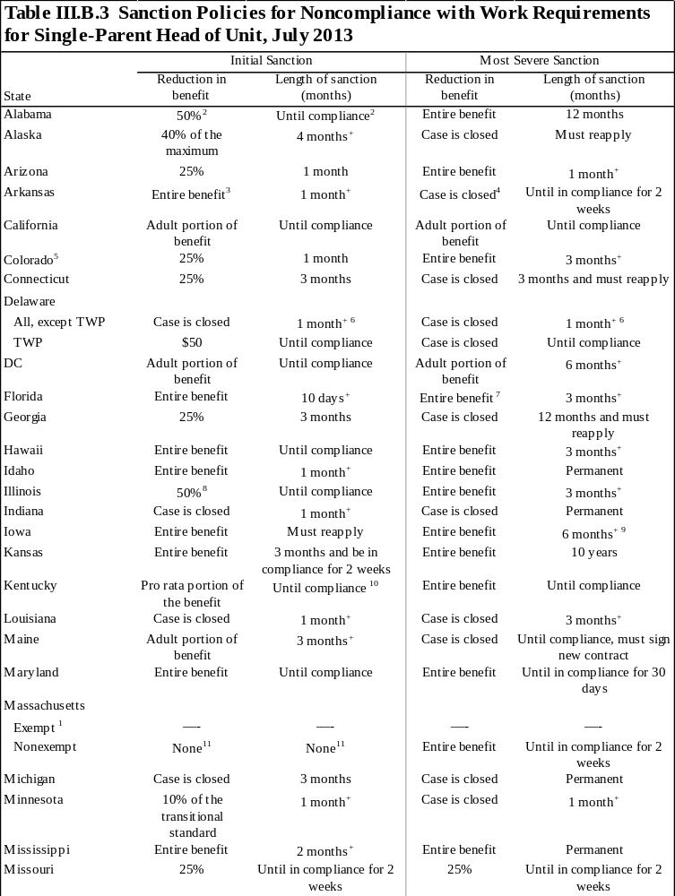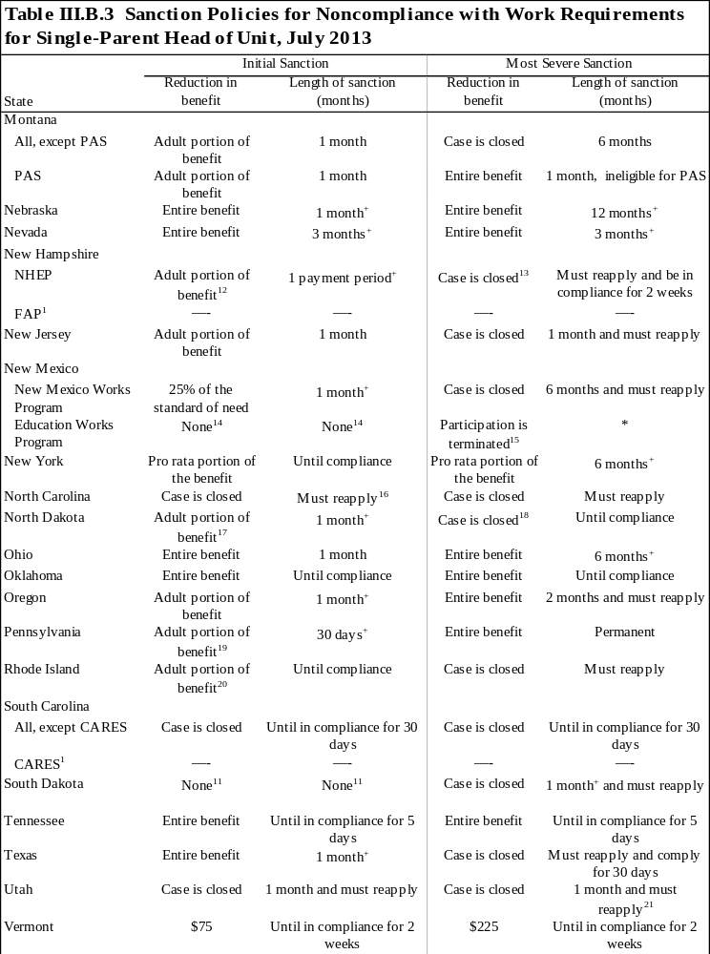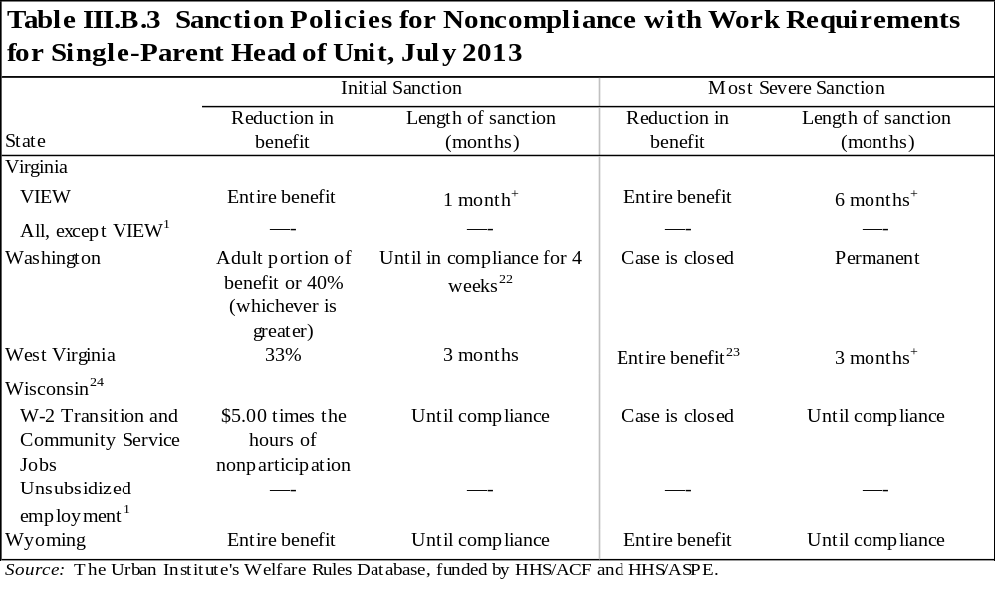
Note: "Adult portion of benefit" describes the portion of the benefit the sanctioned individual would have received. Because the table only represents sanctions for single-parent units, in all cases the sanctioned individual is an adult.

+ The unit is sanctioned for the specified number of months or until the sanctioned individual complies with the activity requirements, whichever is longer.

* Data not obtained.

¹ Recipients in this component are not required to participate in work activities; therefore, they have no sanctions. See appendix 1 for a description of components.
² This sanction applies to noncompliance that occurs during the first 24 months of assistance. For noncompliance that occurs after the first 24 months, the entire unit is ineligible for benefits for 1 month.
³ The benefit is suspended for the month. If the unit complies within 15 days and maintains compliance for two weeks, the suspended benefit is paid to the unit.
⁴ If the case is closed, the unit may reapply for its full benefits, but the application will be pending until the unit has complied with requirements for two weeks.
⁵ Counties have the option to determine the amount and duration of sanctions. These policies refer to Denver County.
⁶ The unit is sanctioned for one month or until the sanctioned individual complies with the activity requirements for four consecutive weeks, whichever is longer.
⁷ Cash assistance may still be provided to the children in the unit who are under age 16; these benefits are issued to a protective payee.
⁸ If noncompliance continues after three months of reduced benefits, the entire unit is ineligible for benefits until compliance.
⁹ The sanctioned parent must also sign a family investment agreement and complete 20 hours of eligible education or work activities to become eligible again. The sanction continues until the parent fully complies.
¹⁰ A caseworker's judgment may be used to determine whether the unit must be in compliance for two weeks before regaining benefits.
¹¹ The initial sanction does not reduce benefits. Recipients are given a written warning detailing the consequences of subsequent failures to comply.
¹² If the adult is compliant within two weeks, only the adult portion of the benefit is removed (this is referred to as the adjusted payment standard). If the adult is compliant within two to four weeks, the adjusted payment standard is reduced by one-third; if the adult is compliant within five to eight weeks, the adjusted payment standard is reduced by two-thirds. In addition, the case may also be closed if the adult is sanctioned for more than three months in any 12-month period (any portion of a month counts as one month).
¹³ If a unit accrues 3 months of sanctions in any 12-month period, the case may be closed. Any portion of a month counts as one full month.
¹⁴ The individual is placed on probationary status for the following school term to improve his/her grade point average (GPA) or meet the educational institution's standards.
¹⁵ The program participant is placed on probation if s/he has not met program requirements. At the end of the probationary period, if standards have not been met or an overall GPA of 2.5 has not been achieved, the department may take action to terminate an individual's participation in the Education Works program.
¹⁶ Individuals who reapply within the first 10 days following the termination month may be eligible for a streamlined application process.
¹⁷ If noncompliance continues for more than one month, the case may be closed. The case can be closed for no longer than 12 months.
¹⁸ If the unit complies within one month of the sanction, the adult portion of the benefit is removed for one month and the case remains open.
¹⁹ The sanction applies for a minimum of 30 days and a maximum of 90 days or until the recipient complies for at least one week. After 90 days of noncompliance, it escalates to a full-family sanction until the recipient complies for at least one week.
²⁰ In a two-person unit, the adult portion is equal to the difference between the benefit a family of three would have received and the benefit the two-person family actually received. For all other family sizes, the adult portion is computed normally, using the difference between the family's current monthly benefit and the monthly benefit for a family size excluding the sanctioned adult.
²¹ The unit must also complete a trial participation period before it is eligible to receive benefits again.
²² The sanction remains in effect until the individual is compliant for four weeks; after four weeks of compliance, benefits are restored to their pre-sanction level. If, after four months, the individual is still in sanction, the case is closed. If the case is reopened, sanctions will continue where they left off when the case closed.
²³ If a nonexempt member of the unit does not comply with work requirements after receiving assistance for 24 months, the case is closed.
²⁴ Wisconsin has three components (see appendix 1 for description of components). If a recipient refuses to participate in an activity, s/he is permanently ineligible for benefits in that component. The unit may receive benefits again if s/he becomes eligible for one of the other components. There is no permanent sanction for individuals in unsubsidized employment.
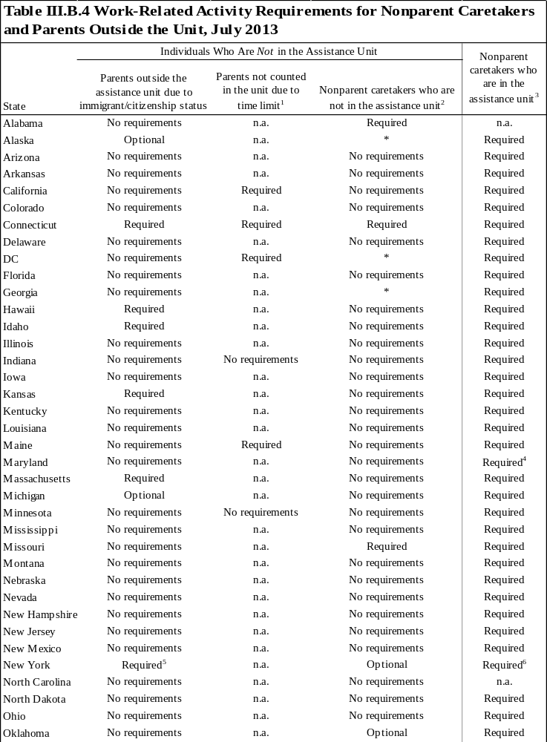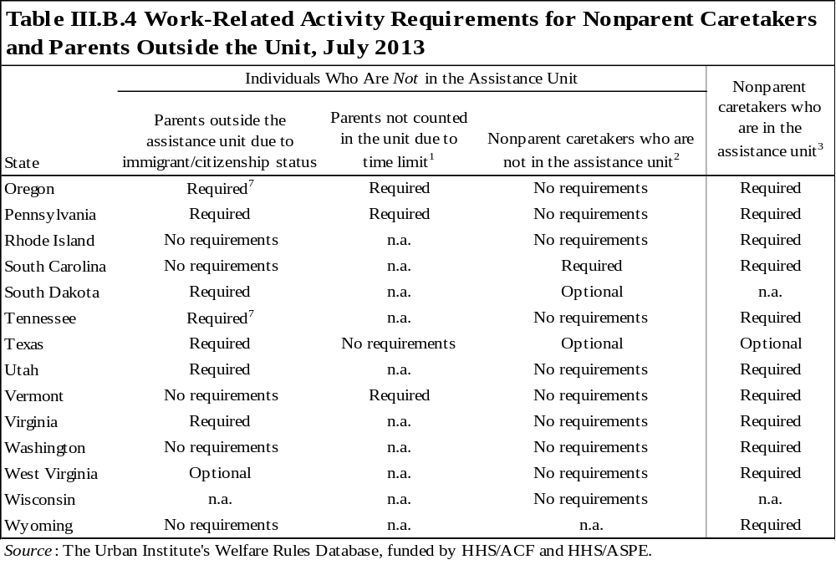
* Data not obtained.

¹ This column is only relevant in those states that, under some circumstances, exclude a parent from an assistance unit after a time limit is reached but continue to pay benefits to the children.
² This column refers to those nonparent caretakers who are either prohibited from being included due to their status as a nonparent or because their nonparent status gives them an option of choosing to not be a part of the unit.
³ An n.a. in this column means the state never allows nonparent caretakers to be a part of the assistance unit.
⁴ Nonparent caretakers are only required to participate if they have children of their own in the unit
⁵ A nonexempt parent residing in the same household as a child receiving assistance and who is receiving nonfederal assistance may be required to participate in work activities up to 40 hours per week, unless otherwise limited.
⁶ A nonexempt individual receiving assistance may be required to participate in work activities up to 40 hours per week, unless otherwise limited.
⁷ Ineligible noncitizen parents are only required to participate if they are legally allowed to work in the United States.

Ongoing Eligibility
The tables in this chapter of the Databook describe key aspects of the rules that affect recipients’ ongoing eligibility as of July 2013. After a family applies for assistance and passes all eligibility tests, its members become recipients and a benefit is calculated. However, the recipient unit still faces eligibility requirements that affect its ability to continue receiving benefits. Most states impose income and asset tests on recipients, which generally differ from the initial eligibility tests for applicants. When the requirements differ, states typically allow recipients more generous eligibility thresholds.
Recipients’ reproductive choices and the number of months they have received assistance may also affect eligibility and benefits. Some states impose family cap policies on recipients, which restrict benefits from increasing when a child is born to a family receiving assistance. Most states now impose time limits, which reduce or eliminate benefits to recipients based on their accumulated total months of benefit receipt.
The following three sections describe the eligibility requirements that affect the ongoing eligibility of recipients.

A. What eligibility tests must recipient families pass for continuing eligibility?
Like applicants, recipients must pass both nonfinancial and financial tests to remain eligible for assistance each month. The nonfinancial rules generally do not vary for applicants and recipients; however, for some rules, such as two-parent eligibility, they may. Unlike nonfinancial rules, the financial rules often differ for applicants and recipients. The following provides more information on those eligibility rules that tend to differ for applicants and recipients, including two-parent hours tests, treatment of child support income, asset tests, income eligibility tests, earned income disregards, and maximum income for ongoing eligibility.
Two-parent eligibility for recipients: For states providing benefits to two-parent families, table IV.A.1 describes special eligibility rules imposed on two-parent recipients where neither parent is disabled (UP or unemployed-parent families, in the former AFDC program). In addition to the standard eligibility tests that all recipient units must pass, some states impose “hours tests” on two-parent units. Under an hours test, the unit is not eligible if the principal wage earner is working more than a specified number of hours a month. States may apply this rule when determining the initial or continuing eligibility of two-parent families. In 2013, four states had hours tests.
Related tables: See table I.B.2 for details on the hours test for applicants and table L2 for information on the rules for two-parent units from 1996 through 2013.
Treatment of child support income: Table IV.A.2 describes each state’s treatment of child support income for recipients. TANF recipients are required to assign their child support income to the state. The state then decides what portion, if any, of the child support collected is returned to the family as unearned income and how much of that income counts as income for eligibility and benefit computation. The amount of income transferred and disregarded may differ for eligibility calculations and benefit computation.
The first column of the table displays the amount of collected child support that is counted for recipients’ eligibility determination. Typically, states count all child support collected or all but $50 of the amount when considering eligibility, even if the state does not transfer any support directly to the family. Those states that do not count child support for eligibility typically establish some method to ensure that families with high and continuing child support amounts do not remain on the rolls indefinitely.
The second column of the table shows what portion of the collected child support is transferred to the family as unearned income, while the third column indicates how much of that transferred amount is disregarded for benefit computation. The traditional $50 pass-through that states allowed under AFDC would be represented in this table with a “$50” coded in both the second and third columns; $50 is transferred to the unit as unearned income, and, of that amount, all $50 is disregarded for benefit computation.
Asset limits for recipients: Table IV.A.3 describes each state’s asset tests for recipients. States determine the maximum amount of assets—including vehicles and restricted assets—a family may hold and still remain eligible for benefits.
The first column of the table provides the limit on the value of unrestricted assets a family may hold and still be eligible for assistance. Unrestricted assets include the cash value of any asset the state counts toward the limit, regardless of the asset’s purpose. Limits may vary for determining initial eligibility versus continuing eligibility.
The second column describes whether some or all of the value of a vehicle or vehicles is excluded in determining the amount of a family’s assets for eligibility purposes. When a portion of the vehicle’s value is exempted, the value may be given in terms of equity or fair-market value. The fair-market value is the amount for which the vehicle could be sold, while the equity value is the fair-market value minus any amount still owed on the vehicle. When a family still owes money on a vehicle, the equity value will be less than the fair-market value, so this distinction is important when comparing vehicle exemption amounts across states.
The last three columns of the table describe whether the state excludes a portion of assets deposited into savings accounts when earmarked for specific purposes and whether the state (or other entity) deposits additional matching funds into these accounts. For instance, a unit may be allowed to save money toward educational expenses or the purchase of a home without that money counting toward its overall asset limit. Some, but not all, restricted accounts are federally defined individual development accounts (IDAs). In the table, accounts that states specify as IDAs are distinguished from other restricted accounts.
Restricted accounts may or may not include a match, under which a third party, generally the state, contributes additional funds to the amount the family has saved. The match rate is typically defined by the state.
Related tables: See tables L8 and L9 for information on asset rules in effect from 1996 through 2013. See table I.C.1 for the asset tests applied at application.
Income eligibility tests for recipients: Table IV.A.4 describes states’ rules for the income eligibility tests that determine whether a recipient (whose income may have increased since initial eligibility) is eligible to continue receiving benefits. The table indicates which state income standard is used for each test. Even if a family passes all eligibility tests, it is possible in some states that the family will not qualify for a positive benefit under the state’s benefit computation formula. In those cases, the family will not receive a benefit. In some cases, states have streamlined their eligibility policies and do not perform any income tests other than the implicit test imposed by benefit computation. In these states, the table indicates “no explicit tests.” To determine the value of the particular standard for a family size of three, see table I.E.3.
Related tables: As mentioned above, table I.E.3 provides the eligibility standard(s) used to determine eligibility for a three-person family. Tables I.D.1, I.D.2, and IV.A.2 describe policies concerning the deeming of income from grandparents and stepparents, and child support income that may be used in determining gross income for income eligibility tests. Table I.E.2 describes the earned income disregards that may be used for net income tests.
In addition, the tables in sections I.B, I.D, I.E, and II are relevant to ongoing eligibility. In most states, recipients are required to pass both nonfinancial and financial tests to continue receiving benefits.
Earned income disregards for ongoing eligibility: Table IV.A.5 is a new addition to the Databook for 2013, and describes the earned income disregards when the amount of income disregarded for recipients differs from applicants. Some states consider units who have received assistance in one of the previous four months as recipients for the purpose of earned income disregards, even if they have gone off assistance and are reapplying for benefits.
Related tables: Table I.E.2 contains the earned income disregards that apply to new TANF applicants.
Maximum income for ongoing eligibility for a family of three: Table IV.A.6 (previously IV.A.5) synthesizes the various financial rules related to ongoing eligibility to provide information on the maximum amount of income a family of three can earn and still remain eligible for assistance in various months (2, 7, 13, and 25) of combining work and welfare. The maximum income for ongoing eligibility calculation incorporates information on the income eligibility rules for recipients, earned income disregards for ongoing eligibility and benefit computation, benefit computation policies, and the eligibility and payment standards. The calculation determines the maximum amount of earnings a recipient can have and still be technically eligible for assistance in each state. Technical eligibility does not mean the unit will necessarily receive a cash benefit—most states only distribute a cash benefit if it is over $10—but it will have passed all eligibility tests and be eligible for some positive amount.
The calculation assumes the assistance unit includes one parent and two children, has only earned income, has no child care expenses, contains no children subject to a family cap, has no special needs, pays for all shelter costs with no subsidies, and is subject to the benefit standard that applies to the majority of the state’s caseload.
Related tables: Table I.E.4 provides information on the amount of earnings an applicant may have and become eligible for assistance. Table L3 provides this information for 1996 through 2013.

B. Are children eligible if born while the family receives benefits?
Benefits to recipients who give birth to a child while receiving aid may or may not be affected by the addition of the child to the assistance unit. Traditionally, when a child is born to a member of an assistance unit, the benefit increases to meet the needs of the new child; however, many states have changed this policy. Family cap policies, as most states refer to them, prevent or limit an increase in a family’s benefit when another child is born. In these states, the benefit increase an assistance unit would otherwise receive for adding another member to the unit will be limited. Some states provide a percentage of the increase to the unit, while others provide no additional funds to the unit for the addition of a child.
Family caps: Table IV.B.1 describes states’ family cap policies. The table first indicates whether the state imposes a family cap, then provides the number of months following the case opening after which a newborn child is excluded from the assistance unit. The table also describes the impact on the benefit when an additional child is born (whether there is no increase in benefit or some increase smaller than what would occur in the absence of a family cap). In some cases, the amount of cash paid directly to the family does not increase, but the increment that would have been paid in the absence of the policy is instead paid to a third party or provided in the form of a voucher. That information is noted in the table as “voucher” and is explained further in the footnotes. States with “disregard” displayed in the table increase the earned income disregards for families that have a capped child; again, more details are provided in the footnotes. The table also indicates how long a cap, once applied, endures. The table indicates “always capped” if a family is never able to regain benefits for a capped child, even after the case has been closed for a period. Otherwise, the table provides the number of months a family must remain off the rolls for the cap to be removed—that is, for the child to be included in the benefit computation should the family apply for assistance again. States conducting pilot projects that subject units to a family cap in a few counties, but not statewide, are footnoted.
Related tables: Table L10 indicates the presence of family cap policies in 1996 through 2013.

C. How long can a family receive benefits?
Since the passage of PRWORA, most states have limited the number of months an assistance unit that includes adults may receive benefits. (Child-only units are not subject to time limits.) The type and length of these limits vary from state to state. States impose two basic types of limits on recipients: lifetime time limits, which eliminate part of or the entire benefit permanently, and other state time limits, which interrupt or reduce benefits for a certain period but do not eliminate them permanently. Both types may terminate benefits to the entire unit or just the adults in the unit. In addition, some states impose only lifetime limits or only other state time limits, while some states impose a combination of the two types.
Not all assistance units are subject to time limits, however. States may continue to provide benefits to up to 20 percent of their caseload (referred to as the hardship exemption) beyond the federal 60-month time limit. The individuals receiving these exemptions (which stop the time limit clock for a month) or extensions (which add a month of assistance after reaching the time limit) are determined state by state and are eligible to receive federal TANF funds as long as the circumstances that caused their exemption or extension exist. Additionally, some states elect to use non-federal funding to provide benefits to units that have reached the federal limit.
Lifetime time limit: Under TANF, the federal government imposed a maximum 60-month lifetime limit on receipt of TANF funds by adults. Therefore, after 60 months of receiving federally funded TANF benefits, either consecutively or nonconsecutively, an assistance unit with adults is generally no longer eligible for federal cash assistance. Some states have adopted shorter lifetime limits, while others have chosen to fund recipients after the 60 months with state dollars. A few states have also chosen to terminate benefits only for the adults in the unit, in which case all children in the assistance unit remain eligible for benefits after the lifetime limit expires, as a child-only unit.
Table IV.C.1 describes states’ lifetime time limit policies. The first column indicates the total months in which the state allows benefits, while the second and third columns identify whose benefits are terminated.
Other state time limits: States have developed several other time limits that interrupt or limit benefits. These limits are imposed instead of or in addition to the lifetime time limits and include periodic limits and benefit waiting periods. Under a periodic limit, a unit (or the head of the unit) may receive benefits for only a specified number of months in a given period. For example, a state may impose a 12-out-of-24-month periodic limit on the unit, in which the unit is eligible to receive only 12 months of benefits in any 24-month period. Under a benefit waiting period, a unit (or the head of the unit) is ineligible for benefits for a specified number of months after the unit has received benefits for another specified number of months. To use the 12 and 24 example again, a unit may receive 12 months of assistance and is then ineligible for 24 months. This means the unit may receive 12 months of benefits over any period, but after it receives its 12th month of assistance, it will be ineligible for benefits for the next 24 months. Both the periodic limit and the benefit waiting period limit may apply to the entire unit or just the adult head of the unit.
Table IV.C.2 describes other state time limit policies. The first column describes the type of other time limit imposed, while the second and third columns identify whose benefits are terminated.
Exemptions and extensions: Exemption and extension policies are important for understanding time limits in the states. Exemptions and extensions could significantly increase the number of months beyond the state and/or federal time limit that an assistance unit may receive benefits, and, depending on the criteria, a substantial portion of the caseload could be exempted or extended. As used in the tables and WRD, exemptions are defined as policies that stop a recipient’s time-limit “clock” before it reaches the 60-month limit and contrast with extensions, which only occur after the unit has reached its time limit.
Tables IV.C.3 and IV.C.4 describe time limit exemption and extension policies, respectively. The exemption and extension policies for both lifetime limits and other limits are displayed in the tables. If the policies do not apply to both types of limits, the policies for the lifetime limit are displayed in the tables and the policies for the other limit are footnoted.

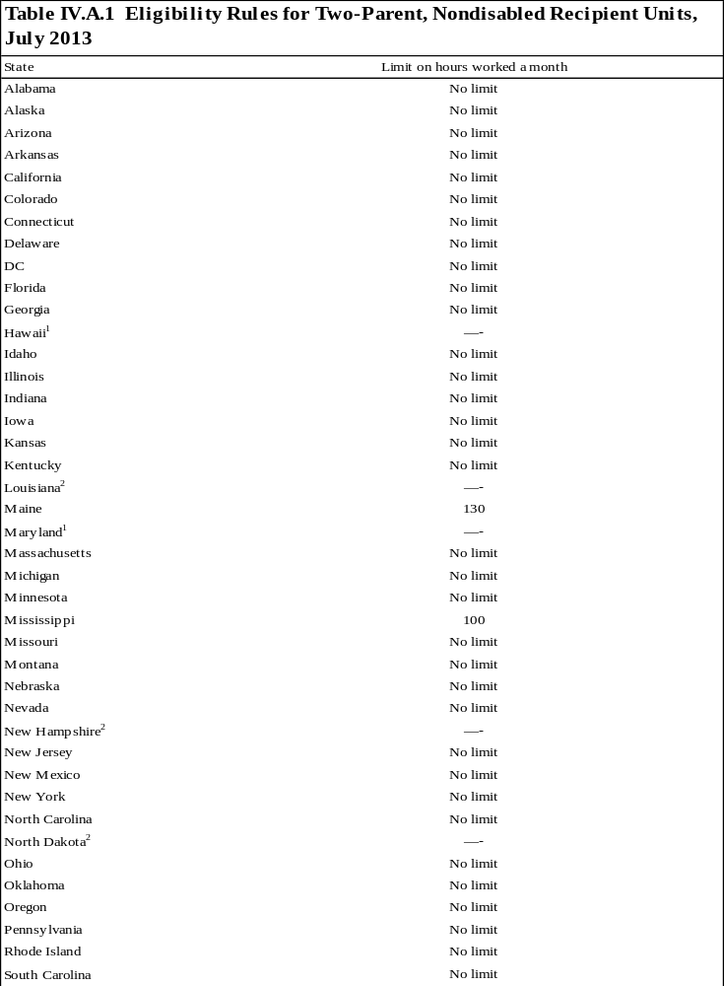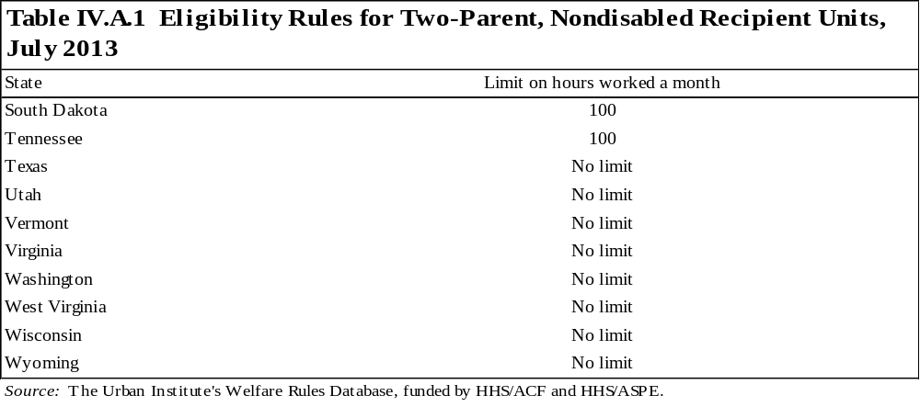
Note: In some states, benefits are provided to two-parent units under a state-funded program instead of through federal TANF. The table describes the treatment of two-parent units, regardless of the funding source.

¹All two-parent families are funded through a state program with the same eligibility rules as the state's TANF program; however, no two-parent families are eligible for TANF funding.
² The state does not provide benefits to two-parent, nondisabled units.
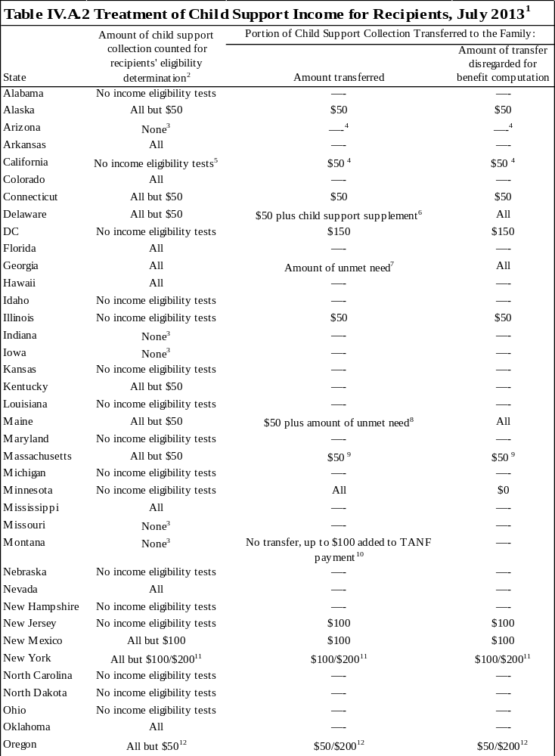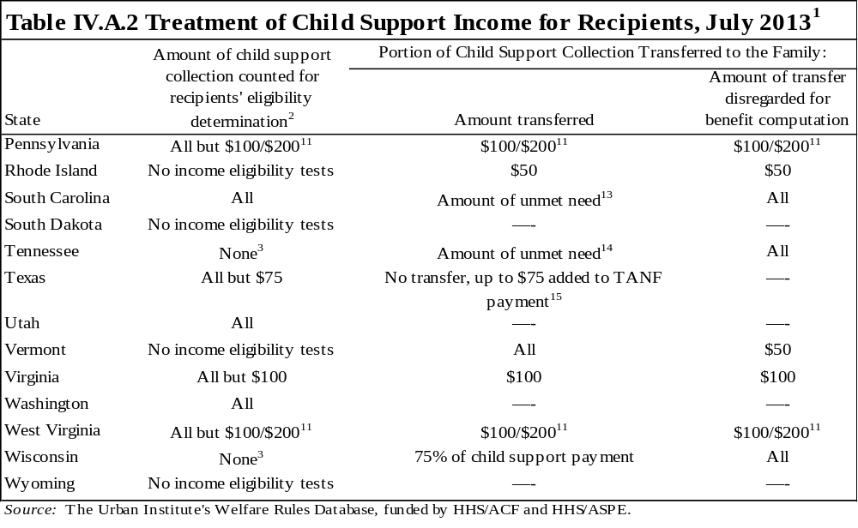
¹ This table describes the treatment of child support collected by the state on behalf of a TANF recipient; it does not cover the treatment of child support received by the family directly from the absent parent. Child support collections may be counted as income for eligibility purposes regardless of whether they are transferred to the family; however, child support retained by the state is never counted for purposes of benefit computation. Although many states have created unique child support policies, some states still provide families with the traditional $50 pass-through used under AFDC. The traditional pass-through is represented in this table with "All but $50" in the first column, and "$50" in the second and third columns. Also, this table does not cover the transfer of child support payments in excess of current or total TANF benefits.
² Some states with values displayed in this column do not have income eligibility tests for recipients, according to table IV.A.4. In table IV.A.4, we do not display net income tests if the calculation of the test and the disregards allowed for the test do not differ from those used to calculate the benefit. However, for families with child support income, the net income eligibility test may differ from the benefit computation. For purposes of calculating eligibility when the family receives child support income, the net income test for recipients is equivalent to the benefit calculation in the state (see tables II.A.1, II.A.2, and II.A.3).
³ States that do not count any child support collections for calculating recipients' eligibility generally use other methods to ensure that families with high and continuing child support amounts do not remain on the rolls indefinitely.
⁴ Any child support collected on behalf of a child subject to a family cap is transferred to the family and treated as exempt income.
⁵ Child support income is not treated as income for initial eligibility grant calculation, but child support income is included in the net nonexempt income calculation for determining ongoing recipient financial eligibility even when the support is redirected to the local child support agency.
⁶ In addition to the $50 pass-through payment, Delaware provides a supplemental child support payment. This payment is calculated by subtracting a recipient's current disposable income from his or her disposable income as it would have been calculated in 1975.
⁷ The amount of child support collected or the amount of unmet need, whichever is smaller, is transferred to the family as unearned income and disregarded for benefit determination. The unmet need, also called the gap payment, is calculated as the standard of need for the unit's family size minus the family maximum for the unit's family size minus the unit's net income. For units affected by the family cap, the amount of unmet need is calculated using the standard of need for the family size that includes the capped child, but using the family maximum that excludes the capped child.
⁸ In addition to the $50 pass-through, the amount of unmet need, also known as the gap payment, is transferred to the family as unearned income and disregarded for benefit determination. The unmet need is calculated as (the standard of need for the unit's family size) minus (the maximum benefit for the unit's family size) minus (the unit's net income). After the pass-through, the state transfers child support in the amount of the unmet need for the family, up to the amount of child support collected.
⁹ All child support collected on behalf of a child subject to the family cap is transferred to the family. For children subject to the family cap, the first $90 of unearned income, including child support, is disregarded for eligibility and benefit computation; the rest is counted.
¹⁰ Montana adds any child support collected up to $100 to the TANF payment. This money is considered an addition to the TANF payment, not a pass-through of child support income, and is disregarded for eligibility purposes.
¹¹ The total pass-through amount is up to $100 if there is one child in the family and up to $200 if there is more than one child in the family.
¹² The total pass-through amount is $50 per child up to $200.
¹³ The gap payment equals 63.7 percent of the smaller of (retained child support for the month) or (the maximum amount that would not make the family ineligible for TANF if counted as income). The state defines "retained child support" as the amount equal to the smaller of the current month's collection, the basic TANF award for the month, or the current monthly obligation excluding arrears.
¹⁴ The amount of child support collected or the amount of unmet need, whichever is smaller, is transferred to the family as unearned income and disregarded for benefit determination. In Tennessee, the unmet need, also known as the gap payment, is calculated as the consolidated need standard for the unit's family size minus the unit's TANF grant minus the unit's net income.
¹⁵ The state will add to the TANF payment the smaller of the court-ordered payment amount, the amount the Office of the Attorney General received during that month, or $75. This money is considered an addition to the TANF benefit, not a pass-through of child support income, and is disregarded for eligibility purposes.
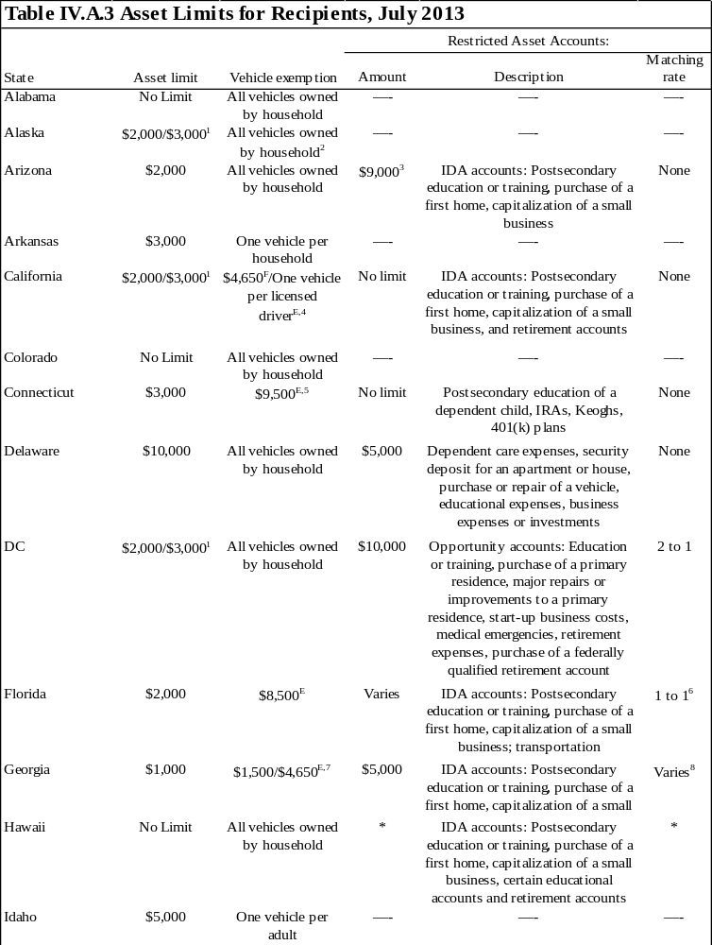

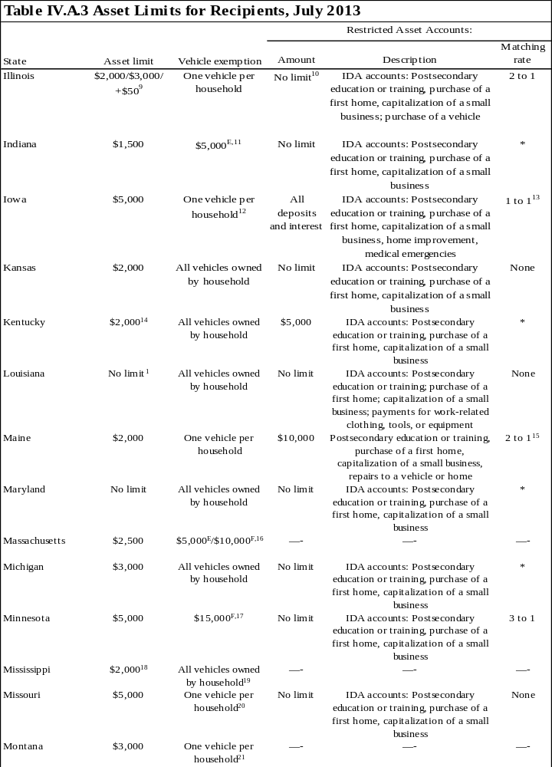
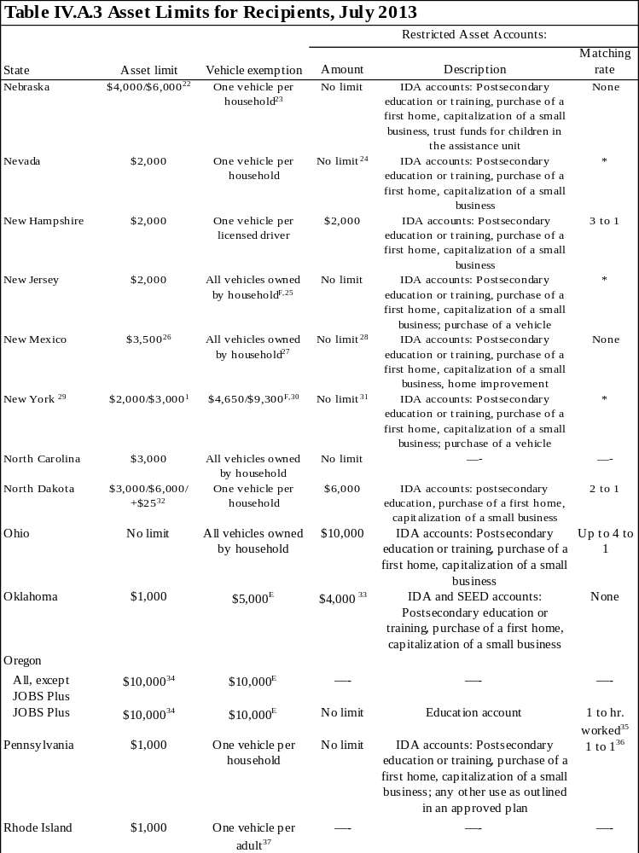

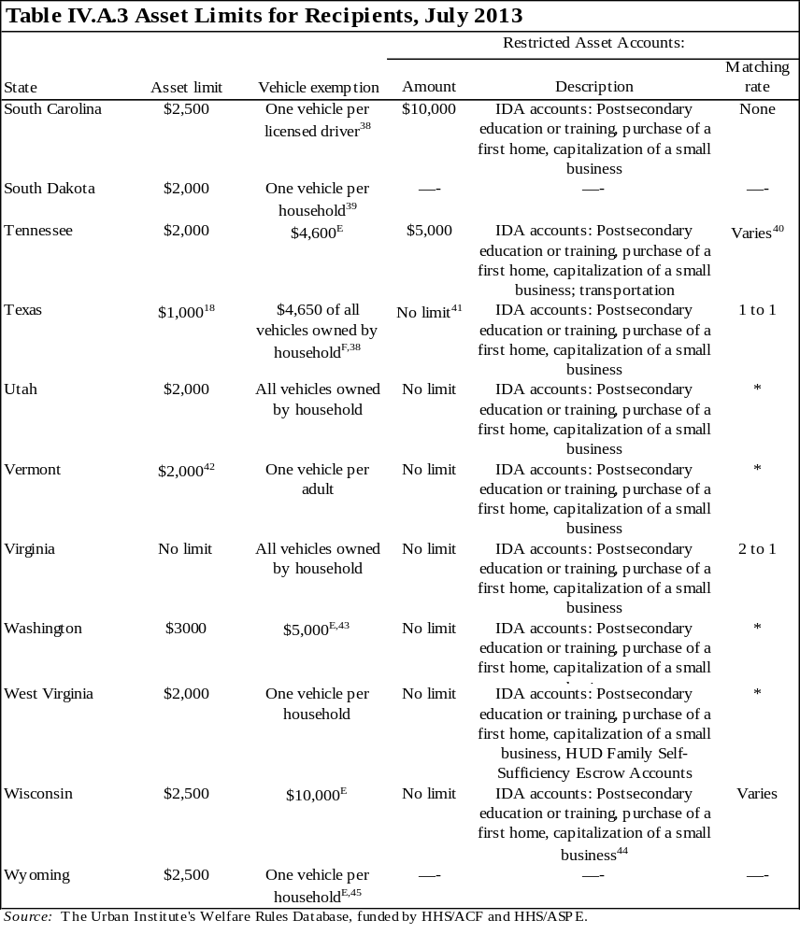
Note: IDA = individual development account.

^{E} Equity value of the vehicle.
^{F} Fair-market value of the vehicle.

* Data not obtained.

¹ Units including an elderly person may exempt $3,000; all other units exempt $2,000.
² Vehicles are exempt if used for one of the following: (1) to meet the family's basic needs, such as getting food and medical care or other essentials; (2) to go to and from work, school, training, or work activity (such as job search or community service); (3) as the family's house; (4) to produce self-employment income; or (5) to transport a disabled family member, whether or not s/he is a part of the assistance unit. If the vehicle does not meet one of these requirements, the equity value of the vehicle is counted in the determination of resources.
³ In addition, 50 percent of earned income that is deposited into an IDA is disregarded for eligibility and benefit computation. The monthly value of the disregard cannot exceed $100.
⁴ Each vehicle must be evaluated for both its equity and fair-market values; the higher of the two values counts against the family's asset limit. Before this calculation, all the following vehicles are completely excluded: (1) vehicles necessary for long-distance travel that is essential for employment; (2) vehicles necessary to transport a physically disabled household member; (3) vehicles that would be exempt under previously stated exemptions, but the vehicle is not in use because of temporary unemployment; (4) vehicles used to carry fuel or water to the home and is the primary method of obtaining fuel or water; and (5) vehicles for which the equity value of the vehicle is $1,501 or less. To determine the countable fair-market value of each remaining vehicle, exclude $4,650 from the vehicle's fair-market value. To determine the countable equity value of each remaining vehicle, exclude one additional vehicle per adult and one additional vehicle per licensed child who uses the vehicle to travel to school, employment, or job search. The full equity value of each remaining vehicle is counted. For each vehicle not completely excluded, the higher of the fair-market value or the equity value counts against the family's asset limit.
⁵ The unit may exempt $9,500 of the equity value of a vehicle or the entire value of one vehicle used to transport a handicapped person.
⁶ The match rate is determined case by case and cannot exceed $1,500 a year.
⁷ If the vehicle is used for job search, to travel to work, or for education and training, the unit may exclude $4,650 of the value. If the vehicle is not used for these purposes, $1,500 of the equity value may be excluded. If the vehicle is used more than 50 percent of the time to produce income or as a dwelling, it is totally excluded.
⁸ Funds in an IDA may also be matched on behalf of the individual by a qualified entity, which may be defined as one of the following: a specific not-for-profit organization, or Georgian state or local government acting in cooperation with a not-for-profit organization.
⁹ The asset limit is based on unit size: one person receives $2,000, two people receive $3,000, and three or more receive another $50 for each additional person.
¹⁰ Deposits must come from earned income, and all deposits must be matched by state or local government, or through contributions made by a nonprofit entity. All withdrawals from the IDA account must be in the form of vendor payments made on behalf of the client for one or more of the intended purposes of the IDA.
¹¹ The $5,000 limit can only be applied to one vehicle.
¹² Additionally, $5,874 of the equity value of a vehicle is exempt for each adult and working teenager whose resources must be considered in determining eligibility.
¹³ The state matches $0.50 for every dollar of a recipient's assets; federal funds match another $0.50.
¹⁴ Only liquid resources are considered for eligibility determinations. Liquid resources include cash, checking and savings accounts, CDs, stocks and bonds, and money market accounts.
¹⁵ Community agencies will contribute matching funds up to $2,000 a year.
¹⁶ The state compares the value of the vehicle with two standards: $10,000 of the fair-market value and $5,000 of the equity value. If the value of the vehicle exceeds either limit, the excess counts toward the asset limit; however, if the value of the vehicle exceeds both limits, only the excess of the greater amount counts toward the asset limit.
¹⁷ The amount is the loan value of the vehicle with the highest loan value, which has not already been totally excluded under the following provisions: (1) exclude all motor vehicles essential to operating a self-employment business; (2) exclude any vehicle used as the unit's home; (3) exclude one vehicle per physically disabled person needed to transport the disabled unit member; (4) exclude the value of special equipment added to a vehicle for a handicapped member of the assistance unit; (5) exclude any vehicle used for certain long-distance traveling for the employment of a unit member; and (6) exclude any vehicle if at least 50 percent of its use is to produce income. $7,500 of the loan value of additional vehicles is also exempt. Minnesota uses the loan value of the vehicle as listed in the current NADA Used Car Guide, Midwest edition instead of the fair-market value. The loan value is generally slightly less than the estimated fair-market value.
¹⁸ When a TANF recipient marries while receiving assistance, the liquid resources of the new spouse are excluded for six months beginning the month after the date of the marriage.
¹⁹ Recreational vehicles are not exempt. Additionally, industrial vehicles, such as heavy haulers and pulpwood trucks, are exempt as long as they are used for income-producing purposes over 50 percent of the time, or as long as they annually produce income consistent with their fair-market value. Determination of whether to count a vehicle is made case by case.
²⁰ $1,500 of the equity value of the unit's second vehicle is exempt.
²¹All vehicles whose primary use is to produce income or that are used as a home are also exempt.
²² The asset limit is based on unit size: one person receives $4,000, two or more people receive $6,000.
²³ The entire vehicle is exempt only if used for employment, training, or medical transportation. If a unit has more than one vehicle that meets the exemption criteria, only the vehicle with the greatest equity value will be exempt.
²⁴ Individuals can only deposit earned income into the IDA; the amount of earned income will be considered an earned income disregard in determining eligibility and benefit amounts.
²⁵ Recreational vehicles are not exempt.
²⁶ The total limit is $3,500, but only $1,500 can be in liquid resources and $2,000 can be in nonliquid resources. Liquid resources include the (convertible) cash value of life insurance policies, cash, stocks, bonds, negotiable notes, purchase contracts, and other similar assets. Nonliquid resources include nonexempt vehicles, equipment, tools, livestock (with the exception of nonsalable domestic pets), one-time sale asset conversion, and lump-sum payments.
²⁷ The entire vehicle is exempt only if used for transportation to work, work activities, or daily living requirements. If the vehicle is not used for these purposes, the entire equity value of the vehicle is subject to the asset test.
²⁸ The state does not limit the amount of money a unit may save for postsecondary education or business capitalization, but the unit may only save $1,500 toward the purchase of a new home.
²⁹ Information shown in the table corresponds to cases not in the Child Assistance Program (CAP). CAP cases have no limit on the amount of countable assets that can be held with no restrictions.
³⁰ If the vehicle is needed to seek or retain employment, $9,300 of the vehicle is exempt. Otherwise, $4,650 of the full fair-market value is exempt.
³¹ In addition to the IDA account, recipients may exempt up to $4,650 for the purchase of a first or replacement vehicle that will be used to seek, obtain, or maintain employment. The funds must be kept in a separate bank account from the IDA savings.
³² The asset limit is based on unit size: one person receives $3,000, two people receive $6,000, and another $25 is allowed for each additional person thereafter.
³³Although the asset limit is $4,000, the unit may only save $2,000 in an IDA and $2,000 in the Savings for Education, Entrepreneurship, and Down (SEED) payment accounts, which are savings accounts for individuals age 13 through 18 and are dedicated for purposes such as postsecondary education or training expenses, purchase of a first home, or capitalization of a small business.
³⁴ The limit is reduced to $2,500 if the recipient does not cooperate with his/her case plan.
³⁵ The participant's employer contributes one dollar for every hour the participant works.
³⁶ The Pennsylvania Department of Community and Economic Development will contribute matching funds up to $1,000 a year. NonIDA postsecondary education savings accounts are not subject to a match rate.
³⁷ Exemptions for adult drivers cannot exceed two vehicles per household. Additionally, the entire value of a vehicle used primarily to provide transportation for a disabled family member is exempt.
³⁸ All licensed vehicles used for income-producing purposes or for transporting a disabled household member are exempt.
³⁹ In addition to one primary vehicle, an assistance unit may totally exclude a vehicle used to transport water or fuel to the home when it is not piped in or to transport a disabled member or SSI recipient in the household. The unit may also exclude $4,650 of the fair-market value of a vehicle used to transport members of the unit for education or employment.
⁴⁰ Local banks, churches, or IDA nonprofit sponsors will contribute matching funds from rates of 1 to 1, up to 9 to 1.
⁴¹ Only deposits from earnings or EITCs are disregarded. Any withdrawals from an IDA account made for non-allowable purposes are counted as resources.
⁴² In addition to the $2,000 asset limit, assets accumulated from earnings, interest earned on those assets, and nonliquid assets purchased with savings from earnings and other excluded income or resources are excluded as resources.
⁴³ The entire equity value of a vehicle used to transport a disabled household member is also exempt.
⁴⁴ The information in the table refers to the Wisconsin Community Action Program IDA program. There are two other IDA programs in Wisconsin for which data on limits, uses, and matching are unavailable.
⁴⁵ This exemption applies to a single-parent unit. Two vehicles are exempt for a married couple.

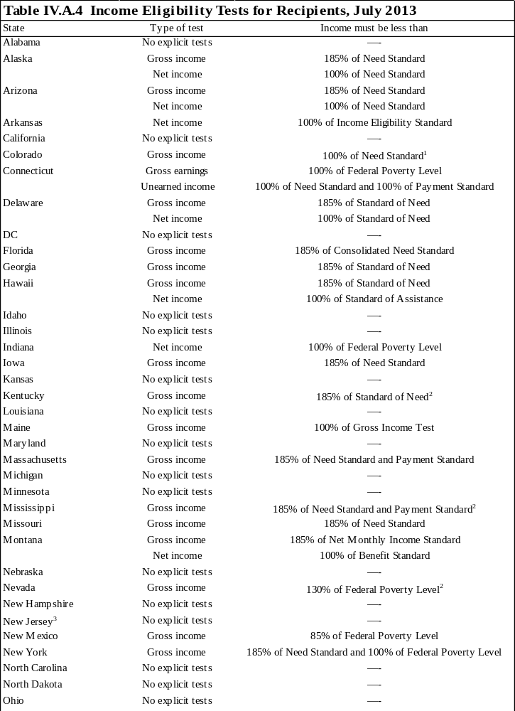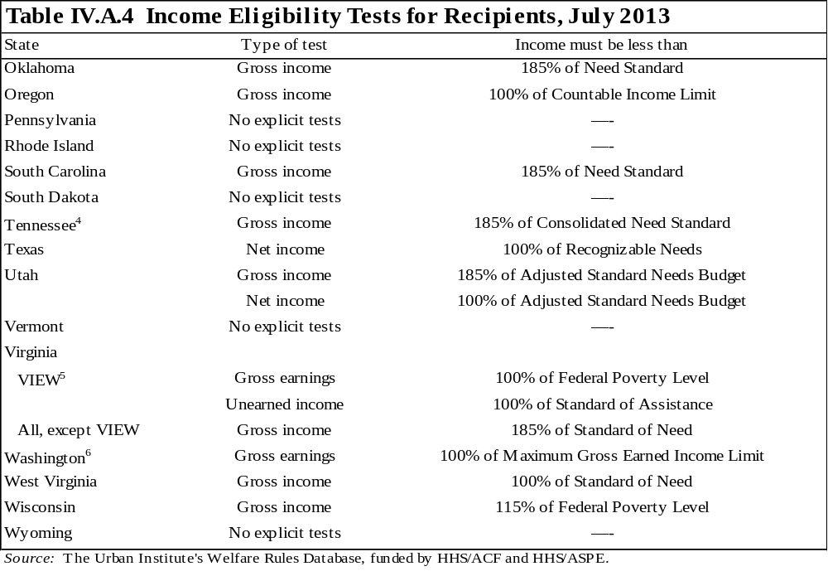
Notes: "No explicit tests" indicates either that the state imposes no income tests on recipients or that the state imposes an income test but the calculation of the test and disregards allowed for it do not differ from those used to calculate the benefit.

See table II.A.2 for information on benefit computation policies.
See table I.E.3 for information on eligibility standards.

¹ The gross income test does not apply to earnings for recipients who are receiving the 67 percent benefit computation disregard.
² The gross income test does not apply to earnings for recipients who are receiving the 100 percent benefit computation disregard.
³ In households where the natural or adoptive parent is married to a nonneedy stepparent, the gross household income may not exceed 150 percent of the federal poverty level.
⁴ When a caretaker marries while receiving assistance, the unit may choose to exclude the new spouse from the unit for three months. During this time, the spouse's income is not considered in determining the unit's eligibility. After the three-month period, the new spouse must be included in the unit, and his/her income and resources must be considered in determining eligibility.
⁵ For two-parent units to be eligible, their gross earned income must be below 150 percent of the federal poverty level and their unearned income must be below 100 percent of the standard of assistance.
⁶ Child-only units are eligible up to 300 percent of the federal poverty level.
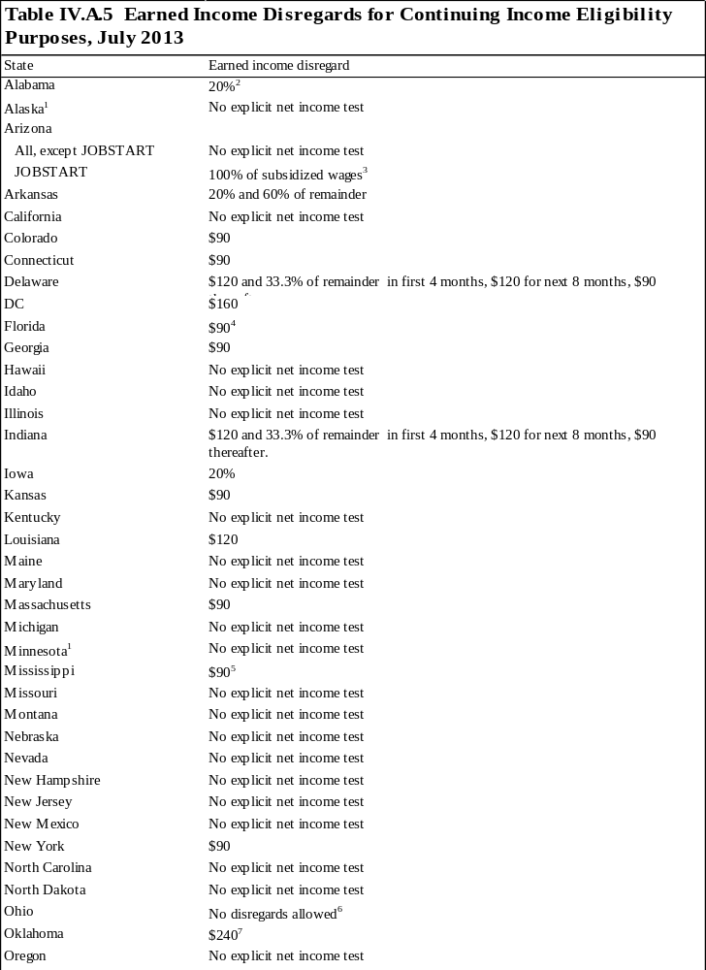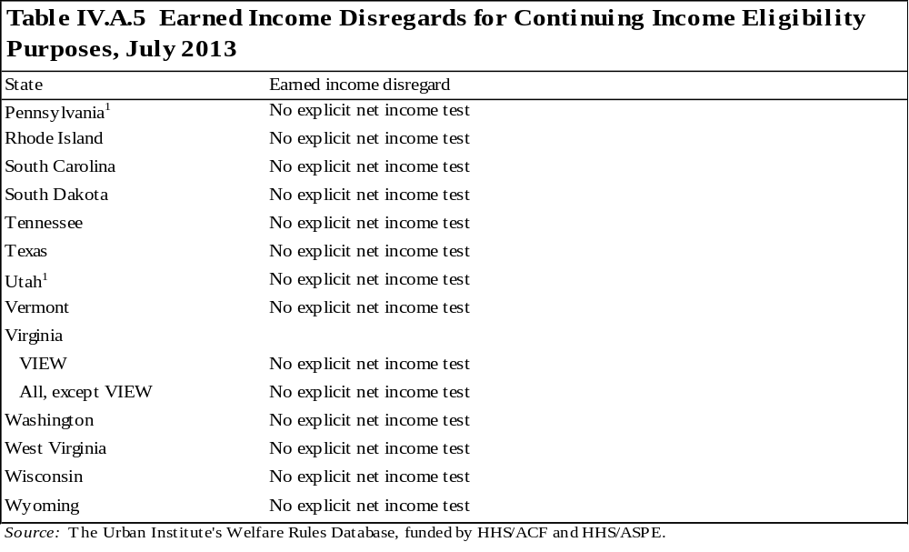
Notes: Only earned income disregards are described in the table. Child care disregards and other special disregards, such as deductions for units subject to a time limit or a family cap, are not included.

The table describes the disregards used for ongoing, recipient eligibility purposes. See table I.E.2 for disregards used for initial, applicant eligibility purposes. See table II.A.2 for information on benefit computation policies. "No explicit net income test" indicates that either the state does not impose a net income test for ongoing eligibility, or the state imposes a net income test, but the calculation of the test and disregards allowed for the test are the same as those used to calculate the benefit. See table II.A.1 for earned income disregards specifically for benefit computation and table II.A.2 for information on benefit computation policies.

¹This states considers units who have received assistance in one of the previous four months as recipients for the purpose of earned income disregards.
² The earned income disregard cannot be applied to the earnings of an individual receiving assistance beyond the 60th month under a hardship extension.
³ In addition to the 100 percent disregard of all subsidized JOBSTART wages, recipients can disregard the standard $90 and 30 percent of the remainder for any non-JOBSTART earned income.
⁴ Applicant units receiving assistance in one of the last four months may disregard $200 and 50 percent.
⁵ If a recipient marries for the first time, his/her new spouse may receive a one-time 100 percent disregard for six consecutive months.
⁶ This state does test net income for eligibility but does not allow units to apply the type of earned income disregard discussed in this table. The net income test includes more specific disregards, such as deductions for dependent care.
⁷ This disregard applies to individuals working full time (defined as 20 hours a week for individuals with a child under age 6 and 30 hours a week for all others). Individuals who are not employed full time may disregard $120.
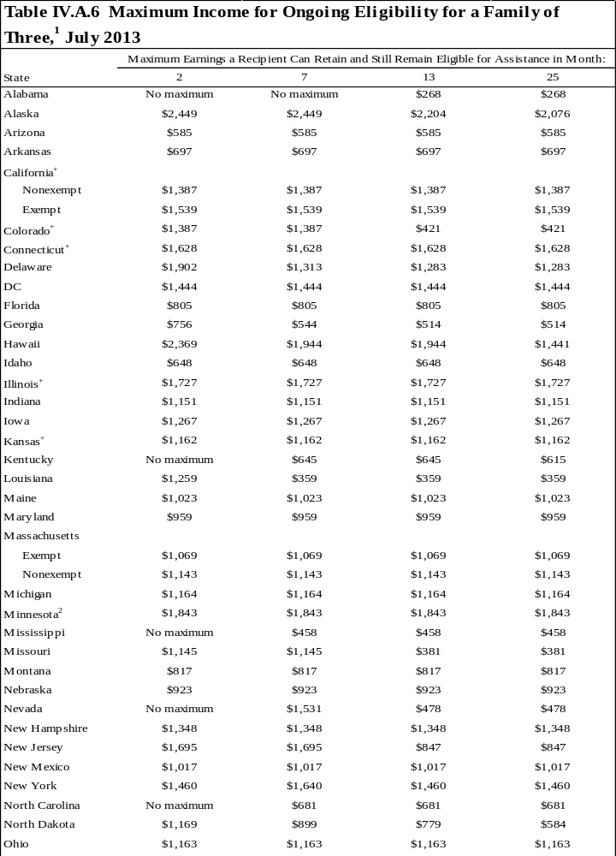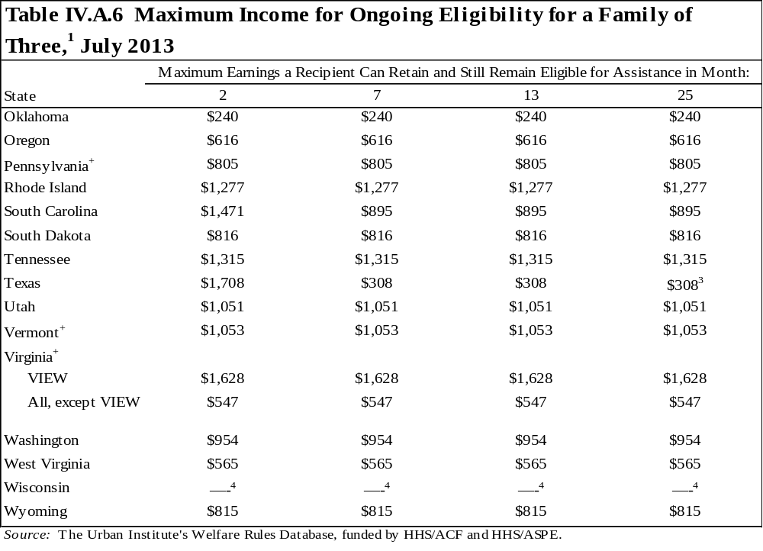
Note: Ongoing eligibility is calculated assuming that the unit found new employment while on assistance, has only earned income, has no child care expenses, contains one adult and no children subject to a family cap, has no special needs, pays for shelter, and lives in the most populated area of the state.

+ Dollar amount used to calculate benefit varies within the state, either by county or by region of the state. Calculations are based on the dollar amount that applies to the majority of the state. See WRD for more information.

¹ The values in this table represent the maximum amount of earnings a recipient in various months of combining work and TANF can retain and still be “technically eligible" for assistance in each state. Technical eligibility does not mean that the unit will necessarily receive a cash benefit, but it will have passed all the eligibility tests and is eligible for some positive amount. Most states only distribute a cash benefit equaling $10 or more.
² This table captures the maximum earnings a recipient may have in the months following his/her completion of the mandatory four month diversion program. During the diversion program different earned income disregards and benefit computation rules apply.
³ Based on the assumption made for these calculations, the recipient is not receiving the state's 90 percent disregard. However, under different assumptions, it is possible that the recipient may receive the 90 percent disregard in the 25th month of combining work and welfare.
⁴ Units with earnings at application will not receive a cash benefit, except for some Community Service Job participants who may qualify for a prorated cash benefit. Applicants may earn up to $1,872 and still be eligible for nonfinancial assistance.
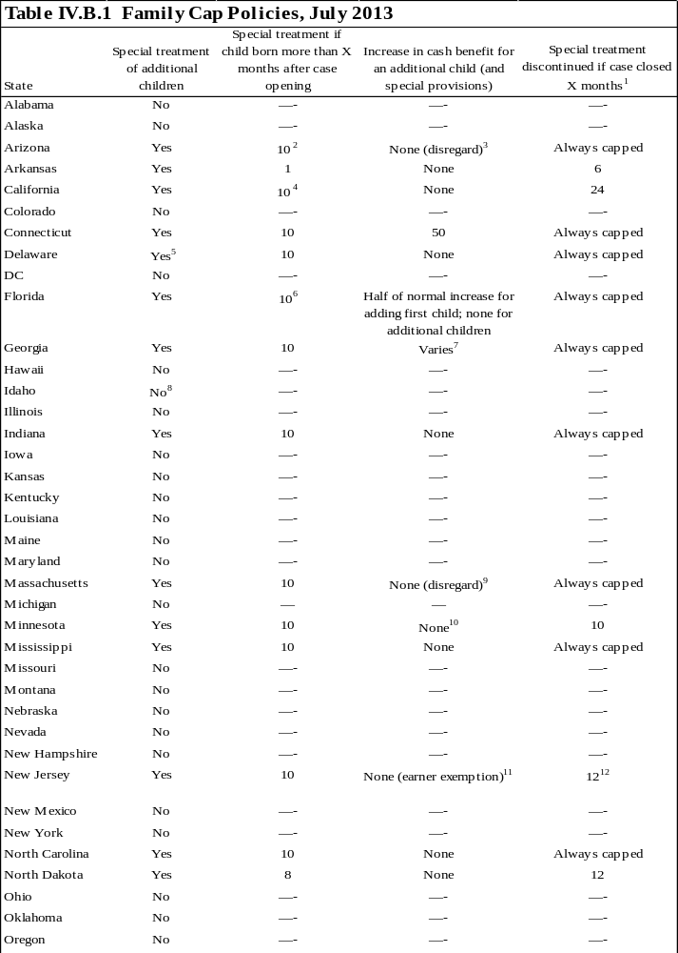
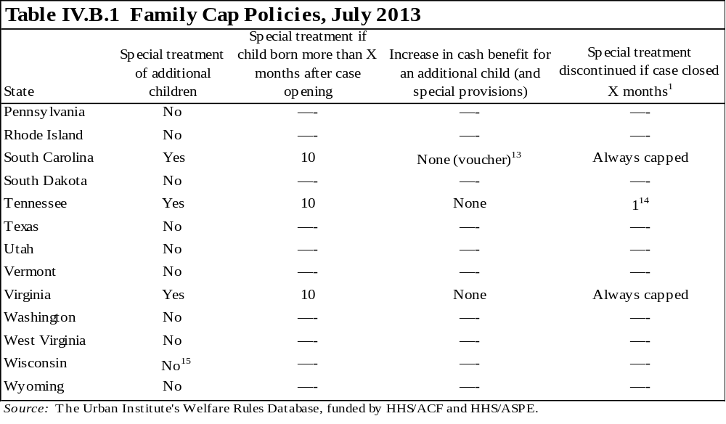
Note: Some units may be exempt from the family cap policies. See the WRD for more details on exemption policies.

¹ This column describes the number of months a unit must remain off assistance to regain eligibility for a previously capped child. Some states permanently exclude capped children, even if the unit cycles on and off assistance, while other states may include previously capped children in benefit and eligibility calculations if the unit has not received assistance for a specified period.
² The 10-month grace period only applies to the first child born after November 1, 1995. All subsequent children born to the family are capped unless they were conceived during a 12-month or longer period of nonreceipt.
³ Units subjected to the family cap receive an additional earned income disregard equal to the lost benefit amount. This additional disregard is allowed for each month the member is excluded due because of cap.
⁴ The family cap provision does not apply to units who did not receive notification of the rule at least 10 months before the birth of the child or units who leave assistance for at least 2 consecutive months during the 10-month period leading up to the birth.
⁵ In addition to the family cap policy, any child born after December 31, 1998, to an unmarried minor parent is ineligible for cash assistance, regardless of whether the minor was receiving aid at the time of the birth. If the minor received benefits within 10 months of the birth of the child, the child will always be capped. If the minor did not receive benefits within 10 months of the birth of the child, the child will be eligible for assistance once the minor turns 18. Units in which the child is not permanently capped may receive noncash assistance services in the form of vouchers upon request, but s/he will not be automatically given each month. Receipt is based on need, and the total monthly value of the vouchers is capped at $69.
⁶ If the family reapplies for assistance after a break of 6 or more continuous months, the family cap will apply again to any child born more than 10 months from the date of reapplication, and there will be no increase in the benefit.
⁷ The additional child increases the standard of need but not the family maximum. If the family has no income, the cash benefit will not increase. However, if the family has income, the benefit may increase, but cannot increase higher than the maximum payment for the family size excluding the capped child.
⁸ The state provides a flat maximum benefit, regardless of family size. However, the work incentive payment increases with family size, so the benefit for a unit with income may increase with an additional child, but never beyond the maximum benefit level.
⁹ Units subject to the family cap receive an additional earned income disregard equal to the first $90 of income received by or on behalf of a capped child in any month.
¹⁰ The family cap applies only to the cash assistance portion of the benefit the additional child would receive. The child will still be eligible for the food portion of the benefit.
¹¹ Units in which at least one adult member of the unit is working (any number of hours) are not subject to the family cap.
¹² After case closure, if the recipient is employed for three months and loses the job by no fault of his/her own and then reapplies for assistance, the previously capped child is included in the unit. These units, however, do not receive a new 10-month grace period for any subsequent pregnancies.
¹³ Benefits are available in the form of vouchers up to the amount of increase in cash benefits the unit would have received for the child.
¹⁴ The family cap will continue until the case is closed. If the case is reopened, the cap is discontinued unless the case was closed for noncooperation with child support requirements or noncompliance with the work activity requirement.
¹⁵ The state provides a flat benefit, regardless of family size.
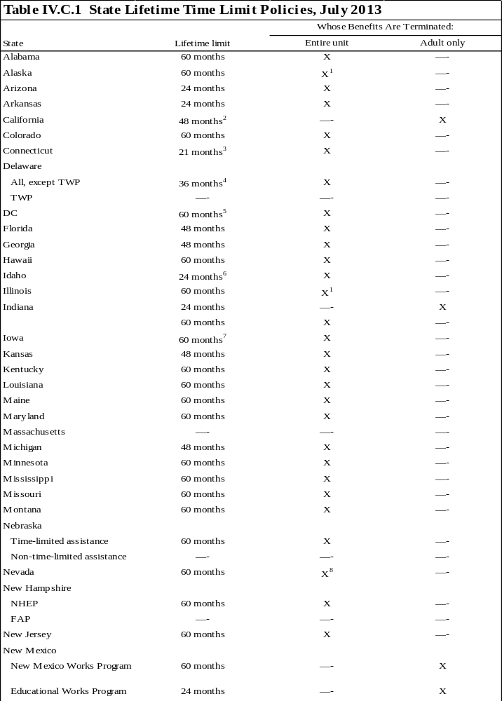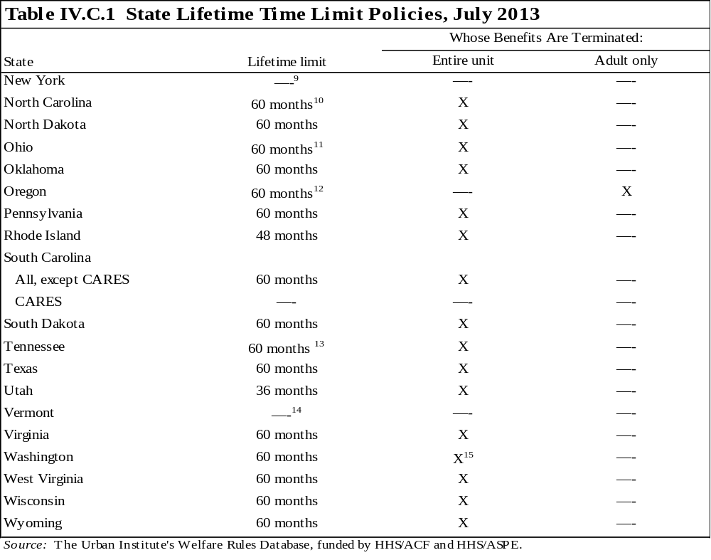
¹ If the adult who has reached the 60-month lifetime limit is not the parent of any child in the assistance unit, only the adult is ineligible for benefits. Children who do not live with a parent can, therefore, continue to receive assistance after their caretaker reaches the 60-month limit.
² California's TANF funding began in December 1996, but recipients' benefit months did not begin to count against units' 60-month limit until January 1998. Using state funds, California will extend recipients' benefits beyond 48 months if the unit received assistance between December 1996 and January 1998. The length of the extension equals the number of months the unit received benefits during this period.
³ Recipients may apply for extensions after 21 months of benefits, but they may not receive more than 60 total months of assistance. See table IV.C.4 for more information on extensions.
⁴ The 36-month time limit applies to assistance units that applied for benefits on or after January 1, 2000. Units who received benefits before this date are eligible for 48 months of assistance.
⁵ After 60 months, the unit remains eligible if the net income falls below the reduced payment level. Benefits are reduced to 80 percent of the payment level for the unit size.
⁶ When there is more than one adult in the family, the adult with the greatest number of months of participation must be used to determine when the family reaches the time limit.
⁷ In addition to the 60-month lifetime limit, units must establish a time frame, with a specific ending date, during which the recipient expects to become self-sufficient (i.e., when income will be above eligibility limits).
⁸ The entire family becomes ineligible unless it qualifies for a hardship extension.
⁹ Units in compliance with TANF program rules may continue to receive benefits through a separate state program beyond 60 months.
¹⁰ In certain circumstances, a child may be able to continue receiving benefits after the 60 months. Because the time limit follows the adult, a child may enter a new household and become eligible in a new assistance unit.
¹¹ After receiving 36 months of assistance, the case is closed; however, it is possible to receive 24 additional months of benefits if the unit has not received benefits for at least 24 months and can demonstrate good cause for reapplying.
¹² Oregon’s 60-month lifetime limit retroactively affects recipients; all months of benefit receipt since July 2003 are counted against a unit’s 60-month limit.
¹³ If clients marry with different months of assistance, the number of months counted towards the time limit will be the higher of the two. If a marriage dissolves, the number of countable months of the two-parent unit will be the same if the parents reapply for assistance regardless of months earned prior to the marriage.
¹⁴ Recipients who reach the 60-month federal time limit are placed in a solely state-funded program.
¹⁵ The entire family becomes ineligible unless it qualifies for a hardship extension. In addition, units in compliance with TANF program rules may continue to receive benefits beyond 60 months.
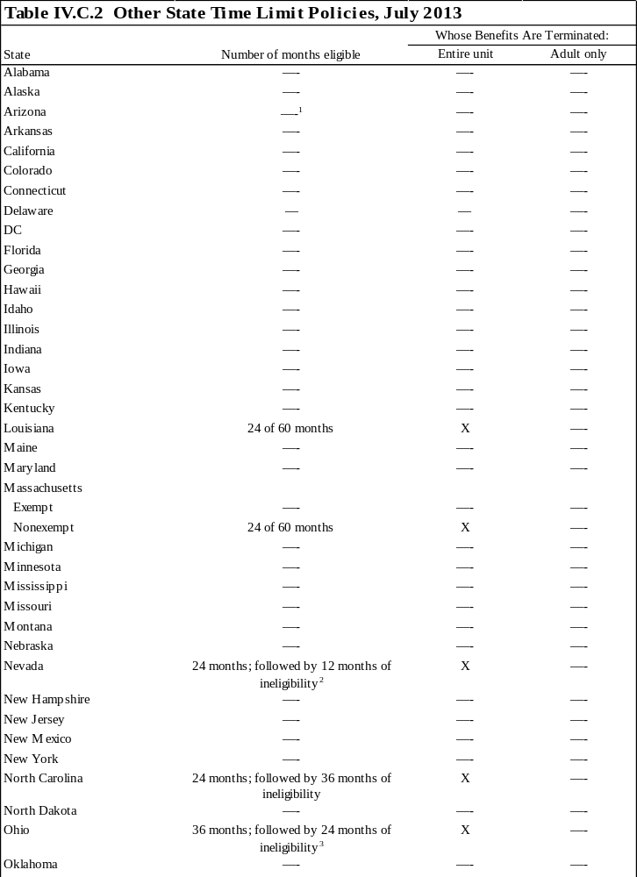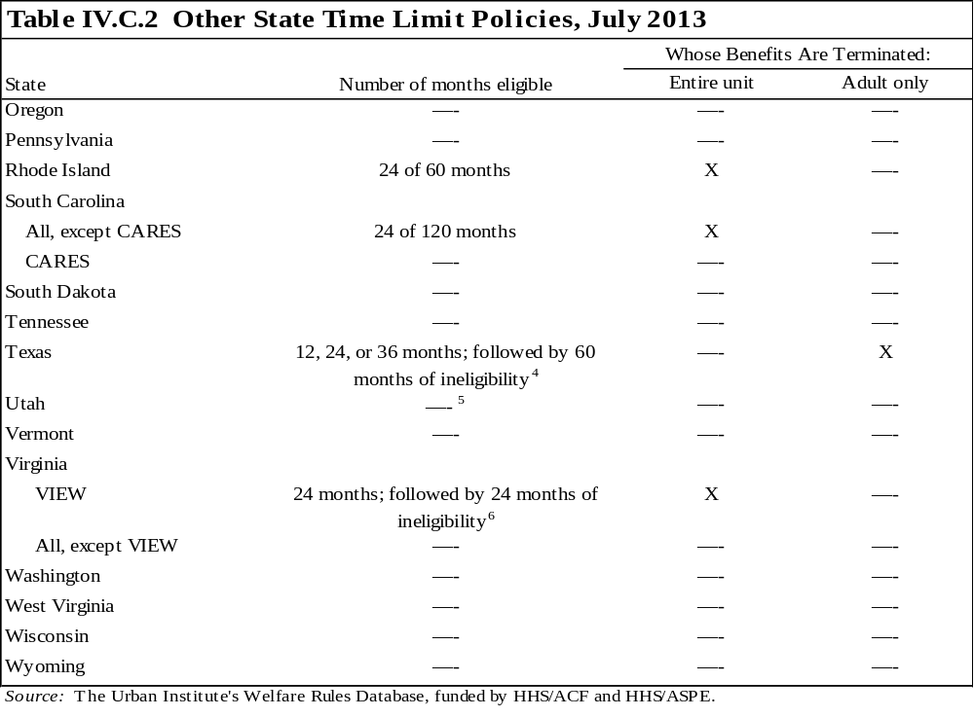
¹ Two-parent families, in which neither parent is disabled, are eligible for only six months of assistance in any 12-month period.
² After receiving 24 months of cumulative or consecutive assistance, the household is ineligible for TANF cash benefits for 12 consecutive months, unless a qualifying hardship exists. This continues until the household has received 60 months of TANF assistance from Nevada or any other state.
³To receive benefits after the 24-month period of ineligibility, the family must demonstrate good cause for reapplying. Good cause may include loss of employment, inability to find employment, divorce, domestic violence, or other reasons determined by the caseworker.
⁴ The 12-month limit applies to nonexempt recipients who (1) did not complete the 11th grade and have 18 months or more of recent work experience or (2) have a high school diploma or GED, a certificate from postsecondary school, or a certificate or degree from vocational or technical school and any work experience. The 24-month limit applies to nonexempt recipients who (1) did not complete the 11th grade and have between 6 and 17 months of recent work experience or (2) completed the 11th grade but not the 12th grade or have a GED, and have completed 17 or fewer months of work experience. The 36-month limit applies to nonexempt recipients who (1) have less than six months of recent work experience and (2) did not complete the 11th grade.
⁵ Two-parent families, in which the principal wage earner is unemployed, are eligible for only 7 months of assistance in any 13-month period.
⁶ After receiving 24 months of assistance, the unit may receive up to 12 months of transitional benefits. The 24 months of ineligibility begins with the month in which the case was closed or in the month transitional benefits were terminated, whichever is later.
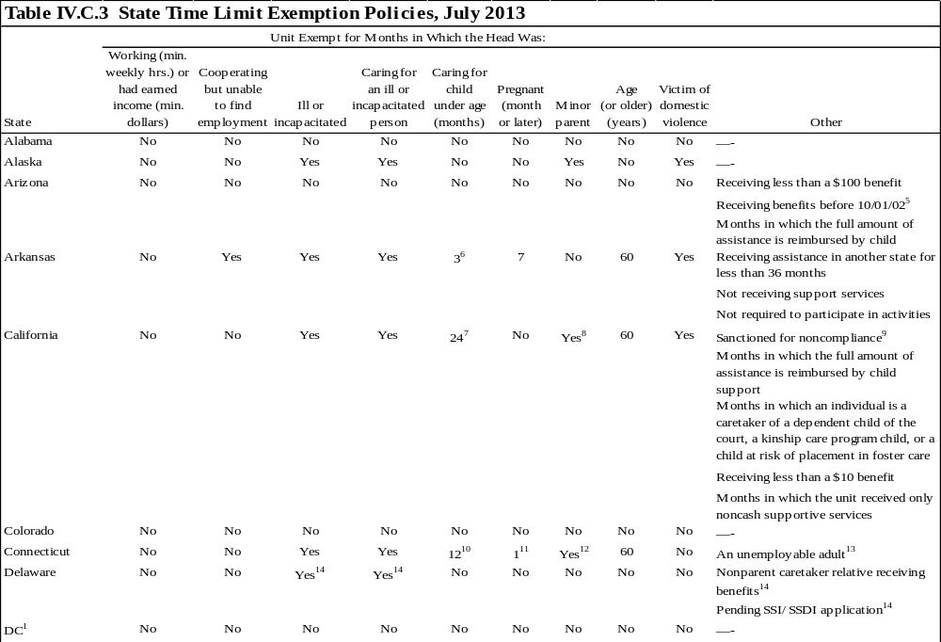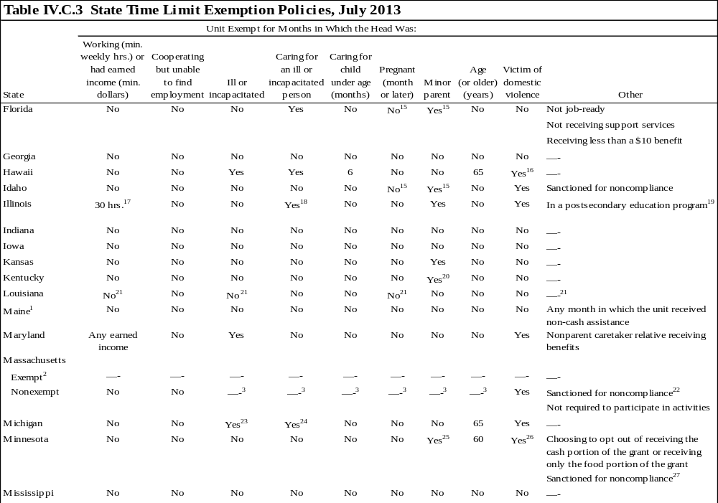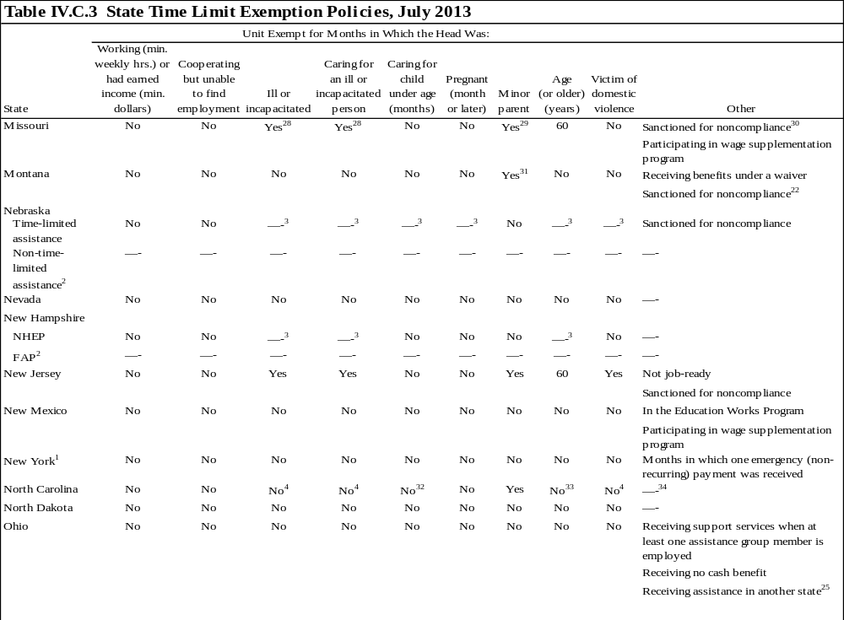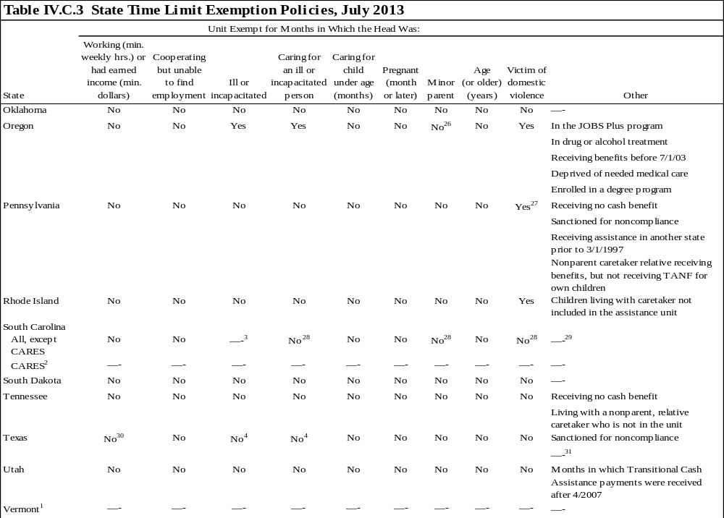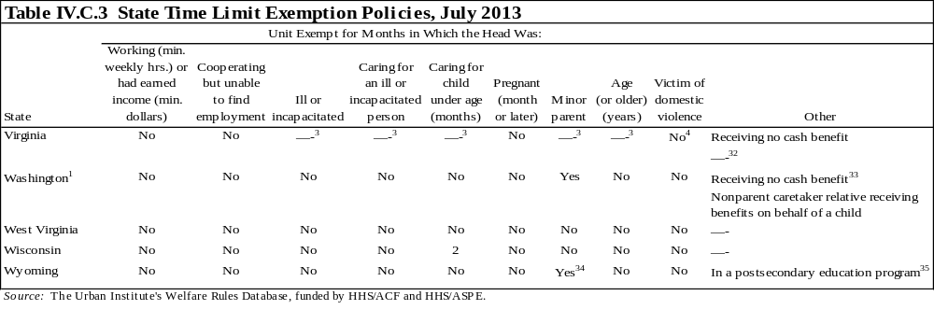
Notes: Exemption policies apply to months in which the state does not count a month of assistance toward the state's time limit (or "stops the clock"). These policies are potential exemptions and may not be granted to all that are eligible. In most states, caseworkers have discretion in applying the exemptions.

If a state has multiple time limits (for example, a periodic limit and a lifetime limit) and applies the exemption policies differently to the time limits, the exemptions in the table apply to the lifetime limit, and the exemptions for the periodic limit are footnoted.

The federal government requires that states disregard months during which an adult lived on a Native American reservation or in an Alaskan Native village with an adult unemployment rate of at least 50 percent. Additionally, because time-limit calculations apply only to families that include adults (or minor heads of household), time limits do not apply to child-only units or to any month in which an adult received assistance as a dependent child.

Many states exempt months in which a unit receives diversion payments. These policies are captured in table I.A.1.

¹ This state continues to fund families beyond 60 months of benefit receipt. However, the state may exempt certain months in calculating the number of federally funded months of assistance.
² Recipients in this component are exempt from time limits. The criteria for inclusion in this component may include some of the exemptions listed in this table; see appendix 1 for more information on the composition of the component.
³ Individuals with this characteristic are placed in an alternative component that is exempt from time limits. See appendix 1 for more information on components.
⁴ This group is exempt from the benefit waiting period but not the lifetime limit.
⁵Any months of assistance received in Arizona or any other state before October 2002 do not count toward the time limit.
⁶ The exemption applies to parents who have child care. If no child care is available, parents caring for children under 12 months old are exempt.
⁷ Recipients caring for one child age 12 through 23 months or for two or more children under 6 years old are exempt.
⁸ Minor parents are exempt in months in which they are eligible for, participating in, or exempt from the Cal-Learn program.
⁹ Any month in which the adult is removed from the grant as a result of sanctions does not count toward the time limit.
¹⁰ The exemption does not apply to children subject to a family cap.
¹¹ Women who are pregnant or have just given birth are exempt if a physician certifies the woman's inability to work. In addition, a woman whose pregnancy ended within six weeks is exempt.
¹² All minor parents are exempt (whether they head the unit or not), provided the minor parent is in high school or earning his or her GED.
¹³ To be unemployable, an adult must (1) be age 40 or older, (2) be unemployed, (3) be fully cooperating with program requirements, (4) have not completed grade 6, and (5) have not been employed more than six months in the past five years.
¹⁴ Individuals meeting these criteria will be placed in a separate, nontime limited program.
¹⁵ A minor is exempt from the time limit if he or she has a child or if she is pregnant.
¹⁶ To be exempt, the individual must be unemployed or employed less than 20 hours a week, have had a relationship to the perpetrator of the violence, and have taken action as a result of the domestic violence (such as getting a court order protecting the individual from the perpetrator or living in a domestic violence shelter within the past 12 months).
¹⁷ The head of a one-parent unit must work 30 hours a week, while both parents of a two-parent unit must work a combined total of 35 hours a week to receive the exemption.
¹⁸ The ill or incapacitated person must be a related child under age 18, a spouse, or a child approved for a waiver under the home and community-based care program.
¹⁹ To be exempt, the caretaker relative must attend the postsecondary education program full time and retain a cumulative GPA of at least 2.5.
²⁰ To be exempt, the minor parent must live in an adult-supervised setting and not be considered a head of household.
²¹ Months in which an individual is eligible for the state's $900 earned income deduction (the deduction is allowed for up to six months), recipients who are ill or incapacitated, women in the last three months of pregnancy and first month after the birth of the child, and months in which the individual received assistance in another state are exempt from the periodic time limit but not the lifetime limit.
²² This exemption only applies to months in which sanctions reduce the amount of the benefit to $0.
²³ The recipient must be incapacitated greater than 90 days.
²⁴ Exempt from the state time limit only for a disabled spouse or dependent child.
²⁵ To be exempt, minor parents must be living in a supervised setting and complying with a social service plan or, if they are 18 or 19 years old, they must be complying with education requirements.
²⁶ To be exempt, the family must be complying with a safety plan.
²⁷ This exemption applies to months in which the caretaker is disqualified from assistance because of an intentional program violation. The exemption only applies to violations that occurred after October 1, 2007.
²⁸ To meet this exemption, there must be no other satisfactory alternative plan or care available.
²⁹ The minor parent is exempt if he or she is attending school and entered in the JOBS system in education related to employment or vocational education and training.
³⁰ This exemption applies to months in which an individual is sanctioned for certain reasons before October 1998.
³¹ To be exempt, the minor parent must be complying with activities requirements.
³² Single parents caring for a child under 12 months old are exempt from the benefit waiting period time limit but not the lifetime limit.
³³ Individuals age 65 and older are exempt from the benefit waiting period time limit but not the lifetime limit.
³⁴ Months in which the family does not have access to support services, receives assistance from another state, or is not required to participate in activities are exempt from the benefit waiting period time limit but not the lifetime limit. Counties may also choose to exempt from the benefit waiting period time limit those with physical, mental, or emotional barriers to work.
²⁵ This exemption only applies to months of assistance received in another state during which that state had a waiver of time limits in effect.
²⁶ This exemption applies to recipients who were dependent children and became minor parents and receive assistance as caretaker relatives of their own children.
²⁷ A victim of domestic violence is exempt for an initial six months. An additional six-month period may be granted if a domestic violence counselor verifies the need.
²⁸ This group is exempt from the periodic time limit but not the lifetime limit.
²⁹ Months in which the unit received benefits in another state, did not receive support services, or received a benefit less than $10 are exempt from the periodic time limit but not the lifetime limit. Months in which a child is being cared for by a nonparent caretaker relative and the alternative placement is foster care are also exempt from the periodic limit, but not lifetime limit.
³⁰ Individuals earning up to $168 a month may be exempt from the benefit waiting period time limit but not the lifetime limit.
³¹ Individuals who are unemployed because of high local unemployment may be exempt as long as they contact an average of 40 employers a month (job search). This exemption applies only to the benefit waiting period time limit.
³² Individuals not receiving support services may be exempt from the benefit waiting period time limit but not the lifetime limit.
³³ This exemption applies to recipients in the Community Jobs program and earning income that exceeds the benefit amount, causing the grant to be suspended.
³⁴ Up to one year of assistance will count against minor parents who received assistance before reaching their 18th birthday. All months beyond 12 will not count toward the lifetime limit.
³⁵ This exemption applies to individuals who participate in the state's State Adult Student Financial Aid program, meet the attendance requirements of their educational institution, and receive a passing grade (no incompletes or Fs) in all classes each semester.
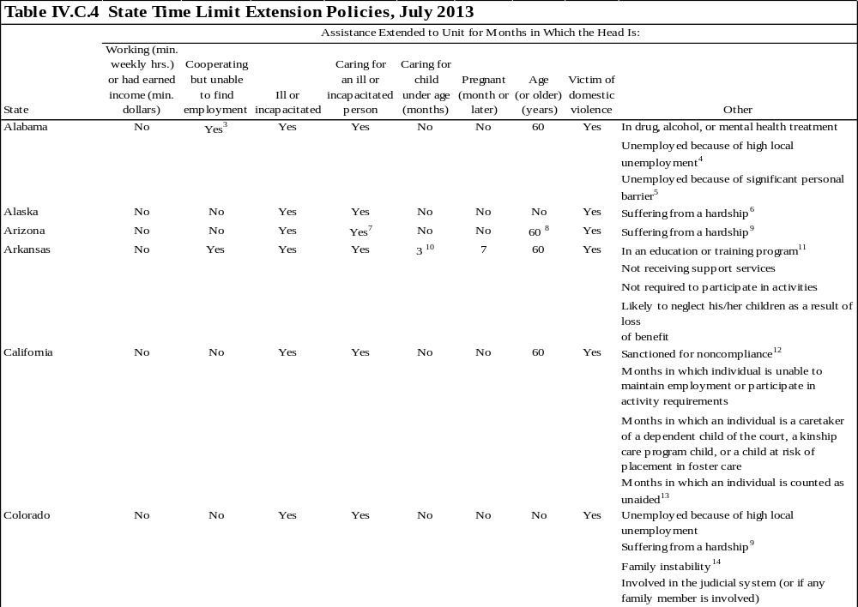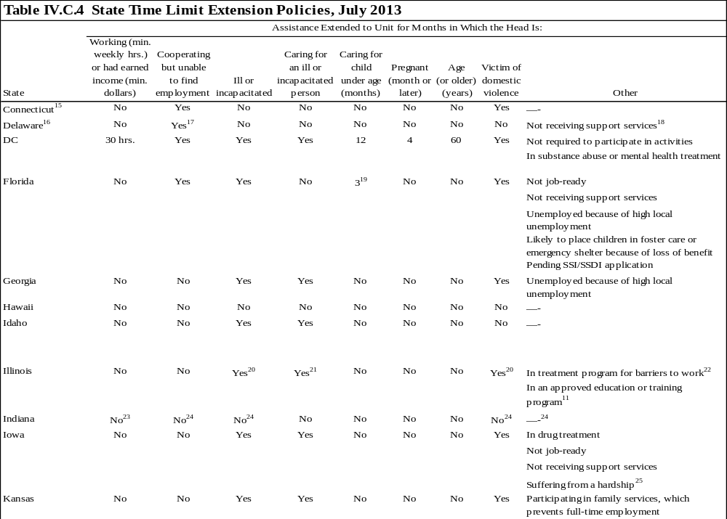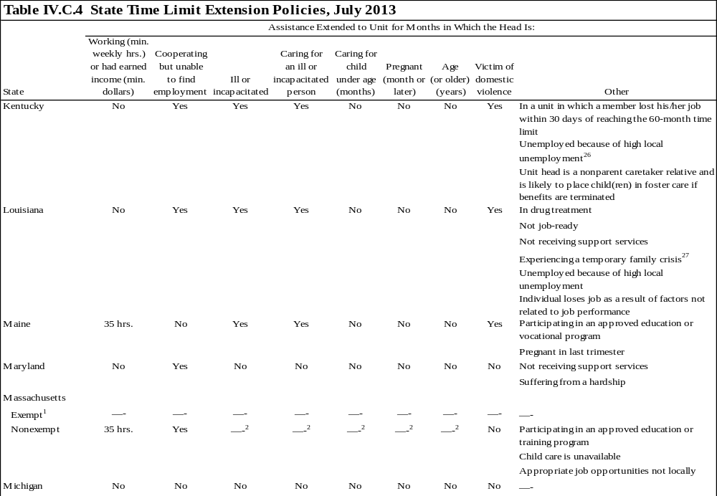
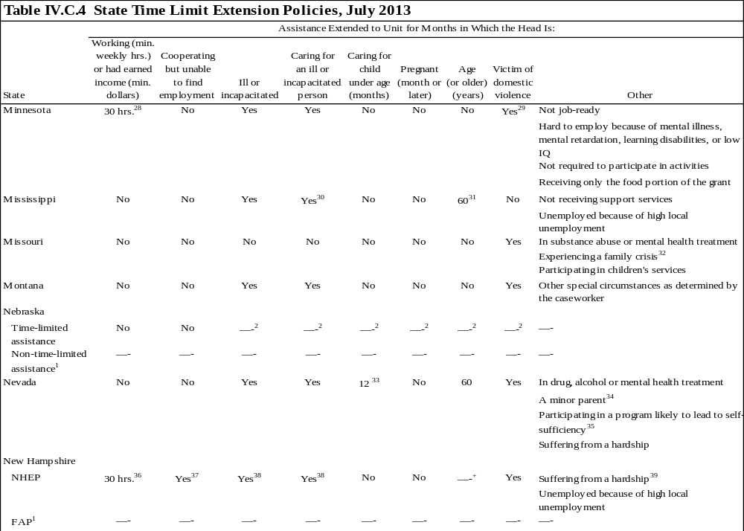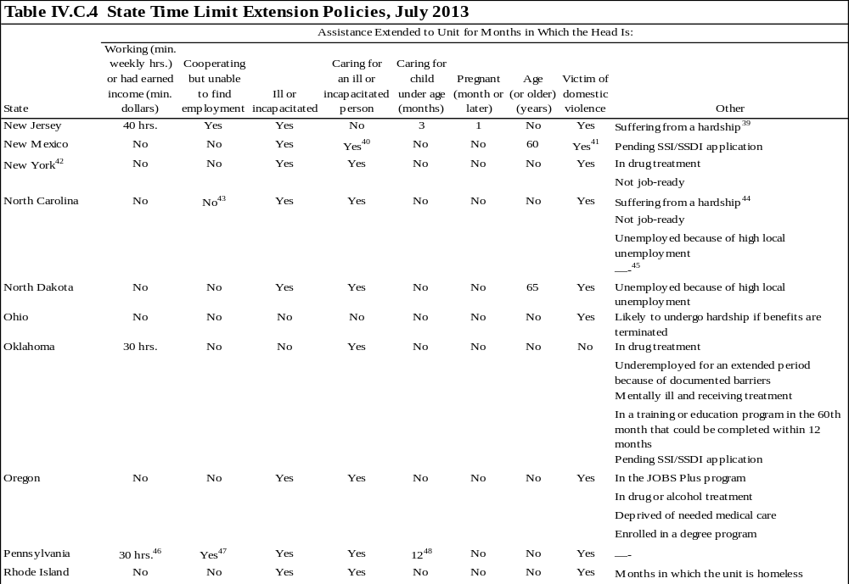
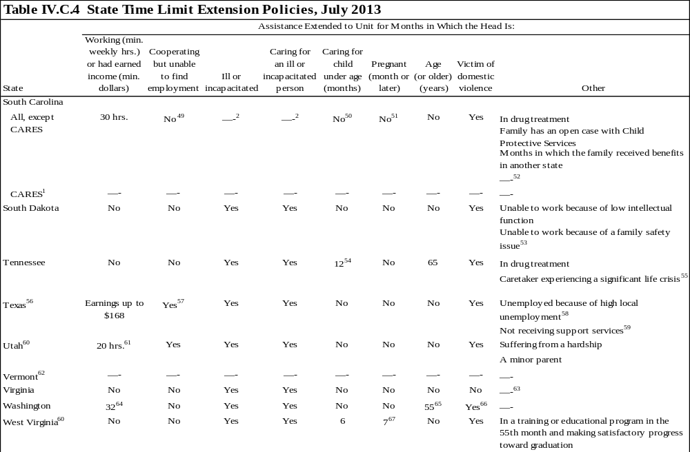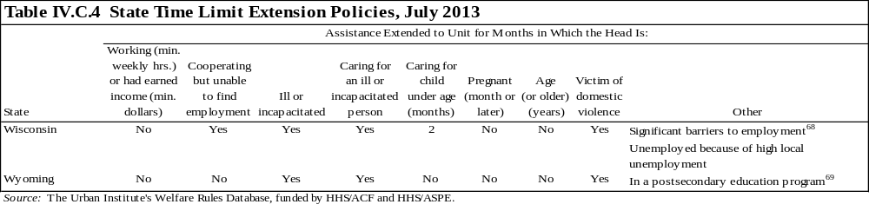Notes: Extension policies apply to months in which the state provides additional benefits to families after they have reached their time limit. These policies are potential extensions and may not be granted to all that are eligible. In most states, caseworkers have discretion in applying the extensions.
If a state has multiple time limits (for example, a periodic limit and a lifetime limit) and applies the extension policies differently to the time limits, the extensions in the table apply to the lifetime limit and the extensions for the periodic limit are footnoted.
The federal government requires that states disregard months during which an adult lived on a Native American reservation or in an Alaskan Native village with an adult unemployment rate of at least 50 percent. Additionally, because time limit calculations apply only to families that include adults (or minor heads of household), time limits do not apply to child-only units or to any month in which an adult received assistance as a dependent child.
¹ Recipients in this component are exempt from time limits. The criteria for inclusion in this component may include some exemptions listed in this table. See appendix 1 for more information on the composition of the component.
² Individuals with this characteristic are placed in the alternative component, which is exempt from time limits. See appendix 1 for more information on components.
³ To receive an extension, the individual must have received at least 12 of the last 24 months of assistance under a basic hardship, be compliant with JOBS, not have been disqualified for noncompliance, and be certified as not currently employable by a JOBS caseworker.
⁴ To receive an extension, the individual must live in a SNAP Able-bodied Adults Without Dependents (ABAWD) waiver county, be compliant with JOBS, not have been disqualified for noncompliance, and be unemployed.
⁵ To receive an extension, the individual must be engaged in activities to overcome his/her personal barriers. Examples of barriers may include, but are not limited to, the inability to speak English, needing extensive dental work, or having a learning disability, such as attention deficit disorder.
⁶ Benefits may be extended if the family experiences circumstances outside of their control that prevent the caretaker from participating in work activities or becoming self-sufficient, and the loss of benefits would result in conditions that threaten the health and safety of the family.
⁷ This extension is limited to single-parent units where the caretaker provides care for a disabled child. The unit must receive respite care for less than 20 hours a week and the disabled child may not attend school more than 20 hours a week.
⁸ This extension is limited to cases in which the unit head is a nonparent-specified relative and is included in the unit.
⁹ The extension is provided to families that have inadequate or unavailable transportation, child care, or housing.
¹⁰ Three months applies to parents who have child care. If no child care is available, parents caring for children under 12 months old receive the extension.
¹¹ The individual must be within six months of completing his or her education or training program.
¹² Any month in which the adult is removed from the grant as a result of sanctions does not count toward the time limit.
¹³ To be eligible for this extension, the individual must be excluded from the assistance unit for reasons other than exceeding the time limit.
¹⁴ Family instability may be caused by a caretaker's inability to maintain stable employment or his/her inability to care for the children in his/her own home or in the home of a relative.
¹⁵ Recipients may only receive two extensions unless they meet specific criteria (see WRD for information on extension criteria). If recipients are sanctioned during the extension period, they are ineligible to receive benefits again. Units may receive only 60 total months of benefits, including extensions.
¹⁶ Extensions will not be granted if the caretaker adult received and rejected offers of employment, quit a job without good cause, was fired for cause, or did not comply with the contract. Units who reapply after their time limit may receive assistance if circumstances exist for an extension to be granted.
¹⁷ Recipient must be unable to find employment that provides income at least equal to the payment standard after deduction of work expenses, earned income disregards, and child care expenses, and that provides wages at least equal to the minimum wage. The extension is limited to a total of 12 cumulative months.
¹⁸ Support services include, but are not limited to, domestic violence counseling, substance abuse treatment, family planning, and employment training.
¹⁹ Three months applies to parents who have child care. If no child care is available, then single parents caring for children less than 6 years old receive an extension.
²⁰ The extension is granted if the condition prevents the individual from working full time.
²¹ The ill or incapacitated person must be a related child under age 18, a spouse, or a child approved for a waiver under the home and community-based care program.
²² The extension is granted if the treatment prevents the individual from working at least 30 hours a week. Treatment programs for barriers to work include mental health and substance abuse treatment, homelessness, domestic violence, child protective services, and vocational rehabilitation.
²³ An individual may earn one month for every six months s/he works in an unsubsidized job. This extension applies to the benefit reduction limit but not the lifetime limit.
²⁴ Individuals meeting these criteria may receive an extension to the benefit reduction limit but not the lifetime limit.
²⁵ Benefits will be extended if the individual suffers from a hardship that keeps him/her from becoming self-sufficient. Examples of hardships may include, but are not limited to, the following (some of which are included above): domestic violence, physical or mental health problems, substance abuse problems, the inability to find or keep a job, lack of suitable child care, difficult housing situations, or caring for a child with special needs.
²⁶ To receive this extension, recipients must participate in activities requirements for 30 hours a week.
²⁷ A temporary family crisis may include death of a family member, eviction, serious illness, or an accident.
²⁸ The 30 hours a week applies to one-parent families. Two-parent families must participate in activities for 55 hours a week. For one-parent families, 25 of the 30 hours must be in employment; for two-parent families, 45 of the 55 hours must be in employment. Participants must be in compliance in the 60th month as well as for 10 of the last 12 months preceding the 61st month to be eligible for the extension. Individuals with a verified medical condition are eligible for this extension, provided they work the number of hours specified by their health care provider and follow the provider's treatment recommendations.
²⁹ To receive the extension, the family must be complying with a safety plan.
³⁰ This extension is limited to parents caring for an incapacitated child or adult in the household.
³¹ Units with an elderly caretaker may have their benefits extended beyond 60 months by converting the case to child-only.
³²A family crisis may include, but is not limited to, a home destroyed by fire, a temporary disability of the payee, an accidental injury of family member, a job loss due to a poor economy, or being a victim of a crime.
³³ Months in which the parent was exempt from activities requirements because s/he was caring for a young child are deducted from the 12-month extension period. For example, if the unit head was previously exempted from activities requirements for 3 months and then reaches the 60-month time limit, s/he may only receive an additional 9-month extension, provided one of his/her children is under 12 months old.
³⁴ To receive the extension, the minor parent must be in compliance with high school attendance and living arrangement requirements.
³⁵ To receive the extension, the individual must be participating in a program that the caseworker determines likely to result in self-sufficiency.
³⁶ The extension is available only to assistance groups whose cases were closed because of time limits and who are reapplying for assistance.
³⁷ This extension cannot be used for cases that are reapplying for an extension after the case has been closed.
³⁸ Some recipients with this characteristic may be determined unable to work and are moved into the alternative component, which is exempt from time limits. Recipients with this characteristic who are determined to have a temporary condition remain in the time-limited component but may receive an extension.
³⁹ Hardships may include lack of adequate child care, loss of employment, life-threatening circumstance or emergency situation, medical condition, medical condition of another household member, learning disability, participation in a substance abuse or mental health program, and family/domestic violence. In addition, families that are reapplying after case closure because of the 60-month time limit may receive an extension for working 30 or more hours a week or on a case-by-case basis if they do not fall into one of the hardship criteria listed above.
⁴⁰ Benefits are extended to families if termination would subject the family to extreme hardship. Extreme hardship is defined as one of the following (some of these are included above): periods of temporary incapacity resulting in work deferrals of more than 12 consecutive months that did not allow the recipient sufficient time to gain self-sufficiency; the existence of a current temporary deferral, such as for incapacity due to pregnancy or the need to care for a child under 12 weeks old; the existence of a current temporary deferral because of such circumstances as a lack of transportation or available child care to support work; if participant has been fully compliant with program requirements with no more than one sanction in the previous 12 months and s/he is still unable to obtain sufficient employment; or a domestic violence situation renders a recipient temporarily incapable of sustaining the family without continued support.
⁴¹ The participant must be the sole care provider for an ill/incapacitated family member who lives in the home and does not attend school on a full-time basis.
⁴² In addition to victims of domestic violence, individuals considered battered or subjected to extreme cruelty receive an extension. Battery and extreme cruelty occur when an individual has been physically attacked, sexually abused, raped, threatened with physical or sexual abuse, exposed to mental abuse, or deprived of medical care.
⁴³ New York continues to provide noncash assistance to all units that have reached the 60-month federal time limit. These extensions apply to the 60-month limit for receiving regular cash assistance.
⁴⁴ Individuals who are substantially complying with their mutual responsibility agreement and are unable to obtain or maintain employment that provides a basic subsistence (defined as less than the state's maximum work first payment minus 27.5 percent from each worker's income) receive an extension from the benefit waiting period time limit but not the lifetime limit.
⁴⁵ A family may receive a hardship extension if a unit member (some of these are included above) has been battered or abused, has suffered a severe illness, has an inhibiting education level, has severe unemployment, lacks of child care, is participating in substance abuse treatment, has an inhibiting criminal record, is homeless or has substandard housing, has one or more children in the home receiving child welfare services, had inadequate access to employment services during the 60 months, lacks transportation, or has any other situation that makes employment unattainable. These apply to the lifetime time limit but not the benefit waiting period.
⁴⁶ Participants in postsecondary education programs may receive an extension to the benefit waiting period time limit but not the lifetime limit.
⁴⁷ Two-parent families must work 55 hours a week to receive this extension. An individual may also receive this extension if s/he is working 20 hours a week and participating in approved work or training activities for at least 10 hours a week.
⁴⁸ To receive this extension, an individual must have completed the eight-week job search and, in the first 12 months of assistance, begun an approved employment and training program for 30 hours a week or a full-time postsecondary educational activity.
⁴⁹ Recipients caring for children under age 6 may also receive an extension if an alternative child care arrangement is unavailable.
⁵⁰ Recipients may receive an extension to the periodic limit but not the lifetime limit.
⁵¹ Individuals caring for children under 1 year old or cooperating but unable to find employment may receive an extension to the periodic time limit but not the lifetime limit.
⁵² A pregnant woman, who has not been participating in the work program because she is in the seventh month of her pregnancy, may receive an extension to the periodic limit but not the lifetime limit. The woman must begin participating in the work program to receive the extension.
⁵³ Participants may receive an extension to the period waiting period for months in which the recipient is involved in a county approved training program that will not be completed by the 24th month.
⁵⁴ Examples of family safety issues include homelessness or domestic violence.
⁵⁵ This extension applies to single parents. Two-parent families may be granted an extension when caring for a child less younger than 16 weeks.
⁵⁶ A significant life crisis may include eviction from the home, natural disaster, family crisis, or complications for pregnancy or birth.
⁵⁷ To qualify for any extension, a caretaker must have fewer than 12 months of activities or child support sanctions since November 1, 1996.
⁵⁸ To be eligible for an extension, the recipient must have been unable to obtain sufficient employment during the last 12 consecutive months before the end of the 60-month limit and may not have had more than one sanction since November 1, 1996. The inability to obtain sufficient employment cannot be the result of voluntarily quitting a job. This applies to the lifetime limit but not the benefit waiting period.
⁵⁹ This extension can continue as long as the recipient contacts an average of 40 employers a month. This applies to both the benefit waiting period time limit and the lifetime limit.
⁶⁰ To be eligible for this extension, the recipient must reside in a county in which s/he receives minimum or mid-level services during the 60th month (or at any time during the 11 countable months immediately preceding the 60th month) of benefit receipt.
⁶¹ For two-parent households, both parents must be eligible to receive an extension for the unit to qualify for continued financial assistance. If either parent does not qualify for an extension, the household is not eligible for continued financial assistance.
⁶² An extension is granted if the following two conditions are met: (1) during the previous month, the parent was employed for no less than 20 hours a week, (2) the parent is expected to be employed for no less than 20 hours a week in the month for which financial assistance is being authorized.
⁶³ Recipients who reach the 60-month federal time limit are placed in a solely state-funded program.
⁶⁴ VIEW participants in the following groups may receive an extension from the benefit waiting period time limit but not the lifetime limit: (1) individuals suffering from a hardship, (2) individuals unemployed because of high local unemployment, and (3) individuals enrolled in employment-related education or training programs if the program is expected to conclude within 12 months.
⁶⁵ After 60 months of assistance, households exempt from work requirements or experiencing documented hardship may continue to receive benefits at the same level that they received under TANF. Households not meeting this criterion must participate full time (32 to 40 hours a week) in work-related activities, which may include a combination of working, job search, or preparing for work, in order to continue receiving assistance.
⁶⁶ This exemption applies only to nonparent relative caretakers.
⁶⁷ Must be participating in specialized activities in individual plan.
⁶⁸ Single, pregnant women (including emancipated minor parents under 18 years old) who will be in their third trimester or have a child under the age of 6 months during their 60th month of assistance may receive an extension until their child is 6 months old. If the pregnancy does not end in a live birth, the extension continues for two months following the end of the pregnancy.
⁶⁹ Significant barriers include, but are not limited to, low achievement ability, learning disability, severe emotional problems, or family problems, which include legal problems, family crises, homelessness, domestic abuse, or children's school or medical activities that affect a member of the W-2 group.
⁷⁰ To receive the extension, the individual must be within one year of completing the degree.

Policies across Time, 1996–2013

This chapter of the Databook includes longitudinal tables for selected areas of policy from 1996, 2002, 2007, and 2013 (as of July of each year). Although not every policy from the previous sections has a companion table here, data for every year from 1996 through 2013 for each policy can be found in the WRD.
To help users more easily identify changes in policies across time, the changes from one year to the next have been bolded in all the longitudinal tables. Because the tables do not represent every year, the changes may have occurred in a year before the bolded year. Information on when specific changes occurred is available in the WRD.
The following discussion provides more information on the policies included in this section and the specific policies discussed in the tables.
Formal diversion: Table L1 indicates which states have a formal diversion program that diverts eligible applicants or recipients from ongoing TANF receipt by providing a one-time cash payment directly to the family or to a vendor for expenses incurred by the family. Other strategies that states may use to divert applicants from ongoing receipt of cash benefits (such as requiring an applicant to participate in job search or resource and referral services) are not identified as diversion programs in the table.
States did not have the option to divert units under AFDC. However, a few states experimented with diversion through waivers. Generally, diversion programs began as pilot projects in a few counties and, after TANF, were expanded statewide.
Two-parent eligibility: Table L2 describes states’ deviation from the prior federal AFDC rules for two-parent, nondisabled units over time. The key AFDC policies were the 100-hour rule for applicants and recipients, a six-out-of-13-quarter work history test, and a 30-day waiting period. “Standard AFDC” describes the states that impose the AFDC rules. “Modified” describes the states that no longer impose all the former AFDC requirements on units but still impose some additional requirements. The specific combination of modified rules is footnoted. States that no longer impose any special requirements on two-parent units are denoted by “None.”
Many states began modifying or removing special requirements for two-parent units under waivers. This process continued under TANF, which does not require states to impose any special requirements on two-parent units.
Initial eligibility at application: Table L3 calculates the amount of earned income a three-person unit can receive and still be technically eligible for assistance. Technically eligible means the unit is eligible for assistance but may not actually receive a cash benefit. Most states will not pay out a benefit for less than a specified amount (usually $10), but as long as the unit’s potential benefit is positive, it is technically eligible. The calculations in this table are based on the states’ income eligibility tests, earned income disregards, benefit computation, and eligibility and payment standards.
Earned income disregards for benefit computation: Table L4 describes the earned income disregards allowed in determining net income used for benefit computation. The disregards in this table apply to recipients. Earned income disregards for benefit computation under AFDC were a standard $120 and 33.3 percent for the first four months, $120 for the next eight months, and $90 thereafter. Through waivers, many states began changing their disregard policies, which often allowed units to keep more of their income and remain eligible for aid. This broadening of disregards continued under TANF, which allows states to determine their own disregard policies.
Maximum monthly benefit for a family of three with no income: Table L5 indicates the benefit that a family of three will receive if it has no income. The benefits are calculated assuming the assistance unit includes one parent and two children, contains no children subject to a family cap, has no special needs, pays for all shelter costs with no subsidies, and is subject to the benefit standard that applies to the majority of the state’s caseload.
Maximum benefits have always varied across states. Benefit computation formulas and payment standards were two policies that states were able to determine under AFDC. The wide variation in states’ benefits still exists under TANF, but benefits have changed relatively infrequently across time.
Work-related exemption when caring for a child under X months: Table L6 indicates what age a child must be under for the unit head to be exempt from work-related requirements. The unit head is assumed to be a single parent age 20 or older with a high school diploma or GED. Under AFDC, parents were exempt from the Job Opportunities and Basic Skills Training (JOBS) program if they had children less than 36 months old. Under waivers, many states began reducing the age of the child exemption. Then, with the passage of TANF, the federal government reduced the maximum age for the exemption to 12 months for the state’s participation rate calculation. States can exempt units with children younger or older than 12 months, but units with children over 12 months old will be included in their work participation rate denominator. States with waivers also can continue their previous exemption policy under TANF until the waivers expire.
Most severe sanction policy for noncompliance with work requirements for single-parent adults: Table L7 describes the most severe sanction policy for noncompliance with work requirements. Under AFDC, the worst-case sanction for not complying with work requirements was the removal of the adult for benefit computation purposes. The unit was sanctioned for six months or until compliance. By 1996, a few states had begun to impose more severe sanctions on noncompliant units. These policies continued and expanded under TANF. The federal government requires that all states sanction individuals for not complying with work requirements, but states are allowed to determine the severity of the sanction.
Asset tests: Tables L8 and L9 describe the asset limits and vehicle exemptions for recipients, respectively. If the tests differ for applicants, they are footnoted. States have liberalized asset tests over the past several years, and, since the beginning of TANF, states’ asset limits (and the decision whether to impose limits) have generally trended toward fewer restrictions or higher asset thresholds. Under AFDC rules, the federal government set the maximum amount of assets a unit could retain and still remain eligible at $1,000 of countable assets, with an exclusion of $1,500 of the equity value of a vehicle. During the early 1990s, states began experimenting with higher asset limits and vehicle exemptions through waivers. Under TANF, states determine the maximum allowable level of assets.
Family caps: Table L10 indicates which states have implemented family cap policies. States did not have the option to cap additional children under AFDC. However, a few states experimented with family caps through waivers. TANF neither requires nor prohibits family cap policies.
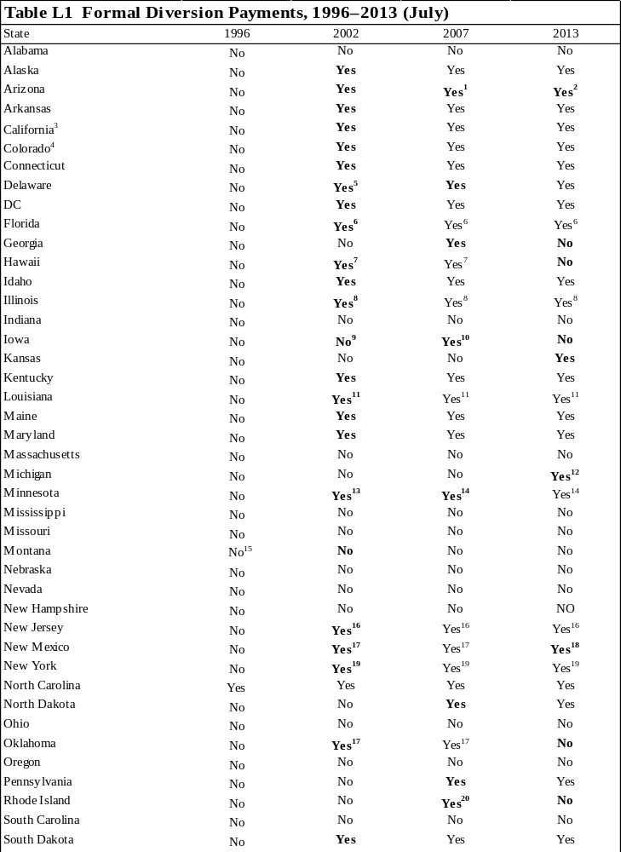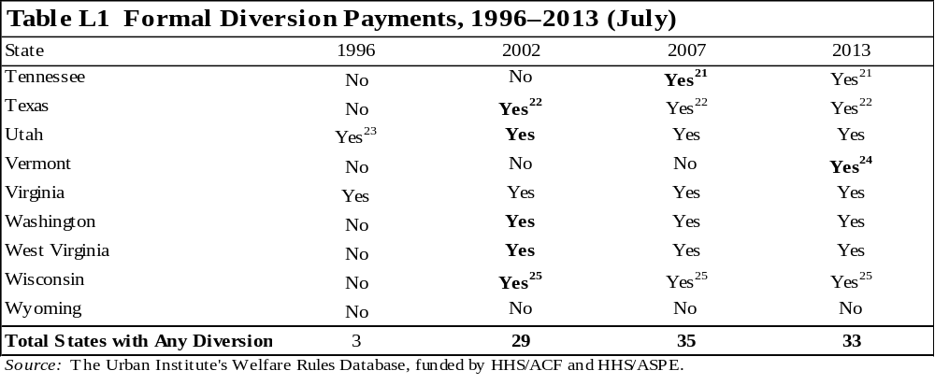
Note: Bolded text indicates a change from the previous year shown.

¹Eligibility for diversion assistance includes obtaining employment or an offer of employment. In select local offices participating in a pilot program, individuals must be referred to a jobs program assessment for job search assistance before approval for diversion assistance.
² To be eligible, applicants must be employed full time, have an offer of full-time employment, or be likely to gain full-time employment based on education, skills, and work history. Applicants must also have a short-term verified financial need that is a barrier to achieving self-sufficiency, such as needing car repairs, child care, work clothes, overdue housing expenses, or transportation assistance.
³ Counties have the option to vary their diversion programs. These policies refer to Los Angeles County.
⁴ Counties have the option to vary their diversion programs. These policies refer to Denver County.
⁵ The state's diversion program is related to retaining or obtaining employment and is only for parents living with natural or adopted children.
⁶ Florida has three separate diversion programs. Up-front diversion is for individuals in need of assistance because of unexpected circumstances or emergency situations. Relocation assistance is available for individuals who reside in an area with limited employment opportunities and experience one of the following: geographic isolation, formidable transportation barriers, isolation from extended family, or domestic violence that threatens the ability of a parent to maintain self-sufficiency. Early exit diversion is available to TANF recipients if they meet the following criteria: they are employed and receiving earnings, they are able to verify their earnings, will remain employed for at least six months, they have received cash assistance for at least six consecutive months since October 1996, and they are eligible for at least one more month of TANF.
⁷ To be eligible for diversion assistance, a household must include at least one work-eligible individual as defined by the state, include one adult who has a work history of at least 6 months in the 36 months before the month of request for diversion assistance, and must be eligible for cash assistance in the month the diversion assistance was issued.
⁸ An applicant who has found a job that will make him or her ineligible for cash assistance or who wants to accept the job and withdraw his or her application for assistance is eligible for a one-time payment to begin or maintain employment.
⁹ Diversion offered through a limited pilot program.
¹⁰ To receive diversion assistance, applicants must either be in danger of losing employment or have evidence of barriers to accepting a verified offer of employment. Also, countable income must be at or below 200 percent of the federal poverty level.
¹¹ Although it still exists in the law, Louisiana's diversion program has not received funding since September 2002. According to the legislation authorizing the program, a recipient can receive a cash payment worth up to four months of TANF benefits and is subsequently ineligible for TANF for four months without a penalty after receiving diversion. An individual can receive diversion payments twice in a lifetime, but no more than once every 12 months.
¹² To receive diversion assistance, applicants must meet cash assistance eligibility criteria in the application month or the following month, except participation in required work activities. The program targets families who are normally self-sufficient, have not received cash or diversion assistance payments from any state in the past 12 months, expect to need assistance only for a short time, and are able to return to self-sufficiency without further assistance. Decisions about diversion eligibility criteria are made case by case.
¹³ To be eligible for the diversion program, the assistance unit must meet all the following criteria: (1) at least one family member has lived in Minnesota for at least 30 days; (2) the caregiver has lost a job, is unable to obtain a job, or has a temporary loss of income, and this loss of income is not a result of refusing suitable employment without good cause; (3) the family is at risk of MFIP eligibility if assistance is not provided; and (4) the family is not eligible for emergency assistance.
¹⁴ Minnesota's Diversionary Work Program (DWP) is mandatory for most TANF applicants. DWP consists of four months of intensive employment services, focused on helping the participant obtain an unsubsidized job before entering welfare.
¹⁵ Montana conducted a pilot project in eight counties that provided diversion assistance to its clients.
¹⁶ New Jersey's diversion program, the Early Employment Initiative (EEI), is mandatory for applicants who have a work history that equals or exceeds four months of full-time employment in the past 12 months, appear to meet TANF eligibility requirements, are not in immediate need, and do not meet criteria for a deferral from work requirements. Participants receive a one-time, lump-sum payment and are required to pursue an intensive job search for 15 to 30 days while their application is processed. If participants obtain employment and withdraw their application, they are eligible to receive a second lump-sum payment to assist in the transition to employment. If no employment is secured, the applicant is referred back to the Work First New Jersey (WFNJ)/TANF agency for cash assistance.
¹⁷ The diversion payment is only available to assist applicants in keeping a job or accepting a bona fide offer of employment.
¹⁸ The diversion payment is only available to assist applicants in keeping a job, accepting a bona fide offer of employment, or remedying an emergency situation or an unexpected short-term need.
¹⁹ New York has three types of diversion payments: diversion payments (for crisis items such as moving expenses, storage fees, or household structural or equipment repairs), diversion transportation payments (for employment-related transportation expenses), and diversion rental payments (for rental housing).
²⁰ To be eligible, the applicant must not have received assistance payments during the 12 months before the date of application, and the adult in the unit must not have terminated employment within 60 days of application for benefits.
²¹ To be eligible, the applicant must have an identifiable one-time financial need, have been a resident of Tennessee for 6 months, have not received cash assistance in any state in the past two years, have never received a diversion payment in any state, have no identifiable barriers to employment, have earned a high school diploma or GED, and either be currently employed or have been steadily employed in 6 of the last 12 months, with at least 3 being consecutive. In two-parent units, both parents must meet the eligibility criteria to qualify for a diversion payment.
²² To qualify for the state's diversion program, the assistance unit must meet one of the crisis criteria, including (1) the caretaker or second parent lost employment in the process month, application month, or two months before application; (2) a dependent child experienced a loss of financial support from the legal parent or stepparent within the past 12 months as a result of death, divorce, separation, abandonment, or termination of child support and the caretaker was employed within 12 months of the application or process month; (3) the caretaker or second parent graduated from a university, college, junior college, or technical training school within 12 months of the application or process month and was underemployed or unemployed; or (4) the caretaker and/or second parent is currently employed but still meets TANF requirements and is facing the loss or potential loss of transportation and/or shelter or has a medical emergency temporarily preventing him/her from continuing to work. If the unit has an open TANF activity requirement sanction and fails to demonstrate cooperation within the allowed time or is not eligible for a TANF grant of at least $10, the unit is ineligible for diversion assistance.
²³ Utah phased 50 percent of the caseload into the diversion program in 1996, and then the remainder in 1997.
²⁴ To be eligible for diversion assistance, an applicant family must meet cash assistance financial eligibility and diversion eligibility criteria and, if it has no members who are mandatory applicants, must choose to participate in the diversion program. Families who meet the following criteria are mandatory applicants: (1) at least one member of the family is work eligible, (2) work-eligible individuals in the family are neither disregarded from nor meeting their cash assistance work requirement, (3) none of the work-eligible individuals have received a diversion assistance payment in the 12 months before the application month, and (4) at least one work-eligible adult is part of a two-parent family, has recent and stable employment with earnings of at least 150 percent of the federal poverty level, or has a marketable college degree or vocational education certificate.
²⁵ The diversion payment is considered a loan to assist with expenses related to obtaining or maintaining employment, and it must be repaid. Repayments are expected within 12 months but may be extended to 24 months. The loan may be paid back in cash or through a combination of cash and volunteer community service (valued at the higher of the state or federal minimum wage).
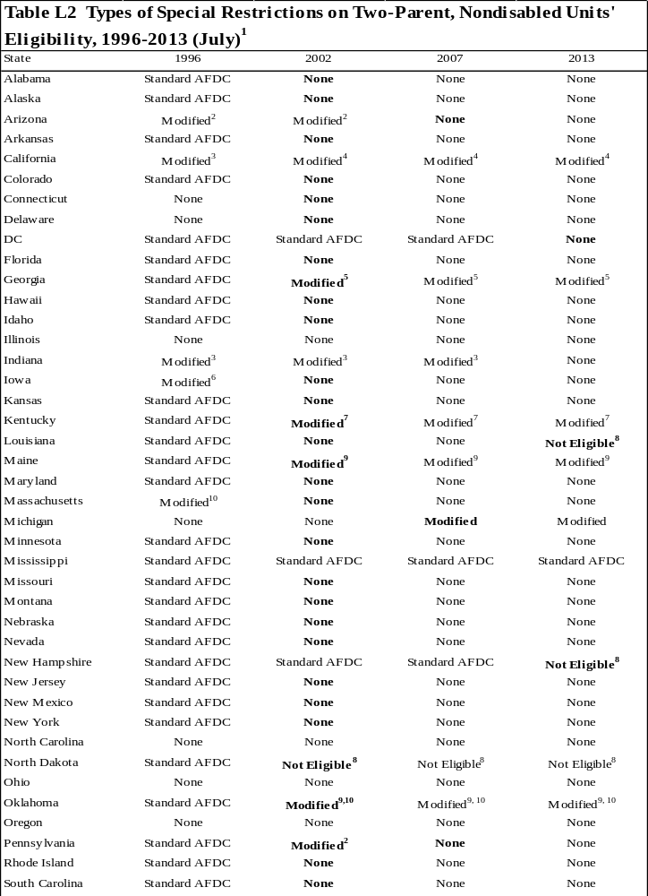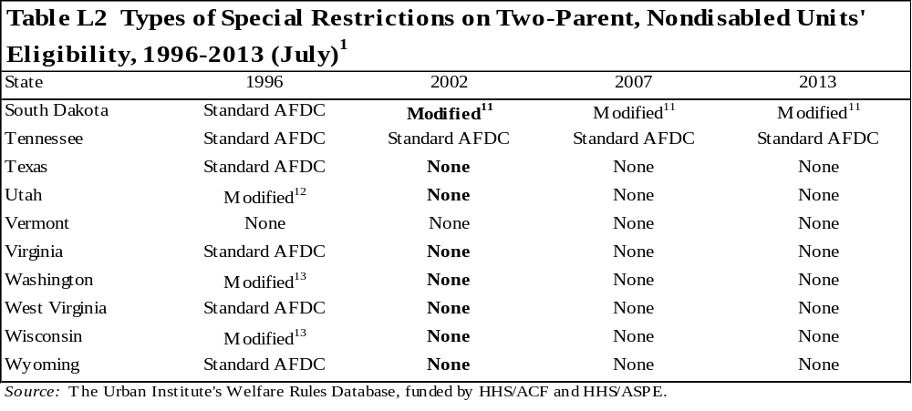Notes: Standard AFDC rules for two-parent units include the following: (1) a 100-hour limit on work for both applicants and recipients, (2) applicants must have worked in at least 6 of the last 13 calendar quarters before application, and (3) applicants must have been unemployed for a minimum of 30 days before application.

Bolded text indicates a change from the previous year shown.

¹ The special restrictions considered in this table include limits on work hours for applicants and recipients, work history requirements, and waiting period restrictions. The combination of restrictions does not, however, include any variation in state programs from special time limits that apply only to two-parent units.
² Modified rules for two-parent units: 6 of the last 13 quarters work history.
³ Modified rules for two-parent units: 100-hour work limit for applicants only, 6 of the last 13 quarters work history, and 30-day waiting period.
⁴ Modified rules for two-parent units: applicants must have been employed less than 100 hours during the four weeks before the date of application.
⁵ Modified rules for two-parent units: must be connected to the workforce, which includes (1) currently working at least 20 hours a week; (2) receiving unemployment compensation; (3) unemployed or working less than 20 hours a week and has earned at least $500 within the six months before application; (4) receiving retirement benefits; or (5) received disability benefits based on 100 percent disability in any of the last six months.
⁶ Modified rules for two-parent units: 30-day waiting period. The determination of primary earner was also eliminated, meaning although there is no limit to the number of hours either parent can work, they are still subject to unemployment classifications depending upon the number of hours they work. If one parent is working more than 100 hours, then the family may not receive assistance for 30 days. If both parents are working less than 100 hours then the assistance begins 30 days from the date either one of the parents worked more than 100 hours. This applies to both applicants and recipients.
⁷ Modified rules for two-parent units: 100-hour work limit for applicants, applicant must have earned at least $1,000 during the 24-month period before the month of application, and 30-day waiting period. Two semesters of full-time attendance in a postsecondary institution may be substituted for $500 of the $1,000.
⁸ The state does not provide benefits to two-parent, nondisabled units.
⁹ Modified rules for two-parent units: 100-hour work limit for applicants, 130-hour work limit for recipients, 6 of the last 13 quarters work history, and 30-day waiting period.
¹⁰ Modified rules for two-parent units: 6 of the last 13 quarters work history and 30-day waiting period.
¹¹ Modified rules for two-parent units: 100-hour work limit for applicants, 100-hour work limit for recipients, and applicants must have a combined (both parents) gross income over the past six months equal to at least $1,500. Parents must not have terminated employment, reduced hours worked, or refused a job offer within the previous six months (without good cause).
¹² Modified rules for two-parent units: 30-day waiting period.
¹³ Modified rules for two-parent units: 100-hour work limit for applicants, no work limit for recipients, 6 of the last 13 quarters work history, and 30-day waiting period.
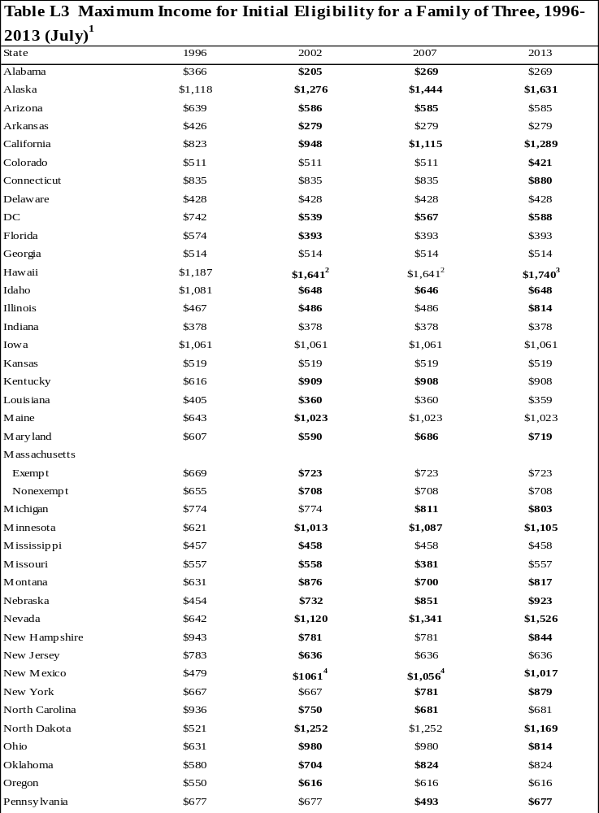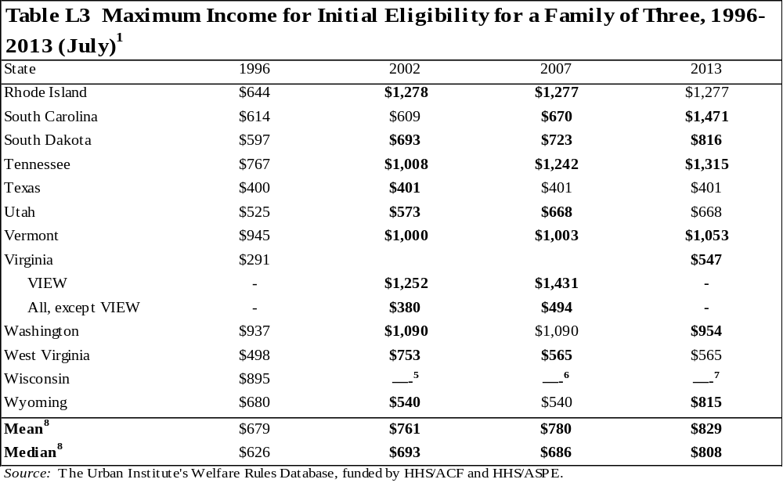
Notes: Initial eligibility is calculated assuming that the unit is employed at application, has only earned income, has no child care expenses, contains one adult and no children subject to a family cap, has no special needs, pays for shelter, and lives in the most populated area of the state

Bolded text indicates a change from the previous year shown.

¹ The values in this table represent the maximum amount of earnings an applicant can have and still be technically eligible for assistance in each state. Technical eligibility does not mean that the unit will necessarily receive a cash benefit, but it will have passed all the eligibility tests and is eligible for some positive amount. Most states only distribute a cash benefit equaling $10 or more.
² Applies to units that have received assistance for no more than two months in a lifetime. For units applying for their third and subsequent months of benefits, the eligibility threshold for a family of three is $1,362.
³ Applies to units that have received assistance for no more than two months in a lifetime. For units applying for their third and subsequent months of benefits, the eligibility threshold for a family of three is $1,441.
⁴ For purposes of the state's earned income disregard, the adult head is assumed to be working 40 hours a week.
⁵ Units with full-time employment (generally greater than 30 hours a week) will not receive a cash benefit in the state. There are provisions to provide prorated benefits to Community Service Jobs participants who are also employed part-time at an unsubsidized job. These eligibility determinations are made on a case-by-case basis. Recipients may earn up to $1,439 and still be eligible for nonfinancial assistance.
⁶ Units with full-time employment (generally greater than 30 hours a week) will not receive a cash benefit in the state. There are provisions to provide prorated benefits to Community Service Jobs participants who are also employed part-time at an unsubsidized job. These eligibility determinations are made on a case-by-case basis. Recipients may earn up to $1,645 and still be eligible for nonfinancial assistance.
⁷ Units with full-time employment (generally greater than 30 hours a week) will not receive a cash benefit in the state. There are provisions to provide prorated benefits to Community Service Jobs participants who are also employed part-time at an unsubsidized job. These eligibility determinations are made on a case-by-case basis. Recipients may earn up to $1,872 and still be eligible for nonfinancial assistance.
⁸ The calculations only include one value per state (the policy affecting the largest percent of the caseload), and the eligibility threshold for Wisconsin is included in the calculation.
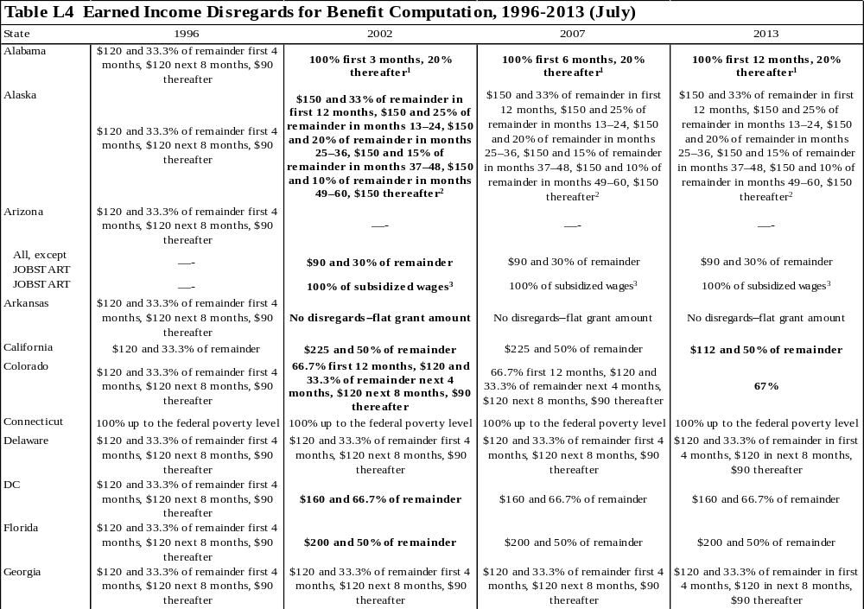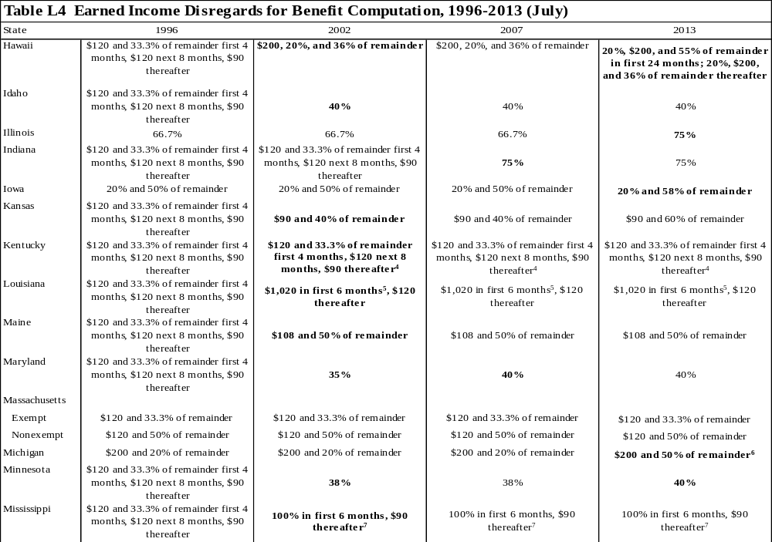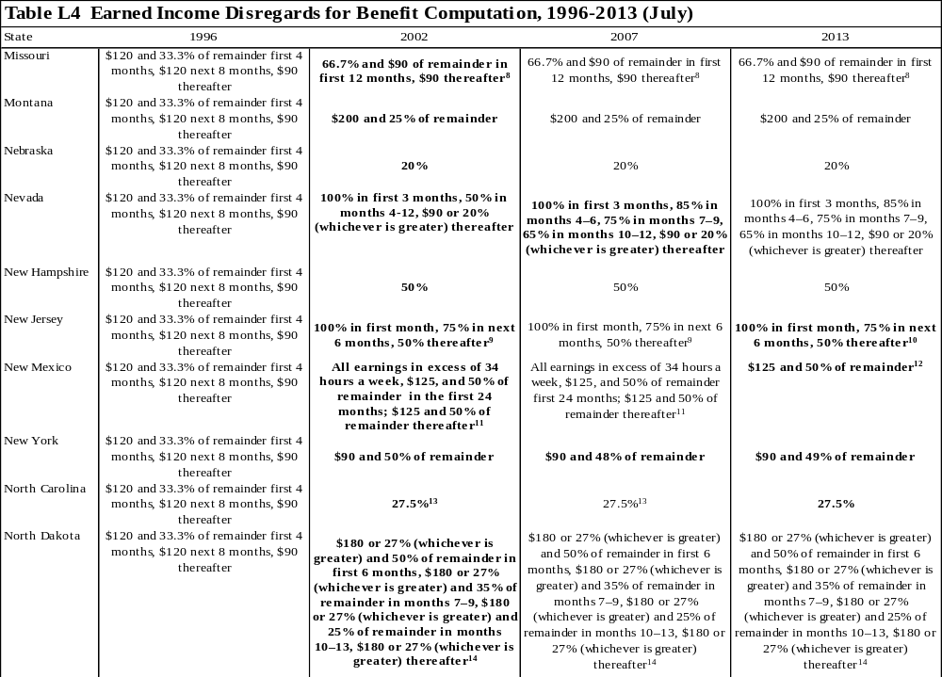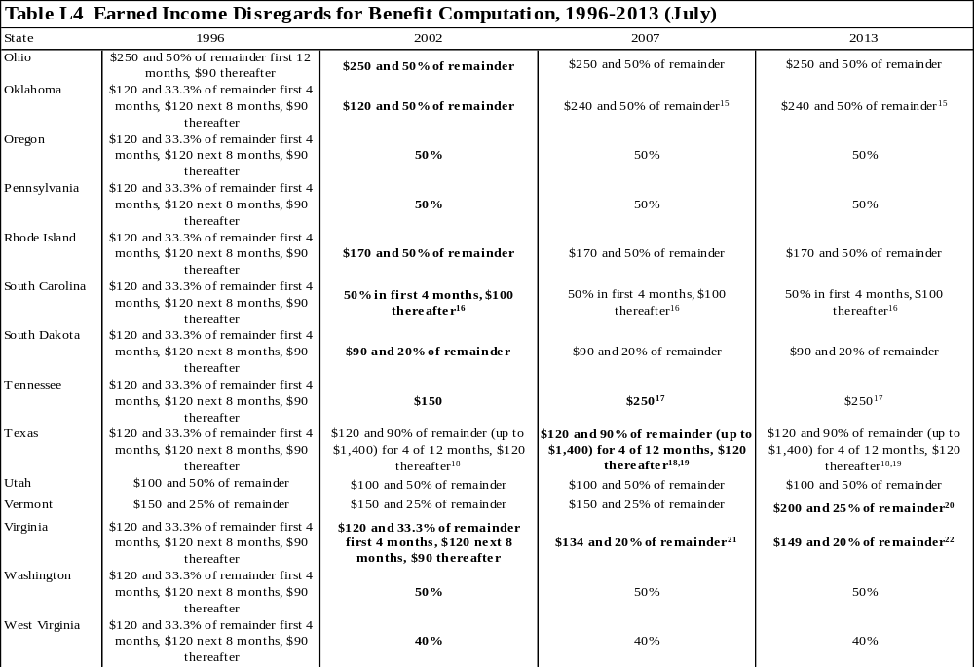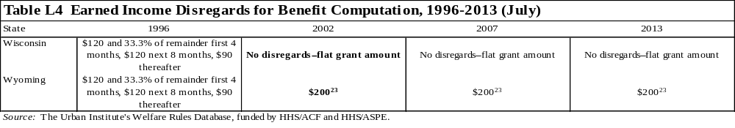
Notes: Only earned income disregards are described in the table. Child care disregards and other special disregards, such as deductions for units subject to a time limit or a family cap, are not included.

The table describes benefit computation disregards for recipients. If the disregards differ for applicants, it is footnoted.

Bolded text indicates a change from the previous year shown.
¹ The earned income disregard cannot be applied to the earnings of an individual receiving assistance beyond the 60th month under an exemption or extension. The disregard can only be applied to earnings reported within 10 days of receipt.
² If a recipient qualifies for an extension to the 60 month time limit, s/he is still eligible for this disregard.
³ In addition to the 100 percent disregard of all subsidized JOBSTART wages, recipients can disregard the standard $90 and 30 percent of the remainder for any non-JOBSTART earned income.
⁴ Recipients are eligible for the one-time 100 percent disregard if they become newly employed or report increased wages acquired after approval.
⁵ The six months in which the extra $900 is disregarded need not be consecutive, but the recipient may use this extra disregard in no more than six months over the course of his or her lifetime.
⁶ Applicants may disregard $200 and 20 percent of remainder.
⁷ Recipients are eligible for the one-time 100 percent disregard if they find employment of 35 hours a week within the first 30 days of their initial approval for TANF. If work is not found within 30 days, the recipient is ineligible to ever receive the disregard again. An additional 100 percent disregard is available to units for three months when the unit's case is subject to closure because of increased earnings and the individual is employed for at least 25 hours a week at the federal minimum wage or higher. The recipient may not have already received the six-month disregard, unless there has been at least a 12-month break in receipt of TANF benefits. The 3-month disregard may be received more than once during the 60-month TANF benefit period provided there is a period of at least 12 consecutive months in which a family does not receive TANF benefits before the family reapplies for assistance. Two-parent units may disregard 100 percent of earnings for the first 6 months, $120 and 33.3 percent in the next 12 months, and $90 thereafter. If a recipient marries for the first time, his or her new spouse may receive a one-time, 100 percent disregard for six consecutive months.
⁸ This policy applies only to recipients who become employed while receiving TANF. Applicants and recipients who gained employment before receiving TANF are allowed to disregard $120 and 33.3 percent of remainder for first four months, $120 next eight months, $90 thereafter.
⁹ These disregards apply to individuals working 30 or more hours a week. Individuals employed fewer than 30 hours a week may disregard 100 percent in the first month of employment and 50 percent thereafter. The 100 percent disregard is applicable only once every 12 months, even if employment is lost and then regained.
¹⁰ These disregards apply to individuals working 20 or more hours a week. Individuals employed fewer than 20 hours a week may disregard 100 percent in the first month of employment and 50 percent thereafter. However, if an individual's hours increase to 20 hours during the first six months, s/he may disregard 75 percent for the remainder of the six-month period. The 100 percent disregard is applicable only once every 12 months, even if employment is lost and then regained.
¹¹ Two-parent units may disregard all earnings in excess of 35 hours a week for one parent and 24 hours a week for the other parent, $225, and 50 percent in the first 24 months. Thereafter, they may disregard $225 and 50 percent of the remainder. The disregard for earnings in excess of the participation requirement only applies to recipients for the first 24 months of benefit receipt, for both single- and two-parent units.
¹² Two-parent units may disregard $225 and 50 percent of the remainder.
¹³ The 100 percent disregard is available only once in a lifetime and may be received only if the recipient is newly employed at a job that is expected to be permanent for more than 20 hours a week.
¹⁴ If a parent marries while receiving assistance, the income of his or her new spouse is disregarded for the first six months. The disregard for the new spouse only applies if his or her needs were not previously included in the unit.
¹⁵ These disregards apply to individuals working full time, defined as 20 hours a week for recipients caring for a child under age 6 and 30 hours a week for all other recipients. Individuals working less than full time may disregard $120 and 50 percent of the remainder.
¹⁶ The 50 percent disregard is available only once in a lifetime and may only be applied to consecutive months.
¹⁷ If a parent marries while receiving assistance, the unit may choose to exclude the new spouse from the unit for three months. At the end of the three-month period, however, the new spouse becomes a mandatory member of the assistance unit, and his or her income is counted in benefit computation calculations.
¹⁸ Once the recipient has received four months (they need not be consecutive) of the 90 percent disregard, s/he is not eligible to receive the disregard again until the TANF case has been denied and remains denied for 1 full month, and 12 calendar months have passed since the denial. The 12-month ineligibility period begins with the first full month of denial after the client used the 4th month of the 90 percent disregard.
¹⁹ The earnings of a TANF recipient's new spouse are disregarded for six months if the total gross income of the budget group does not exceed 200 percent of the federal poverty level.
²⁰ These disregards apply to recipients with income from unsubsidized employment or a combination of subsidized and unsubsidized employment. For recipients with earnings from subsidized employment only, the disregard is $90.
²¹ The disregard varies by family size; for one to three family members, the disregard is $134. For four members, the disregard is $139l for five members, the disregard is $162; and for six or more family members, the disregard is $186.
²² The disregard varies by family size; for one to three family members, the disregard is $149. For four members, the disregard is $160; for five members, the disregard is $187; and for six or more family members, the disregard is $214.
²³ Married couples with a child in common may disregard $400.
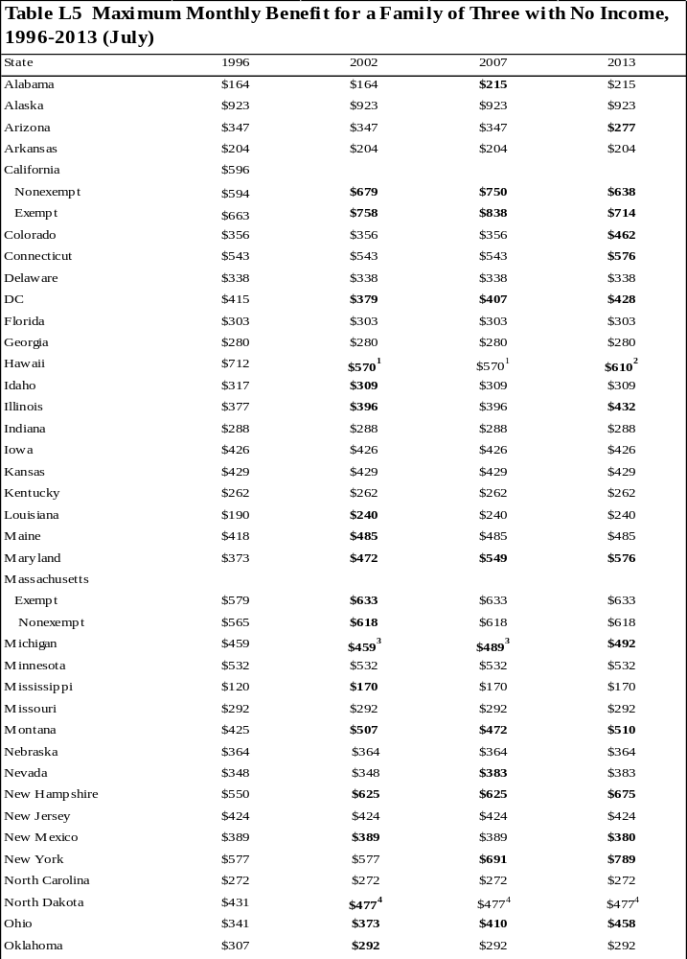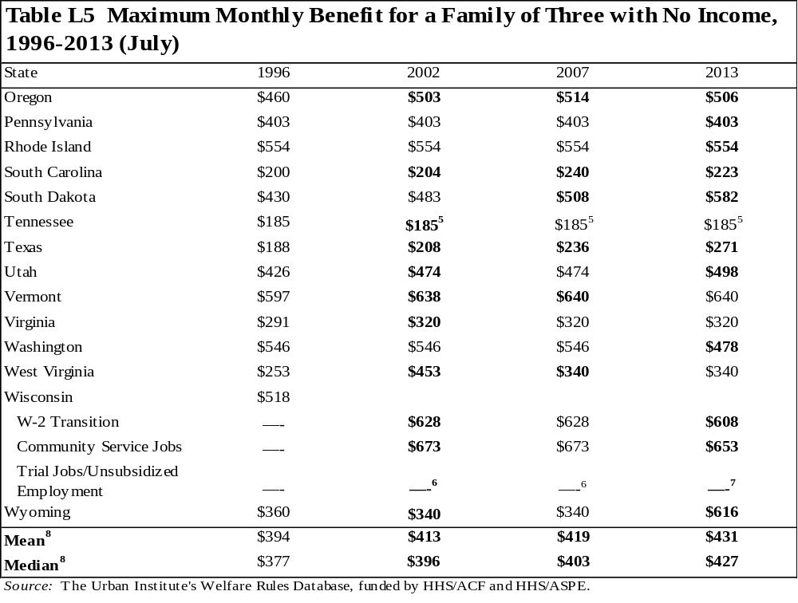
Notes: Maximum benefits are calculated assuming that the unit contains one adult and two children who are not subject to a family cap, has no special needs, pays for shelter, and lives in the most populated area of the state.

Bolded text indicates a change from the previous year shown.

¹ Applies to units who have received assistance for two or more months in a lifetime. For units applying for their first or second months of benefits, the maximum monthly benefit for a family of three is $712.
² Applies to units who have received assistance for two or more months in a lifetime. For units applying for their first or second months of benefits, the maximum monthly benefit for a family of three is $763.
³ Applies to units that have at least one employable adult. For units where all adults either receive SSI or are exempt from work requirements for reasons other than caring for a child under three months old, the maximum monthly benefit for a family of three is $477.
⁴ This amount includes a $50 increase to the payment standard given to units who pay for shelter.
⁵ For units where the caretaker is over 65, disabled, caring full-time for a disabled family member, or excluded from the assistance unit, the maximum monthly benefit for a family of three is $232.
⁶ The benefits in these components are based on the wages earned by individual recipients.
⁷ Trial Jobs was discontinued as a component in June 2013.
⁸ The calculations only include one value per state (the policy affecting the largest percent of the caseload).
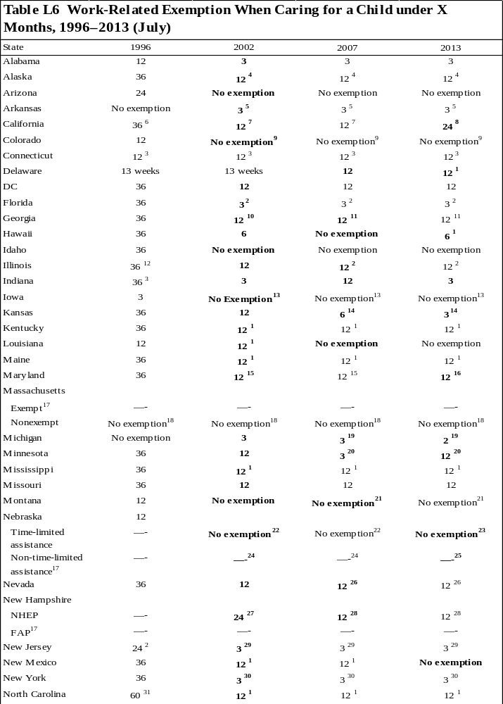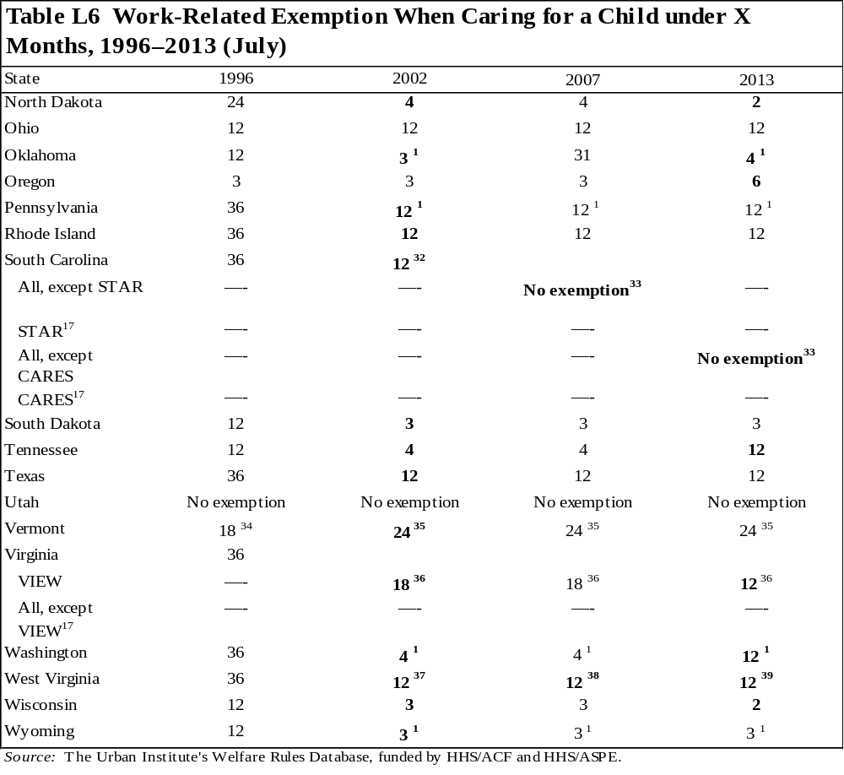
Notes: This table refers to single-parent unit heads over 21 years old.

Bolded text indicates a change from the previous year shown.

¹ The exemption is limited to 12 cumulative months in the recipient's lifetime.
² Recipients may be required to attend classes or other activities.
³ The exemption applies only if the child is not subject to a family cap.
⁴ The exemption is limited to 12 cumulative months in the recipient's lifetime. While the caretaker is exempt, s/he may be required to participate in self-sufficiency activities.
⁵ A parent loses this exemption after retaining it for 12 cumulative months. Months in which the parent is exempt because child care is unavailable for a child less than 12 months old also count toward the 12-month lifetime limit.
⁶ This exemption is limited to one child during a period of continuous TANF eligibility, where continuous is defined as receiving welfare without a break of at least six consecutive months.
⁷ The recipient may only receive this exemption once; however, s/he may also receive a limited exemption for a second or subsequent child under 6 months old.
⁸ Recipients may receive an exemption for caring for a child less than 24 months of age. This is a once in a lifetime exemption, though subsequent exemptions are available for children under 6 months old. This is a statewide exemption.
⁹ A recipient caring for a child under the age of 6 may not be sanctioned if the individual has a demonstrated inability to obtain child care.
¹⁰ The exemption is limited to once in the recipient's lifetime.
¹¹ Single custodial parents can have one 3-month exemption per child up to a cumulative total of 12 months.
¹² This exemption does not apply to units in which the youngest related child is age 13 or older.
¹³ Although recipients are not exempt, they may be absent from work without sanction if they have a newborn child. Absence from activities is determined using the standards of the Family and Medical Leave Act of 1993. The maximum time available for one parent is 12 workweeks during any 12-month period and for two parents is the aggregate of 12 workweeks of leave for both parents.
¹⁴ The exemption cannot be claimed by any adult in the unit when at least one adult has reached the 48th month of cash assistance.
¹⁵ This is a one-time exemption for the first child only. A single parent caring for a child under age 6 who is unable to obtain child care may be exempt.
¹⁶ The exemption is limited to 12 cumulative months in the recipient's lifetime. A single parent caring for a child under the age of 6 who is unable to obtain child care may be exempt.
¹⁷ Recipients in this component are automatically exempt from activities requirements. See appendix 1 for more information on the composition of the component.
¹⁸ Individuals caring for a child under 2 years old are placed in an alternative component. See appendix 1 for more information on components.
¹⁹ Women are exempt from activities requirements when the newborn is in the home or for postpartum recovery when the newborn is not in the home.
²⁰ The exemption applies only once in a lifetime.
²¹Although it is technically not an exemption, individuals caring for a newborn child may count this activity toward participation requirements for two full months following the child's birth. The lifetime limit for this activity is 12 months.
²² Recipients caring for children under 3 months old are placed in an alternative component. See appendix 1 for more information on components.
²³ Recipients caring for children under 12 weeks old are placed in an alternative component. See appendix 1 for more information on components.
²⁴ Although recipients caring for children between 3 and 6 months old are in the non-time-limited assistance component, they are expected to participate in limited work activities. Recipients caring for a child under three months are exempt. See appendix 1 for more information on components.
²⁵ Recipients caring for a child under 3 months old are exempt and would be non-time-limited for the period they qualify for this exemption. This exemption can be extended if a written statement from the attending physician states that the parent requires additional postpartum recovery time, or special medical conditions of the child require the presence of at least one parent or needy caretaker relative, guardian, or conservator. See appendix 1 for more information on components.
²⁶ There is an allowed exemption of three months per child. There is a 12-month cumulative limit.
²⁷ Recipients who have received 39 or more months of assistance will not receive a child care exemption. Recipients who conceive a child while on assistance are exempt only until the child is 12 months old.
²⁸ The exemption is limited to 12 cumulative months in the recipient's lifetime. If the recipient has received the 12-month exemption and has an additional child, the unit must participate in NHEP until the child is 12 weeks old. Recipients who have received TANF assistance for 39 or more months are not eligible for this exemption.
²⁹ The exemption may be extended if a physician certifies it is medically necessary for the parent or child.
³⁰ The exemption may last for no more than 12 months in a recipient's lifetime and it may not last for more than three months for any one child unless the social services official determines to extend the exemption for up to the total 12 months.
³¹ The exemption does not apply to parents who are working more than 30 hours a week. These parents are automatically enrolled into the Work First component and are subject to activities requirements.
³² The exemption does not apply to individuals under the age of 25 without high school diplomas or GEDs.
³³ A parent personally providing care for his/her child under age 1 will be expected to participate in the work program but cannot be sanctioned for failure to do so.
³⁴ The parent is exempt from working but must participate in the Reach Up program.
³⁵ Work requirements may be modified or deferred for recipients caring for a child under 24 months old. The work requirement cannot be deferred for more than 24 months during a lifetime. However, recipients who have exhausted the 24-month exemption and are caring for a child under 13 weeks old may receive a work exemption.
³⁶ The exemption is limited to 12 cumulative months in the recipient's lifetime. The caretaker can be exempt for a maximum of six additional weeks if s/he has another child after the limit expires. Recipients caring for a child subject to a family cap are only exempt while the child is under 6 weeks old.
³⁷ The exemption applies only to the birth of a first child. The recipient is exempted for only six months after the birth of any additional child (the six months include any time the recipient chooses to be exempt during pregnancy).
³⁸ The exemption is limited to six months for each child and may be taken at any time while the child is under 12 months old.
³⁹ The state does not consider these groups technically exempt; however, they may meet the state's criteria for good cause for noncompliance or deferral. This is a one-time exemption and may be taken any time while the child is under 12 months. In addition, all mothers are eligible for a 12-week postpartum exemption following the birth of any additional child.
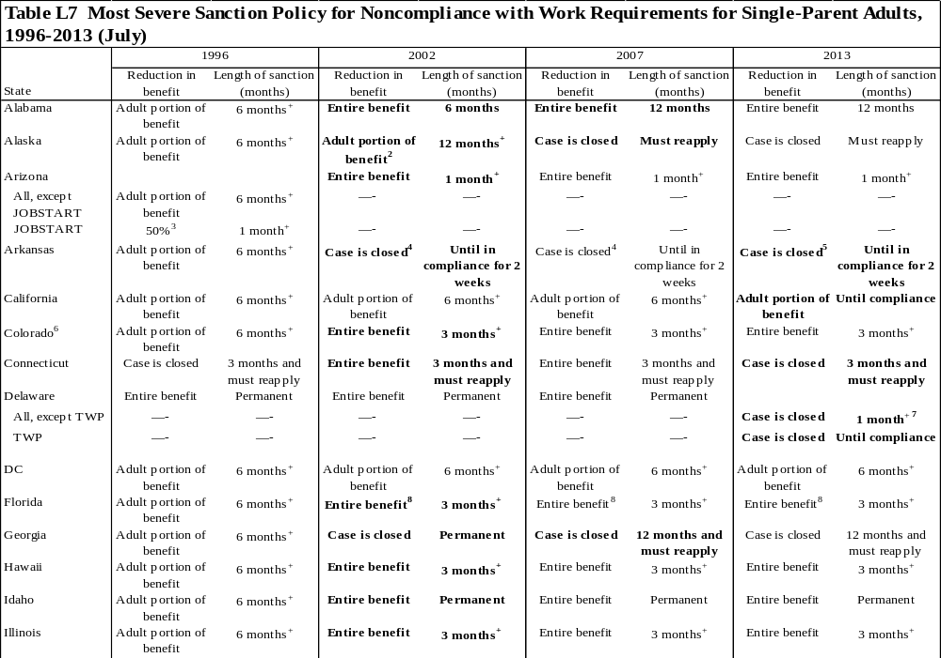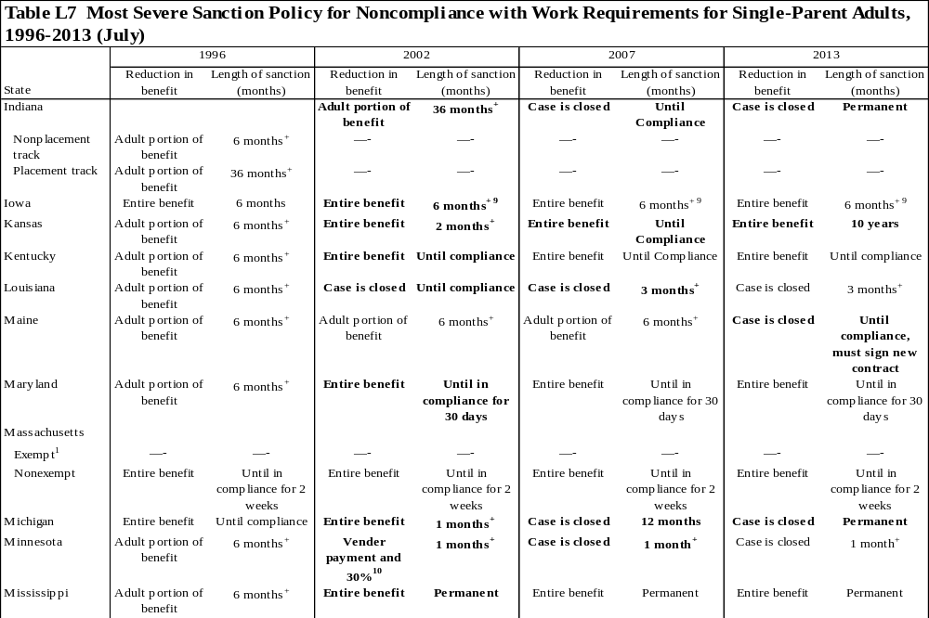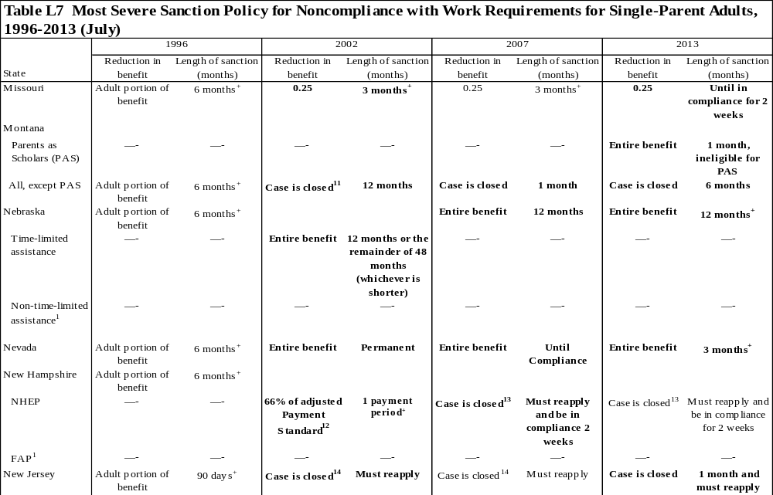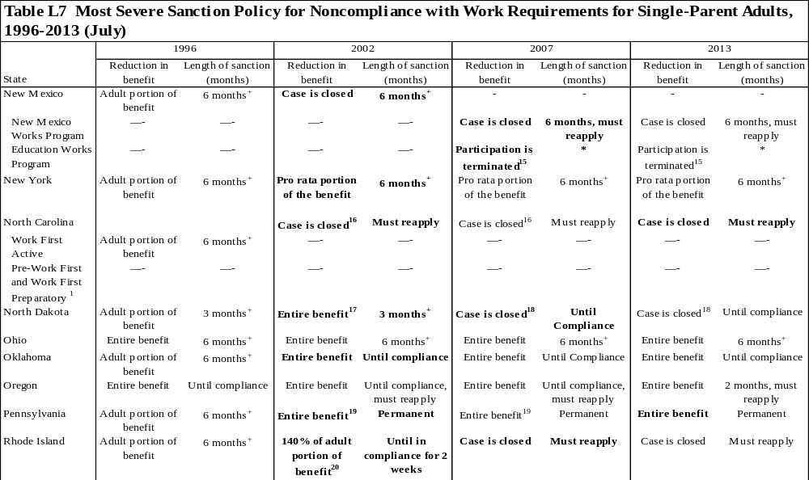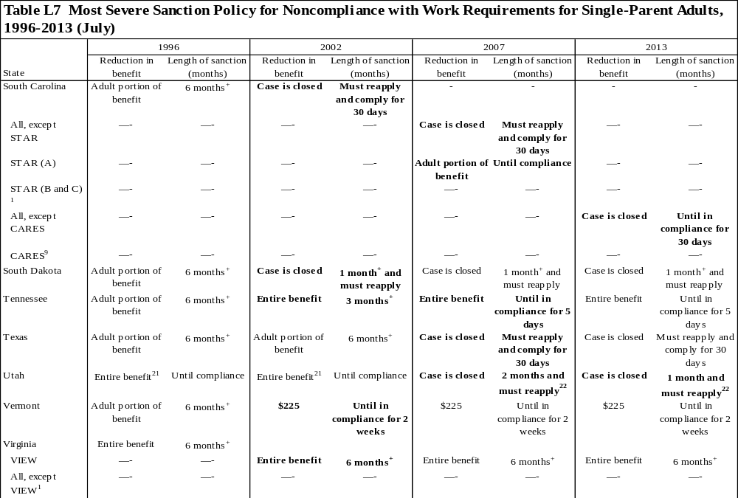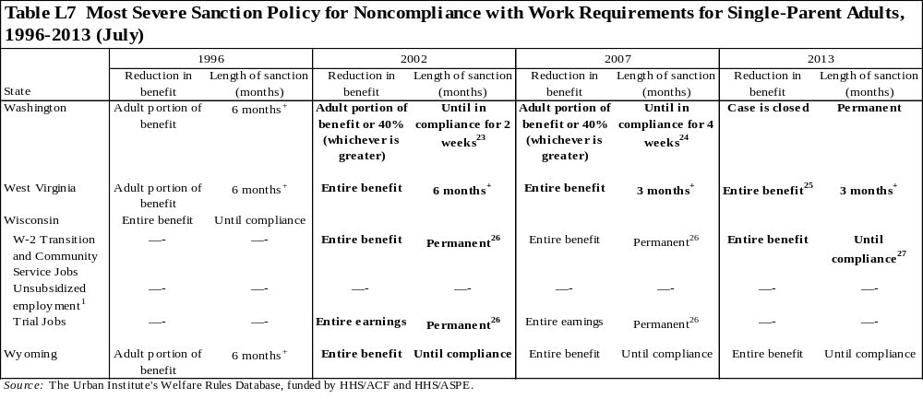
Notes: "Adult portion of benefit" describes the portion of the benefit the sanctioned individual would have received. Because the table only represents sanctions for single-parent adults, in all cases the sanctioned individual is an adult.

Bolded text indicates a change from the previous year shown.

+ The unit is sanctioned for the specified number of months or until the sanctioned individual complies with the activity requirements, whichever is longer.

* Data not obtained

¹ Recipients in this component are not required to participate in work activities; therefore, they are not subject to sanctions (see appendix 1 for a description of components).
² The adult portion of the benefit is calculated by subtracting the child-only need standard for a one-person household from the adult-included need standard for a two-person household.
³ The participant will be removed from the JOBSTART program but will be eligible to participate in the non-JOBSTART component.
⁴ For the seventh and subsequent months of noncompliance, the caseworker has discretion to either reduce the unit's benefits by 50 percent or close the case. If the case is closed, the unit may reapply for its full benefits, but the application will be pending until the unit complies with requirements for two weeks.
⁵ If the case is closed, the unit may reapply for its full benefits, but the application will be pending until the unit has complied with requirements for two weeks.
⁶ Counties have the option to determine the amount and duration of sanctions. These policies refer to Denver County.
⁷ The unit is sanctioned for one month or until the sanctioned individual complies with the activity requirements for four consecutive weeks, whichever is longer.
⁸ Assistance may still be provided to children under age 16 in the unit; these benefits are issued to a protective payee.
⁹ The sanctioned parent must also sign a family investment agreement and complete 20 hours of eligible education or work activities to become eligible again. The sanction continues until the parent fully complies.
¹⁰ The shelter costs are paid directly to the vendor; any remaining amount of benefit is reduced by 30 percent of the transitional standard. Vendor payments continue for six months after the month in which the parent complies.
¹¹ When a recipient fails to comply for the fourth or subsequent time, the needs of the individual are removed and the benefit is paid to a protective payee. The individual is sanctioned for 12 months. If a new contract has not been negotiated by one month after the end of the sanction period, the case is closed for noncompliance. The unit may reapply for benefits after a one-month period of ineligibility.
¹² The adjusted payment standard refers to the new benefit amount once the adult portion is removed.
¹³ If a unit accrues 3 months of sanctions in any 12-month period, the case may be closed. Any portion of a month counts as one full month.
¹⁴ This sanction applies to noncompliance that continues for three or more months. If the adult is noncompliant for less than three months, the pro rata share is removed, but the case remains open.
¹⁵ The program participant is placed on probation if s/he has not met program requirements. At the end of the probationary period, if standards have not been met or an overall GPA of 2.5 has not been achieved, the department may take action to terminate an individual's participation in the Education Works program.
¹⁶ This sanction applies to noncompliance that continues for three or more months. If the adult is noncompliant for less than three months, the entire benefit is removed, but the case remains open.
¹⁷ If the adult is noncompliant for less than four months, only the adult portion of the benefit is removed. If noncompliance continues after four months of reduced benefits, the entire unit is ineligible for benefits.
¹⁸ If the adult is noncompliant for one month or less, only the adult portion of the benefit is removed. If noncompliance continues after one month of reduced benefits, the case is closed. The case can be closed for no longer than 12 months.
¹⁹ This sanction applies to noncompliance that occurs after the first 24 months of assistance. For instances of noncompliance occurring within the first 24 months of assistance, the needs of the sanctioned individual are permanently excluded for benefit calculation purposes.
²⁰ If the individual is noncompliant for 1 to 6 months, 110 percent of the parent's benefits is reduced from the unit's benefit. For 7 to 12 months of noncompliance, 120 percent of the parent's benefits is reduced from the unit's benefit. Months 13–18, 130 percent reduction. Months 19–24, 140 percent reduction. Following 24 months of noncompliance, the reduction is decreased to 100 percent of the parent's benefit, but the entire remaining benefit must be made to a protective payee. The individual is sanctioned until s/he is in compliance for two weeks.
²¹ The entire unit is ineligible if the adult is in noncompliance for two or more months. If the adult is noncompliant for less than two months, only $100 of the benefit is removed.
²² The unit must also complete a trial participation period before it is eligible to receive benefits again.
²³ The sanction remains in effect until the individual is compliant for two weeks; after two weeks of compliance, benefits are restored to their pre-sanction level and the individual is paid retroactively for the two weeks of compliance.
²⁴ The sanction remains in effect until the individual is compliant for four weeks; after four weeks of compliance, benefits are restored to their pre-sanction level.
²⁵ If a nonexempt member of the unit does not comply with work requirements after receiving assistance for 24 months, the case is closed.
²⁶ Wisconsin has multiple components (see appendix 1 for description of components). If a recipient refuses to participate in an activity, s/he is permanently ineligible for benefits in that component. The unit may receive benefits again if it becomes eligible for one of the other components. There is no permanent sanction for individuals in unsubsidized employment.
²⁷ The sanction remains in effect until the individual is compliant for four weeks; after four weeks of compliance, benefits are restored to their pre-sanction level. If after four months the individual is still in sanction, the case is closed. If the case is reopened sanctions will continue where they left off when the case closed.
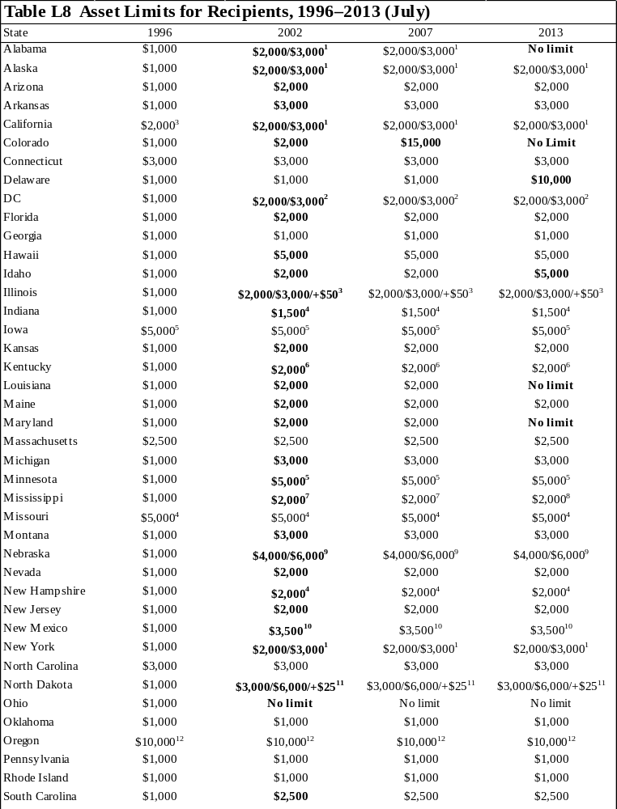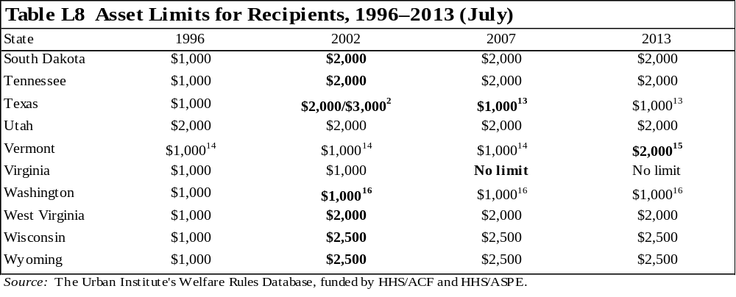 Notes: This table describes the asset limits for recipients. If the exemptions differ for applicants, it is footnoted.

Bolded text indicates a change from the previous year shown.

¹ Units including an elderly person may exempt $3,000; all other units exempt $2,000.
² Households including an elderly or disabled person may be exempt $3,000, regardless of whether that person is in the assistance unit. All other units exempt $2,000.
³ The asset limit is based on unit size: one person receives $2,000, two people receive $3,000, and three or more receive $3,000 plus $50 for each additional person.
⁴ The asset limit for applicants is $1,000.
⁵ The asset limit for applicants is $2,000.
⁶ Only liquid resources are considered for eligibility determinations. Liquid resources include cash, checking and savings accounts, CDs, stocks and bonds, and money market accounts.
⁷ When a TANF recipient marries for the first time while receiving assistance, the resources of the new spouse are disregarded for six consecutive months. This is a one-time, lifetime disregard.
⁸ If the unit is considered broad-based categorically eligible, it is not subject to asset limits. In addition, when a TANF recipient marries for the first time while receiving assistance, the resources of the new spouse are disregarded for six consecutive months. This is a one-time, lifetime disregard.
⁹ The asset limit is based on unit size: the limit for one person is $4,000, and the limit for two or more people is $6,000.
¹⁰ The total limit is $3,500; however, only $1,500 of that amount can be in liquid resources and only $2,000 can be in nonliquid resources. Liquid resources include the (convertible) cash value of life insurance policies, cash, stocks, bonds, negotiable notes, purchase contracts, and other similar assets. Nonliquid resources include nonexempt vehicles, equipment, tools, livestock (with the exception of nonsalable domestic pets), one-time sale asset conversion, and lump sum payments.
¹¹ The asset limit is based on unit size: one person receives $3,000, two people receive $6,000, and another $25 is allowed for each additional person thereafter.
¹² The limit is reduced to $2,500 if the recipient does not cooperate with his or her case plan. The asset limit for applicants first applying for TANF is $2,500. If the applicant makes it through the first stage of application, s/he must participate in the assessment program, in which he or she is assessed and given a case plan to follow. If the applicant does not follow the case plan, s/he maintains the $2,500 asset limit as long as s/he is in the assessment program. If the applicant complies with the case plan, s/he is allowed a $10,000 asset limit.
¹³ When a TANF recipient marries while receiving assistance, the liquid resources of the new spouse are excluded for six months beginning the month after the date of the marriage. To receive the disregard, the resources must result from the new spouse's earnings and total gross income must not exceed 200 percent of the federal poverty level.
¹⁴ In addition to the $1,000 asset limit, assets accumulated from earnings, interest earned on those assets, and nonliquid assets purchased with savings from earnings and other excluded income or resources are excluded as a resource.
¹⁵ In addition to the $2,000 asset limit, assets accumulated from earnings, interest earned on those assets, and nonliquid assets purchased with savings from earnings and other excluded income or resources are excluded as a resource.
¹⁶ $3,000 in a savings account or certificates of deposit may also be excluded.

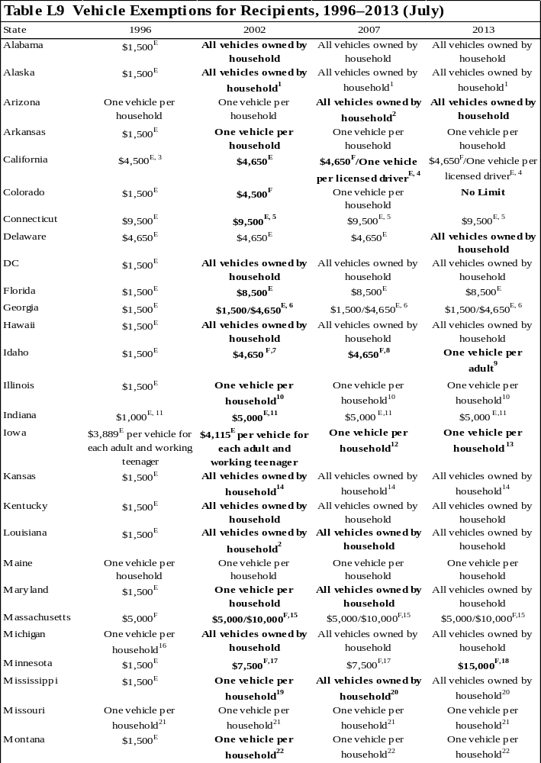
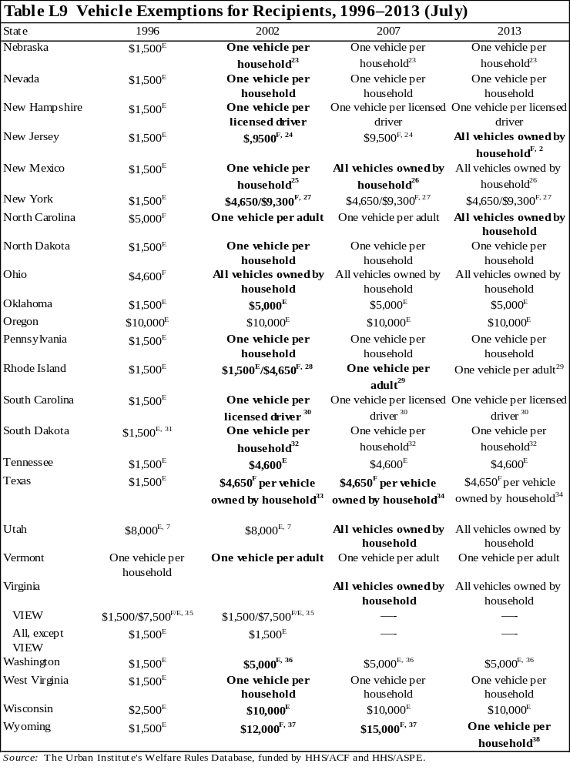
^{E} Equity value of the vehicle.
^{F} Fair-market value of the vehicle.

Notes: This table describes the vehicle exemptions for recipients. If the exemptions differ for applicants, it is footnoted.

Bolded text indicates a change from the previous year shown.

¹ Vehicles are exempt if used for one of the following: (1) to meet the family's basic needs, such as getting food and medical care or other essentials; (2) to go to and from work, school, training, or work activity (such as job search or community service); (3) as the family's house; (4) to produce self-employment income; or (5) to transport a disabled family member, whether or not he or she is a part of the assistance unit. If the vehicle does not meet one of these requirements, the equity value of the vehicle is counted in the determination of resources.
² Recreational vehicles are not exempt.
³ Applicants may only exempt $1,500 of the equity value of a vehicle.
⁴ Each vehicle must be evaluated for both its equity and fair-market values; the higher of the two values counts against the family's asset limit. Before this calculation, all the following vehicles are completely excluded: (1) vehicles used primarily for income-producing purposes, (2) vehicles that produce annual income consistent with its fair-market value, (3) vehicles necessary for long-distance travel that is essential for employment, (4) vehicles used as the family's residence, (5) vehicles necessary to transport a physically disabled household member, (6) vehicles that would be exempt under previously stated exemptions but it is not in use because of temporary unemployment, (7) vehicles used to carry fuel or water to the home and is the primary method of obtaining fuel or water, and (8) vehicles of which the equity value is $1,501 or less. To determine the countable fair-market value of each remaining vehicle, exclude $4,650 from the vehicle's fair-market value. To determine the countable equity value of each remaining vehicle, exclude one additional vehicle per adult and one additional vehicle per licensed child who uses the vehicle to travel to school, employment, or job search. The full equity value of each remaining vehicle is counted. For each vehicle not completely excluded, the higher of the fair-market value or the equity value counts against the family's asset limit.
⁵ The unit may exempt $9,500 of the equity value of any vehicle or the entire value of one vehicle used to transport a handicapped person.
⁶ If the vehicle is used to look for work, or to travel to work or education and training, the unit may exclude $4,650 of the value. If the vehicle is not used for these purposes, $1,500 of the equity value will be excluded. If the vehicle is used more than 50 percent of the time to produce income or as a dwelling, it is entirely excluded.
⁷ The value of one specially equipped vehicle used to transport a disabled family member is also exempt.
⁸ The value of one specially equipped vehicle used to transport a disabled family member and vehicles with a fair-market value of under $1,500 are exempt.
⁹ Vehicle must be used primarily for transportation. In addition, the value of one specially equipped vehicle used to transport a disabled family member or necessary for household functions, is not counted in determining resources. Also, vehicles with a fair market value under $1500 are not counted.
¹⁰ When there is more than one vehicle, the equity value of the vehicle of greater value is exempt. If a vehicle has special equipment for the disabled, the added value of the special equipment is exempt and does not increase the vehicle's value.
¹¹ The asset limit can only be applied to the value of one vehicle.
¹² Additionally, $4,639 of the equity value of an additional vehicle is exempt for each adult and working teenager whose resources must be considered in determining eligibility.
¹³ Additionally, $5,874 of the equity value of an additional vehicle is exempt for each adult and working teenager whose resources must be considered in determining eligibility.
¹⁴ Campers and trailers are also considered excludable vehicles.
¹⁵ The state compares the value of the vehicle with two standards: $10,000 of the fair-market value and $5,000 of the equity value. If the value of the vehicle exceeds either limit, the excess counts toward the asset limit; if the value of the vehicle exceeds both limits, only the excess of the greater amount counts toward the asset limit.
¹⁶ The value of any additional vehicle necessary for employment is also exempt.
¹⁷ Minnesota uses the loan value of the vehicle as listed in the current NADA Used Car Guide, Midwest edition, instead of the fair-market value. The loan value is generally slightly less than the estimated fair-market value.
¹⁸ For the applicants, Minnesota exempts $15,000 of the loan value of a vehicle. For the recipients, all the following vehicles are completely excluded first: (1) vehicles used for a self-employment business, (2) vehicles used for certain long-distance traveling for the employment, (3) vehicles used at least 50 percent of the time for income-producing purposes, (4) vehicles used as a home; and (5) one vehicle per physically disabled person used to transport him or her. Additionally, if a vehicle has special equipment for the disabled, the added value of the special equipment is exempt. $15,000 of the loan value of an additional vehicle is also exempt. Minnesota uses the loan value of the vehicle as listed in the current NADA Used Car Guide, Midwest edition, instead of the fair-market value. The loan value is generally slightly less than the estimated fair-market value.
¹⁹ $4,650 of the fair-market value of the unit's second vehicle is exempt.
²⁰ Recreational vehicles are not exempt. Additionally, industrial vehicles, such as heavy haulers and pulpwood trucks, are exempt as long as they are used for income-producing purposes over 50 percent of the time, or as long as they annually produce income consistent with their fair-market value. Determination of whether to count a vehicle is made case by case.
²¹ $1,500 of the equity value of the unit's second vehicle is exempt.
²² All vehicles for which the primary use is to produce income or that are used as a home are also exempt.
²³ The entire vehicle is exempt only if used for employment, training, or medical transportation; any motor vehicle used as a home is also exempt. If a unit has more than one vehicle, the vehicle with the greatest equity will be excluded. The equity value of any other vehicles will be counted in the resource limit.
²⁴ Units with two adults or one adult and a minor child at least 17 years old may exempt up to $4,650 of the fair-market value of a second vehicle if it is essential for work, training, or transporting a handicapped individual.
²⁵ When public transportation is available, the value of the first vehicle is exempt. When public transportation is not available, the value of one vehicle per participant involved in work activity is exempt.
²⁶ The entire vehicle is exempt only if used for transportation to work, work activities, or daily living requirements.
²⁷ If the vehicle is needed to seek or retain employment, $9,300 of the vehicle's fair-market value is exempt. Otherwise, up to $4,650 may be exempt.
²⁸ A unit may choose to exempt $4,650 of the fair-market value of each vehicle or $1,500 of the equity value of each vehicle. In addition, the value of vehicles used primarily for income-producing purposes is excluded (such as delivery trucks or taxi cabs). Vehicles used to get to and from work are not considered income-producing vehicles.
²⁹ Exemptions for adult drivers cannot exceed two vehicles per household. Additionally, the entire value of a vehicle used primarily for income-producing purposes, used as a family home, or used to provide transportation for a disabled family member is exempt.
³⁰ Vehicles owned by or used to transport disabled individuals, vehicles essential to self-employment, income-producing vehicles, and vehicles used as a home are also exempt.
³¹ A vehicle owned by a child at least 14 years old is exempt if the child is at least a part-time student and a part-time worker, a portion of the payment for the car comes from the child's income, and the car's trade-in value does not exceed $2,500.
³² In addition to one primary vehicle, an assistance unit may totally exclude a vehicle used to transport water or fuel to the home when it is not piped in, a vehicle used to transport a disabled member or SSI recipient in household, or a vehicle used in producing income or as a home. An assistance unit may also exclude $4,650 of the fair-market value of a vehicle used to transport members of the unit for education or employment.
³³ All licensed vehicles used for income-producing purposes are exempt.
³⁴ All licensed vehicles used for income-producing purposes or for transporting a disabled household member are exempt.
³⁵ If the fair-market value of the vehicle is greater than $7,500, any equity value greater than $1,500 is counted in the resource limit.
³⁶ The entire equity value of a vehicle used to transport a disabled household member is also exempt.
³⁷ The exemption applies to one vehicle for a single-parent unit. A married couple may split the exemption between two cars.
³⁸ This exemption applies to a single-parent unit. Two vehicles are exempt for a married couple.
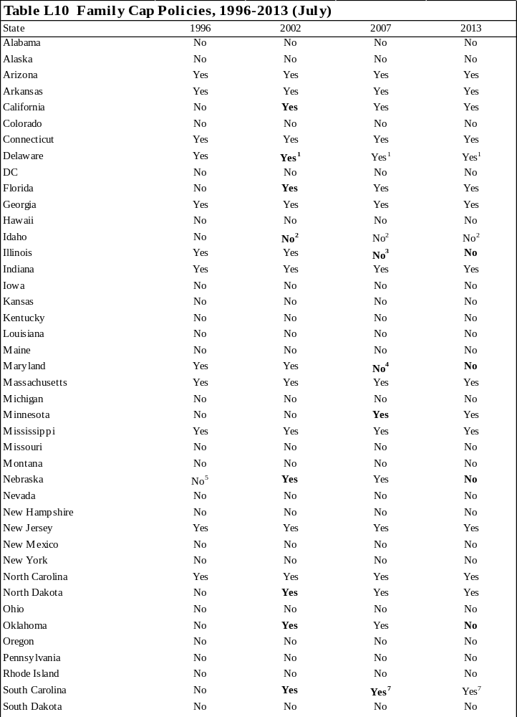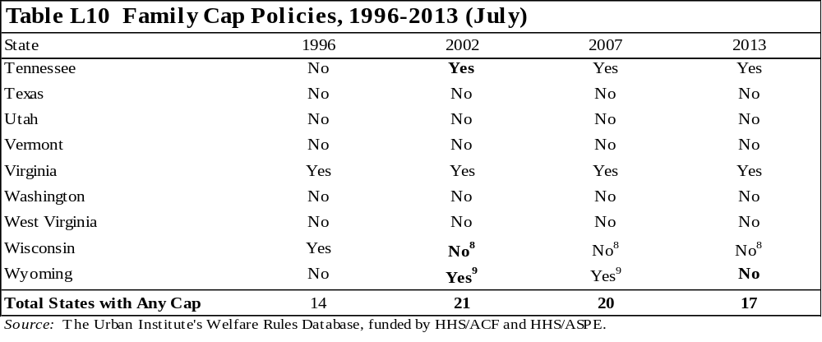
Note: Bolded text indicates a change from the previous year shown.

¹ In addition to the family cap policy, any child born after December 31, 1998, to an unmarried minor parent is ineligible for cash assistance, regardless of whether the minor was receiving aid at the time of the birth.
² The state provides a flat maximum benefit, regardless of family size. However, the Work Incentive Payment increases with family size, so the benefit for a unit with income may increase with an additional child, but never beyond the maximum benefit level.
³ Illinois no longer has a family cap; however, the state applied a cap to children born more than 10 months after case opening between January 1, 1996, and January 1, 2004. Children who were capped during this period continue to be capped. The cap may be removed for these children if the unit does not receive benefits for a minimum of nine months and has not previously experienced an increase in the payment standard as the result of a birth while receiving TANF.
⁴ Although the family cap still exists in state law, all local offices have implemented waivers to discontinue the family cap policy. In addition, formerly capped children are no longer subject to the cap.
⁵ Nebraska is conducting a demonstration project in five counties that subjects units to a family cap
⁶ The unit is not eligible for assistance if the only child in the unit is the capped child.
⁷ The state provides a flat benefit, regardless of family size.
⁸ The state does not allow any individual—including parents, adult relatives, or older children—to be added to the unit's payment 10 months after the initial qualification for assistance. A new individual's income and resources will be counted for eligibility and benefit determination.

Appendix 1:
Component Descriptions
The WRD and this book define a state’s TANF program as having a component when the state divides its entire caseload into mutually exclusive groups that are treated differently across more than one policy area. These groups are usually defined by more than one characteristic. Not every state uses components. For those that do, the following table describes how recipients are divided among the components, how long recipients can remain in the various components, and any interaction between the components.
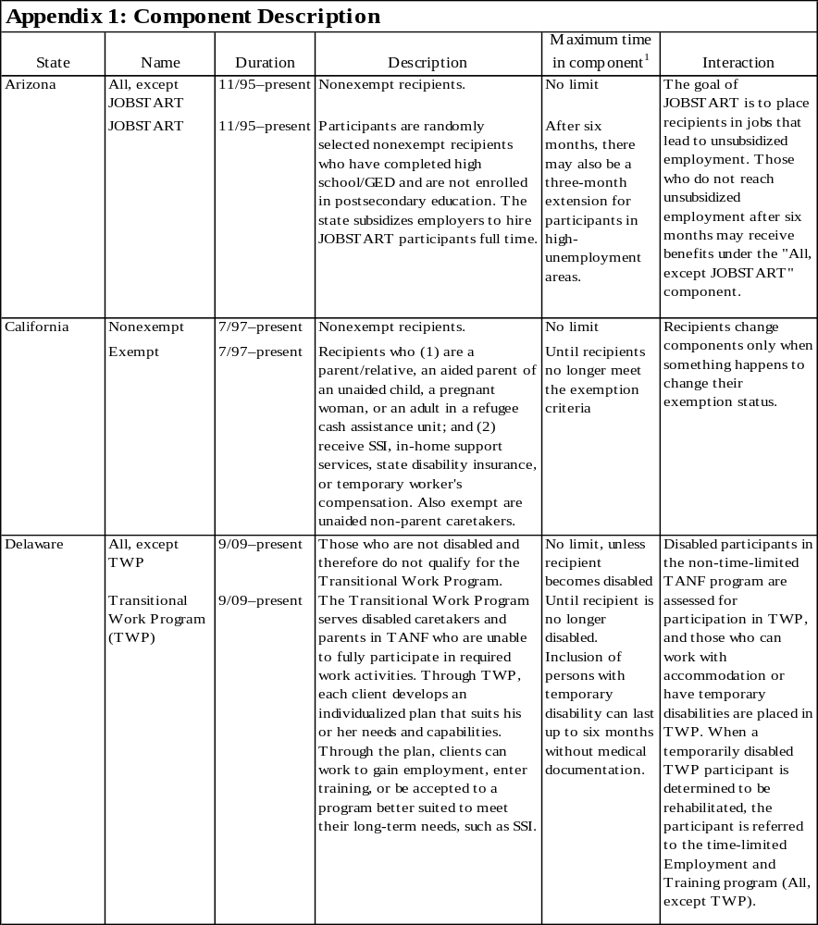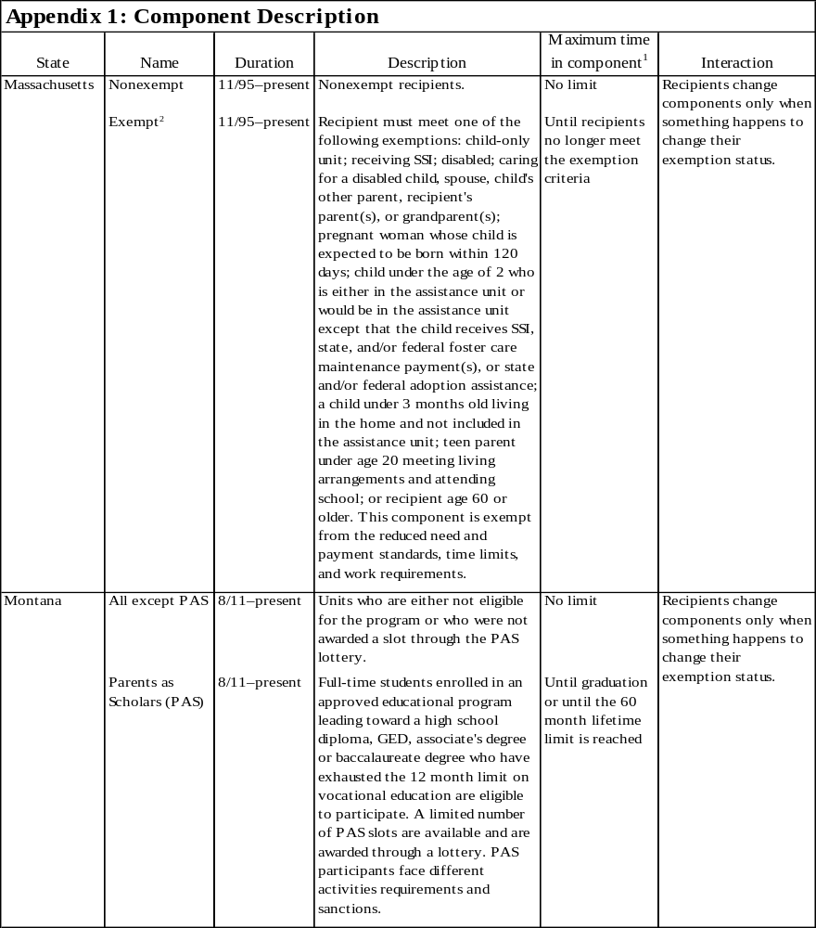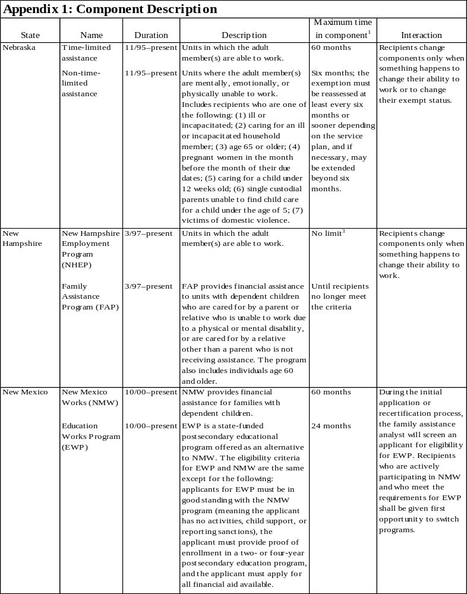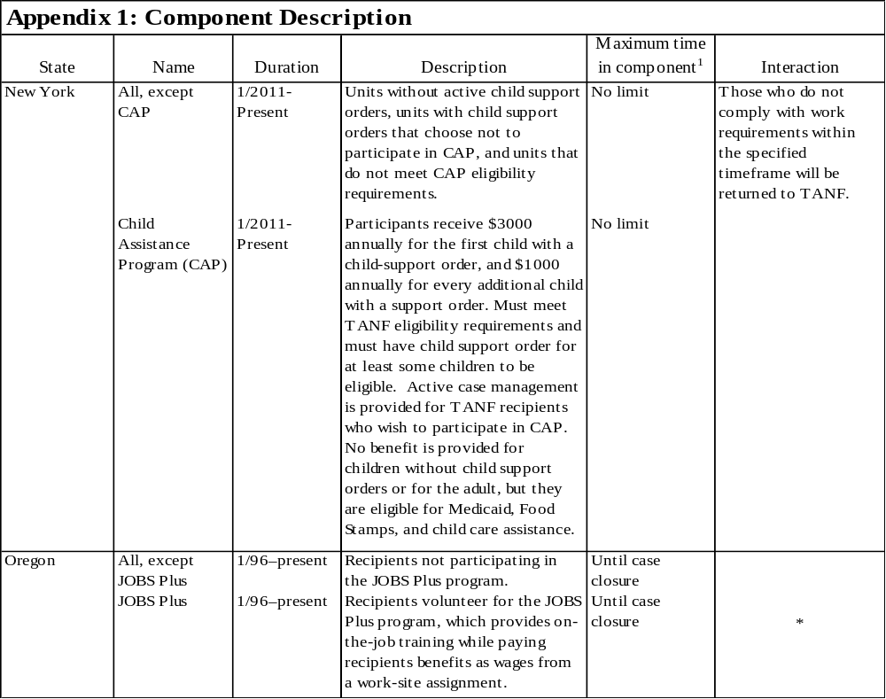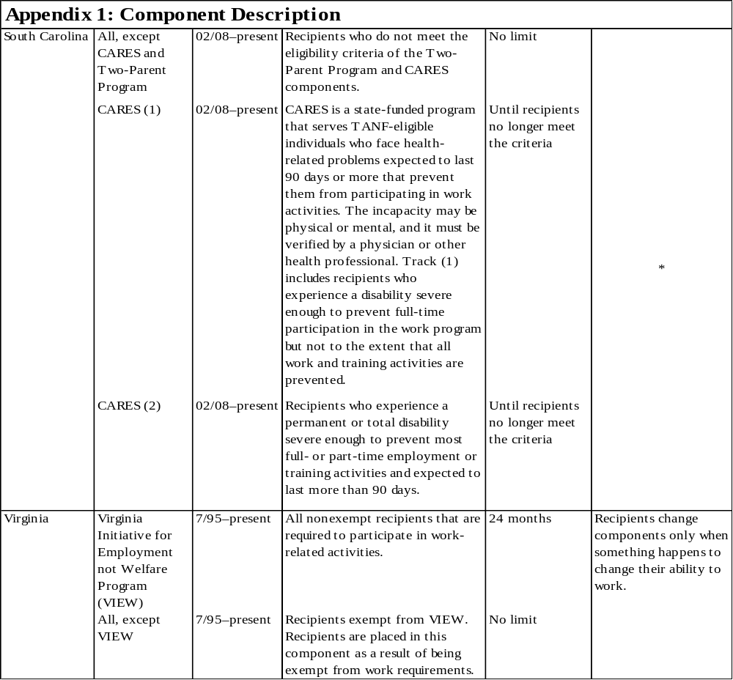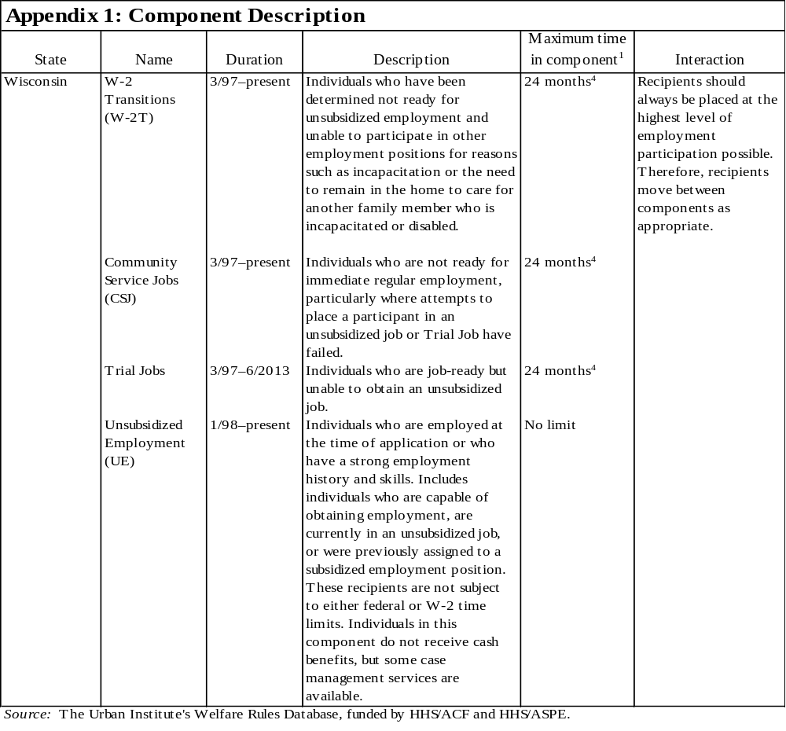
Note: Only those states that have clearly delineated components are included in this table.
Where "no limit" is listed for "maximum time in component," it is assumed that units in this component are bound by state time limits. See tables IV.C.1 and IV.C.2 for information on the maximum amount of time recipients are allowed to receive assistance in the state.

* Data not obtained.

¹ For more information on work exemptions and time limit exemptions, see tables III.B.1, IV.C.3, and IV.C.4. Or for more detail, see the WRD.
² In Massachusetts, the exempt component makes up the majority of the caseload.
³ Participants may request a six-month extension of eligibility based on hardship. There is no limit on the number of extensions for which a NHEP group may qualify.
⁴ From March 1997 until October 2009, participants were limited to 24 months in a component. Wisconsin discontinued the time limit from November 2009 through December 2011, and reinstated the time limit in January 2012.

About the Authors
Erika Huber is a research associate with the Urban Institute’s Income and Benefits Policy Center. In addition to co-managing the Welfare Rules Database, her work has focused on the Special Supplemental Nutrition Program for Women, Infants, and Children (WIC) and microsimulation.

David Kassabian is a research associate at the Urban Institute. His research focuses on various issues related to TANF and work support programs. He is the principal investigator for the Welfare Rules Database project.

Elissa Cohen is a research assistant with the Urban Institute’s Income and Benefits Policy Center. In addition to coding and verifying data in the Welfare Rules Database, she has worked on projects focused on TANF policy microsimulation and workforce development.


2100 M Street, N.W.
Washington, D.C. 20037

Phone: 202.833.7200
Fax: 202.467.5775
E-Mail: publicaffairs@urban.org
http://www.urban.org
Welfare Rules Databook

Welfare Rules Databook

See Falk, Gene. “The Temporary Assistance for Needy Families (TANF) Block Grant: A Primer on TANF Financing and Federal Requirements.” Congressional Research Service. November 6, 2012. http://greenbook.waysandmeans.house.gov/sites/greenbook.waysandmeans.house.gov/files/2012/documents/RL32748_gb_v2_0.pdf
Treatment of Additional Adults in the Household includes policies related to both financial and nonfinancial eligibility, as well as benefit computation. Therefore, the category could be included under sections I.A, I.D, and II.A.
Information in Dollar Amounts is also relevant to other categories, including Deemed Income, Income Eligibility Tests, and Benefit Computation.
Most states base benefits on the net income of the recipient. Net income is calculated by determining the gross income of a recipient and subtracting any earned income disregards the state may allow. Therefore, the Earned Income Disregard category is also relevant for section II.A.
The child support requirements for which a recipient may be sanctioned are included in the Child Support category listed under section I.D.
Owing to the difficulty of obtaining caseworker manuals during the transition from AFDC to TANF, the 1996 data in the WRD are coded using several different sources, including (a) caseworker manuals, when available; (b) AFDC State Plans submitted by states to the federal government; (c) waiver terms and conditions; and (d) telephone calls to states to clarify the implementation dates of waivers.
From this point forward, “states” refers to the 50 states and the District of Columbia.
The states that allow counties to vary policies (that are included in this book) are California and Colorado. The largest counties in each state are Los Angeles County in California and Denver County in Colorado. The WRD provides additional information on other states that allow counties to vary policies (that are not included in this book).
For an index of TANF-related laws and regulations compiled by the Administration on Children and Families, Office of Financial Assistance, see http://www.acf.hhs.gov/programs/ofa/programs/tanf/laws-regulations.
Information on transitional benefits is not presented in the Databook but is available in the full database.
In the financial-related tables, states that vary dollar amounts used for eligibility or benefit standards are denoted.
A “child-only” family may also be created if a parent is excluded from the unit because of a sanction or because of reaching a time limit results in removing the adult from the unit.
In some states, benefits are provided to two-parent units under solely state-funded or separate state programs funded by state monies rather than the TANF grant. Table I.B.2 includes those states as providing benefits to two-parent families regardless of the funding source as long as these provisions are specified in each state’s TANF policy manual.
Under AFDC, waiting periods were imposed only on two-parent units. However, under TANF, some states have begun to apply waiting periods to all types of units. The WRD does not currently capture waiting periods that apply to all units.
In general, states may not provide federally funded assistance to minor parents who are not living in an adult-supervised setting. However, there are some exceptions to this requirement.
Qualified aliens include legal permanent residents, asylees, refugees, aliens paroled into the United States for at least one year, aliens whose deportations are being withheld, aliens granted conditional entry, certain battered alien spouses and their children, battered alien children and their parents, Cuban/Haitian entrants, and aliens granted conditional entry before April 1, 1980.
The federal law exempts several groups of aliens from the five-year bar. They are refugees and asylees, individuals who had their deportation withheld, veterans or individuals on active duty along with their spouses and unmarried dependent children, Cuban/Haitian entrants, and certain Amerasians.
The five-year bar applies only to those aliens who entered the United States—whether legally or illegally—on or after August 22, 1996. Therefore, a person may have entered illegally in 1994 and become a legal permanent resident in 2000. As long as that person has been continuously present in the United States, the bar would not apply to him or her. See the Department of Justice’s Interim Guidance on Verification of Citizenship, Qualified Alien Status and Eligibility under Title IV of PRWORA at 62 Federal Regulation 61415 (November 17, 1997). Further, if the noncitizen enters the United States on or after August 22, 1996, but is not qualified when he or she enters, the five-year clock begins on the date his or her immigrant status becomes qualified.
States must permit the following qualified aliens who meet the state’s eligibility criteria to receive TANF benefits for five years after the date of entry into the United States or the date asylum or withholding of deportation was granted: refugees (and victims of severe forms of trafficking and certain family members), asylees, aliens whose deportation has been withheld, Amerasians, and Cuban/Haitian entrants. Also, states may never deny eligibility to veterans or individuals on active duty along with their spouses and unmarried dependent children.
States may never deny eligibility to legal permanent residents who have passed the five-year bar, accumulated 40 qualified quarters of work, and not received any federal means-tested benefits during any quarters beginning after December 1996. Forty quarters is approximately 10 years for one person; however, an alien may be credited with quarters of coverage worked by a parent or a spouse under certain circumstances.
These state rules must be viewed in the context of the federal prohibitions and requirements affecting the eligibility of noncitizens for federally funded assistance. The eligibility rules for noncitizens are very complex. This discussion is a summary intended for researchers and should not be used for assessing the policy options available to a state under federal law or whether particular state policies fully comport with federal law.
Arkansas and Wisconsin do not vary their benefits by net income or allow disregards. Instead, they provide a flat benefit to the assistance unit. This means the unit receives a set amount every month no matter what its countable income is (as long as the income does not exceed the state’s income eligibility thresholds).
The work participation rate indicates what percentage of the state TANF caseload must be participating in work activities. Both the number of hours required to qualify for the rate and the percentage have increased semiannually since 1996. According to legislation, as of 2013, 50 percent of a state’s single-parent caseload was required to participate an average of 30 hours a week. Two-parent families were required to participate at a rate of 90 percent for an average of 35 hours a week.
For more information about the Deficit Reduction Act of 2005, see the Reauthorization of TANF Interim Final Rule, June 29, 2006, http://www.acf.hhs.gov/programs/ofa/law-reg/tfinrule.html, accessed June 25, 2014.
Such parents may or may not be exempt from participation requirements. A single parent may only be excluded from the participation rate calculation under these circumstances for a maximum of 12 months over the assistance unit’s lifetime.
The federal government requires that the minimum state sanction for noncompliance with work requirements be a pro rata reduction in benefits.
North Dakota no longer provides TANF benefits to two-parent, nondisabled units. Also, in some states, benefits are provided to two-parent units under solely state-funded or separate state programs funded by state monies rather than the TANF grant. The table includes those states as providing benefits to two-parent families regardless of the funding source.
States are required to pay a share (equal to the state’s Medicaid match rate) of all child support collected on behalf of TANF recipients to the federal government. States may still provide all child support collected to the recipient; in that case, the state must use other funds to pay the federal share.
The TANF regulations indicate that the federal 60-month time limit does not count against child-only units (units that include no adults). However, a few states count months in which units are child-only because of the ineligibility of their parents based on immigrant status or illegal activity.
The table includes only those time limits that affect the majority of units. For a description of time limits affecting other groups, see the WRD.
All years of data are available through the online WRD database or through previous years of the Welfare Rules Databooks. The Databooks for 1999–2013 are available on the WRD web site.
Years in which the state implemented a diversion program as a pilot project in only a few counties are footnoted.
If units in the first month of receipt (applicants) receive different disregards, they are footnoted. This table does not include disregards related to child care or any other special disregards for units affected by family caps or time limits.
States had the option to require JOBS participation of parents with children as young as 12 months old.
Years in which the state imposed a family cap as a pilot project in only a few counties are footnoted.

